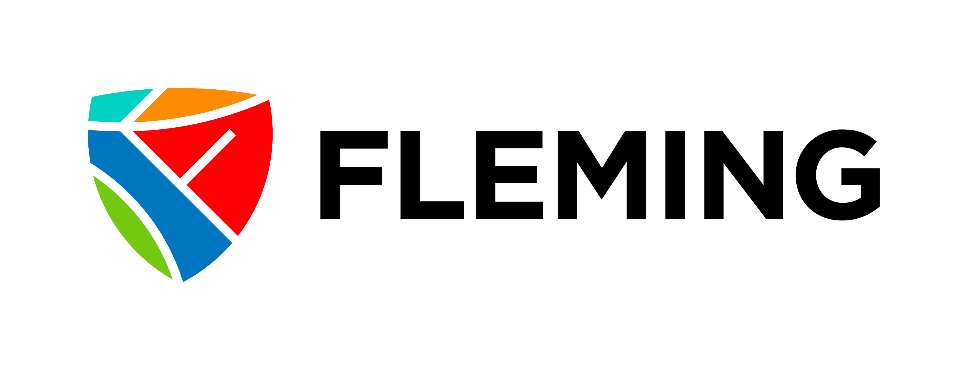

**Academic Council**

________________________________________________________________________________________

|  |  |  |  |  |  |
| --- | --- | --- | --- | --- | --- |
| Date: | | | Monday, November 25, 2024 | | |
| Time: | | | 2 PM – 4 PM | | |
| Location: | | | Sutherland Campus – B3330 | | |
| Virtual Option: | | | **Join on your computer, mobile app, or room device**  [**Join the meeting now**](https://teams.microsoft.com/l/meetup-join/19%3ameeting_ZWQ0ZTg3MWUtY2YxNi00YThiLWExOTUtOGJlODY4NTM0NDY1%40thread.v2/0?context=%7b%22Tid%22%3a%2206a77143-e151-4722-8efb-d5b7a0a53f54%22%2c%22Oid%22%3a%2255502391-db43-4884-92b3-5bdb43e98ced%22%7d)  Meeting ID: 233 892 868 488  Passcode: KVaFeC | | |
|  | | |  | | |
| **Time** | **Item** | | **Topic** | **Presenter** | |
| 10 mins | 1 | | **Welcome**   * Oct minutes |  | |
| 20 mins | 2 | | **Round table/Discussion Items**   * Updates | All | |
| 20 mins | 3 | | **Regular Check-ins**   * Department updates   + LDS, AES/Counseling, RO/BIAS, Academic Integrity, Library, Academic Quality, Student Experience, IT |  | |
| As needed | 4 | | **Final round table** | All | |
|  | 5 | | **Adjournment** |  | |