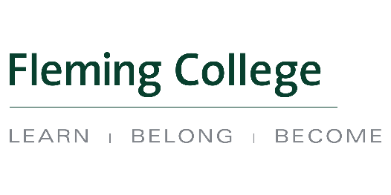
Aboriginal Education Council
Thursday April 13, 2017
Frost Campus; FR252
13h00 – 15h00

Attendees: Chair Liz Stone, Mark Gray, Trish Schneider, Tony Tilly, Judith Limkilde, Letticia Amyotte, Adam Hopkins, Kristi Kerford, Nancy Marsden-Fox, Brad Hodgson

Guests: Nick Duley, Madeline Whetung (by phone), Ron MacDonald, Winona Ominika, Tommy Akulukjuk, Kent Hodgin

Recorder: Cindy English

Regrets: Elder Shirley Williams, Deanna Jacobs, Rachel Charles, Karrie MacMurray, Kylie Fox, Cristine Rego, Jo-Anne Green

Agenda Ref. | Key Points / Actions | Action Item Details
1. | Smudge and prayer provided to the group by Letticia Amyotte
2. | Call to Order at 1h05  - Student Awards Acknowledgement  - Welcomed guests and round table introductions
3. | AEC Meeting Agenda – April 13, 2017  Motioned to approve by Trish Schneider  Seconded by Mark Gray  AEC Meeting Minutes – February 16, 2017  Motioned to approve by Letticia Amyotte  Seconded by Adam Hopkins
4. | Review of Membership – Liz Stone  Mississaugas of Scugog Island First Nation position vacant.  Request for new external members recommendations:  - Lori Flynn (Exec. Director, Friendship Centre) for at large  - Alumni were suggested  - member from Niijkiwendidaa Anishinaabekwewag Services Circle  - Winona Ominika, Student position  Internal members will be designated before September | Cindy English to follow up with Mississaugas of Scugog Island First Nation.  Cindy English to confirm with absent members that their external appointment on AEC will continue and that all seats are filled.  Cindy English to add Membership Review as an Annual April Agenda item  Cindy English to ensure internal seats have been designated
5. | Student Profile -Winona Ominika  Student from the Outdoor Adventure Program, 1 year left at Fleming
6. | Educational Managers and Registrar Meeting Update - Kristi Kerford  Two Fleming departments met with AEC Education Managers (Registrar, Counselling/AES)  Purpose was to raise awareness, improve connections & understand roles
7. | Outreach and Engagement Research Findings - Madeline Whetung/Mark Gray  Report was provided to AEC for review | Cindy English to send follow up email to AEC for feedback  with 2 or 3 guiding questions  Kristi Kerford to present report to key tables at Fleming  Future Agenda item to monitor progress
8. | Fleming College- Public Facing website - Cindy English/Kristi Kerford  Current websites could be more user friendly with the information more accessible  Mount Royal University and Confederation College were provided as examples  Suggestions:  - Territorial Acknowledgment on the main page | Kristi Kerford and Cindy English will move forward on this project and will ask for input from AEC as required.
10. | College Business Plan- IEP Review, Past-Present-Future  Year runs September-August. We are on track with year 2  Highlights:  -programs are continuing to add Indigenous content  -hiring curriculum and outreach and engagement positions | Cindy English to ensure this update is a public document.  Kristi to include AEC Chair in IEP planning meeting
11. | Review of “Priorities for the Year”  Summarized and highlighted that the Biishkaa Trail is about to open
12. | Round Table  Thank you and best wishes to Chair Liz Stone
 | Meeting Adjourned at 15h15

