Guest Parking Instructions
Sutherland Campus

Parking Services would like to welcome you to Fleming College and hope that we can make your arrival on campus as welcoming and seamless as possible.

As an invited guest you are being provided with complimentary parking. Please follow these instructions when you arrive on campus:

- You may park in ELM Lot (please park in the same row as the Pay and Display Machine)

- Go to the Pay & Display Machine located in the lot.

- Press the “Code” Button.

- Enter the following code 77770218

- Press the Green Button with the check mark.

- The code will take a moment to process (watch the screen for confirmation)

- Press the “Prepaid” button once the code is processed to print a payment receipt.

- Display the payment receipt on your dash with the date, time and amount visible.

- If you need assistance in locating a department or meeting room the Information Booth is located inside the main entrance or you can contact them from any campus phone at extension 8000.

Please remember that all students, employees and visitors to campus are required to abide by the College Parking Regulations and to obey posted signage.

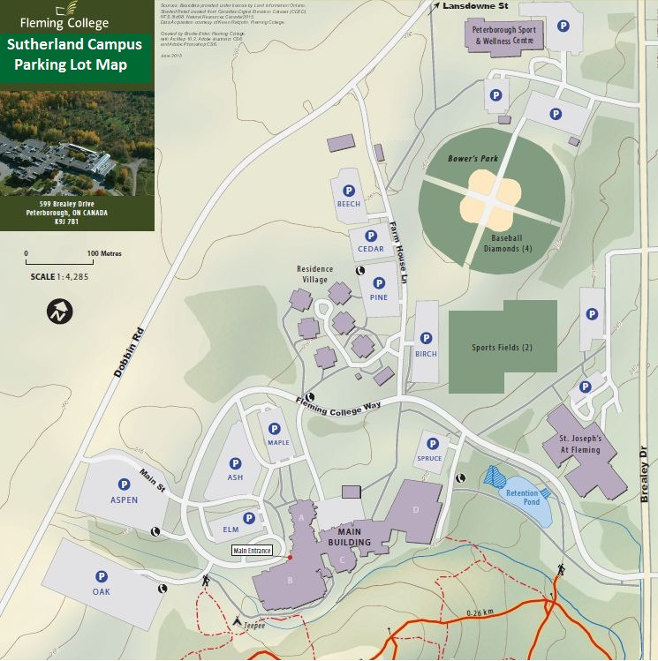

Parking Lot Information:
Ash Lot: General Permits Only
Aspen Lot: General Permit and Pay & Display
Beech Lot: Economy Permits Only
Birch Lot: General Permit and Pay & Display (Sports Field Users no charge after 5pm)
Cedar Lot: Residence Permits Only
Elm Lot: Pay & Display Only (Visitors)
Maple Lot: Premium Permits Only
Oak Lot: General Permit and Pay & Display
Pine Lot: General Permit and Pay & Display (Sports Fields overflow – payment required)
Spruce Lot: Pay & Display Only (Visitors)

