Status Report

Project Summary
Report Date | Project Name | Prepared By
December 4, 2017 | Indigenous Outreach & Engagement | Kylie Fox

Status Summary
During the week of September 18, 2017, I began my work as the new Assistant Manager of Aboriginal Student Services. My mandate being that I focus my project work on the development of an outreach and community engagement strategy for Indigenous Learners.

The first couple of weeks were focused on developing/re-connecting with community contacts involved with the coordination of the APSIP, Aboriginal Post-Secondary Information Program. As the APSIP recruiters had already began the tour, I needed to enlist as a ‘Friend of APSIP’ and formally request approval to join in on the tour for weeks 5,6,7,9,10, and 11. These weeks covered FNMI communities (on and off reserve) in the follow regions: Toronto, Southern Georgian Bay, Sudbury/Manitoulin, Eastern Ontario, Hamilton/Six Nations, and Southwestern Ontario.

Fleming was granted approval by each Week Coordinator to attend and Fleming Aboriginal Student Services staff took turns (in the absence of a hired recruiter) travelling and providing outreach and engagement with the following communities:

Toronto
Oshawa
Scarborough
Port Perry
Scugog Island FN
Wikwemikong
M'Chigeeng,
Rainbow District School Board @ Cambrian College,
Catholic District School Board @ Laurentian University
Wiarton
Owen Sound
Port Elgin
Sutton
Rama FN
Saugeen FN
Chippewas of Nawash FN
Midland, Orillia
Peterborough

Scheduled to visit the following – but had to cancel due to strike (return of students that week)
EASTERN ONTARIO: Belleville, Napanee, Kingston, Cornwall, Sharbot Lake, Tyendinaga,
SIX NATIONS/ HAMILTON: Brampton, Brantford, Niagara-On-The-Lake, Mississaugas of New Credit, Six Nations/Ohsweken
SOUTHWESTERN ONTARIO: Windsor, Ridgetown, Forest, Sarnia, London, Lambton, Wallaceburg, Walpole FN, Delaware FN, Kettle & Stony Point FN, Kitchener

Ideally, we do plan to have someone in a designated recruitment-type role; However, as we begin this work as a team, it was a great opportunity for each staff member to engage with APSIP, with community and to understand the complexities, challenges, and advantages of having a recruiter. Our collective experiences will assist us in the creation of a comprehensive outreach and engagement strategy.

During the three weeks that we were able to join APSIP, we saw over 400 Indigenous students and made over 40 connections with FNMI community representatives, teachers, guidance counsellors, education portfolio holders and community agencies. (data is currently being collected and detailed information re: numbers can be available upon request).

Beyond APSIP (Whetung, 2017) , I have been doing work to develop our internal partnerships, to best support our Indigenous Learners. These internal initiatives and projects will also aide in the improvement of the Indigenous experience on campus, therefore increasing our readiness to bring in more Indigenous learners through outreach and engagement.

Self-Identification
- Currently working with several departments to ensure all self-id data is centralized to our reporting centre so that data collection is more consistent and accurate.
- In October, we worked with the Registrar’s Office to ensure that software ‘spoke to each other’, in order to amalgamate data from multiple places of self-identification opportunity. This improved system function allowed us to access data that was not accessible previously – which almost tripled our number of self-identified FNMI students!
- As you know, our Indigenous student enrollment had been on a decline for the past couple of years, but with this more accurate data collection, we may be able to look back and get a more accurate depiction of our stats for self-id. I will be working with Fleming Data Research to collect and analyze this data as to help guide our plan for strategic future outreach and engagement
- Currently working with Ted Stebbins, one of Fleming’s Technical Business Analysts, to implement an Indigenous self-identification solution in the Student Centre to compliment data already captured for applicants in OUAC. This means students will have the option to self-identify from their student portal and the data will link to our central data collection in Evolve – adding another option for students, improving data collection process, and moving to a more paperless system.

Internal Partnerships:
The following service departments are honouring Fleming’s Commitment to the Indigenous Education Protocol through working partnerships with Fleming Aboriginal Student Services

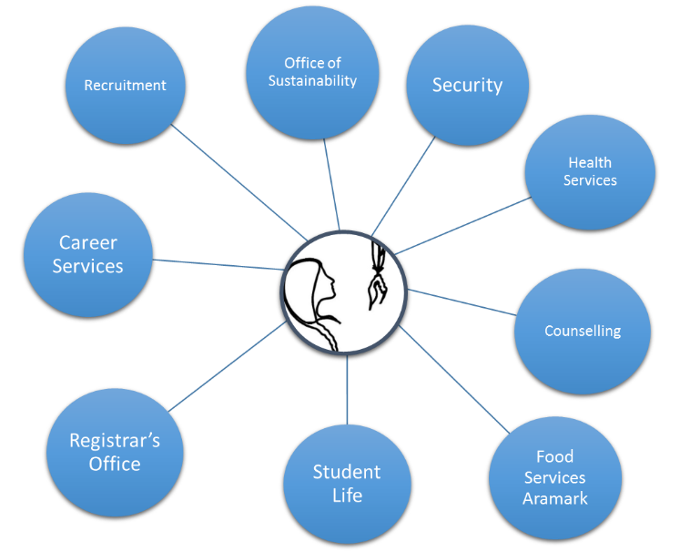
[IEP Commitment #6. Establish Indigenous-centred holistic services and learning environments for learner success.] (College and Institutes Canada)

Security
- Establishment of a Traditional Warrior/Peacekeeper Society on Campus
- made up of Indigenous student volunteers – possibly brough forward by nomination
- I’m Kind Man
- Shkaabaywis?
- Project currently in beginning stages – consultations with Elders and work with John Gallen currently in progress
Health Services
- Indigenous Healthcare Consultations
- m’shkiki (plant-based medicines – smudge, etc)
- Still finalizing staff session, plans to begin weekly visits (biweekly at each campus – alternating ptbo/frost) in January 2018
Counselling
- Dorothy – Elder support/advising in Counselling wing
- Dorothy booked for Nov. 2017-April 2018
- Smudge-friendly spaces
Food Services
- Traditional Indigenous foods available in cafeteria on a regular, consistent basis
- Working with Aramark on this now – they are supportive
Career Services
- designated Indigenous Career Advising
- Established partnership with Lou Anne Hanes
- initiative established
Recruitment
- Partnership includes working together to gather data and development of Indigenous Recruitment strategy
- In progress
Office of Sustainability
- Feast Bundles Program
- In progress
Student Life
- Orientation: Round Dance, Learn to Hoop Dance
- Initiating conversation re: Indigenization of services
Registrar’s Office
- Centralization of Self-identification data
- Indigenous Bursary support
- designated Indigenous RO staff?
- Initiating conversation – beginning stages

Accountability to recommendations outlined in the Internal Research Report Conducted by Madeline Whetung, 2017:

Ahead of schedule | on schedule | behind schedule

Recommendation* | immediate | 2017/18 | 2018/19 | 2019/20 |  | Status
- Indigenous Marketing Materials (Kylie)
- make better use of the website |  |  |  |  |  | In progress
- showcase Indigenous learners |  |  |  |  |  | In progress
- update marketing materials |  |  |  |  |  | Done (on-going improvement)
- Beyond Traditional Recruitment (Kylie)
- Hiring outreach and engagement staff |  |  |  |  |  | Creation of Assistant Manager, Aboriginal Student Services. Focusing work on development of outreach and engagement strategy. Currently reviewing opportunities for internal/external partnerships
- senior investment in community |  |  |  |  |  | Internally: Aakwa ode’ewin  Sessions with senior leaders and college decision makers. Session in the lounge for FNMI students
- relationships with local schools |  |  |  |  |  | In progress
- giving land back (on-going)
- Partnering with Trent University (Kylie)
- recruitment |  |  |  |  |  | Meeting with Director of FPHL in January
- Indigenous student transitions
- Rethinking the recruitment Trail (Kylie)
- making the most of APSIP |  |  |  |  |  | Joined APSIP F2017
- beyond APSIP |  |  |  |  |  | In progress; community visits, pow wows, mail outs, phone calls, etc.
- Engaging Students in Recruitment (Kylie)
- emerging student leaders program
- student transitions programs (Bishkaa) | In progress |  | Evaluate/  expand |  |  | Bishkaa Orientation and Mentorship program ran F 2017 – 3 Indigenous student Mentors hired for academic year
- students recruiting in the north
- Recommendation out of scope (academics)
- Broadening Cultural Competency (Mark)
- training for ELT
- training for administrators |  |  |  |  |  | 1 Session complete and on-going
- training for faculty and staff |  |  |  |  |  | In progress – working with HR

*List of recommendations have come from the internal report: Indigenous Student Outreach and Engagement at Fleming College Internal Report Research Conducted and Report Written by Madeline Whetung April 3, 2017. This report will be the guiding document for work done in the area of Indigenous student outreach and engagement.

