FASS Departmental Update

KEY ITEMS

- Cultural Programming on Campus Dorothy Taylor, Joseph Pitawanakwat, Fire Keeping, Axe Safety
- Salve Making with Joseph Pitawanakwat
- Annual Aboriginal Awareness Week Internal partnerships are underway to expand Indigenous approaches to campus services
- Upcoming Events Come on out!

CULTURAL PROGRAMMING ON CAMPUS

Many programs that embrace culture and traditional perspectives have been taking place at both Sutherland and Frost campuses.

- Elder Dorothy Taylor has continued on campus 2 days per week (1 afternoon at each campus per week). Dorothy provides a group teaching as well as one to one meetings with students as requested.
- Joseph Pitawanakwat is on site 1 time per week, alternating campuses. He shares his knowledge of Indigenous plant-based medicine with students.
- Elder Shirley Williams has continued to at each campus for an afternoon on a monthly basis.
- Brittany MacLeod from MNO has had to put some of her programming on hold due to being the sole site operator in Peterborough. Her programming in the Aboriginal Student Lounge is expected to continue in the Fall.
- The Nogojiwanong Friendship Centre is now providing some cultural programming and resources in the Aboriginal Student Lounge 1-2 times per month.
- Caleb Musgrave provided a day of Fire Keeping teachings to interested students at the Tipi at the Sutherland campus. Caleb also provided a day of Axe Safety and technique to students at Sutherland Campus. Frost Fire Keeping was cancelled at the Frost campus due to a fire ban. However, students from the Frost campus were invited to participate at Sutherland.
- …and much more!

For full details visit the Neechee Community Calendar: https://teamup.com/ks109dbe50c141cb82 TEAM PROJECT WORK

SALVE MAKING

Joseph Pitawanakwat spent 5 days at each campus working with and teaching students about traditional plant based medicines to make Minigan (arthritis medicine)

Students were led by Joseph at the beginning of each day to harvest a medicine from the trails at each campus. Students learned to identify specific medicines and how to harvest in a sustainable way. Students also learned about the medicinal properties as well as how to process the medicine to add to the salve.

At the end of the workshop the Minigan was then given back to Aboriginal Student Services to provide as gifts to elders and community helpers.
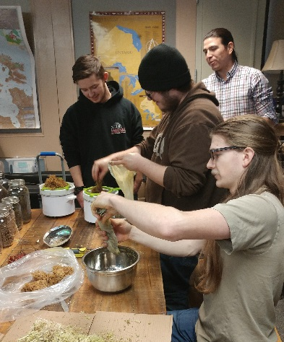
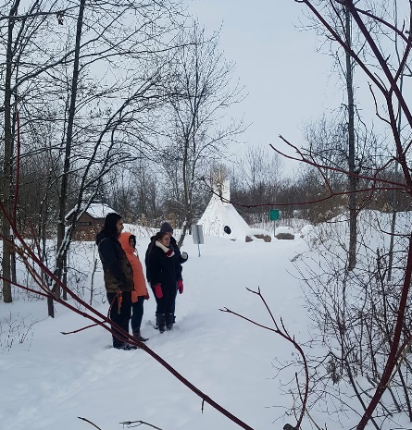
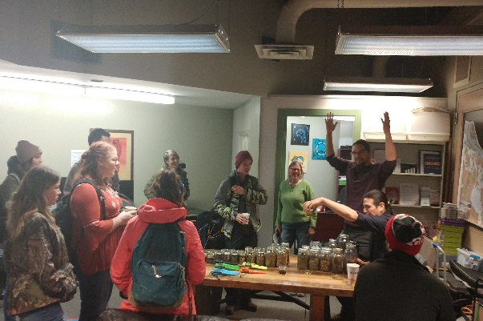

Students at Frost jarring their salve
Students at Sutherland learning about the medicine they are about to harvest
Students at Frost straining the salve to add another medicine

ABORIGINAL AWARENESS WEEK

Aboriginal Awareness Week was celebrated at both Campuses from Monday March 19th to Friday March 23rd

Attached is the schedule of events for both campuses.

Highlights include
- Hoop Dancing performance and demonstration by Nimkii Osawamick
- Charging Horse Singers – Men’s Drum Group
- Women’s Hand drum
- Vendors and Community Agencies
- Much more!

UPCOMING EVENTS – Come join us!

- Hunting and Trapping Skills – Thursday April 19th
Caleb Musgrave will be discussing traditional hunting and trapping skills. Participants will learn the traditional ways of hunting and trapping (specifically Beaver). Participants will also have the opportunity to skin the beaver and prepare it to cook and eat.

- Beading Workshops
In February and March students had the opportunity to learn beading skills for creating their own beaded medallion. Beading workshops will continue on Wednesdays in the lounge as a drop in activity.

For details, contact Ashley Safar or Tommy Akulukjuk: Ashley.safar@flemingcollege.ca or tommy.akulukjuk@flemingcollege.ca

