Indigenous Education Council Meeting | 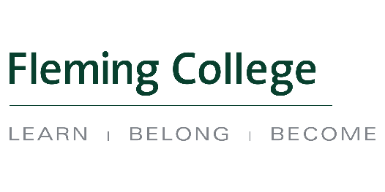

Meeting Date: September 20, 2018| 12h00 – 12h45 Lunch | Regular Business Meeting 13h00 – 15h00
Location: Sutherland Campus – Room B3 330

Agenda Items
Topic | Speaker | Time allotted
Acknowledging the Territory | Chair Trish Schneider
Welcome and Smudge | Ashley Safar
Call to Order  - Brief Introductions - Members and Guests  - Chair’s Remarks    - Fleming College President - Remarks  - Conflict of Interest Items | Chair Trish Schneider | 15 mins
IEC Meeting Agenda- September 20/18   IEC Meeting Minutes- April 12/18  | Chair Trish Schneider | 5 mins
Indigenous Education Protocol   - Review of 3-year work plan  - College representatives attending to present a brief overview | Dean- Carol Kelsey  Marketing/Recruitment – Carrie Truman/Kylie Fox  Indigenous Student Services – Mark Gray  Human Resources – Nick Duley  Physical Resources – Terry Williams | 60 mins
IEC External Member – Discussion  - This will be an opportunity for external members to connect and reflect on IEC in the coming year  - Internal members will be excused |  | 40 mins

 Document provided on IEC website as part of meeting package

Indigenous Education Protocol

- Commit to making Indigenous education a priority.
- Ensure governance structures recognize and respect Indigenous peoples.
- Implement intellectual and cultural traditions of Indigenous peoples through curriculum and learning approaches relevant to learners and communities.
- Support students and employees to increase understanding and reciprocity among Indigenous and non-Indigenous peoples.
- Commit to increasing the number of Indigenous employees with ongoing appointments, throughout the institution, including Indigenous senior administrators.
- Establish Indigenous-centred holistic services and learning environments for learner success.
- Build relationships and be accountable to Indigenous communities in support of self-determination through education, training and applied research.

