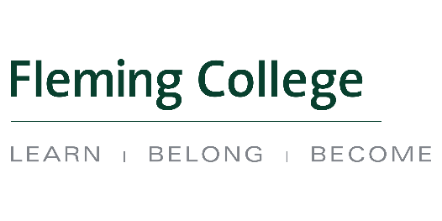
Indigenous Education Council Minutes
Thursday September 20, 2018
Sutherland Campus: Room B3330
13h00 – 15h00

Attendees: Trish Schneider, Jo-Anne Green, Karrie MacMurray, Mary-Anne Hoggarth, Kristi Kerford, Mark Gray, Maureen Adamson, Deanna Jacobs, Brad Hodgson, Ashley Safar

Guests: Carrie Truman, Kylie Fox, Terry Williams, Nick Duley, Carol Kelsey

Recorder: Cindy English

Regrets: Nancy Marsden-Fox, Shirley Williams

Agenda Ref. | Key Points/Speaker | Action Items
1.0 | Acknowledging the Territory - Trish Schneider
2.0 | Welcome and Smudge - Ashley Safar
3.0 | Call to Order 1:06 pm  - Brief Introductions - Members and Guests  - Chair’s Remarks  Trish briefly discussed plans for this year’s meetings:  - December- new format possibly in the new Indigenous Lounge, dinner/feast  - February - Interactive meeting  - April – TBD  - possibility of switching times and locations to better accommodate external members  Volunteer Opportunity- Older Adult in the Community https://department.flemingcollege.ca/aec/news-activities/  - Fleming College President - Remarks  - Conflict of Interest Items
4.0 | IEC Meeting Minutes – April 12, 2018  Motioned to approve by Brad Hodgson  Seconded by Karrie MacMurray  IEC Meeting Agenda – September 20, 2018  Motioned to approve by Jo-Anne Green  Seconded by Brad Hodgson
5.0 | Indigenous Education Protocol - Review of 3-year work plan  Presenters:  Dean- Carol Kelsey  Marketing/Recruitment – Carrie Truman/Kylie Fox  Indigenous Student Services – Mark Gray  Human Resources – Nick Duley  Physical Resources – Terry Williams  Highlights:  IEP Summary  Power Point Presentation  Both of these can be found on the IEC website:  https://department.flemingcollege.ca/aec/2015-2016-meeting-dates/archives/september-2018-meeting-package/
 | Discussion/Suggestions:  - mandatory Indigenous Awareness Training available, similar to WHMIS or Accessibility training  - consider becoming a APSIP member and explore partnering with Trent Suggestion review  - research Fanshawe College as a model for self id, model, reporting etc.  - IEC rep to sit on hiring committees  - Share Traditional Knowledge Holders process and compensation structure to make it consistent within the community. See link for details. https://department.flemingcollege.ca/vpa/indigenous-education/share-traditional-knowledge/ | Human Resources to investigate training options  Indigenous Student Services will continue to work with Trent on partnership and long-term goal is to be a APSIP member  Indigenous Student Services will follow up with Fanshawe to learn more  Human Resources to follow up  Cindy English to provide to Mary Ann Hoggarth and info included in minutes
6.0 | IEC External Member – Discussion | Trish Schneider to debrief with College staff
 | Meeting Adjourned for Internal members at 2:22 pm

