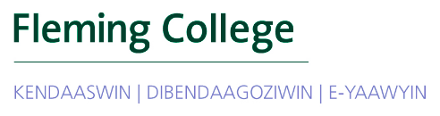
BRIEFING NOTE

Indigenous Outreach & Engagement – Year End Report
Kylie Fox, Assistant Manager - Indigenous Student Services and
Kristi Kerford, AVP – Student Services

OVERVIEW / ISSUE

This report provides an overview of the work completed over the past year by the Assistant Manager, Indigenous Student Services. This pilot position has had a particular emphasis on strengthening our relationships with Indigenous communities with a shared goal of increasing Indigenous student enrolment. It is currently a two year pilot position and given the positive outcomes (see Appendix A for enrollment numbers) that have been achieved, we are now requesting that this become a permanent Manager, Indigenous Student Services at the completion of the pilot in the Fall of 2019.

BACKGROUND

In 2017, a business case was submitted through the Innovation Investment Fund to create a 2-year position: Assistant Manager, Aboriginal (Indigenous) Student Services. This position has a strong emphasis in outreach and engagement with Indigenous communities. The Project Outputs (Deliverables) are as follows:
- incremental increase in Indigenous student enrolment each year;
- partnership with Trent for APSIP tour and other recruitment opportunities; and
- well-developed relations with our local communities to assist in determining local programming needs

ACHIEVEMENTS
Note: Prior to focusing on efforts to increase Indigenous student enrollment, data work was required to establish a base line and to ensure data systems were effective in tracking Indigenous student outreach, engagement and enrolment. This work was done in collaboration with the Registrar’s Office and the Institutional Research Office.

Incremental increase in Indigenous student enrolment each year
- Increased promotion of Fleming College through targeted mail out to Indigenous Communities across Ontario (166 total) with personal follow up call from Indigenous support staff
- New Brand –Aboriginal Student Services has been re-branded to reflect current terminology. Endorsement for name change to Fleming Indigenous Student Services has received by the Fleming Indigenous Education Council in spring of 2018 after many years of discussion. Our department has undergone significant changes to update our brand, including the inclusion of colours that were gifted to us from a local Elder, which have deep cultural significance

Meeting (and exceeding) Enrolment Expectations
- Self-identified Indigenous student enrolment has increased dramatically and we have already exceeded the incremental enrolment increase target for 2020 (see Appendix A).

Partnership with Trent for APSIP tour and other recruitment opportunities
- Fleming took part in 4 out of 15 weeks of the APSIP recruitment tour F2017 and F2018. See Appendix B for list of communities visited
- Discussion occurred with leaders at Trent First People’s House of Learning regarding future partnership opportunities. Trent would like to wait until we have the FT Indigenous Student Transitions Advisor dedicated to Indigenous recruitment/outreach/engagement before committing to formal partnership in this area.
- Plan to participate in all 15 weeks of the APSIP tour F2019 and F2020 through pilot of a 2-year Indigenous Student Transitions Advisor.
- Fleming will become a full member of the APSIP collective come Spring of 2019 given this new commitment
- Trent/Fleming partnering with UNESCO Global Research being done on Indigenous Youth and Education. This will help inform our work on Indigenous outreach and engagement and strategies for success.

Well-developed relations with our local communities to assist in determining local programming needs
- Contributed and coordinated several Indigenous community events
- Improved relationships, lead to new potential partnership for fall 2019; initiative to support Indigenous student recruitment with Trent University. This will allow for Trent and Fleming to have Indigenous staff represented both at APSIP and locally within Indigenous community (on and off-reserve)
- Increased meetings allow for improved relationships with local High Schools (public and catholic) in Peterborough area through increased conversation with Indigenous Student Advisors within the K-12 Board level
- Held community engagement sessions in summer 2018, gathering input on future potential partnerships and community outreach opportunities in local FN’s. Met with local First Nation and Métis education managers and FNMI Student Advisors with local school boards.
- Supporting Indigenous Academic Team and Initiatives. i.e. Career Ready Fund Initiative (Indigenous Perspectives designation). This will involve visiting several First Nation communities in Ontario to partner on student projects, with the potential of creating opportunities for Indigenous youth to visit Fleming College as part of an exchange program

In spring of 2018, our department spent a day conducting an exercise which evaluated the journey of many Indigenous Students. Through this, we were able to map out the Fleming Indigenous Student Experience and identify any/all gaps in service delivery. The following gaps were identified:
- Transitional support into the College through Indigenous cultural pedagogies and approach(es);
- Dedicated Indigenous staff for the APSIP recruitment tour and for regular FNMI community engagement events and opportunities.
- Exit programming and supports for those transitioning out and beyond the College
Each of the identified areas of weakness fell under the transitions umbrella. Therefore, we designed a proposal for a year-round position that will focus on these areas. The Indigenous Student Transitions Advisor has been approved as a 24-month Initiatives and Opportunities contract. This position is currently posted and we plan to hire with a start date of January 2019.
This position will not only address gaps in our support services in order to create a fully robust Indigenous Student Support Department and fulfill the needs of our Indigenous students; but it will also respond to many recommendations made over the years by external contract researchers, internal advisory committees, and the Indigenous Outreach and Engagement Report (Whetung, 2017; See Appendix C). In will also be a draw for potential students.

FUTURE ASSESSMENT REQUIRED

Indigenous Student Services, Frost & Haliburton: Currently assessing needs of Indigenous Learners at Frost Campus in Lindsay, and Haliburton School of Art and Design. Reviewing options to increase staff representation and increased cultural programming.

Mainstream Recruitment: When and where are we meeting Indigenous Learners and potential Fleming students? With the inclusion of a self-identification question to: mainstream lead cards, open house and welcome day registrations, and IRO follow up scripts, this will enhance our data collection to further inform our engagement strategies.

CONCLUSION / RECOMMENDATION(S)

Fleming Indigenous Student Services needs/deserves a champion, a full-time Indigenous Manager dedicated to running the operations of the department, lead Indigenous Student Service initiatives, and act as a liaison between the college and FNMI community leaders with an Indigenous approach to leadership and governance. With the success of the pilot project, we will now be submitting a request to the President that this position become a full-time Manager of Indigenous Student Services.

As we continue to grow and support our Indigenous students there are additional initiatives/services/ resources that will be required. They include:
- Full-time Indigenous Student Services Coordinator at Frost Campus.
- Indigenous Student Transitions Advisor becoming a FT permanent position following 2 year IO (January 2021)
- Full-time Indigenous Academic Chair - UNDERWAY
- Hire a Corporate Indigenization Lead: create college-wide awareness, inclusion, decolonization, and eventually, indigenization.
- Develop and implement an Indigenous student academic transition program through partnership with local school boards, First Nations and Métis community organizations.
- Indigenous student enrolment has become a shared responsibility of Indigenous Student Services and Marketing and Recruitment and the partnership needs to continue to grow.
- Indigenous Enrolment Policy and/or Access Program Options: Many post-secondary institutions have created Indigenous enrolment policies to help close the inequality gaps existing in the education system for Indigenous learners. This is a best practice and we are currently seeking out the possibility of establishing such a policy for the college.
- Continue to grow the number of Indigenous employees, specifically in service areas i.e. Registrar’s Office, Financial Aid, Student Services
- Honouring the Jay Treaty, Vancouver Island University’s Board of Governors has moved to approve a new tuition framework that allows any Indigenous peoples whose ancestral lands are within North America to be considered domestic students rather than international students. The change was made after discussions with Indigenous communities indicated a strong interest in enhancing educational opportunities for members of those communities who live outside of Canada. If implemented at Fleming, this could open our doors to students across North America and further increase Indigenous/domestic student enrollment.
- As the highest Indigenous population resides in urban centres, and as the fastest growing population in Canada, all Fleming recruiters and marketing staff must be culturally aware and must actively promote the college in a way that markets to Indigenous Learners. Hire Indigenous recruiters and ambassadors in liaison office.

APPENDIX A

TABLE 1: Target Indigenous Student Enrolment Increase (as outlined in Business Case Innovation Fund Proposal 2017)

Enrolment implications (if applicable) |  |  |  |  |  |  | Assumptions
Description | FY01  2017-2018 | FY02  2018-2019 | FY03  2019-2020 | FY04  2020-2021 | FY05  2021-2022 | Total
TARGET Annual Indigenous Student Enrolment Increase | 0 | 17 | 22 | 27 | 32 |  | 21 is break even, self ID is not always consistent, key to get a baseline in first 2 years
Actual Increase | 192* | 236 |  |  |  |  | 100 of these could be contributed to data centralization
*increase of 100 students occurred through centralization of self-identification data in F2017. We would not have had capacity to centralize data and take on this project without this new role, further validating our rationale for the position.

To consider:
- Although this impact may not be entirely correlated to the establishment of the position, it does validate the rationale as the position has increased the department’s capacity to complete work that would not have otherwise been done.
- Research has proven that many Indigenous students still chose not to self-identify, therefore the actual numbers are likely much higher.
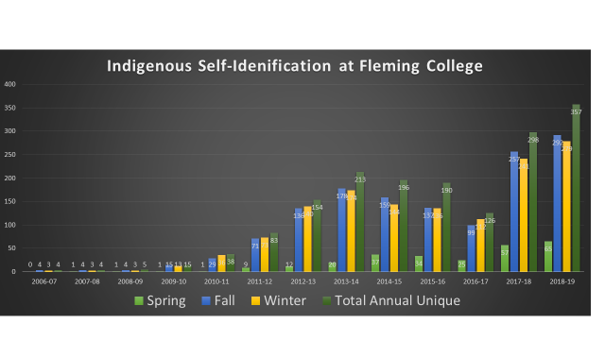

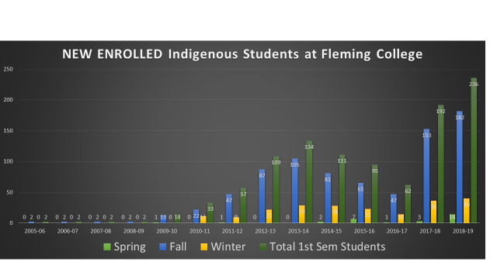

APPENDIX B

Communities we have engaged with through APSIP or other form of recruitment
2017  Toronto  Oshawa  Scarborough  Port Perry  Scugog Island FN  Wikwemikong  M'Chigeeng,  Rainbow District School  Catholic District School Board, Sudbury  Wiarton  Owen Sound  Port Elgin  Sutton  Rama FN  Saugeen FN  Chippewas of Nawash FN  Midland, Orillia  Peterborough  Tyendinaga,  Brantford  Niagara-On-The-Lake  Mississaugas of New Credit  Six Nations / Ohsweken | 2018  Hiawatha First Nation  Na-Me-Res, Toronto  Alderville First Nation  Mississauga's of Scugog Island First Nation  Six Nations, Ohsweken  Wikwemikoong Unceded Indian Reserve  Tyendinaga First Nation  Cape Croker First Nation  Midland  Curve Lake First Nation  Georgina Island First Nation  Community Education Offices - mailout  Northshore  Greater Toronto Area (GTA)  O'Neil Colegiate  G.L Roberts CVI  Scugog Island First Nation  Western Technical Commercial School  East York Collegiate Institute  Aboriginal Education Centre (evening session)  Native Learning Centre, East/Sir Wilfred Laurier Collegiate  Central Tech School  First Nations School of Toronto  Manitoulin Secondary School  Wiikwemikoong Unceded Indian Reserve  Kenjigewein Teg Education Insitutue  MetroFair Toronto  Sutton District High School  Cornwall  Kingston  Sharbot Lake  Napanee  Belleville/Tyendinaga  Curve Lake First Nation  Thomas A. Stewart, Peterborough  Cobourg Secondary School  Peterborough - St. Pete’s

APPENDIX C

Accountability to recommendations outlined in the Internal Research Report Conducted by Madeline Whetung, 2017:

COMPLETE | Ahead of schedule | on schedule | behind schedule

Recommendation* | immediate | 2017/18 | 2018/19 | 2019/20 |  | Status
- Indigenous Marketing Materials, p. 21-22*
Responsibility: Kylie Fox
- make better use of the website |  |  |  |  |  | In progress – this is still a bit of a challenge as nobody within our team has skill base to maintain a website(internal).
- showcase Indigenous learners |  |  |  |  |  | In progress/on-going. Collecting stories and statements from Indigenous Learners. as part of a ‘proud to be…’(self-identification) campaign in 2019 with new release of online self-id option.
- update marketing materials |  |  |  |  |  | COMPLETE re-branding occurred summer 2018.  (on-going improvement)  Indigenous Graduate Profile Campaign currently scheduled for roll-out Spring of 2019
- Beyond Traditional Recruitment, p.23-26*
Responsibility: Kylie Fox
- Hiring outreach and engagement staff |  |  |  |  |  | Creation of Assistant Manager, Aboriginal Student Services. Focusing work on development of outreach and engagement strategy. Currently reviewing opportunities for internal/external partnerships  Created new position which responds to this recommendation and fulfills identified gaps in Indigenous Support Services: Indigenous Student Transitions Advisor- pilot from January 2019 to January 2021.
- senior investment in community |  |  |  |  |  | Internally: Aakwa ode’ewin  Sessions with senior leaders and college decision makers. Session in the lounge for FNMI students  Installation of new President was done very well, and honoured Indigenous ways of doing – this speaks volumes to community  Work in always on-going
- relationships with local schools |  |  |  |  |  | WORK COMPLETE, but always on-going
- giving land back (on-going)
- Partnering with Trent University, p.26-27*
Responsibility: Kylie Fox
- recruitment |  |  |  |  |  | Met with Trent FPHL in 2017 and 2018. Trent is open to potential partnership once Fleming also commits to full time position – will then discuss opportunity to sharing responsibilities of engagement locally and FNMI community abroad
- Indigenous student transitions |  |  |  |  |  | Creation of new ISTA Position means a dedicated staff member committed to Indigenous student transitions – both into and transitioning beyond the college following graduation.  Note that this may or may not lead to formal partnership with Trent U.
- Rethinking the recruitment Trail, p.28-29*
Responsibility: Kylie Fox
- making the most of APSIP |  |  |  |  |  | Joined as ‘Friend of APSIP’ F2017 and F2018, with Full Membership occurring 2019 through newly established ISTA Position
- beyond APSIP |  |  |  |  |  | Complete and on-going: community visits, pow wows, mail-outs to every Ontario FNMI community; phone calls; regular visits and check-ins with local FNMI Education Representatives; sponsorship of FNMI community events, etc.  Annual training to mainstream recruiters regarding our services. More work to be done in the area of identifying Indigenous students at mainstream recruitment events – will be improved by added self-identification to mainstream lead cards and increased hiring of Indigenous recruiters in mainstream recruitment office
- Engaging Students in Recruitment, p.29-31*
Responsibility: Kylie Fox
- emerging student leaders program
- student transitions programs (Bishkaa) | In progress |  | Evaluate/  expand |  |  | Bishkaa Orientation and Mentorship program ran  F2017 and F2018 – 3 Indigenous student Mentors hired for academic year. With FT ISTA position, this program will be restored to its full potential for F2019.
- students recruiting in the north |  |  |  |  |  | Evaluating budget and on the radar for 2019-2020; will also utilize those involved in Indigenous Graduate Campaign for potential recruitment/ambassador positions in their home communities
- Recommendation out of scope (academics), p.31-34*
- Broadening Cultural Competency, p.34-36*
Responsibility: Mark Gray
- training for ELT
- training for administrators |  |  |  |  |  | 1 Session complete and on-going
- training for faculty and staff |  |  |  |  |  | In progress – working with HR

*List of recommendations have come from the internal report: Indigenous Student Outreach and Engagement at Fleming College Internal Report Research Conducted and Report Written by Madeline Whetung April 3, 2017. This report will be the guiding document for work done in the area of Indigenous student outreach and engagement.

