Parking Services
Event & Guest Parking Instructions
Frost Campus

Parking Services would like to welcome you to Fleming College and hope that we can make your arrival on campus as welcoming and seamless as possible.

As an invited guest you are being provided with complimentary parking. Please follow these instructions when you arrive on campus:

- You may park in A or B lots (see map on next page).

- Go to the Pay & Display Machine located in the lot.

- Press the “Code” Button.

- Enter the following code 9090 0177

- Press the Green Button with the check mark.

- The code will take a moment to process (watch the screen for confirmation)

- Press the “Prepaid” button once the code is processed to print a payment receipt.

- Display the payment receipt on your dash with the date, time and amount visible.

- If you need assistance in locating a department or meeting room the Information Booth is located inside the main entrance or you can contact them from any campus phone at extension 8000.

Please remember that all students, employees and visitors to campus are required to abide by the College Parking Regulations and to obey posted signage.

Host Department Notes:

Host department may choose to enter meeting or event details or other instructions in this section.
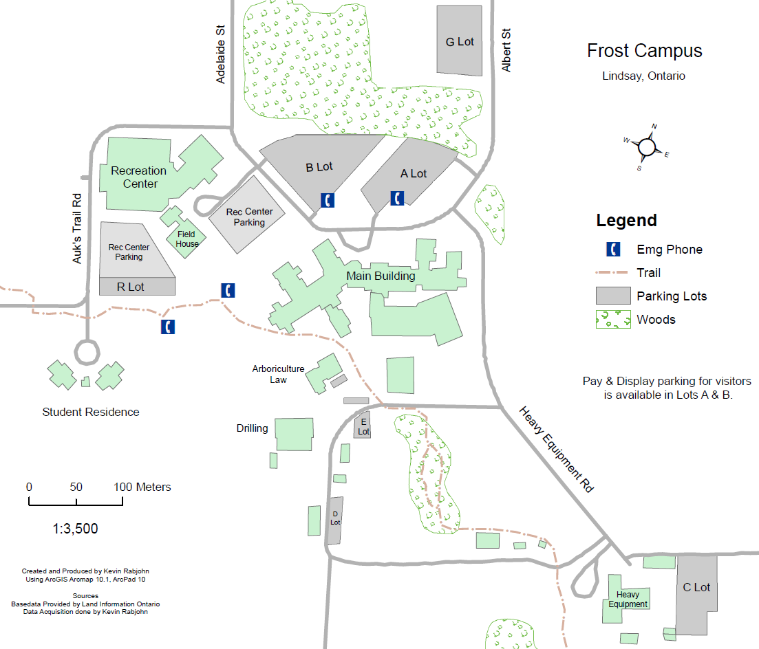

Parking Lot Information:
A Lot: General Permit and Pay & Display
B Lot: General Permit and Pay & Display
C Lot: General Permit and Pay & Display
D lot: General Permit and Pay & Display
E Lot: General Permit and Pay & Display
F Lot: Residence Permits Only
G Lot: Economy Permits Only

Special Event Parking Regulations

- Parking for special events must be arranged through the Information Booth at Sutherland or Frost Campuses a minimum of 5 working days prior to the event.

- Guest parking shall be provided in the most suitable location based on the operational needs of the College.

- For all events it may be necessary to charge a service fee to the host department or organization to cover the cost of lost parking revenue and/or the cost of additional security to control access to the lot.

- The fees charged by Facilities for room bookings do not cover the cost of parking. Arrangements and costs for parking are made separately from the room booking process.

Guest Parking Regulations

- Parking for guests or dignitaries must be arranged through the Information Booth at Sutherland or Frost Campuses a minimum of 1 working day prior to the event.

- Complimentary parking for guests and dignitaries must be approved by Parking Services prior to the event.

- Complimentary parking shall normally only be extended to those persons that are volunteering their time with a College department or school. Exceptions are at the discretion of Parking Services.

- College employees and students that are volunteering for a committee or project are required to pay for parking since their primary relationship with the College is as an employee or student not a volunteer.

- For all guests it may be necessary to charge a service fee to the host department or organization to cover the cost of lost parking revenue and/or the cost of additional security to control access to the lot.

Procedure:

- Once the event or guest parking is approved by Parking Services the Host Department will be provided a code for the event attendees or guests to use at the Pay & Display Machines located in the lots.

- It will be the responsibility of the Host Department to provide the code and the attached instructions to their event attendees or guests.

- Parking Services will track the use of these codes and where appropriate shall invoice the Hosting Department at a discounted rate for the cost of their guest’s parking.

