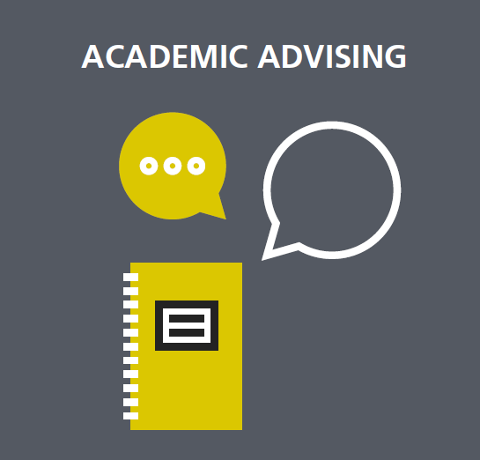
“POP-UP” ACADEMIC ADVISEMENT CALENDAR

- Our academic advising “pop-up” station will be “popping-up” at different campuses, during critical times of the academic year.
How do I prepare?
What’s next?
How can I be proactive?

- Watch your D2L notifications and your Fleming College email for dates during the weeks listed below.
WEEKS 14 16
- Academic Questions and Concerns
- Probation
- Academic Appeals
- Final Grades
- Pathways
- Career Advisement

SEMESTER START
How am I doing? How do I plan for what’s ahead?
WEEKS 9 11
- Academic Preparation
- Academic Questions and Concerns
- Education Pathways
- Course Withdrawal
WEEKS 6 7
- Academic Preparation
- Academic Questions and Concerns
- Tutoring

WEEKS 1 2
- Academic Preparation
- Academic Questions and Concerns
- Accommodation and Education Plans
- Transfer Credits

