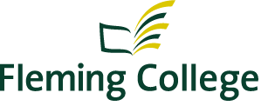

Recommendation Report

Indigenous Awareness Physical Inventory Project

Deepak Kumar
Sukhjit Singh
Gowtham Vishnu

Contents
Objective of This Project 3
Statement of Positionality 3
Research Method 3
Recommendations 3
*Tipi/Wigwam* 4
The Sun Symbol Statue 4
*An Open Air Classroom with Medicine Wheel* 6
Drum And Sticks 8
Aboriginal Symbols 9
*Names to change to Michi Saagiig language* 10
Further Recommendations 10
References 11

Objective of This Project

The purpose of this applied project is to investigate what other college and universities offer to the aboriginal students on their campus. Then compare it to our college and prepare the final recommendation report for what more can be done for aboriginal students. This recommendation report will give us an idea on how to develop the current inventory at Fleming College Sutherland and Frost campuses.

Statement of Positionality

I, Deepak Kumar was born and raised in India. After I completed my education in 2014 I worked at the company; “Tata Consultancy Services”. I was employed there until August 2016. I moved to Peterborough, Ontario (Canada) in September 2016 to further my studies. I am a student of PMG Project Management at Fleming College. I began this course in September 2016 (fall). During this course my team members and I were assigned this Indigenous Inventory Project to create a recommendation report. Since we were not aware of; what Indigenous People meant, where they came from? Or about their history, we had to do a lot of research. When we started working on this project we met Kylie Fox (Aboriginal Student Services Coordinator). She helped us to understand more about First Nation people like; their language, life style and culture. When we started working on this project learned about things like; their medicines, Tipi/Wigwam etc. Kylie Fox (one of our stakeholders) helped us to get information about Indigenous People. There were many barriers we came across; one of these is that we have to be cautious of how we interact with Indigenous peoples in order not to hurt their emotions or oppress them. This was such a great experience for me to learn about the First Nation people in Canada.

Research Method

We have opted an online process for the research as well as; verbal discussion with a stake holder (Kylie Fox) who is employed at Fleming College. It was not possible for us to visit campus to campus to look for physical inventory so we had to look for resources online. We visited many college websites these include; Georgian College, Seneca College, Centennial College, University of Toronto, Trent University, University of Saskatchewan. There was a lot of valuable information that we gathered from each of the websites; many of these had commonalities. After collecting all the information we went to our stakeholder (Kylie fox) to discuss what we should include in the report. We were also able to find resources on the Fleming College to assist with our report. This project helped us to further advance our knowledge regarding Indigenous inventories.

Recommendations

*Tipi/Wigwam*

(Highly Recommended)

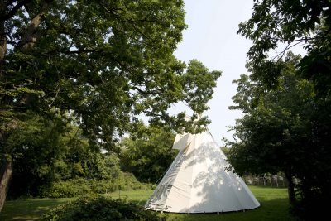
(Centre for Aboriginal Culture and Education, 2017)

Tipi/Wigwam is an example of Indigenous People Engineering. This is used as a home by the people than later it has become the international symbol of Indigenous people in North America. The design was made so that one person can easily put it up and take it down making it an ideal mobile home when following the buffalo. It is traditionally made of buffalo hide or other animal skins, but today canvas is used. On a cold day a fire is kept within to warm the liner and air entering the tipi. The Tipi/Wigwam would be moved to more visible space well it should be ensure that the space should more quite or keeping it in a safe space. This is something that would be discussed with Aboriginal Students.

Traditional spaces such as tipi’s and wigwams help to create safe spaces for students to exercise traditional practices and ceremonies. A recommendation would be continue to offer these spaces to Indigenous community for use and to help maintain positive community relationships with local First Nation. (Mississauga people) (By: Kylie Fox)
(Centre for Aboriginal Culture and Education, 2017)

The Sun Symbol Statue

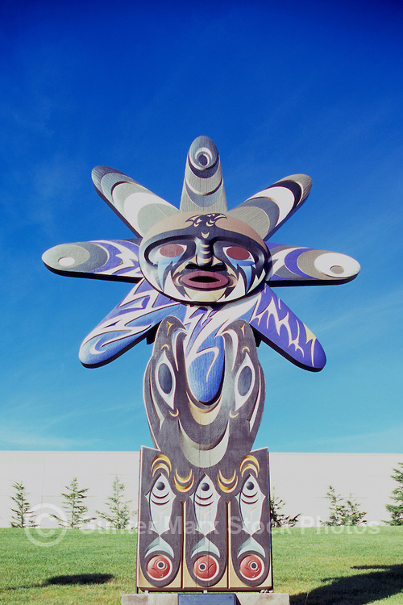
(Marx, 2017)

Recommendation would be that Fleming put a call out for proposals, commission a piece of artwork/statue by a local Indigenous artist.
For example, ______ the statue of the…. Sun gives them a life, Warmth, and light to live. In North America most of the time we have spent in winters and we have less sunlight during the winters. I think they use all this statue symbol to show their love for the sun. It was once believed that one could reach the sun by climbing a chain of arrows and that one would get down by sliding down the rays.
(Spirits of the West Coast Native Art Gallery , 2017)

*An Open Air Classroom with Medicine Wheel*

(Highly Recommended)

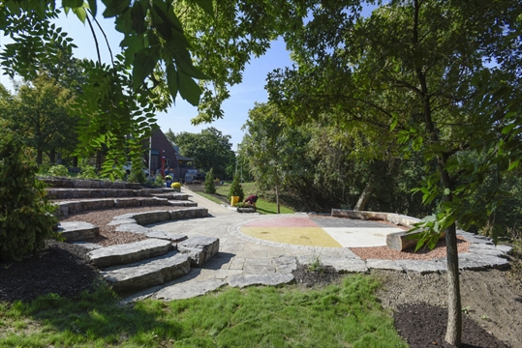
(Noseworthy, 2016)

For example, McMaster University's has created this kind of teaching space for the students with the medicine wheel in the middle. Which reflects how the aboriginal people see the world. (Noseworthy, 2016) We also want pasted description of each color of medicinal wheel so that aboriginal feel comfortable and new aboriginal students feel happy to study over here. It is important for us to find the right space in which indigenous ways of knowing can be done. A similar space can be created at Fleming College too.

It could also include many other traditional aspects such as; Statues, Medicine wheel and tipi/wigwam near to the classroom. Design can be a community project, involving the ideas of local Indigenous peoples. (By: Kylie Fox)

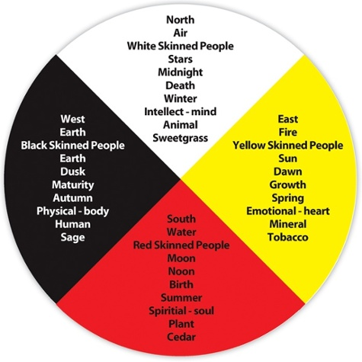
(Joseph, 2013)

This circle shows how the aboriginal students see the whole world. In the process of how life evolves, how the natural world grows and works together, how all things are connected, and how all things move toward their destiny. Aboriginal peoples see and respond to the world in a circular fashion and are influenced by the examples of the circles of creation in our environment.
(Joseph, 2013)

Drum And Sticks

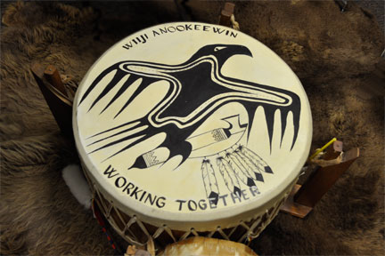
(Conestoga Aboriginal Services, 2017)

The drum is considered to be the first musical instrument used by humans. It is used in many spiritual and sacred ceremonial practices. It says that beat of the drum has the power to change the natural elements, including the weather. It is believed to have the power to heal sickness, and some believe it has the power to send messages both to the animal world and to the spirit world. The drum is a powerful instrument. Indigenous people throughout Turtle Island refer to it as the heartbeat of Mother Earth.
It is shown that drum is the first musical instrument used by the humans. Historians and music ethnologists alike point out that the drum has been utilized by virtually every culture known to mankind for a multitude of purposes. In ancient times, the earliest drums were used for religious rituals, social dances, sporting events, feasts and special ceremonies, in preparation for hunting, and as a prelude to war. However, it is virtually a universally held belief that the original purpose of the drum was to communicate, many times over long distances as a warning or signal. (Mckosato, 2009)

There is a potential for Fleming college to be gifted a drum. There are traditional and cultural practices that govern how and when someone would be given this responsibility. If a drum or any other sacred item was gifted to Fleming it would be recommended that the staff and/or department receiving these gifts seek out the appropriate teachings in order to care for these items respectfully. (By: Kylie Fox)

Aboriginal Symbols

Each symbol has some meanings in Aboriginal Culture these symbols can be used to promote aboriginal initiatives. We can have those symbols in a frame and can be hang around the campus with their meaning.

Tipi: The tipi is a dwelling for First Nations people. Being nomadic people and always on the move, the tipi was designed for easy transport. Secure, mobile and providing shelter, the tipi symbolized the Good Mother sheltering and protecting her children.

Inuksuk: An extension of an Inuk (a human being), the inuksuk were left as messages fixed in time and space. They may represent personal notes or a grief marking where a loved one perished. They act as markers to indicate people who knew how to survive on the land living in a traditional way.

Eagle Feather: The eagle feather is a symbol of truth, power and freedom. The dark and light colors represent balance. It is a very high honor to receive an eagle feather, and usually marks a milestone. When one holds the eagle feather, one must speak the truth in a positive way, showing respect at all times.

Buffalo: The buffalo symbolizes subsistence, strength and the ability to survive. The buffalo is a spiritual animal as it provided so many things, food, clothing, shelter, tools, etc.

Medicine Wheel: The medicine wheel contains four quadrants of life each representing a certain aspect of holistic make-up: intellectual, spiritual, physical and emotional self. The four colors represent the four directions: red, yellow, white and blue (or black, green or darker colors depending on the Aboriginal group). Four is a very significant number in Aboriginal culture.

Red River Cart: The primary means of travel and transportation of goods for Métis people, the Red River cart has become synonymous with the Métis.

Hide With Willow Hoop: All First Nations believe that their values and traditions are gifts from the Creator, including the land, plants and animals. Hides are believed to be offered by the animal as the Creator wished and, therefore, as the animal died the hunter would thank the animal for its offering.

Rainbow: The rainbow is a sign of the great mystery, the Creator’s grace reminding all to respect, love and live in harmony. Rainbow colors are seen as stages in life and they follow individual belief systems of various First Nations.

Métis Sash: The sash is a symbol of present-day Métis identity but had many uses in the early days, often functioning as a rope or a belt. The Infinity sign (∞) on the sash symbolizes two cultures together and the continuity of the Métis culture. The sash uses traditional woven patterns and colors to represent their individual communities.

Drum: Traditionally given to men for ceremony and prayer. The drum is the heartbeat of the Earth, and feeds our spirit. The drum has the spirit of the deer and the tree that were offered as a gift from the Creator for the drum, and it guides people home.

Turtle: Symbolizing Mother Earth, the turtle is depicted with 13 inner markings, each representing a cycle of the Earth around the sun. There are 28 smaller outer markings of the shell representing the days of each cycle.

Star/Star Blanket: The star symbol on star blankets ends with eight outer points to represent one’s travels from grandmother, to daughter/son and then to grandchild and to Mother Earth. Eight diamond quilted shapes form the center and pieces are added to each row to increase the size of the star pattern.
(University of Saskatchewan, 2017)

The Reason that I am including this in my recommendation report is to make other students aware about this symbols that was used by the aboriginal people in the ancient times. And this can also be used to decorate the college campus.

*Names to change to Michi Saagiig language*

(Highly Recommended)

Welcome can be written as Tunngahugit at the main gate.
Library
Learning Resource Centre
Student Service Centre
Registration Office

It is recommended that Fleming College should hire Language Translator because it is very difficult to change it into Anishinaabemowin Language.

Further Recommendations

- It is recommended we can dedicate one day in a month to Aboriginal students. We can have an Aboriginal activity in main foyer.

- It is recommended to increase the presence of local Indigenous languages in signage on campus.

- It is recommended that there is increased efforts to include Indigenous practices in classrooms, student support areas (health services, counselling, orientation, etc.)

- It is recommended that Fleming increases Indigenized spaces for Indigenous learning- as opposed to medicine wheel outside classroom. Specifics such as these should be identified by the FN community.

This report and recommendations should be discussed with Fleming’s Aboriginal Education Council.

References

Centre for Aboriginal Culture and Education. (2017). Tipi. Retrieved from Centre for Aboriginal Culture and Education: https://carleton.ca/aboriginal/resources/tipi/
Conestoga Aboriginal Services. (2017). Aboriginal Services. Retrieved from Conestoga: https://www.conestogac.on.ca/aboriginal-services/services.jsp
Joseph, B. (2013, April 16). WHAT IS AN ABORIGINAL MEDICINE WHEEL? Retrieved from INDIGENOUS CORPORATE TRAINING INC.: http://www.ictinc.ca/blog/what-is-an-aboriginal-medicine-wheel
Marx, G. (2017, april 4). Salish-Pole. Gunter Marx Stock Photos. University of British Columbia, Vancouver. Retrieved from www.guntermarx.photoshelter.com/image/I0000qfnYuCPgM3w: http://guntermarx.photoshelter.com/image/I0000qfnYuCPgM3w
Mckosato, H. (2009, july-august). Drums: Heartbeat of Mother Earth. Retrieved from Native Peoples Magazine Native: http://www.nativepeoples.com/Native-Peoples/July-August-2009/Drums-Heartbeat-of-Mother-Earth/
Noseworthy, K. (2016, Sep 23). McMaster University creates outdoor classroom for Indigenous Students. Retrieved from The Hamilton Spectator: http://www.thespec.com/news-story/6873454-mcmaster-university-creates-outdoor-classroom-for-indigenous-students/
Spirits of the West Coast Native Art Gallery . (2017). The Sun Symbol. Retrieved from Spirits of the West Coast: https://spiritsofthewestcoast.com/collections/the-sun-symbol
University of Saskatchewan. (2017). Aboriginal Symbols. Retrieved from University of Saskatchewan: http://communications.usask.ca/templates-and-guides/aboriginal-symbols.php

