BARS Reports – Budget Activity Reporting System

Where do I find reports?

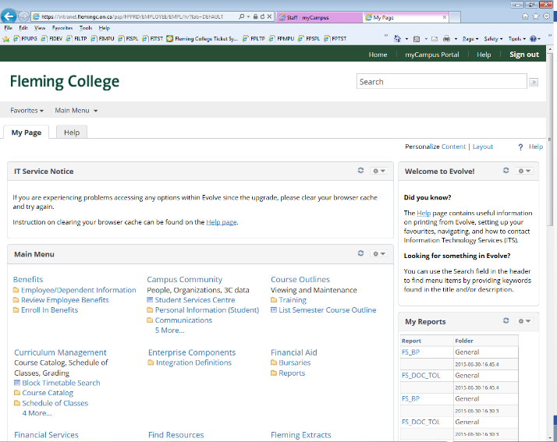
The first place to find reports is on the Evolve Home Page under My Reports. This will only list five reports, but reports will be from both Finance and Human Resources.

If you use the Report Manager link at the bottom of the My Reports section it will also show you all reports from all sources.

The link will open on the Explorer tab of the Report Manager. The Explorer tab contains folders. Click the + to open the folder and see the folder contents.

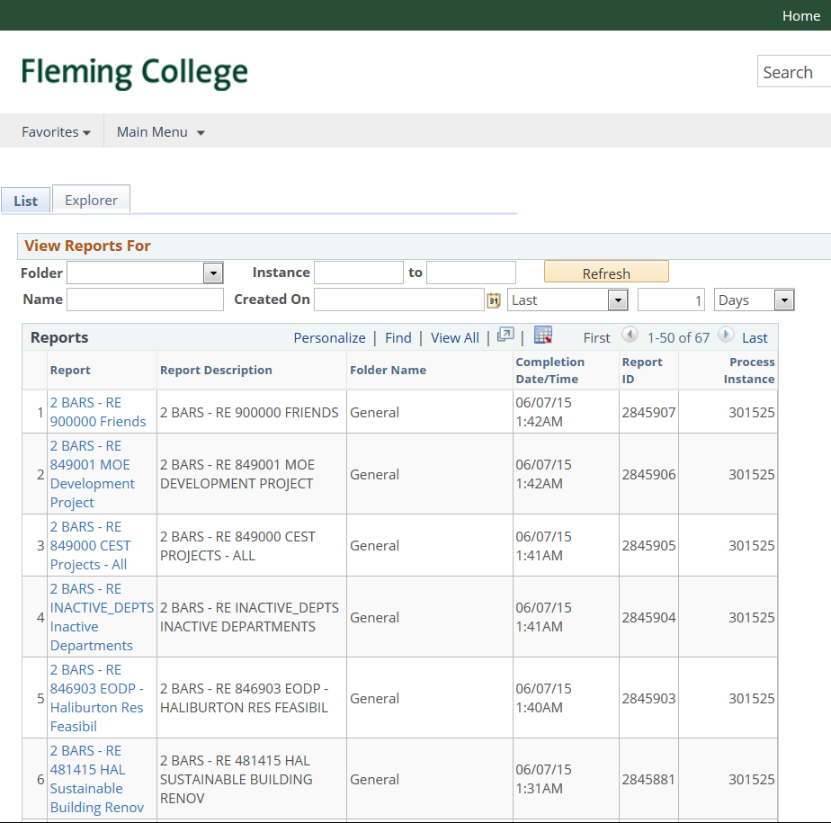

When on the List Tab, reports can be filtered using the View Reports For criteria boxes. Change the # of days that are visible—click Refresh. If you know part of the report title you can use % as a wildcard. %HAL% in the Name box then Refresh will list any report with HAL in the title.

Alternatively, you can view Finance reports, reports that show your Financial position, at Reporting Tools>Finance(FI) Reporting>Report Manager.

Salary reports can now be accessed through the Home Page Report Manager as well. See the separate BARS Salary folder. Alternatively go to Reporting Tools>Human Resources System(HC)>Report Manager.
What Reports exist and when are Reports available?

1 BARS Variance reports are run following month end. 1 BARS Variance reports show current year actuals and budget along with prior year actuals/budget for comparison purposes.

2 BARS RE reports are run every night. 2 BARS RE reports show current year actuals compared to budget.

3 BARS Capital reports are run weekly, every Monday morning. 3 BARS Capital reports show current year actuals compared to budget for capital accounts.

BARS Salary reports are run the Sunday following a pay. BARS salary reports list employee salary actuals for the year up to the current pay.

How do I find the details that make up the amount?
ACTUALS:
General Ledger>Details by Acct & or Dept
General Ledger>Details by Acct for Dept Like
(“Like” in the query title means you can use % as a wildcard in the dept field, i.e. 343% would return all depts starting with 343)

General Ledger>Review Financial Information>Ledger> is another source.

Drilldown:
From the BARS report in Excel when on a cell go to Add-Ins>nVisionDrill>Drill. This will open the window shown at left. Select the view you want. Account Details with vendor is recommended. An Unable to connect to the RenServer message may appear. Click OK. Go to the Report Manager and look for the prefixed DR. Open the report to see details of cell.

Note that you do require Excel macro files added to Excel to enable drilldown. Contact Jill Taylor if you would like this functionality.

COMMITMENTS:
General Ledger>Commitment Details by Acct
General Ledger>Commitment Details by Dept

Purchasing>Purchase Orders>Review PO Information>PO Accounting Entries

FAQs:

When should we use the GL and when should we use the BARS reports?

BARS reports provide a snapshot of the financial position of a department. It shows the revenue and expense actuals line by line with budget amounts for comparison for a whole department or group of departments.

The GL ledger Inquiry can be used for a quick look up of an account/dept, but use of the GL & AP details by Acct-Dept query at Financial Services>General Ledger is recommended to look up details of an expense.

What type of information should we focus on getting from BARS vs the GL?

As above BARS reports show line by line actuals vs budget for a department. When looking at the BARS reports, look for the overall status of your department, favourable or unfavourable. Look for accounts that may be overspent, underspent, or not tracking as expected. If a line is overspent, and you don’t know why, then you need to look at the GL.

The GL as shown by running the query GL & AP details by Acct-Dept query at Financial Services>General Ledger will show the details of the actual amounts for each line.

How can I search for an invoice?

If you are looking for an invoice that should be charged to your department, run GL & AP details by Acct-Dept query at Financial Services>General Ledger. Vendor, voucher and invoice numbers are provided on this report if the invoice was paid through accounts payable. An actual copy of the invoice is not available to view through the system.

If you are looking for an invoice we have issued as per a request to Invoice form and are wondering if the invoice has been paid, you have to contact Finance. You will see the revenue in your department at the time the invoice has been issued, but you are unable to see when the invoice is paid.

How do I see if part-time wages have hit the budget?

Review the BARS salary reports for your departments. Go to the BARS Salary Reports folder in the Report Manager off of the Home page.

How do I know if an expense that was submitted has actually shown up on the budget?

Currently, if the expense was submitted as an expense form the line description contained in any of the GL queries mentioned above will contain Last name, First name and ExpStmt as well as the date. The journal id for expense statements is numeric with no prefix.
If the expense was submitted as a visa expense, VISA will be displayed in the ref field of any of the GL queries. The line description should contain some form of the cardholder’s name. The journal id for Visa transactions is also numeric with no prefix.

When should I be looking at my BARS reports and how often?

It would be prudent to review the 1 BARS reports that are run at every month-end. However, as a department manager you know best your peak spend periods. You have a fixed budget amount. If you know your spend is close to budget you need to be closely monitoring expenses. Similarly, revenue that is not coming in as planned needs to be closely monitored as expenses may need to be reduced accordingly. Over expenditures in one line can be covered off by savings in another line. It is a judgment call on the part of the manager to know how diligently to monitor his or her department finances.

How do I set up Favourites in Evolve?

You can set up favourites in Evolve for frequently used menu items. Simply navigate to the menu item and go to the drop down at the top right and select Add to My Links. You will be prompted to name the link and select the folder to put it in.

I am going on vacation. How do I set up an alternate approver while I am away?

Go to Financial Services>eProcurement>My Profile. Towards the bottom of the page in the Alternate User section, enter the emplid of the alternate approver and enter the start and end date of your absence. Note that an alternate approver has to be set up as a current approver.

I received an email that I have a requisition to approve, but the link to the requisition does not work.

You have to be logged into Evolve in order for the link to work. Log into Evolve and click on the link in the email or go to the Quick Launch section of the home Page. You should see a link there for Worklist, otherwise go to Worklist – Finance off of the main Menu. Each requisition to approve is listed here. Click on any of the hyperlinks to open the requisition details.

Please ensure that you click on each line and verify that the correct account and department are being charged and that you have available budget in that department.

Expense Reports and Travel Authorizations

How do I approve Expense Reports or Travel Authorizations.

You will receive an email notification for each Expense Report or Travel Authorization that requires your approval. Use the link in the email to access the document in Evolve. Please drill down to the line details to ensure the correct account and department are being charged.

Alternatively, if you can’t find the email notification, the Worklist link under the Quick Launch section of the home page in Evolve lists all items from finance that require your approval. Click on any of the blue hyperlinks on the worklist to open the item and approve.

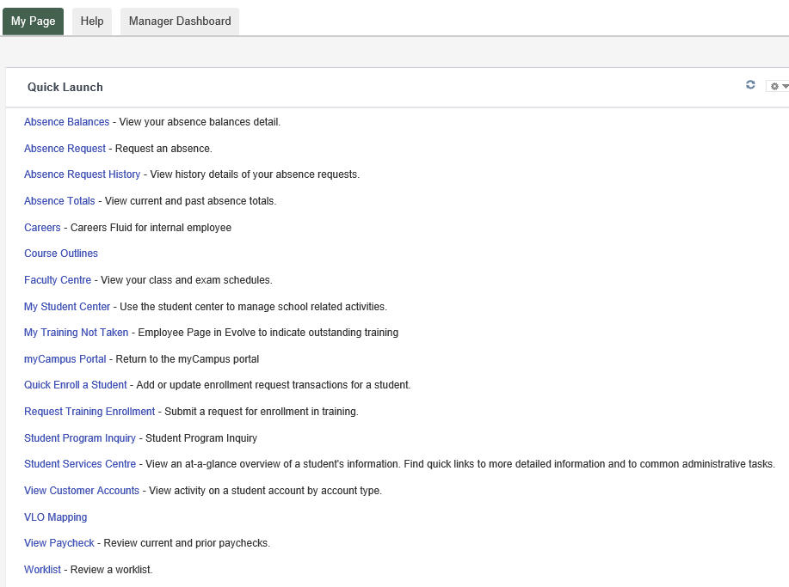

See Approving an Expense Report document on the Finance website for a more detailed description of what to review when approving an expense report.

Do I need to set up an alternate approver for Expense Reports/Travel Authorizations if I am going on vacation.

Yes, an alternate approver for Expense Reports is set up separately from the requisition alternate approver set up.

In Evolve, go to Manager Self Service>Finance Delegations. Click on the Create Delegation Request Tile and follow the four steps to enter your delegate. The delegate you select must be a manager. The selected delegate will get an email notification of the delegation and has to accept the assignment.

See the Approving an Expense Report document on the Finance website for a detailed explanation.

