# Drill down Documentation

## How to Use Drilldown in the 2 BARS – RE Report

The Drilldown feature allows you to view detailed information for any amount listed in any of the “Actual” cells in the 2 BARS RE report. Budget and commitment details are not available through drilldown. This functionality helps you quickly access data without needing to manually search elsewhere.

##### Step 1 Download 2 BARS RE report

Navigate to **Report Manager** to open a 2 BARS RE report in Evolve

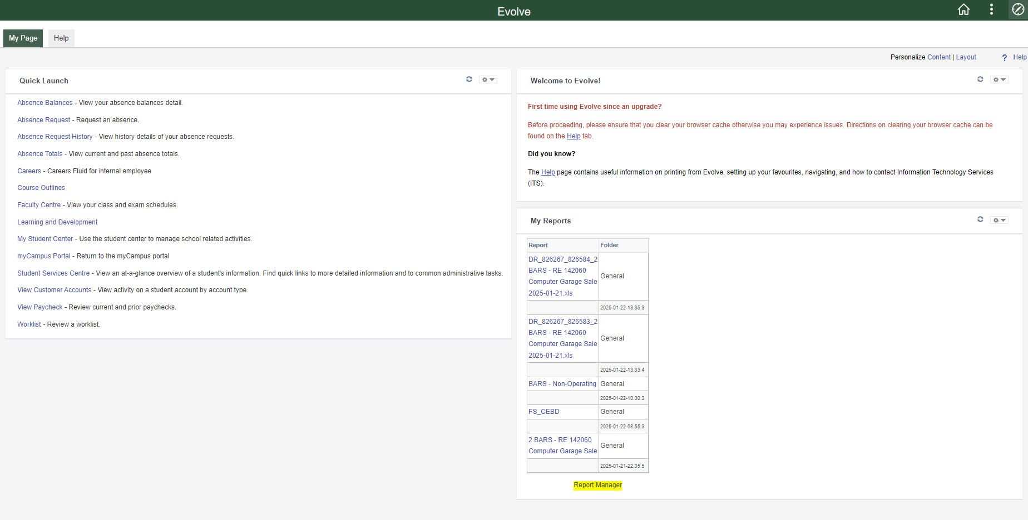

General Folder has the 2 BARS RE reports

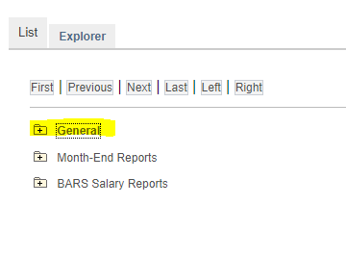

Click on a 2 BARS RE report that you would like more details on  
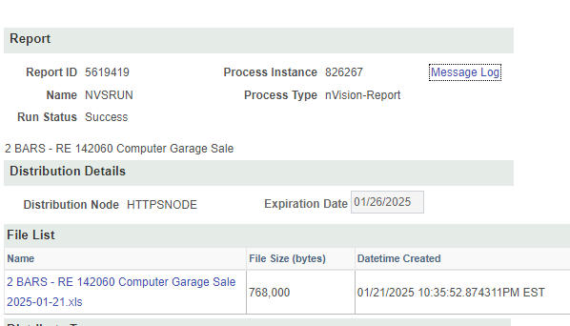

Download the file.

##### Step 2 Add Drilldown Add in

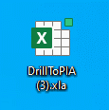For your first time using the drill down you will have to add the excel add in.   
  
*Email Michelle Ephgrave for the drilldown add in file [mailto:michelle.ephgrave@flemingcollege.ca](mailto:michelle.ephgrave@flemingcollege.ca?subject=Drill%20Down%20Add%20in)

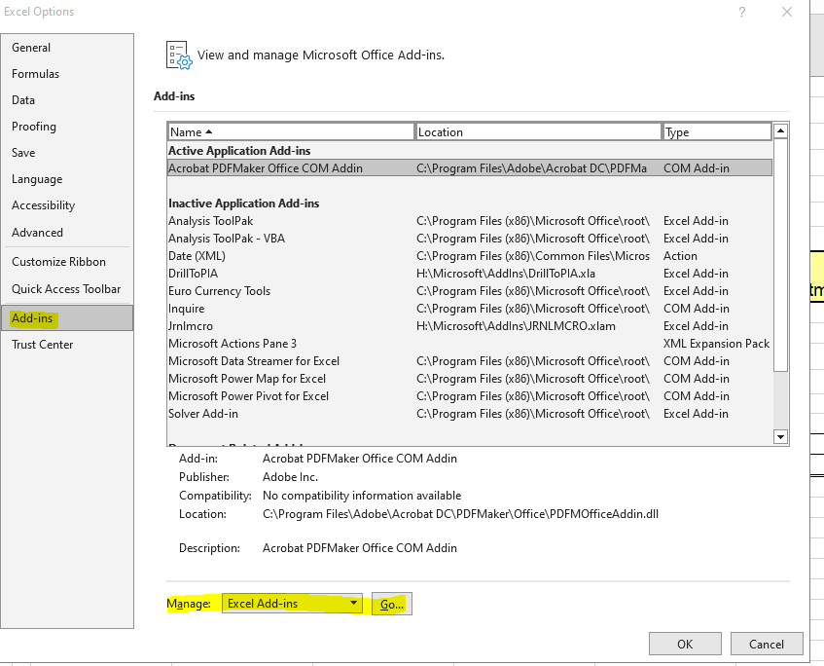

Once the 2 BARS RE report is open navigate to File, Options, Add-ins

Click Go…  
Browse…  
Add in DrillToPIA file

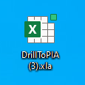

Ensure DrillToPIA is checked

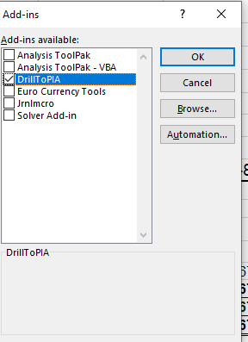

Press OK

##### Step 3 Run Drilldown

Make sure to have DrilltoPIA opened in the background. This will then populate the Add-ins tab in excel

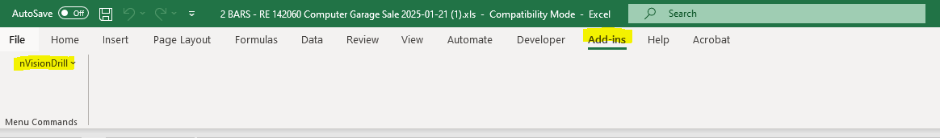

Click on the cell you want to investigate, Add-ins, nVisionDrill, Drill

This will then open Evolve  
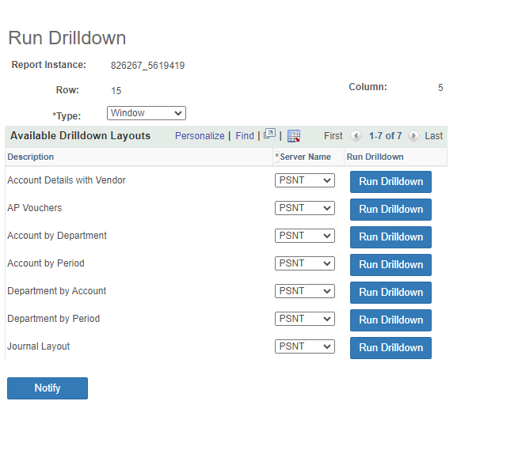

Click Run Drilldown for the one you would like to run (see below for more info)

You may get the error *Unable to connect to the RenServer*. Click OK the report will still run.

You will then see that the report has been queued

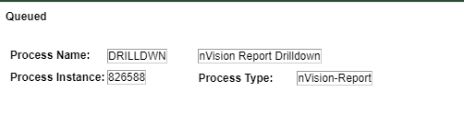

Navigate to Report Manager, List Tab, Folder should have General  
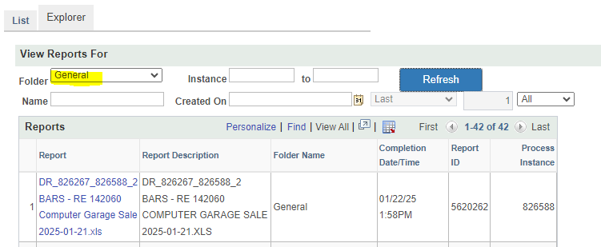

Click the file that begins with DR to download the details.

##### Available Drilldown Layouts

**Account Details with Vendor**This report provides journal entry details and if processed through Accounts Payable, AP details such as the name of the vendor, purchase order number and invoice number for a given cell. It eliminates the need to do more than one drilldown to get additional details.

**AP Vouchers**

Provides voucher number, a description, amount, invoice number and the vendor name for each AP transaction.

Does not show JE, or Visa charges, or student administration.

**Account by Department**

Provides details by account and department for selected cell. This drill down is useful to get account detail from a rolled up or a 2 BARS ALL report.

**Account by Period**

YTD amount spilt out by period (same information shown on 2 BARS report prior to running the drilldown)

**Department by Account**

Provides details by account and department for selected cell. This drill down is useful to get department detail from a rolled up or a 2 BARS ALL report.

**Department by Period**

This drill down is useful to get department detail from a rolled up or a 2 BARS ALL report.

**Journal Layout**

Provides details for JE details