Academic Progression - Probation Tip Sheet

After final grades have been released to students, the Office of the Registrar will assess each student’s grades to determine their academic standing. In some cases, student will fall below the threshold for progression to the next semester of their program as defined by the Academic Standing Procedure 2-201E:

“Students earned a semester GPA of less than 1.0 and/or did not achieve a passing grade in 66 2/3 percent of their registered course load and/or was unsuccessful in pre-requisite/co-requisite or other mandatory requirements.”

Any student who does not meet the requirements necessary for progression is placed on academic probation and will require a mandatory meeting with their Program Coordinator who will submit probation contract documentation to the Records Office.
_____________________________________________________________________________________________________

General Tips

☐Use this flow chart as a quick reference:
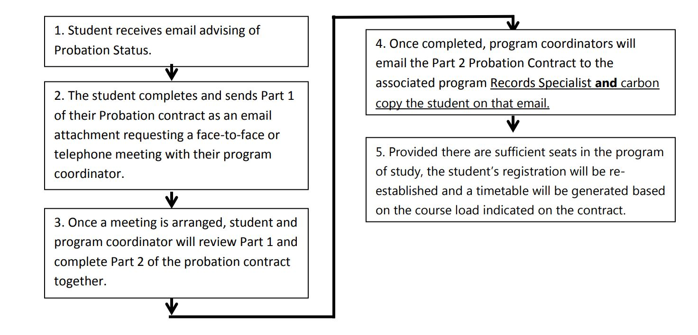

☐Open and save and/or print out the Probation Process for Coordinators document that is emailed to you at the end of each semester.

☐Be sure to account for the time in your own work plan that it will take to meet with the probation students in Week 16, Week 0, and Weeks 1-3 (sometimes up to Week 4) of the next semester. Often the School Office Liaison will email a spreadsheet indicating students on probation, the level of probation, and grades earned in their courses. This is helpful in estimating time required which can range between 30-60 minutes per student.

Student Responsibilities

☐Students will receive an email notifying them of their probation shortly after final grade have been submitted.

☐Students will likely have seen a timetable on their Student Centre prior to the release of final grades. This timetable will be removed. **Note: Students who did not read their probation email may show up in classes and not be on rosters – They are not permitted to attend classes until they have completed the probation process.

☐When a student emails a Coordinator regarding a progression meeting, they should attach the completed Academic Probation Contract Part 1 to this email.

Coordinator Tasks for the Progression Meeting

☐Pre-Meeting Preparation - 5-10 minutes
  - Organize the meeting with the student (emails with instructions or links, telephone calls). It is best if meetings occur in person, however, if a student resides out of town, it is acceptable arrange for a meeting to occur by telephone or online using WebEx or Teams.
  - Locate and read over the student information (Academic Probation Contract Part 1, previous documentation, previous Education Plan, information about accommodations, etc.) from your files.
  - Access the student’s grades on the Learning Management System (D2L portal)
  - Complete portions of the Academic Probation Contract Part 2 already known

☐Face-to-Face, Online, or Telephone Meeting with the Student - 20-35 minutes
  - Discuss items from Academic Probation Contract Part 2 and spend time listening to student views/needs and share information about applicable resources.
  - Emphasize that if they are not successful in their probationary semester, they will be removed from their program for a semester. This may also mean that they will have to reapply to their program if/when they wish to resume their studies.
  - Create an Academic Plan with them in Academic Probation Contract Part 2. It is best to map out all semesters to completion of their diploma/certificate. In this way, the student has a clear picture of the time required and options for program completion. This can be tricky for some programs (ie. only Fall intake).
  - Reach out to Discipline Coordinators (ie. Mathematics, Psychology, Communications) to find out which courses are running and if there are online or Ontario Learn options.
  - Connect with Program Coordinators when there is a student program transfer request.
  - Ensure that the conditions and expectations for the Academic Plan fit with any existing Education Plans and accommodations or that students are directed to services areas for revision and further assessment and planning.
  - Ensure that the Academic Plan is meaningful in that the student chooses what they are prepared to do in order to increase their commitment to the plan for academic success.
  - If the meeting occurred online or by phone, indicate this in the signature line of the Academic Probation Contract Part 2 document.
  - Schedule 10-minute monthly follow-up meetings with each student that work in their timetable. Do this during the first meeting and send students meeting requests which populate your Outlook calendar and the student’s calendar.

☐Post-Meeting Follow-up Tasks – 5-15 minutes
  - Save the Academic Probation Contracts Parts 1 and 2 in your hard copy and/or electronic records.
  - Send an electronic copy to the Records -cc student.
  - Connect with any additional support as needed.
  - Document both the initial meeting and follow-up meetings either in hard copy or electronically. This documentation is helpful for refreshing your memory before subsequent meetings and should you need the support of the Chair/Dean when requesting that a student withdraw from courses/program.

Be Aware

☐If a student is changing programs for the subsequent semester, they must meet with the Coordinator of their NEW program.

☐If a student does not have the prerequisite courses necessary to be considered a full-time student, there will be OSAP implications. Bring this to the student’s attention and direct them to follow up with Financial Aid.

☐It is not permissible to include additional General Education courses to a student timetable in order to meet full-time student status. Only courses required for the program of study are acceptable. (Some programs do require 2 General Education (GNED) courses so these could be taken in any semester they are offered).

