myCampus Step by Step Instructions for New Students
Step #1 – Log on to https://mycampus.flemingcollege.ca/web/portal/home and click “Get Started”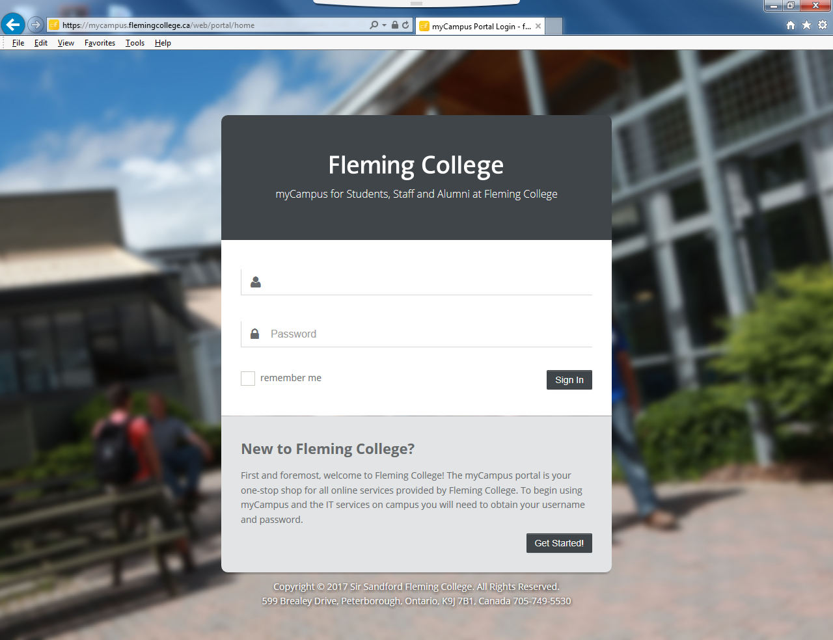
Step #2 – Locate and enter Student Number on your correspondence from Fleming College, and enter Date of Birth and press “continue”.
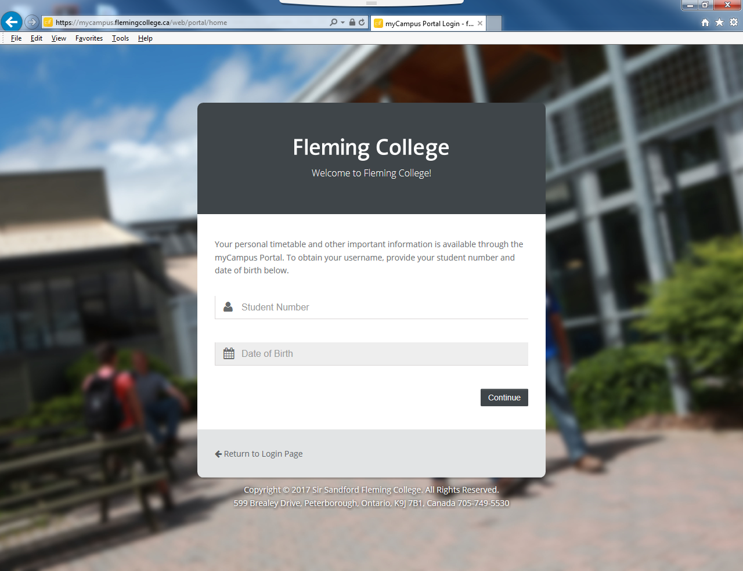

(This will generate a User Name & Fleming Email; password is automatically set to Student Number until changed)
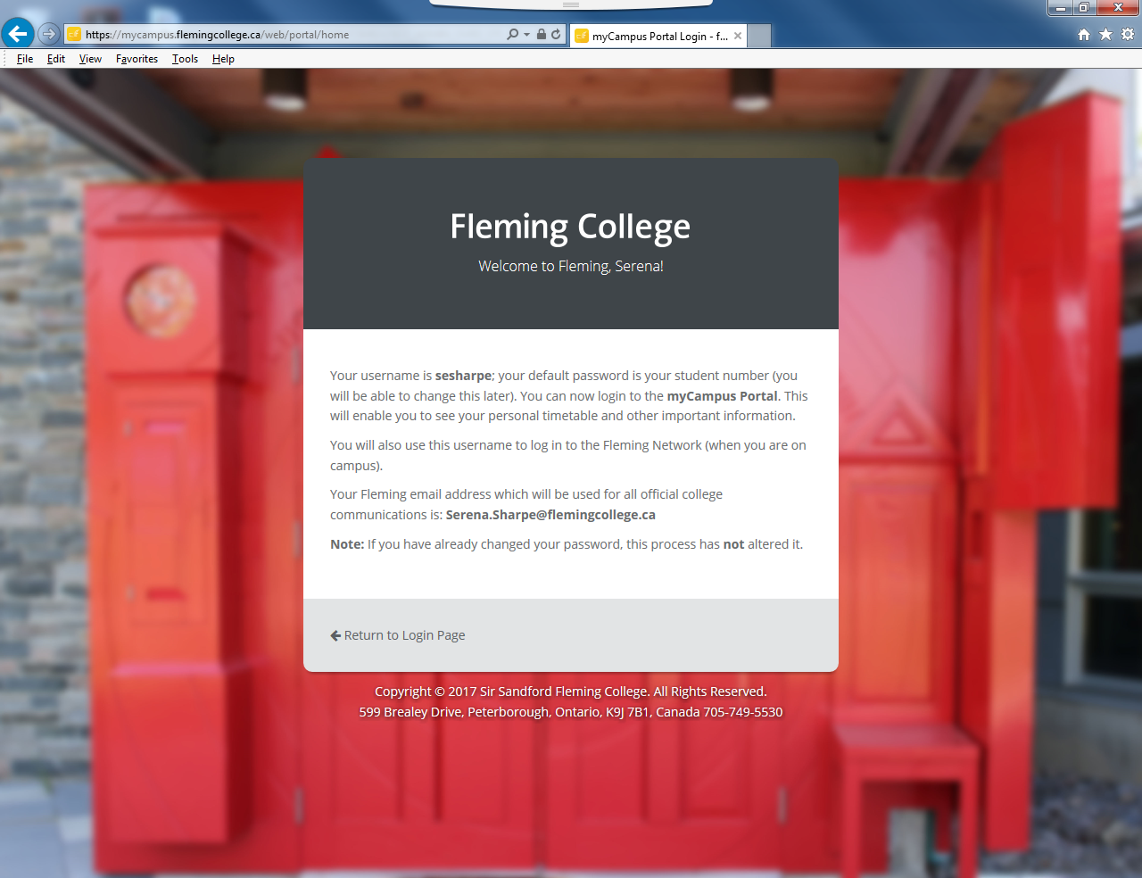
Step #3 – Write down User Name and Email Address and select “Return to Login Page”. Enter User name and password and select “Sign In”

Step # 4 - From here, you can use the side panel links to access such items as your Fleming Email, Desire2Learn (D2L), My Student Centre. See Examples below of D2L and My Student Centre.
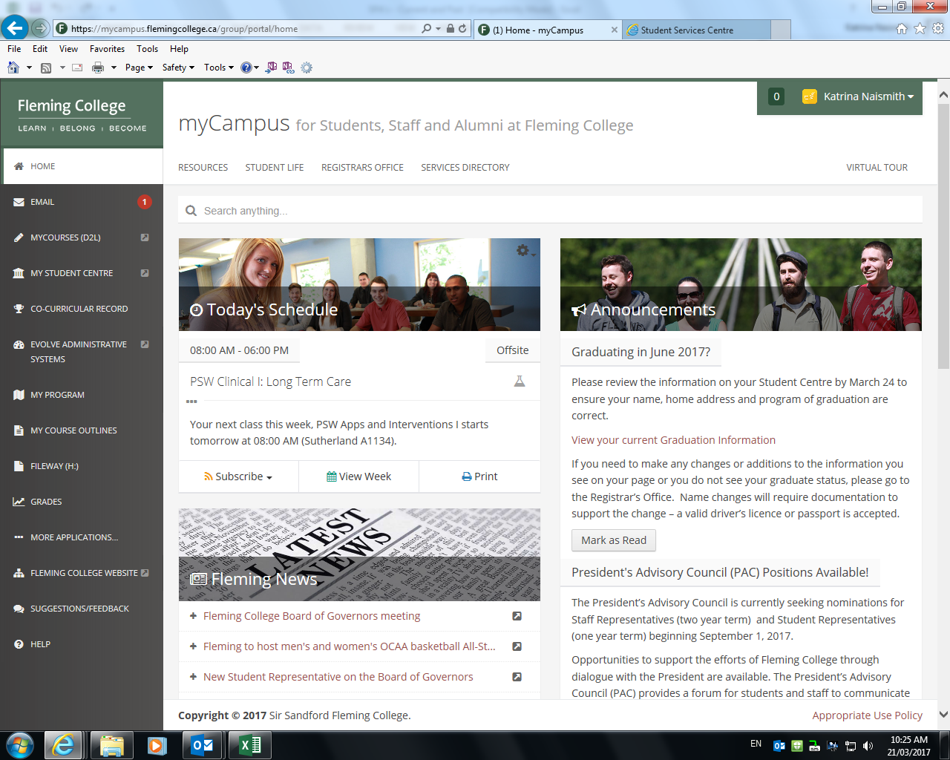

Screen Examples
Desire2Learn (D2L)/ My Courses
This is where you will find information and documents regarding your classes.
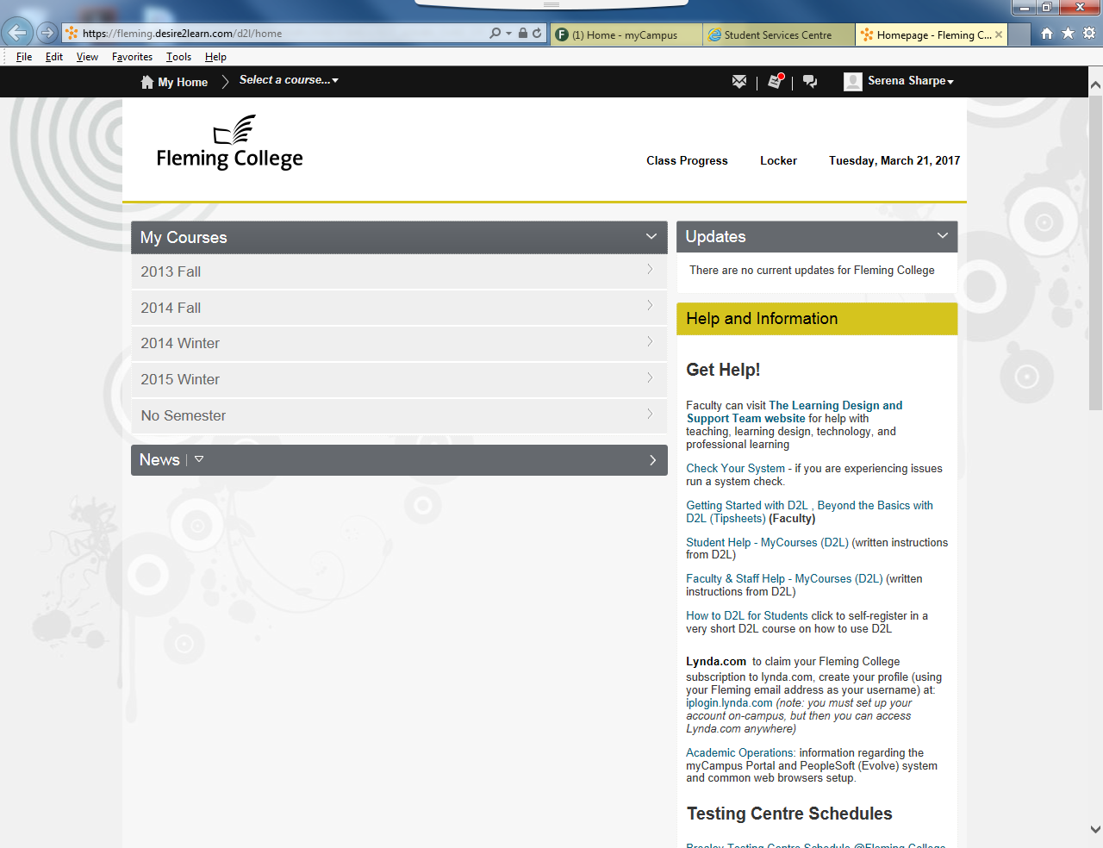

My Student Centre
Timetable Location, Personal Information, etc...
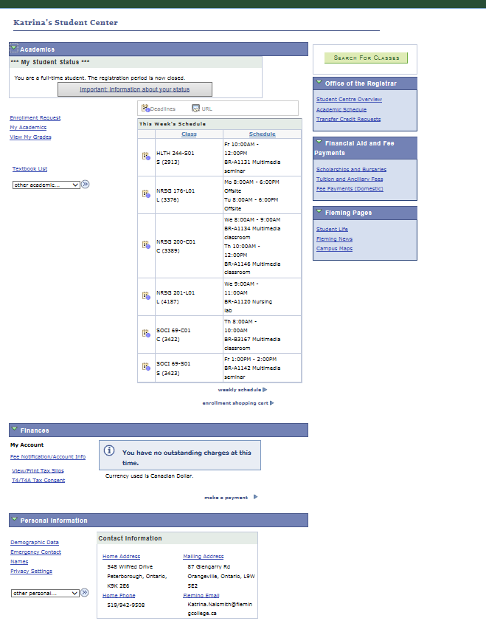

Fleming Email
**Note** Please use ONLY the Fleming email to correspond with the College and Faculty, as this will verify your identity.
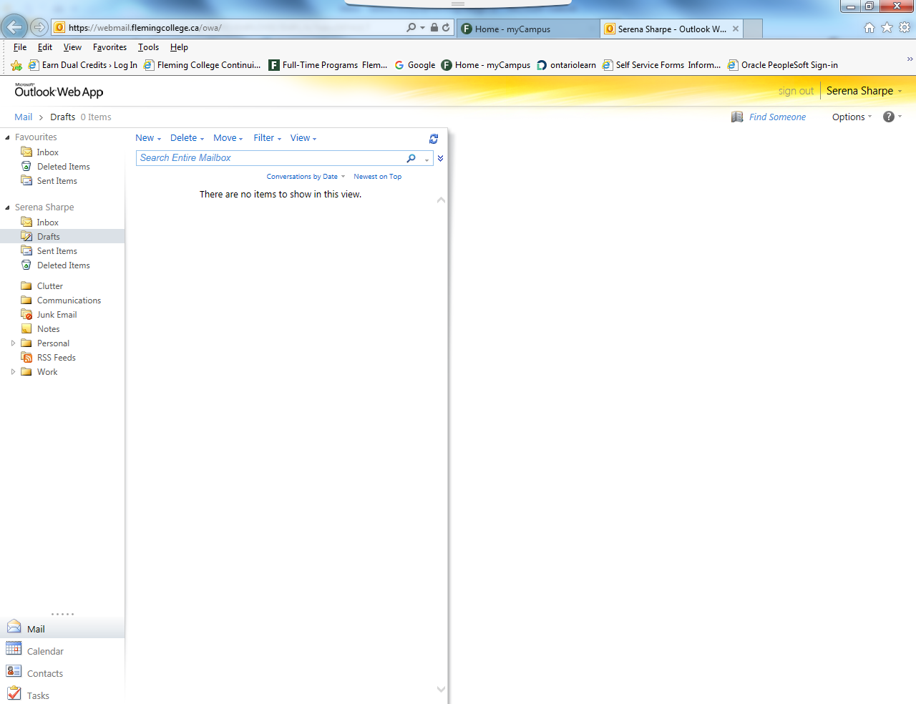

Welcome to Fleming College and Good Luck in your studies!!

