Fleming College – Fall 2018
Dual Credit

User ID:

Student #:

Password:

Your Fleming Email Address:

Note: Hold on to these instructions & record your student number and login information in your phone or wallet.
_________________________________________________________________________________________________________________

Login to myCampus:

- Open Fleming College’s main webpage: www.flemingcollege.ca

- Click on “myCampus Login” in the top right hand corner

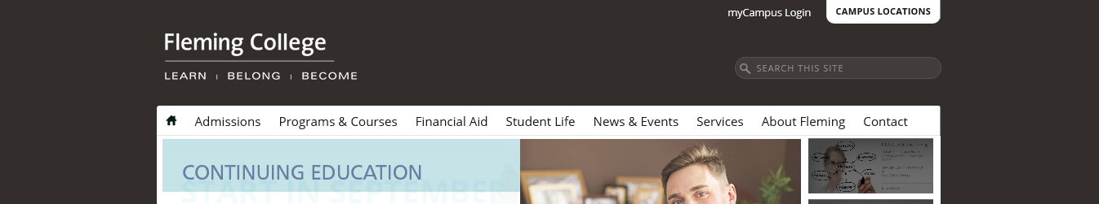

- If you already have a Fleming login & email address, login on this page.
Otherwise, scroll down to the section: “New to Fleming College”
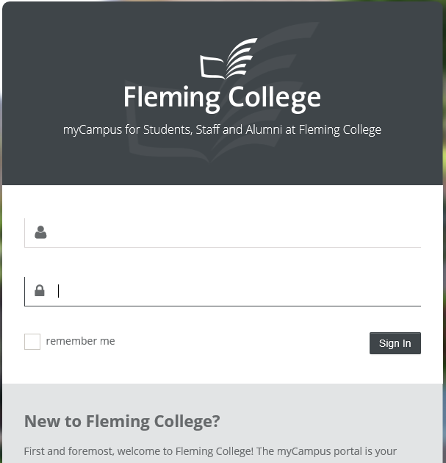

- Click on “Get started”

- Enter your student number and birth date.

- Click on “Continue”

- From this step you will obtain your username and email address. Your default password follows the pattern ####YYYYMM where:
- #### is the last 4-digits of your student number
- YYYY is your 4-digit year of birth
- MM is your 2-digit month of birth (01-12)

- Login to myCampus

- Your email and “MyCourses (D2L)” will appear in a banner on the left hand side of the screen
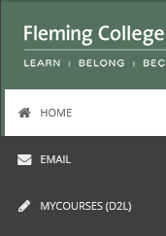

** Please note – If you have taken a dual credit course before, your password may be the old password configuration. This defaults to your student number. If you forgot your password, please contact the IT Service Desk (1-866-353-6464 x4111 Option 1).**

