How to View Paycheck Online
Three easy steps to viewing your paycheck through the portal.
Step 1:
After logging into myCampus you will be taken to the home page. Click “Evolve Administrative Systems” from the left hand menu bar.
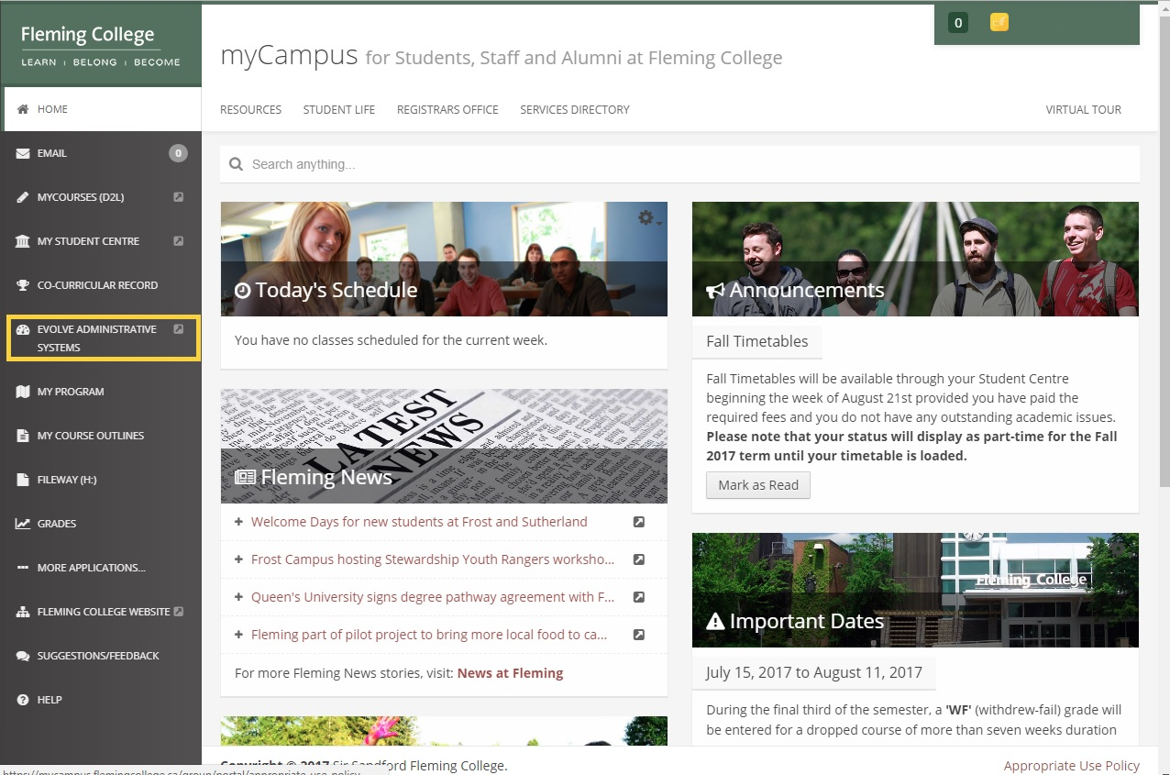

Step 2:
Evolve will now open. Under the “My Page” tab in the “Quick Launch” section, click on “View Paycheck”.
Full-Time and Part-Time Employee View: 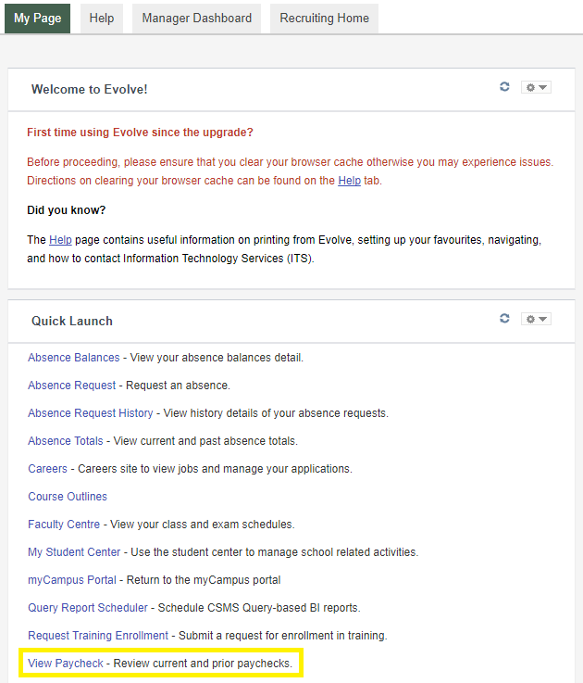
Student Worker View:
Step 3:
You will now be taken to the View Paycheque page. Here you can see all paycheques available to you. Select “View Paycheque” and a new window will open. 