A How-to Guide for School Board Teachers

Introduction to Desire2Learn for Dual Credit
This document is a summary guide to assist school board teachers to navigate the Desire2Learn Learning Management (LMS) system for dual credit courses.

Document Information
Document name | A How-to Guide for School Board Teachers: Introduction Desire2Learn for Dual Credit
Document version number | 1.0
Document version date | September 5, 2018

Revision History
Version # | Ver. date | Revised by | Description of change
1.0 | Sept 5, 2018 | Deborah Leal | Original Document

Overview
Welcome to Fleming College’s Learning Management System (LMS) – “Desire2Learn”!
This document outlines the functionality that a School Board Teacher is authorized to view within the Fleming College LMS, including viewing the content, available marks, and student progress.

Table of Contents
Document Information 2
Revision History 2
Overview 3
Table of Contents 3
Login to Desire2Learn 4
Navigate the course content using content browser 6
Use sidebar to navigate content 8
Use top menu to view grades 10
Use top menu to view content 12
Use top menu to view class progress 14
Logout of Desire2Learn 15

Login to Desire2Learn
- Go to Fleming College’s Desire2Learn website (https://fleming.desire2learn.com/d2l/login)

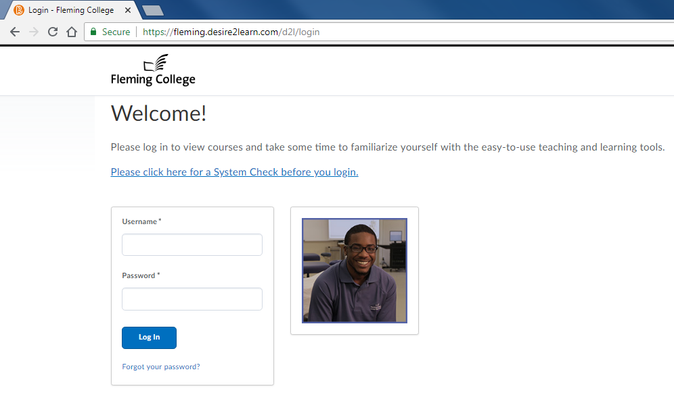
- Enter your Fleming provided username into the username field
- Enter your Fleming provided password into the password field

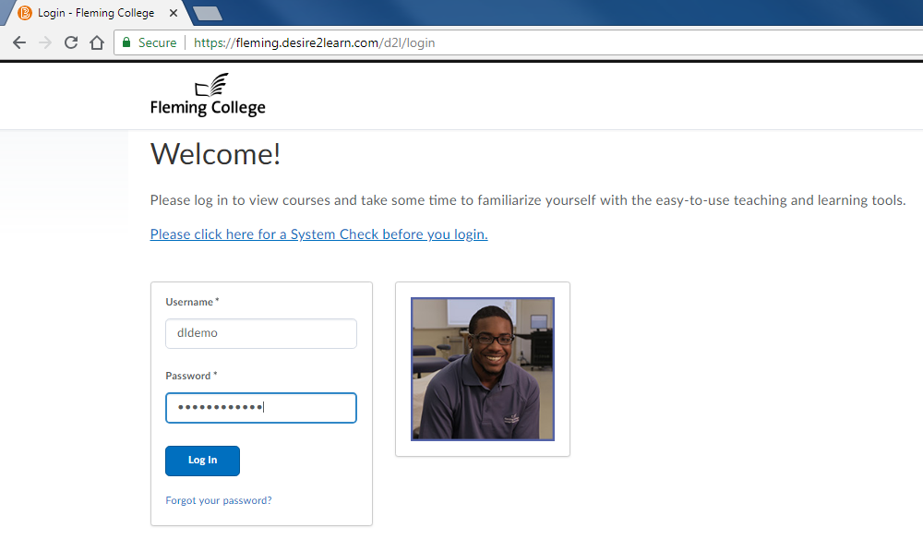

- Click the ‘Log in’ button

- The following homepage should appear, and display any courses to which you have access:

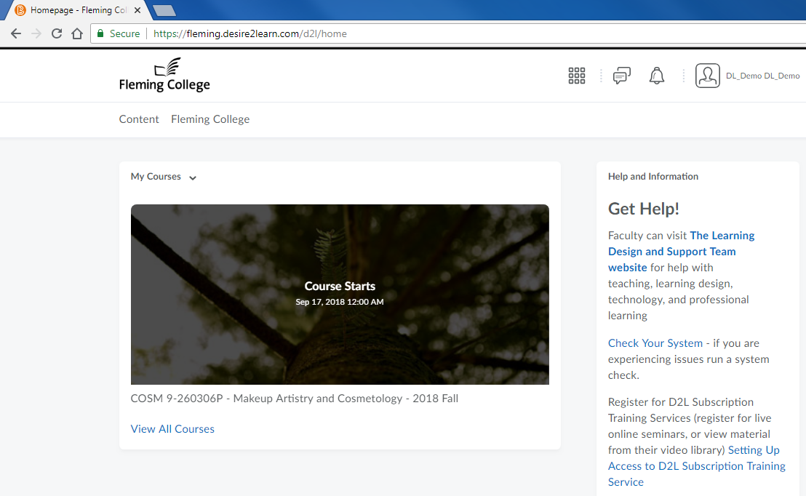

Navigate the course content using content browser
- Click on the rectangle image for the course you wish to view

- The following course homepage will be displayed. This page is customized by the course instructor. As a result, the appearance of the homepage in the image below may not match what you see in the course you are viewing.

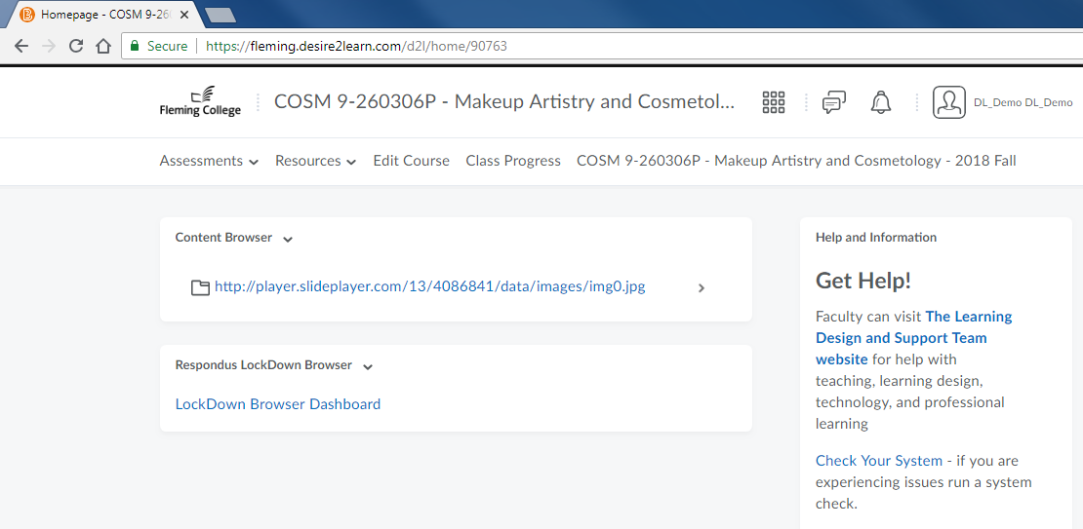

- Click the blue arrow beside the ‘Content Browser’ heading

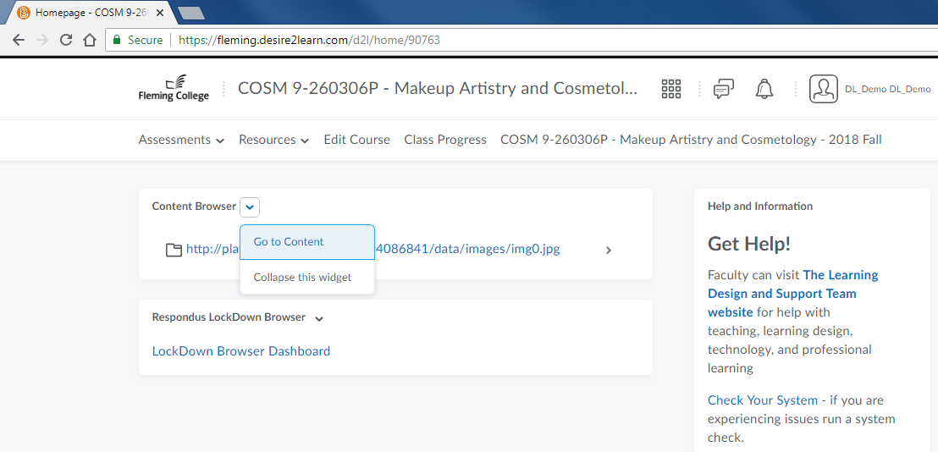

- Click ‘Go to Content’

Use sidebar to navigate content
- Click on the headings in the sidebar to view the content available to learners. These headings are customized by the course instructor. As a result, the headings you see in the image below may not match what you see in the course you are viewing.

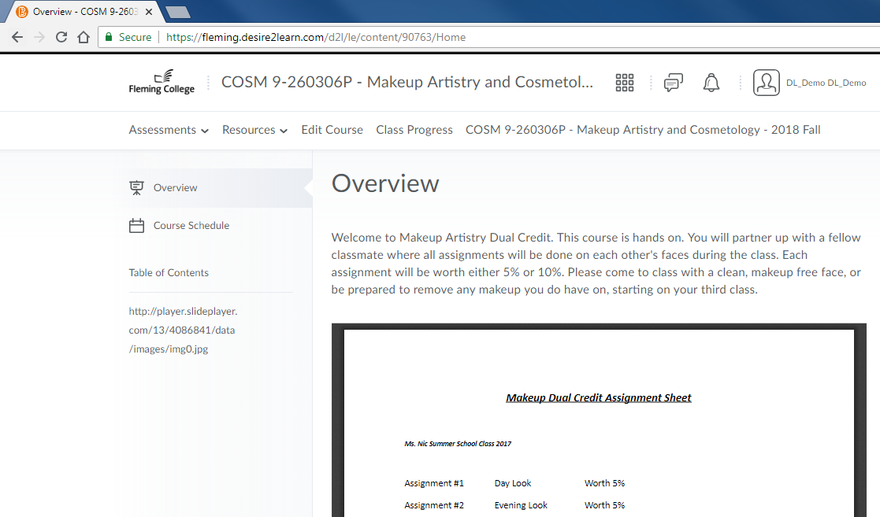

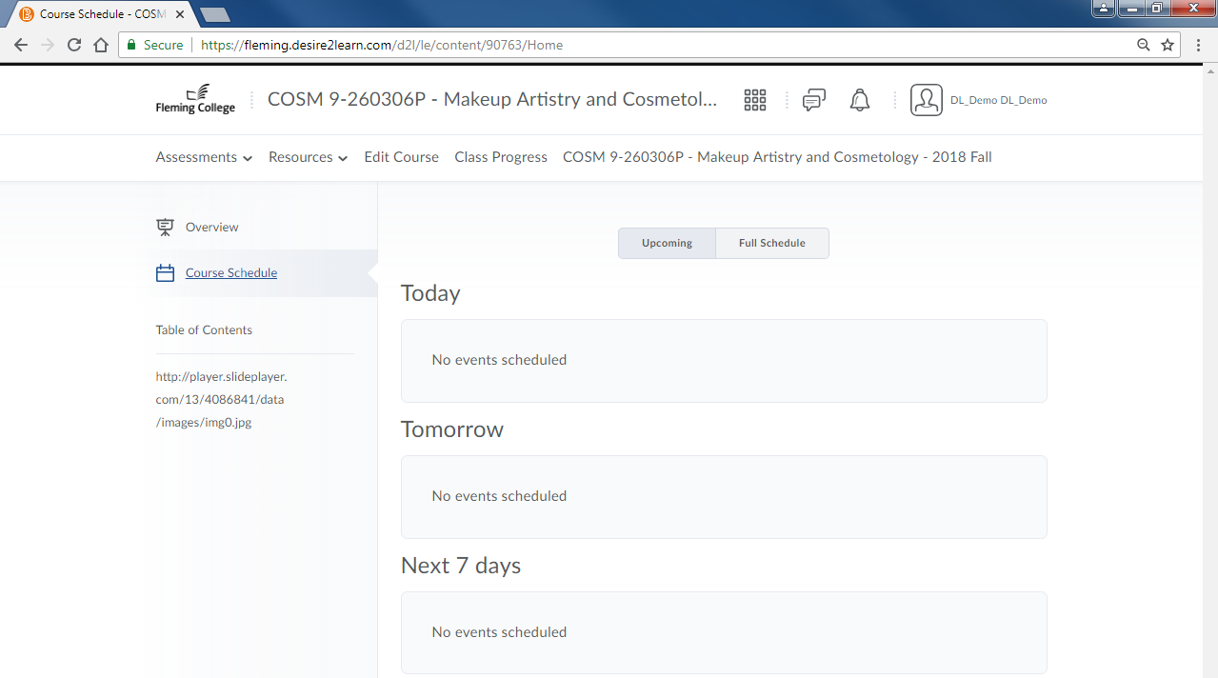
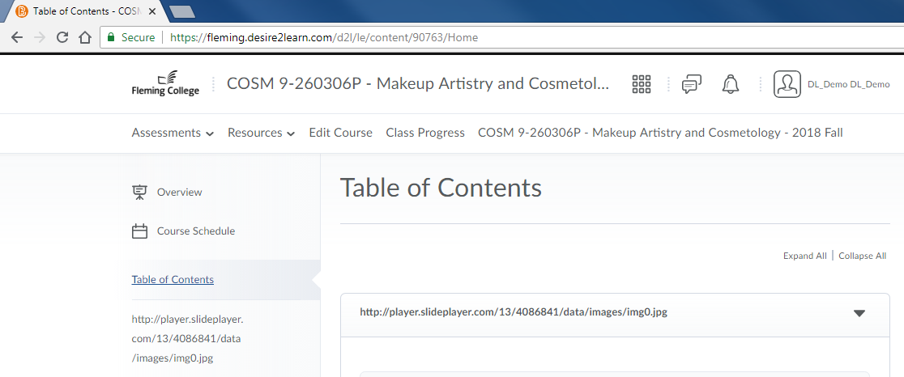

Use top menu to view grades
- Click ‘Assessments’ in the top menu bar.

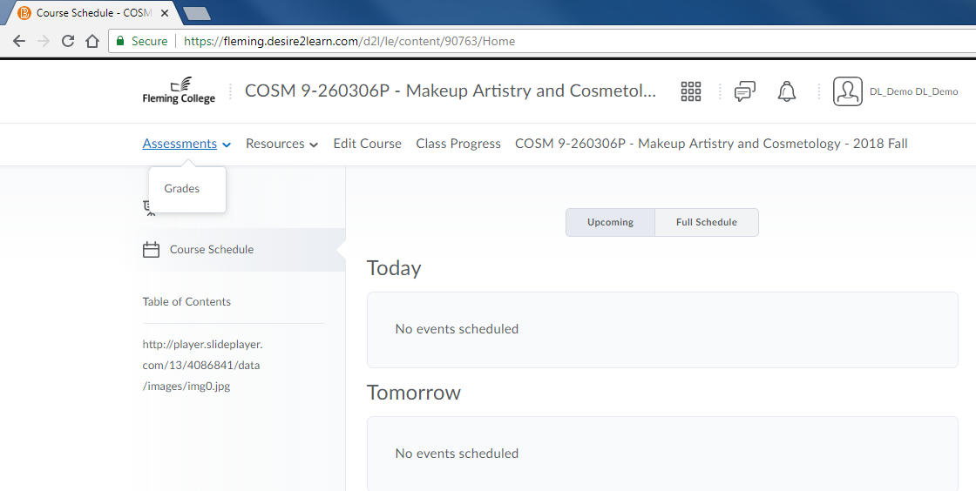

- Click ‘Grades’ to view the available marks in the course.

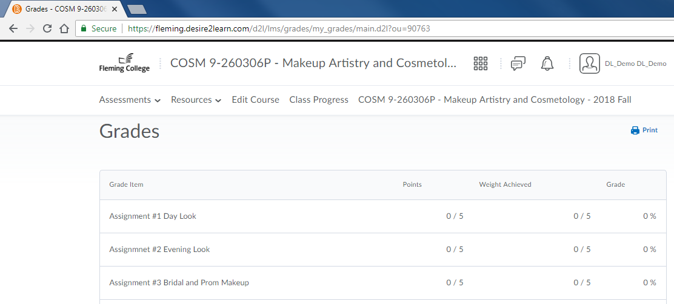

Use top menu to view content
- Click ‘Resources’ in the top menu bar.

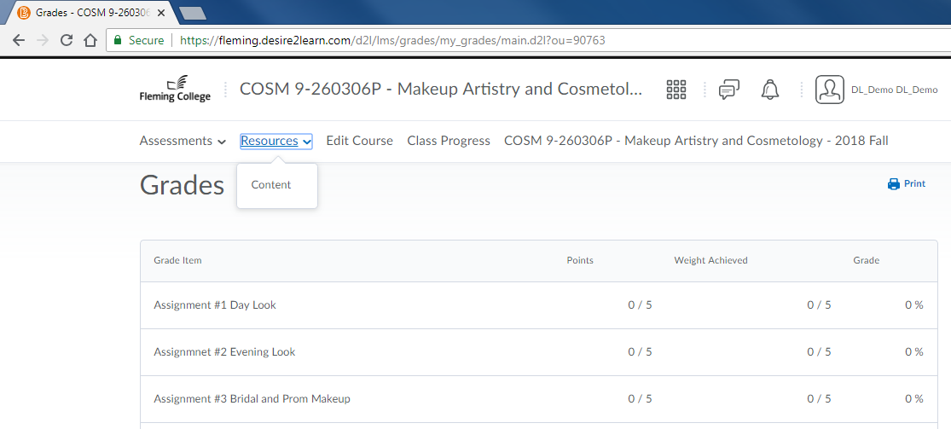

- Click ‘Content’ for another method of viewing the content in the course.

Use top menu to view class progress
- Menu Bar: Click ‘Class Progress’ in the top menu bar to view the students and their level of engagement and participation with the course content in the LMS.

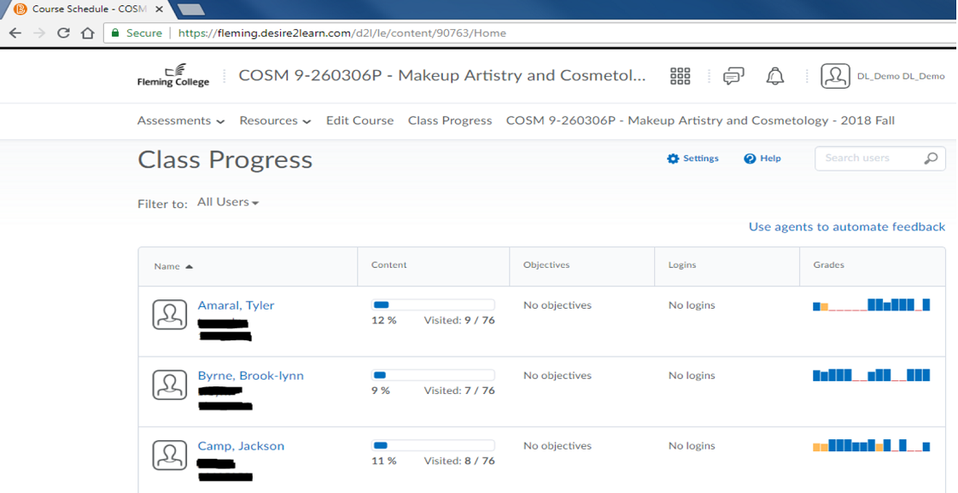

Logout of Desire2Learn
- Click your ‘name’ in the top right corner of the screen

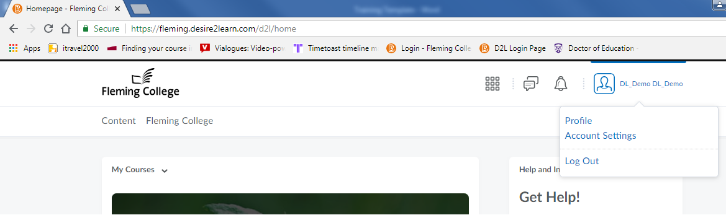

- Click ‘Log Out’

[END OF DOCUMENT]

