**myCampus Step by Step Instructions for New Students**

**Step #1** – Log on to <https://mycampus.flemingcollege.ca/web/portal/home> and click “***Get Started***”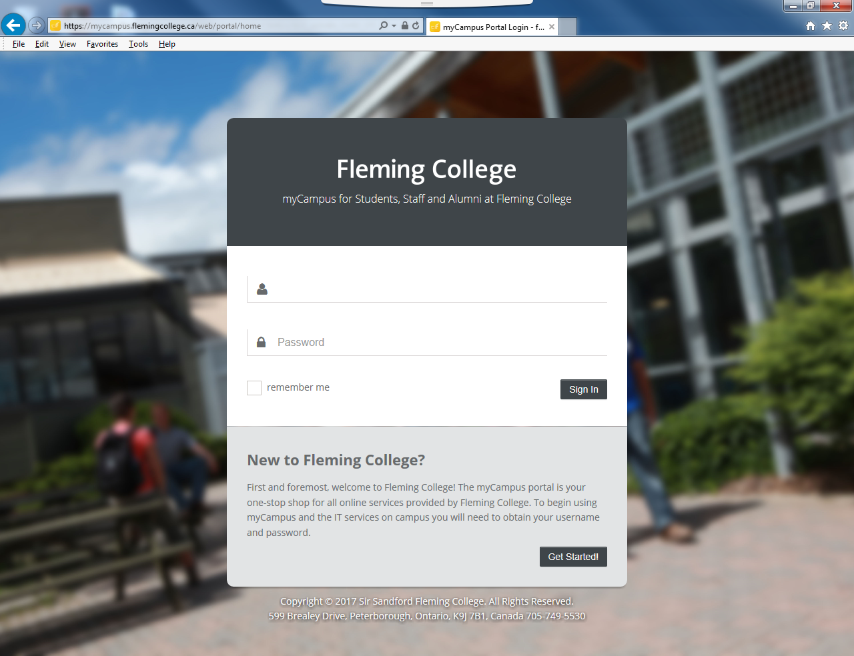

**Step #2** – Locate and enter ***Student Number*** on your correspondence from Fleming College, and enter ***Date of Birth*** and press “***continue***”.

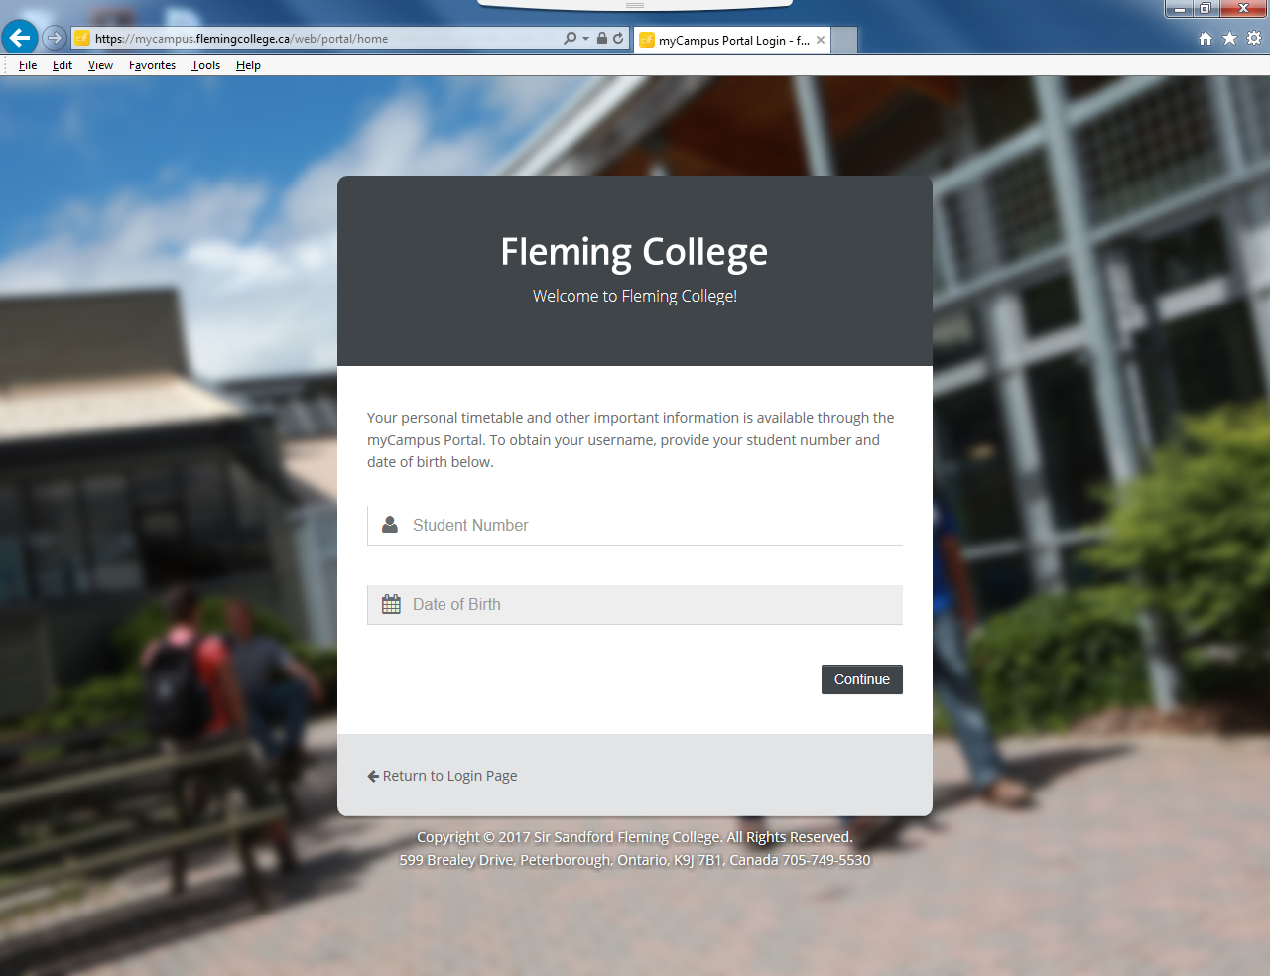

(This will generate a User Name & Fleming Email; password is automatically set to Student Number until changed)

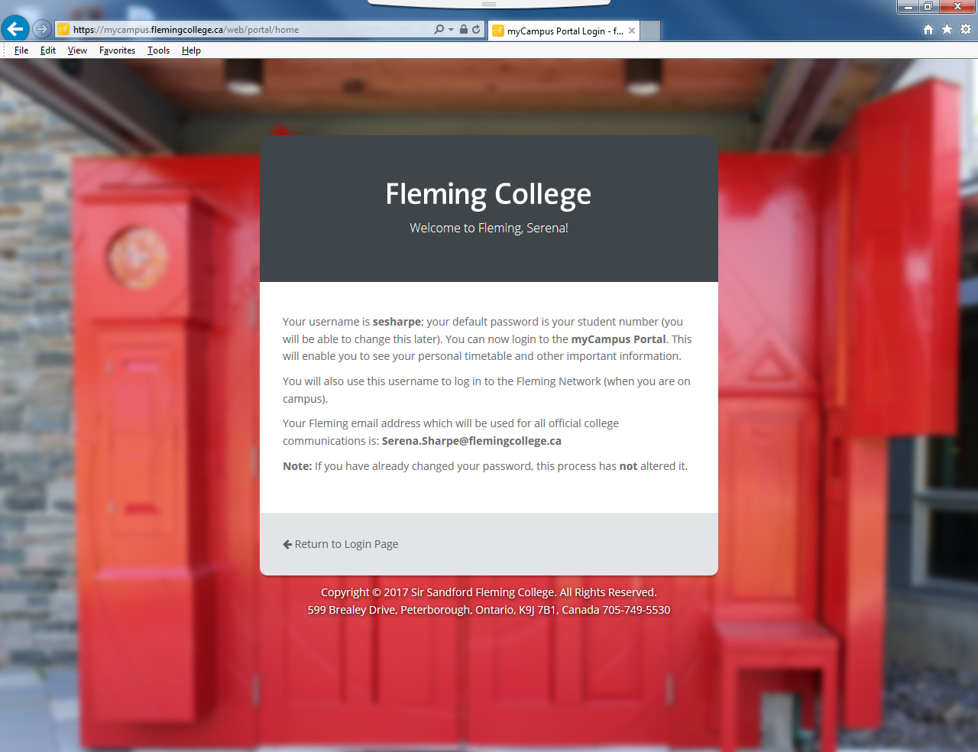

**Step #3** – Write down ***User Name*** and ***Email*** ***Address*** and select “***Return to Login Page***”. Enter User name and password and select “***Sign In***”



**Step # 4** - From here, you can use the side panel links to access such items as your *Fleming Email*, *Desire2Learn (D2L)*, *My Student Centre*. See Examples below of D2L and My Student Centre.

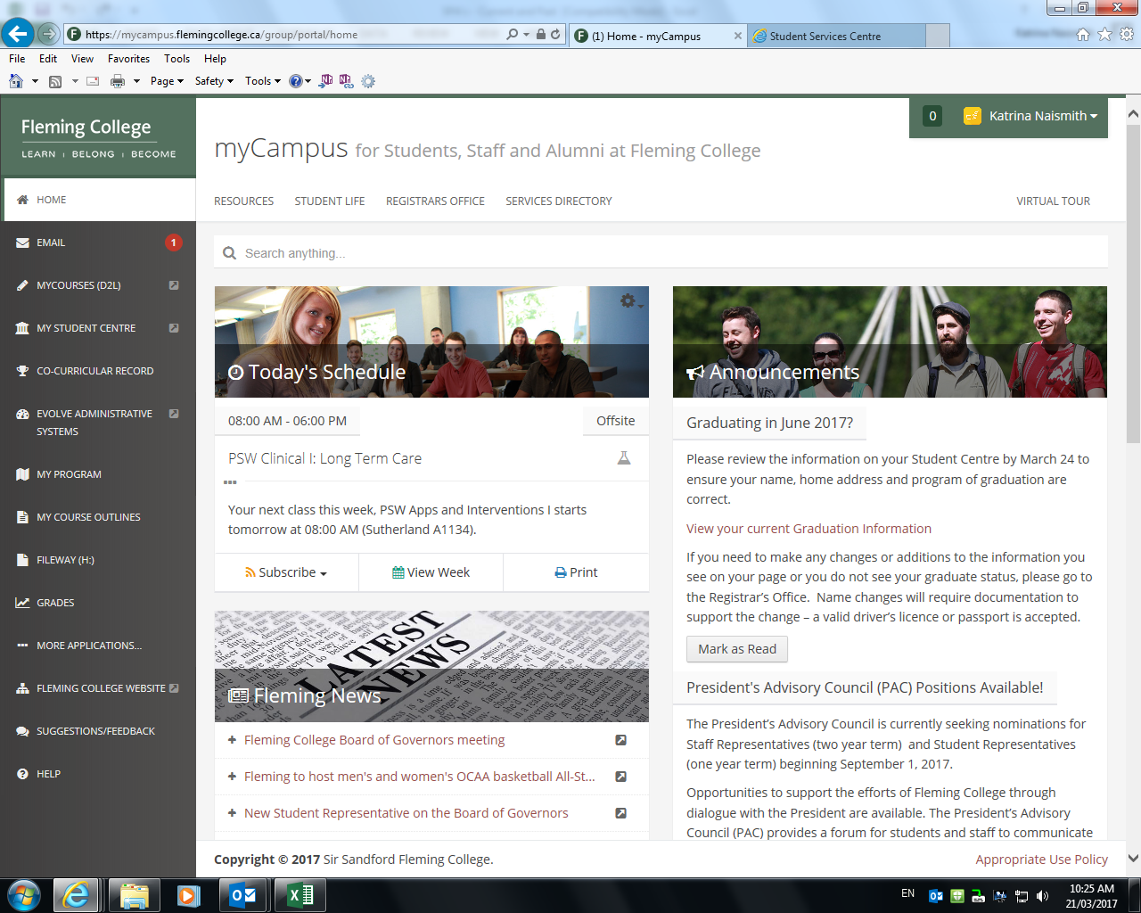

***Screen Examples***

**Desire2Learn (D2L)/ My Courses**

This is where you will find information and documents regarding your classes.

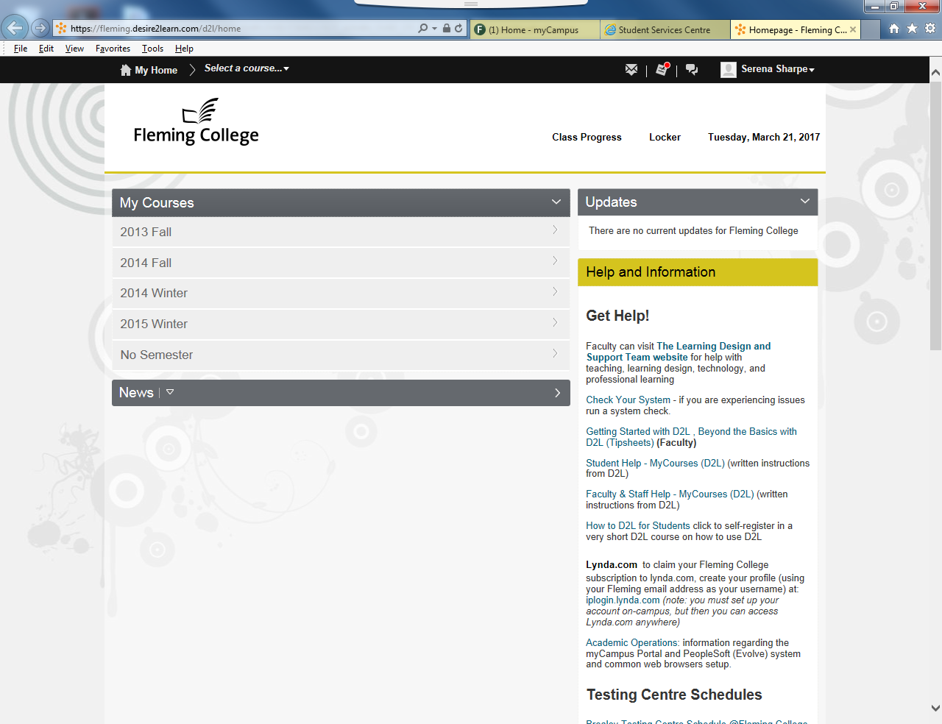

**My Student Centre**

Timetable Location, Personal Information, etc...

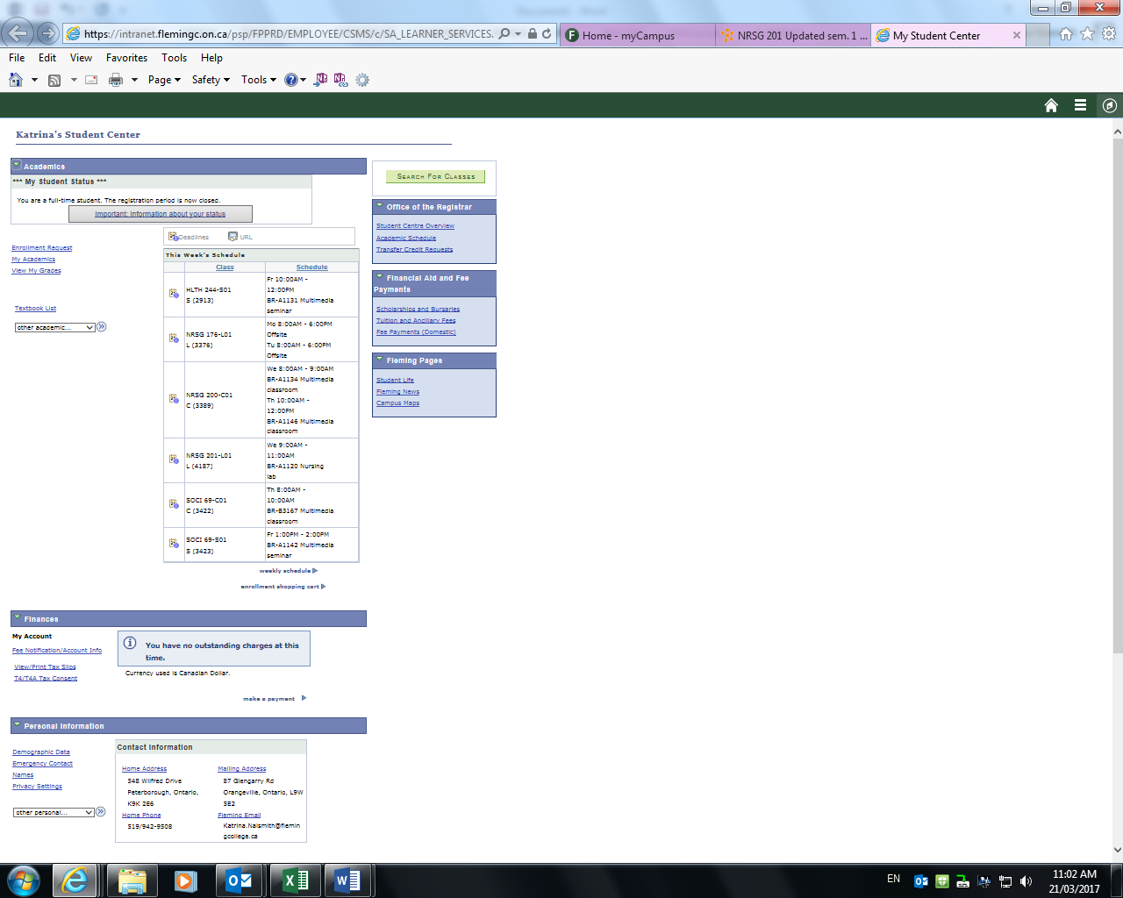

**Fleming Email**

**\*\*Note\*\*** Please use **ONLY** the Fleming email to correspond with the College and Faculty, as this will verify your identity.

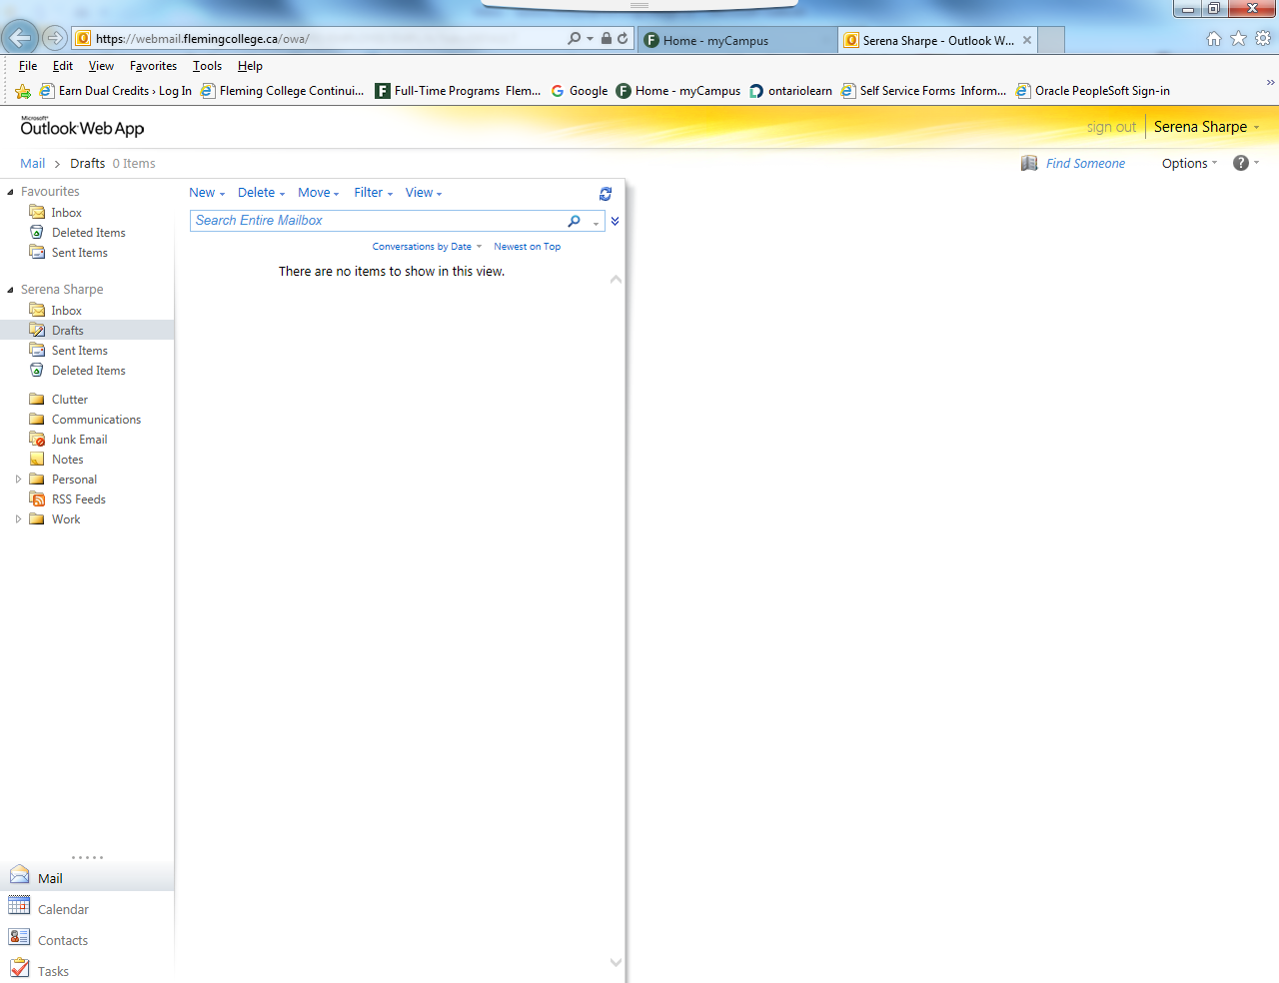

***Welcome to Fleming College and Good Luck in your studies!!***