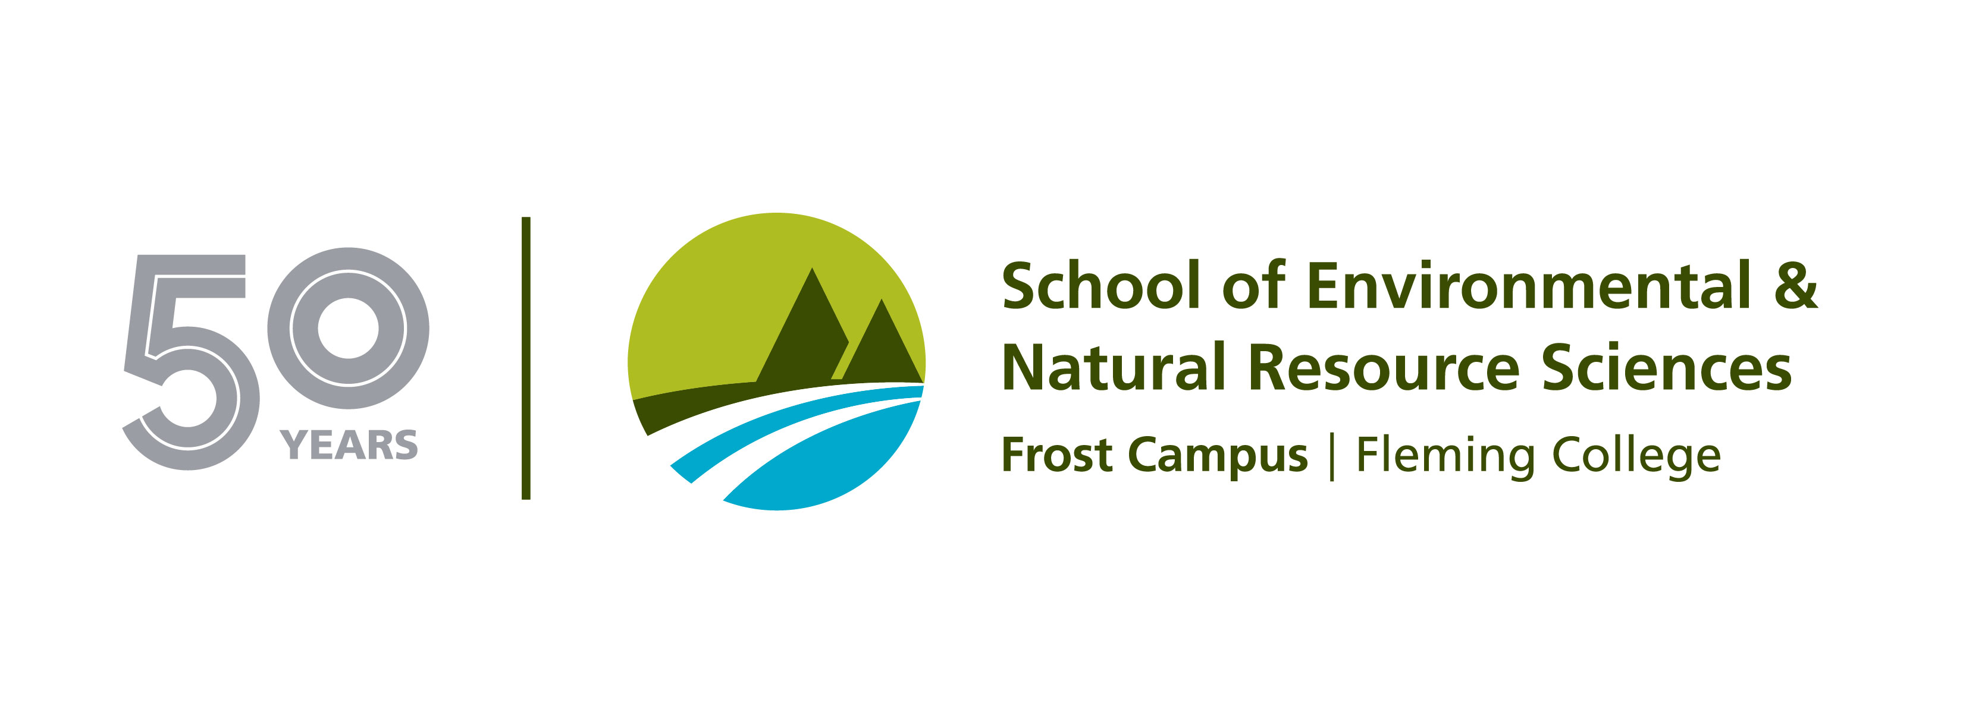

MEDIA RELEASE

Wilfrid Laurier University and Fleming College to offer new “2 + 2” diploma-degree pathway

Peterborough ON - (May 29, 2017) – Fleming College and Wilfrid Laurier University have signed a “2 + 2” diploma-degree pathway agreement, the first of its kind for the university.

Under the agreement, eligible graduates of three Fleming programs can enter directly into the third year of Laurier’s Honours Bachelor of Arts in Environmental Studies, allowing the students to complete a diploma and degree in four years.

The agreement applies to Environmental Technician, Ecosystem Management Technician, and Fish and Wildlife Technician, all two-year diploma programs in Fleming’s School of Environmental and Natural Resource Sciences.

“This is an exciting opportunity for our Environmental and Natural Resource Sciences students at Fleming,” said Brett Goodwin, dean of Fleming’s School of Environmental and Natural Resource Sciences. “It will allow our students to combine the applied skills of their college diploma with the theoretical knowledge and research skills of an honours degree, ensuring a depth and breadth in their skill set that will help them advance within their chosen careers.”

“The nature and depth of the Fleming programs make them a natural fit with Laurier’s Environmental Studies program,” said Sean Doherty, chair of Laurier’s Department of Geography and Environmental Studies. “We look forward to immersing students into our department where they can confront challenging environmental issues, further expand and put into practice their impressive skill set, and engage with our existing students in ways that raise the profile of the whole program.”

Laurier’s Environmental Studies program combines natural and social sciences to better understand the human relationship with the natural environment. Students focus on issues such as sustainability in land and water management, and acquire applied skills in environmental impact assessment, geovisualization, remote sensing, and research methods. Hands-on experiential, field, and community-engaged learning opportunities are built into all aspects of the program.

Fleming graduates in Laurier’s degree program will be required to take core Geography and Environmental Studies courses such as environmental theory/issues, hydrology, geographic information systems (GIS) and research methods to expand their knowledge and immerse them in the same level of experience as current majors.
Diploma-to-degree pathways have become a popular option for students seeking both an applied and theoretical education. The pathways often allow students to complete both credentials in less time and at a lower cost.
The pathway program will be offered beginning in September 2017.
About Fleming College
Located in the heart of Central Ontario, Fleming College has campus locations in Peterborough, Lindsay, Cobourg and Haliburton. Named for famous Canadian inventor and engineer Sir Sandford Fleming, the college features more than 100 full-time programs in Arts and Heritage, Business, Environmental and Natural Resource Sciences, General Arts and Sciences, Health and Wellness, Justice and Community Development, Skilled Trades and Technology, and Continuing Education. Fleming College has more than 5,900 full-time and 10,000 part-time students, and 71,000 alumni. flemingcollege.ca

About Wilfrid Laurier University
Wilfrid Laurier University is a leading Canadian university known for academic excellence and a culture that inspires lives of leadership and purpose. Laurier has a distinct commitment to teaching, research and scholarship, combined with a strong student focus, high levels of student satisfaction and a deep sense of community. Laurier’s innovative educational model purposefully integrates the academic learning experience with an experiential learning component. The university has more than 19,000 students throughout its campuses in Waterloo and Brantford and locations in Kitchener and Toronto. The university celebrated its centennial in 2011. www.wlu.ca
-30-
Members of the media, for more information please contact:
Laura Copeland
Communications Officer
Fleming College
laura.copeland@flemingcollege.ca or 705.749.5530 ext. 1370

Kevin Crowley
Director, Communications & Public Affairs
Wilfrid Laurier University
kcrowley@wlu.ca or 519.884.0710 ext. 3070

