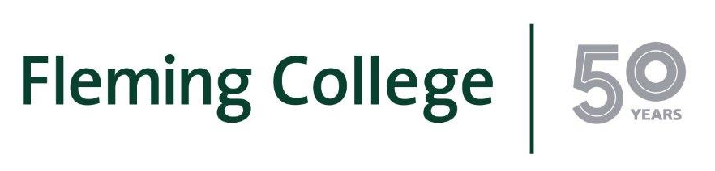
MEDIA RELEASE

Queen’s University and Fleming College sign degree pathway agreement
Peterborough ON - (July 10, 2017) – Fleming College students now have a pathway to a degree at Queen’s University, the first agreement of its kind between the two institutions.

Eligible graduates of Fleming’s Pre-Health Sciences Pathway to Advanced Diplomas and Degrees certificate program (PHS) can now pursue a Bachelor of Health Sciences Degree (Honours) at Queen’s University. Students taking advantage of this pathway will be awarded 12 credit hours, which is equivalent to nearly one semester of credit.

“This is a groundbreaking agreement for Fleming College, and it is a definite advantage for our graduates,” said Sandra Dupret, dean of the School of General Arts and Sciences at Fleming. “Providing the opportunity to pursue a degree at a highly regarded and respected institution such as Queen’s University represents continued progress and growth for us as an institution and is, we believe, a testament to the quality of the program and the ability of our graduates.”

“Queen’s University’s Bachelor of Health Sciences program is pleased to welcome Fleming College graduates who are ready to pursue an advanced degree in health, and want to do so through a state-of-the-art, customizable, and flexible online program,” notes Dr. Michael Adams, Director of the Bachelor of Health Sciences program at Queen’s. “This partnership with Fleming College will give students a head-start in building a fulfilling and challenging career in healthcare.”

The Pre-Health Sciences Pathway to Advanced Diplomas and Degrees program, within Fleming’s School of General Arts and Sciences, is a two-semester certificate program intended to prepare graduates for more advanced studies in health sciences. The program provides students with core knowledge, skills and abilities that are fundamental to academic success in health sciences and related programs. The program further offers extensive, hands-on laboratory-based learning in preparation for post-secondary level science programs.

About Fleming College
Located in the heart of Central Ontario, Fleming College has campus locations in Peterborough, Lindsay, Cobourg and Haliburton. Named for famous Canadian inventor and engineer Sir Sandford Fleming, the college features more than 100 full-time programs in Arts and Heritage, Business, Environmental and Natural Resource Sciences, General Arts and Sciences, Health and Wellness, Justice and Community Development, Skilled Trades and Technology, and Continuing Education. Fleming College has more than 5,900 full-time and 10,000 part-time students, and 71,000 alumni.
-30-
Media, for more information please contact:
Laura Copeland
Communications Officer
laura.copeland@flemingcollege.ca
705.749.5530 x 1370

