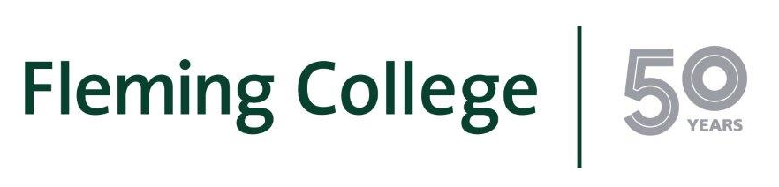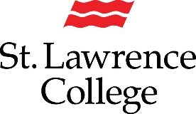

MEDIA RELEASE
New pathway agreement between Fleming College and St.Lawrence College
Peterborough ON - (Aug. 29, 2017) – A new educational pathway will benefit students and graduates from Fleming College’s Fish and Wildlife Technician program and St. Lawrence College’s Veterinary Technology program.
Fleming College and St. Lawrence College (SLC) recently signed a new bilateral articulation agreement that will allow qualified students and graduates from each institution to transfer credit and gain advanced standing.
“I’m excited about this agreement, which formalizes an on-going relationship between our Fish and Wildlife program and St. Lawrence College’s Vet Tech program,” said Brett Goodwin, Dean of Fleming’s School of Environmental and Natural Resource Sciences. “This agreement will provide a unique opportunity for students to gain training in both the fish and wildlife and vet tech fields, which prepares them to be able to provide very specific services such as wildlife immobilizations.”
Qualified students and graduates from Fleming’s Fish and Wildlife Technician program will receive transfer credits equivalent to seven courses in St. Lawrence College’s Veterinary Technology program. SLC’s Veterinary Technology program is a three-year advanced diploma program offered on SLC’s Kingston campus. The program produces graduates with excellent scientific training as well as the practical laboratory and veterinary technical skills needed in today’s workplace.
Qualified students and graduates from St. Lawrence College’s Veterinary Technology program will receive transfer credits equivalent to nine courses in Fleming’s Fish and Wildlife Technician program, allowing them to enter directly into the program’s second year. Fleming College’s Fish and Wildlife Technician program is a two-year (four semesters) diploma program that features an optional co-operative education experience. It leads graduates into a rewarding career, combining their love of the outdoors and keen interest in fish and wildlife, with a commitment to responsible resource management.
“We are grateful for this partnership with Fleming College. This articulation agreement will benefit St. Lawrence College Veterinary Technology graduates by granting them the opportunity to earn a second college credential in only two academic semesters. By taking advantage of this new educational pathway, our Veterinary Technology graduates can diversify their knowledge and skill set, thereby expanding their career opportunities,” said Robin Hicks, Dean of the Faculty of Applied Science at St. Lawrence College.”
Each year, Fleming College will reserve two seats in the Fish and Wildlife Technician program for St. Lawrence College Veterinary Technology graduates. Both seats for this fall are already filled with two Veterinary Technology graduates from SLC enrolled in the Fish and Wildlife Technician program at Fleming.
About St. Lawrence College
With three friendly campuses in Brockville, Cornwall, and Kingston, St. Lawrence College is an integral part of the economic life and social fabric of Eastern Ontario with a close-knit community of 10,000 full-time students, and more than 88,000 proud alumni. Hundreds are also enrolled in our online and continuing education courses each year. As part of our ongoing sustainability initiatives, the College boasts more than 1,600 rooftop solar modules on our Kingston and Brockville campuses, the largest solar rooftop installation of any post-secondary institution in Canada. The college has many Applied Research projects in progress, as well, our Corporate Learning and Performance Improvement group has helped more than 350 organizations grow and prosper. Through our Employment Service offices, we work with thousands of clients annually.
About Fleming College
Located in the heart of Central Ontario, Fleming College has campus locations in Peterborough, Lindsay, Cobourg and Haliburton. Named for famous Canadian inventor and engineer Sir Sandford Fleming, the college features more than 100 full-time programs in Arts and Heritage, Business, Environmental and Natural Resource Sciences, General Arts and Sciences, Health and Wellness, Justice and Community Development, Skilled Trades and Technology, and Continuing Education. Fleming College has more than 5,900 full-time and 10,000 part-time students, and 74,000 alumni. The Frost Campus, located in Lindsay, is home to the renowned School of Environmental and Natural Resource Sciences. The School, which offers active, outdoor, hands-on learning with field trips, field schools, and co-op education, has more graduates working in the environmental and natural resource fields than any other college in Canada.
-30-
Media, for more information please contact:
Laura Copeland
Communications Officer
laura.copeland@flemingcollege.ca
705.749.5530 x 1370

