
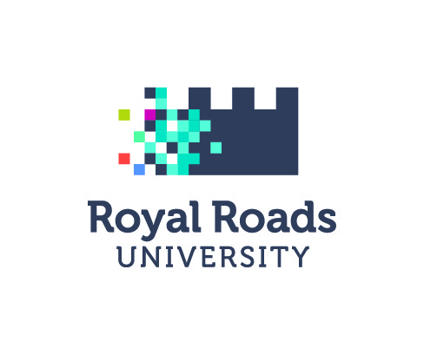
MEDIA RELEASE

Renewed diploma-to-degree pathways from Fleming College to Royal Roads University

Peterborough ON – (August 30, 2019) – Fleming College in Peterborough, Ontario and Royal Roads University in Victoria, British Columbia, have renewed a wide-ranging transfer agreement that provides pathways to five Royal Roads bachelor degrees from 15 Fleming diploma programs.

Through the renewed agreement, eligible Fleming students in select programs can enter into their third year of study in the following Royal Roads’ degrees: Bachelor of Arts in International Hotel Management, Bachelor of Business Administration in Sustainability and International Business, Bachelor of Arts in Global Tourism, or Bachelor of Arts in Environmental Practice/ Bachelor of Science in Environmental Practice.

“Fleming College is a true partner in building bright and prosperous futures for our students, and we are pleased to continue our strong partnership with Royal Roads University to offer students national pathway opportunities,” said Maureen Adamson, Fleming College President. “Colleges and universities working together create pathways and communities that allow access to innovative education, research and real-world experiences needed for Fleming students to be best-in-class.”

“Royal Roads welcomes students from Fleming College interested in completing their bachelor degrees with us,” says Dr. Stephen Grundy, vice-president academic and provost of Royal Roads University. “We invite you to consider a future at Royal Roads, where we study the tough challenges facing Canada and the world with a focus on practical solutions.”

A full listing of Fleming’s programs available for this education pathway between the institutions can be found at the Fleming College and Royal Roads University websites.

About Fleming College
Located in the heart of Central Ontario, Fleming College has campus locations in Peterborough, Lindsay, Cobourg and Haliburton. Named for famous Canadian inventor and engineer Sir Sandford Fleming, the college features more than 100 full-time programs in Arts and Heritage, Business, Environmental and Natural Resource Sciences, General Arts and Sciences, Health and Wellness, Justice and Community Development, Skilled Trades and Technology, and Continuing Education. Fleming College has more than 6,800 full-time and 10,000 part-time students, and 75,000 alumni.

About Royal Roads University
Royal Roads University, a public university established in 1995, offers a progressive model of post-secondary education, delivering applied and professional programs. The university offers a blended learning experience combining online and on-campus instruction, as well as full time intensive on-campus instruction for undergraduate and graduate degrees, doctoral degrees, certificates and diplomas. It also offers progressive, professional continuing studies programs.
-30-
Media, for more information please contact:
Sara O’Halloran
Communications Officer
sara.ohalloran@flemingcollege.ca
705.749.5530 x 1366

Cindy MacDougall
Communications Officer, Royal Roads University
Cindy.MacDougall@royalroads.ca
P 250-391-2600 x 4021 C 250-882-3481

Peterborough  Sutherland Campus  599 Brealey Dr.  Peterborough ON K9J 7B1  Ph: (705) 749-5530 | Lindsay  Frost Campus  200 Albert St. S., Box 8000  Lindsay ON K9V 5E6  Ph: (705) 324-9144 | Haliburton  Haliburton Campus  P.O. Box 839  Haliburton ON K0M 1S0  Ph: (705) 457-1680 | Cobourg  Cobourg Campus  1005 Elgin St. W.  Cobourg ON K9A 5J4  Ph: (905) 372-6865
Web: flemingcollege.ca
Facebook: facebook.com/flemingcollege
Twitter & Instagram: @FlemingCollege
Connect with Royal Roads University: www.royalroads.ca

