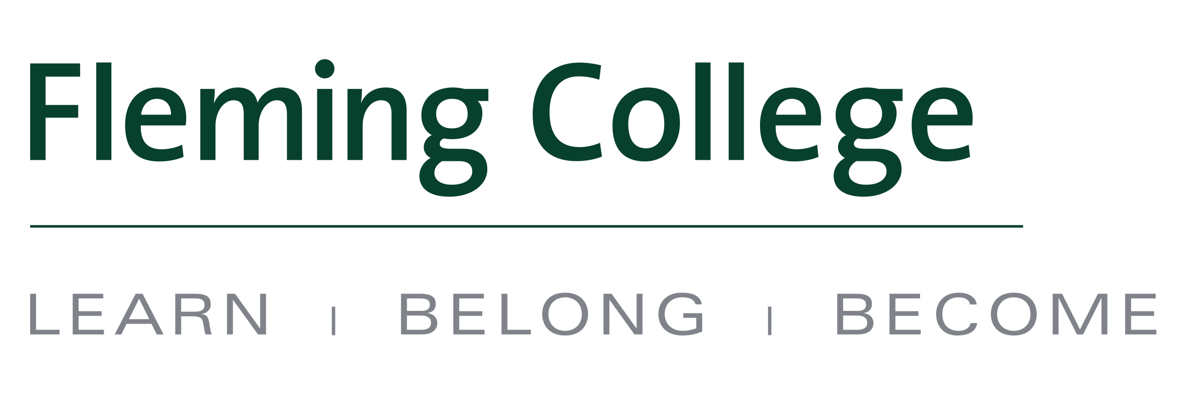


MEDIA RELEASE

Fleming College and OCAD University renew degree pathway agreement

Haliburton, ON (July 8, 2016) – OCAD University (OCAD U) and Fleming College have renewed an agreement that provides a pathway to a Bachelor of Fine Arts (BFA) degree for Fleming graduates.

The articulation agreement, initially signed in 2009, was recently renewed through to 2019. It will allow eligible graduates of Fleming’s Visual and Creative Arts diploma program to continue to apply for upper year entry into the BFA program at OCAD U.

“We are pleased to continue this partnership and provide our graduates with an excellent pathway and opportunity to continue their visual arts studies. Students who leave our Visual and Creative Arts program are fully prepared for the increased rigours of OCAD U, which is recognized by the ongoing renewal of this agreement. This past year we had four VCA grads take advantage of this pathway, which is a great measure of success,” says Sandra Dupret, Dean of the Haliburton School of Art + Design (HSAD) and Principal of Haliburton Campus.

The Visual and Creative Arts diploma program is part of HSAD and is delivered at Fleming’s Haliburton Campus. It offers unique and flexible options for completing the program – a suite of foundational courses combined with elective courses. Foundational courses include: 3D Design; Art History; Business for Artists; Design; Concept Development; and Drawing Disciplines. Students can complete the diploma program in an accelerated format, in as few as three semesters.

About Fleming College
Located in the heart of Central Ontario, Fleming College has campus locations in Peterborough, Lindsay, Cobourg and Haliburton. Named for famous Canadian inventor and engineer Sir Sandford Fleming, the college features more than 100 full-time programs in Arts and Heritage, Business, Environmental and Natural Resource Sciences, General Arts and Sciences, Health and Wellness, Justice and Community Development, Skilled Trades and Technology, and Continuing Education. Fleming College has more than 5,800 full-time and 10,000 part-time students, and 71,000 alumni.

About OCAD University
OCAD University (www.ocadu.ca) is Canada’s university of the imagination. The university, founded in 1876, is dedicated to art and design education, practice and research, and to knowledge and invention across a wide range of disciplines. OCAD University is building on its traditional, studio-based strengths, adding new approaches to learning that champion cross-disciplinary practice, collaboration and the integration of emerging technologies.
-30-
Media, for more information please contact:
Laura Copeland
Communications Officer, Fleming College
laura.copeland@flemingcollege.ca
705.749.5530 x 1370

flemingcollege.ca
@flemingcollege
facebook.com/flemingcollege

