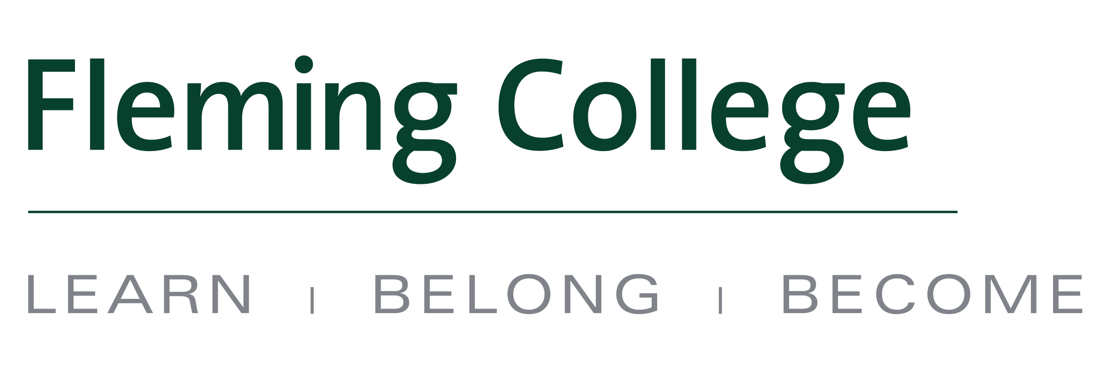
MEDIA RELEASE

Fleming College and Algoma University sign new diploma-to-degree agreement

Peterborough, ON (September 12, 2016) – Fleming College and Algoma University have signed a new, wide-ranging transfer agreement that provides a pathway to a degree from all Fleming programs.

The agreement allows eligible graduates from any of Fleming’s advanced diploma, diploma or certificate programs the opportunity to apply and obtain credit for related courses within Algoma’s Bachelor of Arts, Bachelor of Business Administration, Bachelor of Computer Science, Bachelor of Social Work, Bachelor of Science, or Bachelor of Fine Arts programs.

Further, the new partnership provides more specific transfer agreements around certain programs within Fleming’s School of Environmental and Natural Resource Sciences, allowing students to obtain a diploma and a degree in as few as four years.

“Colleges and universities working together can create a powerful learning environment for students. This new pathway agreement with Fleming College provides students with the ability to combine and enhance their diploma success with the high quality degree completion opportunity that is available at Algoma University. When outstanding institutions such as Fleming College and Algoma University work together in a cooperative manner, our students benefit,” said Algoma University President and Vice Chancellor, Dr. Craig Chamberlin.

“The Fleming/Algoma pathway permits students to “come south” and “go north.” We are seeking those special students who will recognize that this is an outstanding opportunity – a chance to learn from faculty, with other students, and from life experiences that can lead to fulfilling work and careers across Ontario and beyond,” said Fleming College President, Dr. Tony Tilly.

More often, students are opting to obtain both a diploma and a degree as it allows them to gain both hands-on experience as well as theoretical studies. Most of Fleming’s full-time programs have diploma-to-degree options – you can learn more about the college’s pathways at flemingcollege.ca/education-pathways.

About Algoma University
Algoma University was established in 1965 and is located in Sault Ste. Marie, Ontario. Algoma University is a small, undergraduate, teaching-focused university that places an emphasis on serving the needs of Northern Ontario. Algoma University offers a wide range of degrees spanning the liberal arts, sciences, and professional disciplines. As a partner with Shingwauk Kinoomaage Gamig, Algoma University has a special mission to cultivate cross-cultural learning between Aboriginal populations and other communities. Algoma University also offers satellite programming in Brampton and Timmins. For more information, please visit www.algomau.ca.

About Fleming College
Located in the heart of Central Ontario, Fleming College has campus locations in Peterborough, Lindsay, Cobourg and Haliburton. Named for famous Canadian inventor and engineer Sir Sandford Fleming, the college features more than 100 full-time programs in Arts and Heritage, Business, Environmental and Natural Resource Sciences, General Arts and Sciences, Health and Wellness, Justice and Community Development, Skilled Trades and Technology, and Continuing Education. Fleming College has more than 5,800 full-time and 10,000 part-time students, and 71,000 alumni.
-30-
Media, for more information please contact:
Laura Copeland
Communications Officer
laura.copeland@flemingcollege.ca
705.749.5530 x 1370

Meaghan Kent, M.A.
Communications Writer & Sports Information
Algoma University
Work: (705) 949-2301, Ext. 4121
Cell: (705) 971-2227
meaghan.kent@algomau.ca
Peterborough  Sutherland Campus  599 Brealey Dr.  Peterborough ON K9J 7B1  Ph: (705) 749-5530 | Lindsay  Frost Campus  200 Albert St. S., Box 8000  Lindsay ON K9V 5E6  Ph: (705) 324-9144 | Haliburton  Haliburton Campus  P.O. Box 839  Haliburton ON K0M 1S0  Ph: (705) 457-1680 | Cobourg  Cobourg Campus  1005 Elgin St. W.  Cobourg ON K9A 5J4  Ph: (905) 372-6865
flemingcollege.ca
@flemingcollege
facebook.com/flemingcollege

