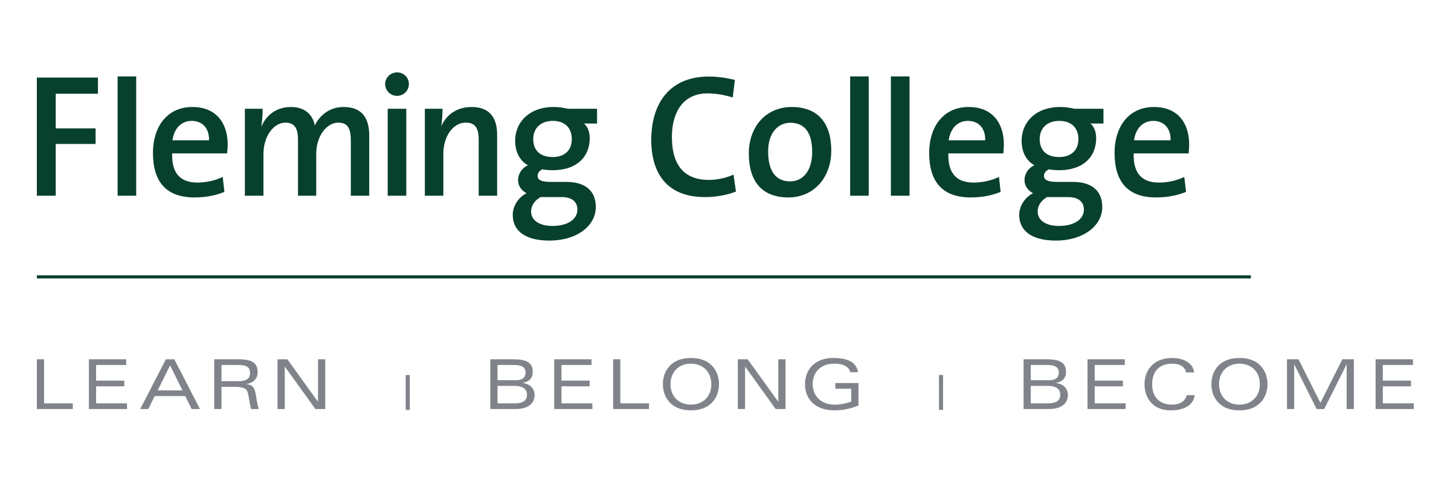


MEDIA RELEASE

New 2+2 diploma-degree pathway from Fleming College to School of Business at Trent University one-of-a-kind in Ontario

Peterborough, ON (Nov. 2, 2016) – Building on the long-standing relationship between Fleming College and Trent University, the two institutions have signed a new “2 + 2” pathway agreement that allows students to complete a diploma and degree in Business – Accounting in just four years – the first program of its kind in Ontario.

Graduates of Fleming’s two-year Accounting diploma program can now attain a Bachelor of Business Administration with a Specialization in Accounting from the School of Business at Trent University with just two further years of study. Eligible students will be admitted directly into the third year of the degree program and will not be required to take any additional bridging or reach-back courses.

This unique and seamless 2+2 partnership between a college and university is a one-of-a-kind in the province, providing students with the opportunity to live and study within the same community while obtaining their credentials.

“There is employment in this area across the spectrum - from diploma to degree - and this agreement provides our students with greater flexibility to address their personal learning and employment goals,” said Maxine Mann, Dean of Fleming College’s School of Business and the School of Trades and Technology.

“We’re excited about partnering with Fleming to create this new accounting pathway that affords students the opportunity to continue their CPA aspirations at Trent University,” added Dr. Kirk Collins, director of the School of Business at Trent University. “The new 2+2 program capitalizes on a long-standing relationship between the two institutions and will benefit students for years to come. We anticipate this learning pathway will be very popular and we look forward to welcoming Fleming students to our Accounting specialization in the School of Business.”

The Accounting program at Fleming teaches students to understand accounting principles applicable to various types of organizations, how to prepare and present financial statements, management accounting concepts, personal tax preparation, financial management, and the impact of external and internal factors on organizational operations.

Accounting is one of the many specializations offered through the School of Business at Trent University, which was officially launched earlier today. At Trent, students have the ability to combine Finance, Accounting, Management, Entrepreneurship, Human Resources, Information Systems and E-Commerce with just about any other subject – arts or science. Trent students further have the opportunity to complete all CPA-PREP modules in preparation for professional accreditation.

Fleming and Trent recently signed a revised agreement that also allows graduates of Fleming’s Business Administration – Accounting program, a three-year advanced diploma, the option to complete a BBA with a Specialization in Accounting with just two further years of study.

Diploma-to-degree pathways have become a popular option for students who are seeking both an applied and theoretical education. The pathways often allow students to complete both credentials in less time and at a lower cost.

Fleming College and Trent University have a number of diploma-to-degree pathways available to eligible Fleming students. For more information, visit: http://flemingcollege.ca/education-pathways/trent-university

About Fleming College
Located in the heart of Central Ontario, Fleming College has campus locations in Peterborough, Lindsay, Cobourg and Haliburton. Named for famous Canadian inventor and engineer Sir Sandford Fleming, the college features more than 100 full-time programs in Arts and Heritage, Business, Environmental and Natural Resource Sciences, General Arts and Sciences, Health and Wellness, Justice and Community Development, Skilled Trades and Technology, and Continuing Education. Fleming College has more than 5,800 full-time and 10,000 part-time students, and 71,000 alumni.

About Trent University
One of Canada's top universities, Trent University was founded on the ideal of interactive learning that's personal, purposeful and transformative. Consistently recognized nationally for leadership in teaching, research and student satisfaction, Trent attracts excellent students from across the country and around the world. Here, undergraduate and graduate students connect and collaborate with faculty, staff and their peers through diverse communities that span residential colleges, classrooms, disciplines, hands-on research, co-curricular and community-based activities. Across all disciplines, Trent brings critical, integrative thinking to life every day. Today, Trent's unique approach to personal development through supportive, collaborative community engagement is in more demand than ever. Students lead the way by co-creating experiences rooted in dialogue, diverse perspectives and collaboration. In a learning environment that builds life-long passion for inclusion, leadership and social change, Trent's students, alumni, faculty and staff are engaged global citizens who are catalysts in developing sustainable solutions to complex issues. Trent's Peterborough campus boasts award-winning architecture in a breathtaking natural setting on the banks of the Otonabee River, just 90 minutes from downtown Toronto, while Trent University Durham – Greater Toronto Area, delivers a distinct mix of programming in the east GTA.

-30-
Media, for more information please contact:
Laura Copeland
Communications Officer
laura.copeland@flemingcollege.ca
705.749.5530 x 1370
Kate Weersink
Media Relations & Strategic Communications Officer
kateweersink@trentu.ca
705-748-1011 x 6180

