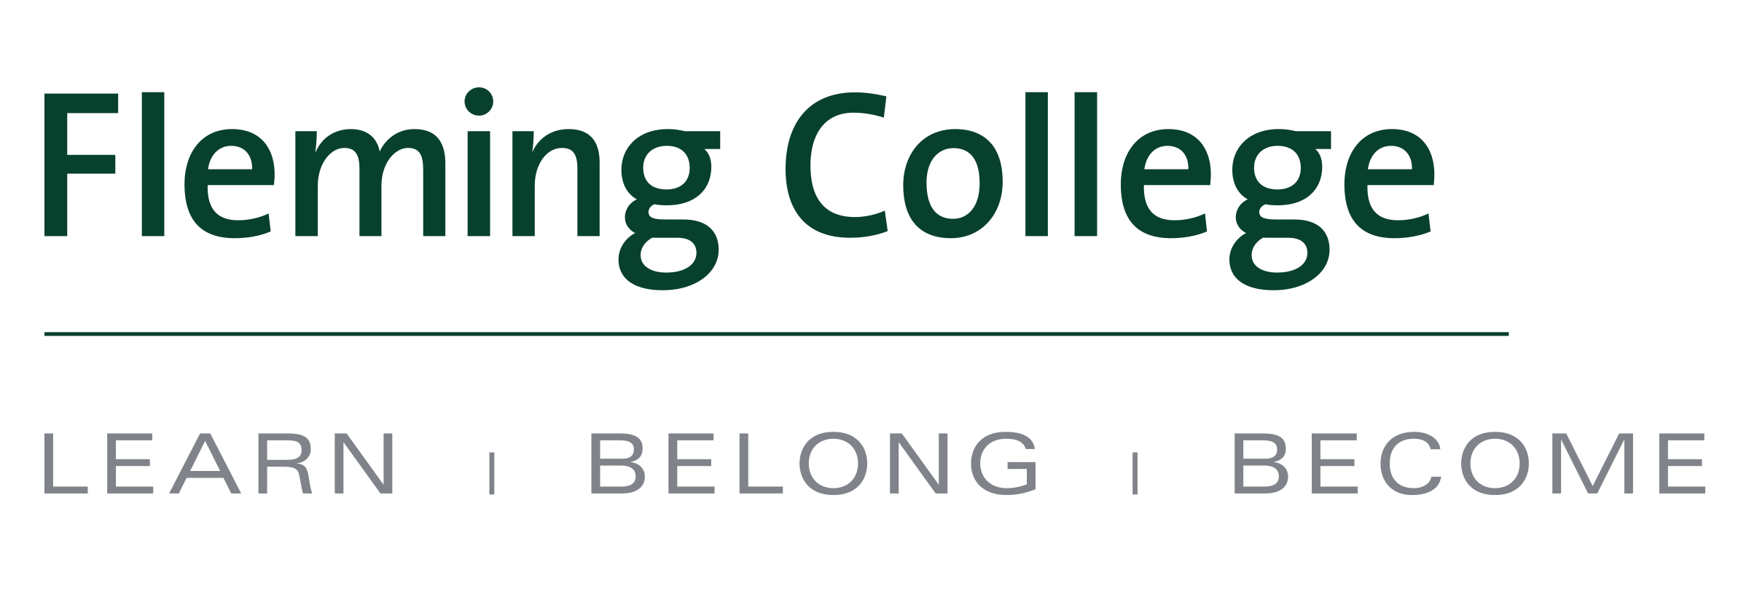
MEDIA RELEASE 
New ‘2+2’ international diploma-degree pathway between Fleming College and Limerick Institute of Technology
Agreement presents the first opportunity for Fleming Sporting Goods Business graduates to obtain a specialized degree in their field

Peterborough, ON (Nov. 16, 2016) – Sporting Goods Business graduates of Fleming College in Ontario can now complete a degree in their field at Limerick Institute of Technology (LIT) in Ireland with just two additional years of study.

A new ‘2+2’ pathway between the two institutions allows eligible Sporting Goods Business graduates seamless entry into the third year of LIT’s Honours Bachelor of Arts in Business Studies with Sport Management program. Students can finish their diploma and degree in just four years.

“We're excited to provide Sporting Goods Business students the opportunity to continue their studies after graduating from Fleming College,” said Charlie McGee, Coordinator of the Sporting Goods Business program at Fleming College. “This agreement will provide students the ability to work towards a university degree at LIT while gaining valuable international life experience. The combination of college and university education plus global experience can assist graduates with their career goal of working and progressing in the evolving international sporting goods industry.”
“The arrangement that Limerick Institute of Technology and Fleming College have brokered is a win-win deal for both institutions. More importantly, though, it is a win for the students in our programmes,” said Clíona Campbell, LIT Director of International Affairs. “To the students here on the Sutherland Campus, it offers an opportunity for degree completion in Business Studies with Sports Management, which is good. What is better again is that we can offer exposure to the European business environment by presenting that opportunity for degree completion in Ireland. In an increasingly global business environment, it is hugely beneficial for graduates to broaden their horizons in this way. Naturally, our teaching and learning environment at home in Ireland benefits from that influx of new perspectives that the Fleming College alumni will bring to LIT.”
Fleming’s Sporting Goods Business program is unique in Canada. The two-year diploma program is on the cutting edge of sporting goods industry trends, ensuring graduates are prepared for the demands of the field. Students have the opportunity to meet and network with program alumni and take sporting goods industry specific classes combined with core business curriculum. Applied projects further provide real-world experience for students.

LIT’s Business Studies with Sports Management Honours BA is designed for individuals with a passion for sport who want to work in an exciting, dynamic global industry. Students learn about working with athletes and training for performance and health as well as develop leadership skills and an understanding of governance and sports development, marketing, sponsorship, finance, law, event management, economics, public relations, and human resource management. The program includes a placement component and has a number of professional links with sporting organizations such as Limerick FC, Munster Rugby, the Irish Sports Council and Coaching Ireland.

The pathway agreement is part of a larger memorandum of understanding signed between Fleming and Limerick IT that paves the way for future student and faculty exchanges, further degree completion opportunities, short-term field study/experience trips, joint classes and projects, and international internships or work placements.

About Limerick IT
Limerick Institute of Technology (LIT) is an institute of higher education in Limerick, in the Mid-West region of Ireland and is one of 13 institutes that are members of the Institutes of Technology, Ireland (IOTI). LIT is the fourth largest IOT in Ireland, with more than 6,000 full-time and part-time students and 500 staff. The Institute has five campuses and a learning centre across Limerick city, Tipperary and Clare. The main campus is located at Moylish Park, with two city centre campuses in Clare Street and Georges Quay in Limerick city. LIT has a distinctive approach to Teaching and Learning known as the Active Learning philosophy. Whatever discipline area is offered the core methodology is active and practical; lab work, studio work, case studies, field visits, group assignments and more.

About Fleming College
Located in the heart of Central Ontario, Fleming College has campus locations in Peterborough, Lindsay, Cobourg and Haliburton. Named for famous Canadian inventor and engineer Sir Sandford Fleming, the college features more than 100 full-time programs in Arts and Heritage, Business, Environmental and Natural Resource Sciences, General Arts and Sciences, Health and Wellness, Justice and Community Development, Skilled Trades and Technology, and Continuing Education. Fleming College has more than 5,800 full-time and 10,000 part-time students, and 71,000 alumni.
-30-
Media, for more information please contact:
Laura Copeland
Communications Officer
laura.copeland@flemingcollege.ca
705.749.5530 x 1370

