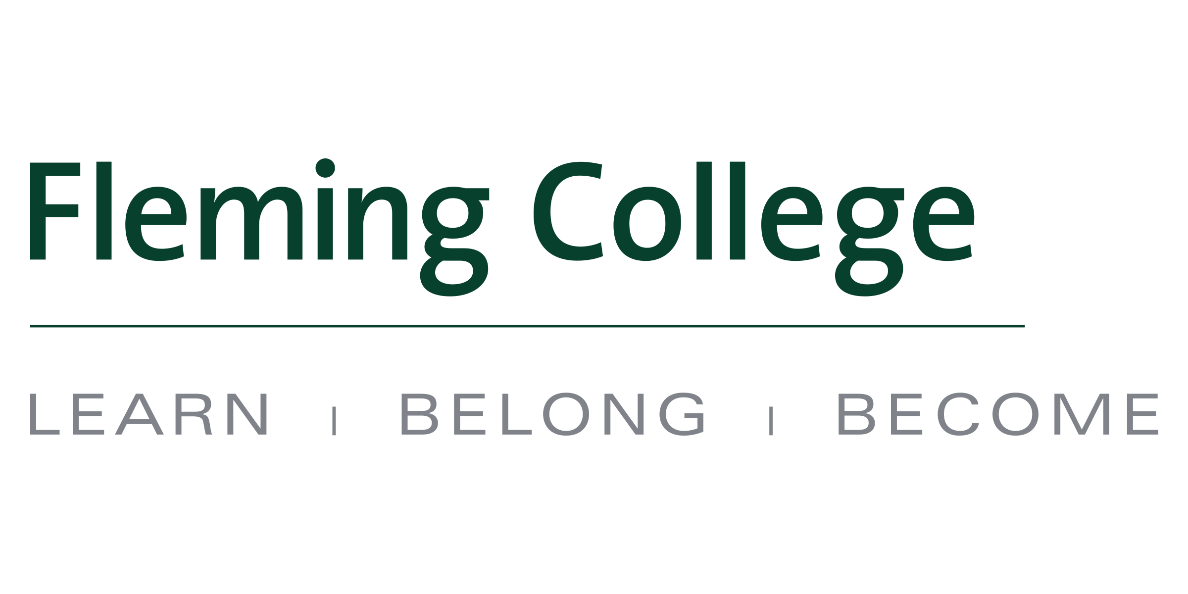
MEDIA RELEASE

New partnership between Fleming College and IT Sligo paves the way for degree completion, student exchanges
Multiple Fleming College programs eligible for international degree pathways within newly-signed MOU

Peterborough, ON (Nov. 24, 2016) – Fleming College in Ontario, Canada has signed a comprehensive and ground-breaking memorandum of understanding (MOU) with IT Sligo in Ireland that provides pathways to a degree for 10 Fleming diploma programs.

For the first time ever at Fleming, Carpentry Technician students have a defined pathway to a degree. Eligible graduates can complete IT Sligo’s Bachelor of Science (BSc) in Advanced Wood and Sustainable Building Technology degree program or the BSc in Construction Project Management.

And, in another first for Fleming, eligible graduates of the Instrumentation and Control Engineering Technician program can go on to complete a Bachelor of Engineering (BEng) in Mechatronics.

“IT Sligo and Fleming believe that the changing economic environment is based on knowledge that is international in scope. These pathways acknowledge these changes and offer greater choice to our students to enter that flexible work environment. This MOU is also recognition of the quality of the diplomas offered at Fleming,” said Maxine Mann, Dean of the School of Trades and Technology and the School of Business.

Other pathways within the agreement include:

- Environmental Technician/Technology, Ecosystem Management to BSc in Environmental Protection or BSc in Environmental Science
- Early Childhood Education to BA in Early Childhood Care and Education
- Social Service Worker to BA in Social Care Practice
- Recreation and Leisure Services to Bachelor of Business in Recreation & Leisure
- Computer Engineering Technician/Technology to BSc in Computing in Systems & Networking

Select IT Sligo degree programs offer online options for students, and most of the designated degree programs allow Fleming alumni to complete a degree with just one additional year of study or an honours degree with two further years of study.

The MOU also offers pathways to Fleming College for graduates of IT Sligo Higher Certificate programs, and lays the groundwork to develop opportunities for faculty and student exchanges, professional development, and distance education.

“I have talked personally with Fleming graduates who have gone on to complete degree programs in Ireland. They speak highly of the experience and confirm that their education at Fleming proved to be great preparation for the next stage in their education. I am certain that this agreement with IT Sligo will lead to similar success,” said Fleming College President Tony Tilly.

About IT Sligo
Since it first opened in September 1970, IT Sligo has been one of Ireland’s leading third level institutions. Students are at the heart of what we do. It is home to 6,000 students across the Institute’s full-time, part-time and apprenticeship programmes. Of those, 2,000 are studying online. IT Sligo is the place to help you get ahead in the world of work with an industry placement. Thanks to our close contacts and research collaborations with leading companies and major employers, we can offer you a wide variety of opportunities. Working towards re-designation as a technological university, a €60 million investment in campus facilities over the last decade has created a stunning 21st century learning environment. Across the Institute’s three Schools of Learning in Business & Social Sciences; Engineering & Design; and Science, IT Sligo is constantly developing and enhancing its courses and facilities to provide an overall package which matches the needs of the student today – and tomorrow.
About Fleming College
Located in the heart of Central Ontario, Fleming College has campus locations in Peterborough, Lindsay, Cobourg and Haliburton. Named for famous Canadian inventor and engineer Sir Sandford Fleming, the college features more than 100 full-time programs in Arts and Heritage, Business, Environmental and Natural Resource Sciences, General Arts and Sciences, Health and Wellness, Justice and Community Development, Skilled Trades and Technology, and Continuing Education. Fleming College has more than 5,800 full-time and 10,000 part-time students, and 71,000 alumni.
-30-
Links to the media release online:
https://www.itsligo.ie/2016/11/21/flemingcollege21112016/
Fleming’s here – not posted yet

Media, for more information please contact:
Laura Copeland
Communications Officer
laura.copeland@flemingcollege.ca
705.749.5530 x 1370

Peterborough  Sutherland Campus  599 Brealey Dr.  Peterborough ON K9J 7B1  Ph: (705) 749-5530 | Lindsay  Frost Campus  200 Albert St. S., Box 8000  Lindsay ON K9V 5E6  Ph: (705) 324-9144 | Haliburton  Haliburton Campus  P.O. Box 839  Haliburton ON K0M 1S0  Ph: (705) 457-1680 | Cobourg  Cobourg Campus  1005 Elgin St. W.  Cobourg ON K9A 5J4  Ph: (905) 372-6865
Web: flemingcollege.ca
Facebook: facebook.com/flemingcollege
Twitter & Instagram: @flemingcollege

