The following walks the user through how to create and use the ledger inquiry. This inquiry replaces the current AS400 Financial Inquiries 452 and 459.

Navigation: Main Menu > Financial Services > General Ledger > Review Financial Information > Ledger
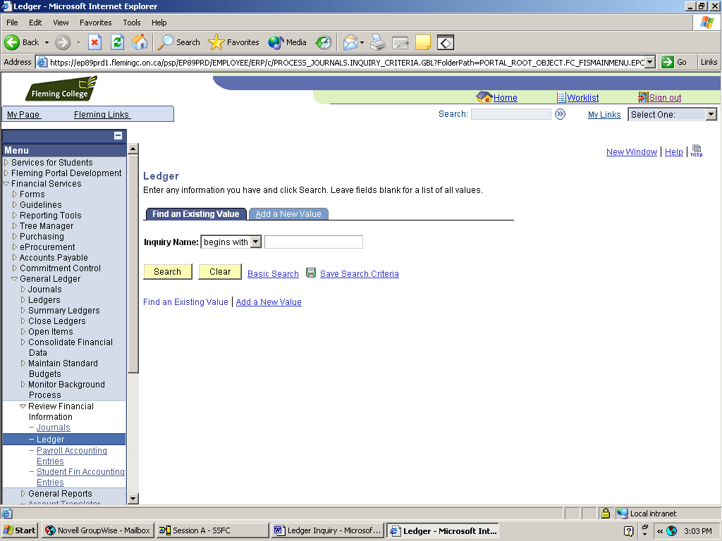

Click to Add Inquiry

Set Up the Ledger Inquiry

The first time you use Ledger Inquiry, you will need to set up the request. This is done using the following steps:

- Click on the tab “Add a New Value” or link Add a New Value.
- Name the Inquiry, remembering the maximum length is 8 characters. Eg ACCTBAL
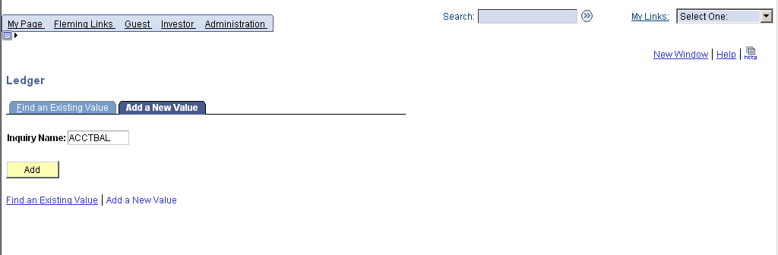

- Complete the Ledger Criteria fields as follows:

  - Unit = ‘FLEMG’ (use drop-down list)
  - Ledger = ‘ACTUAL’ (use drop-down list)
  - Fiscal Year = ‘2007’
  - From Period = ‘1’ Current Year, Full Year
  - To Period = ‘12’
  - Check box for “Show YTD Balance” (uncheck if not using Period 1)

- Hit the Save button at bottom of screen.
- To run Ledger Inquiry, hit the “Search” button”.

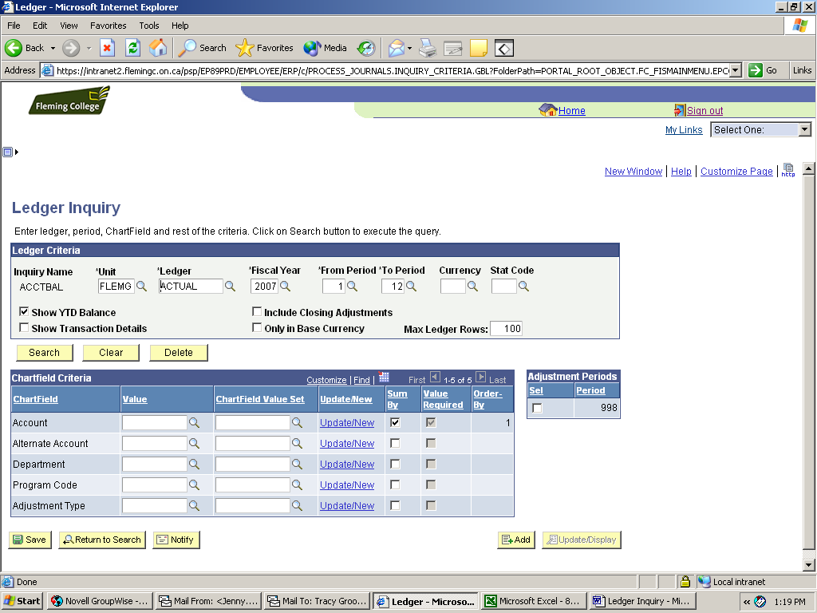

To run the inquiry

To save the inquiry

Change Criteria for Ledger Inquiry

Chartfield Criteria

To get the equivalent of entering a single account into the AS400 Financial Inquiry 452, you need to choose an Account and a Department in the Chartfield Criteria. You can use the drop-down to search for the account and department you are interested in. The example below is for office supplies for the Financial Services department.
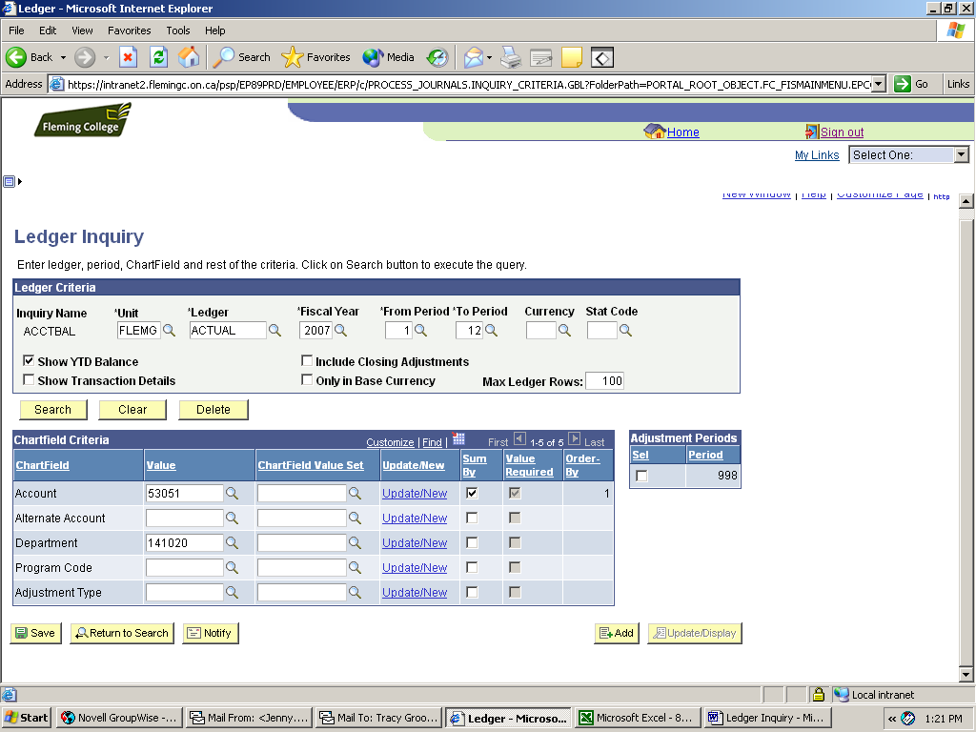

The results of the search are shown below. Note the following:
- Activity is shown by period
- If no currency is entered in the criteria, the default is the business unit currency = CAD. To see US dollar transactions, choose currency = “USD”
- Change Max Ledger Rows if there are more than 100 entries in an account
- To see the transactions for one period, click on the Activity link. The next screen will list the journal entries posted to the account.
- To go back and change criteria for the search, click on the Inquiry Criteria link
- To see all departments for an account, click on the Detail link
Ledger Summary Results

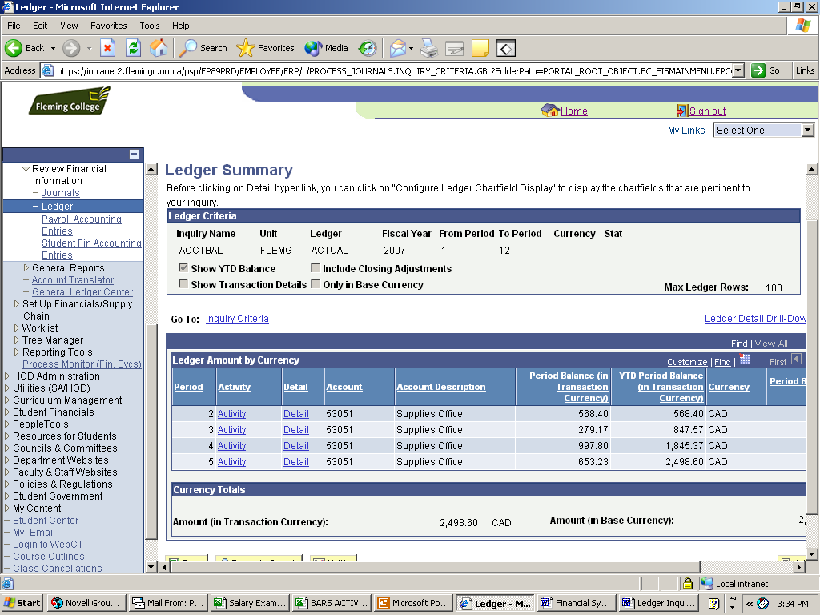

Return to search criteria

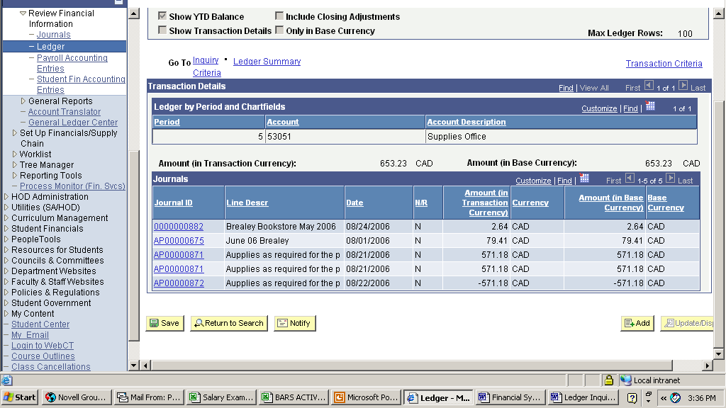

See activity for period

To see the journal entry details, click on the Journal ID Link for the entry you are interested in. This takes you to the Journal Inquiry screen.
Journal Inquiry Details

Use the Ledger Summary or Transaction Details links to return to prior ledger inquiry screens.
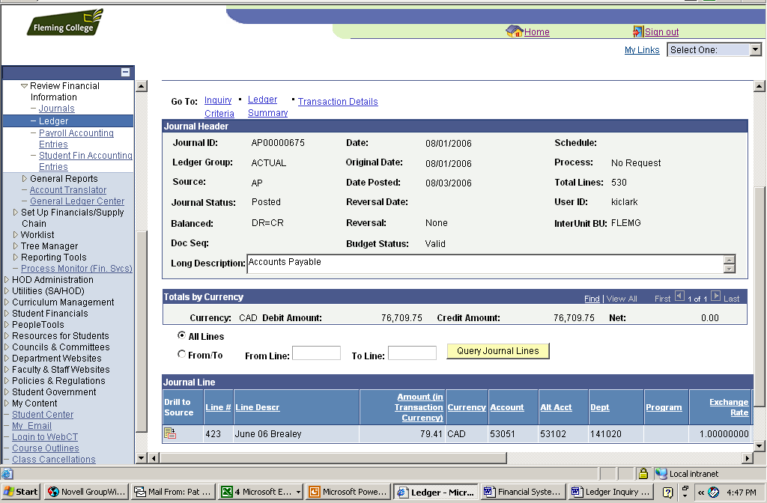

Return to ledger inquiry screens

See full entry

To see other lines in the journal entry, use the Query Journal Lines button. The default is “All Lines”. Large entries will only display 100 lines so enter lines around the line # in the From/To Line boxes.

The following is a list of journal sources:

Source | Description
ADJ | Accounting Adjustments
ALO | Allocation
AP | Accounts Payable
CLO | Closing Journal Entry
CNV | Conversion Journal
ONL | On-Line Journal Entry
PAY | Payroll Processing
PO | Purchasing
SA | Student Admin
Department Ledger Inquiries

In order to look at all accounts in your department, choose only department in the chartfield criteria. To pull only the accounts for revenue and expense or capital accounts, use the following chartfield value sets instead of a specific account:

REVENUEEXPENSE – Revenue and expense accounts
CAPITAL – Capital expenditures

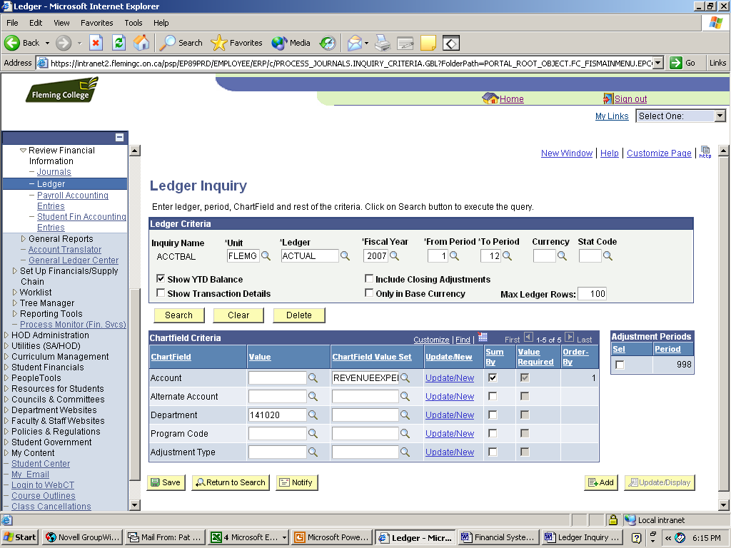

Budget Ledger

The budget is kept in a separate ledger called “BUDGET” and all budgets have been uploaded into Period 1. To change the inquiry to pull budget numbers, change the Ledger to BUDGET. This will bring up a new set of chartfield criteria and take out any of your previous settings.
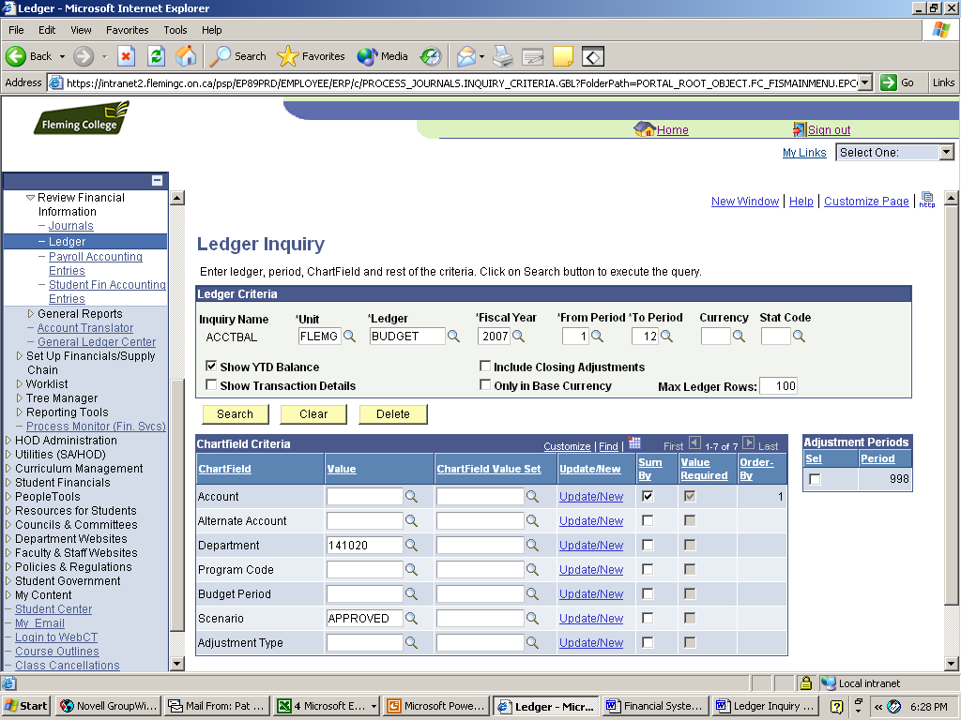

There are currently three scenarios for BUDGET: APPROVED, PRELIM and UPDATE. For most inquiries you want to use the APPROVED scenario. Putting no scenario will result in doubled or tripled figures.

Include only the Department and the budget for each account will be displayed. If you want to see only your revenue and expense or capital budget, you can use the chartfield value sets.

