Gift Certificate Process

The Finance department provides campuses/departments designated gift certificate custodian with preprinted/prenumbered Gift Certificates upon request, a confirmation receipt is signed by the custodian and returned to the Finance department. There is a shared excel “Gift Certificate Log” file which each gift certificate custodian is responsible for updating as gift certificates are issued (this file is located in the S:Gift Certificates folder). This shared file is reconciled against the applicable General Ledger account on a monthly basis by the Finance department, as such it is very important that the file is updated on a timely basis (should be updated same day as the gift certificate is issued).

- Gift Certificates are NO LONGER to be issued for promotional/advertising purposes by the College, due to the Enrolment reporting which the College must provide to the Ministry

- Gift Certificates are NEVER to be issued relating to a course in place of a refund occurring, it is extremely important that the College’s refund process be followed in these situations

Recording the Purchase of a Gift Certificate

When a gift certificate is purchased the process in Evolve to be followed is as follows:
- Item type “600000040003 - Gift Certificate Purchase” is added as a charge to the Gift Cert-FC corporate account (10096250),the gift certificate number is to be entered in the Ref Nbr field
- Payment for the gift certificate is processed to the Gift Cert-FC corporate account (10096250)

The Excel “Gift Certificate Log” file will be updated the same day which the gift certificate is purchased/issued. The log file requires the following information to be entered for the applicable gift certificate number: 1) Date Issued 2) Amount 3) Campus 4) Department 5) Purchaser name 6) Issued to (if applicable) and 6) Issued by (employee name)

Navigation: Student Financials > Charges & Payments: Post Corporation Transaction

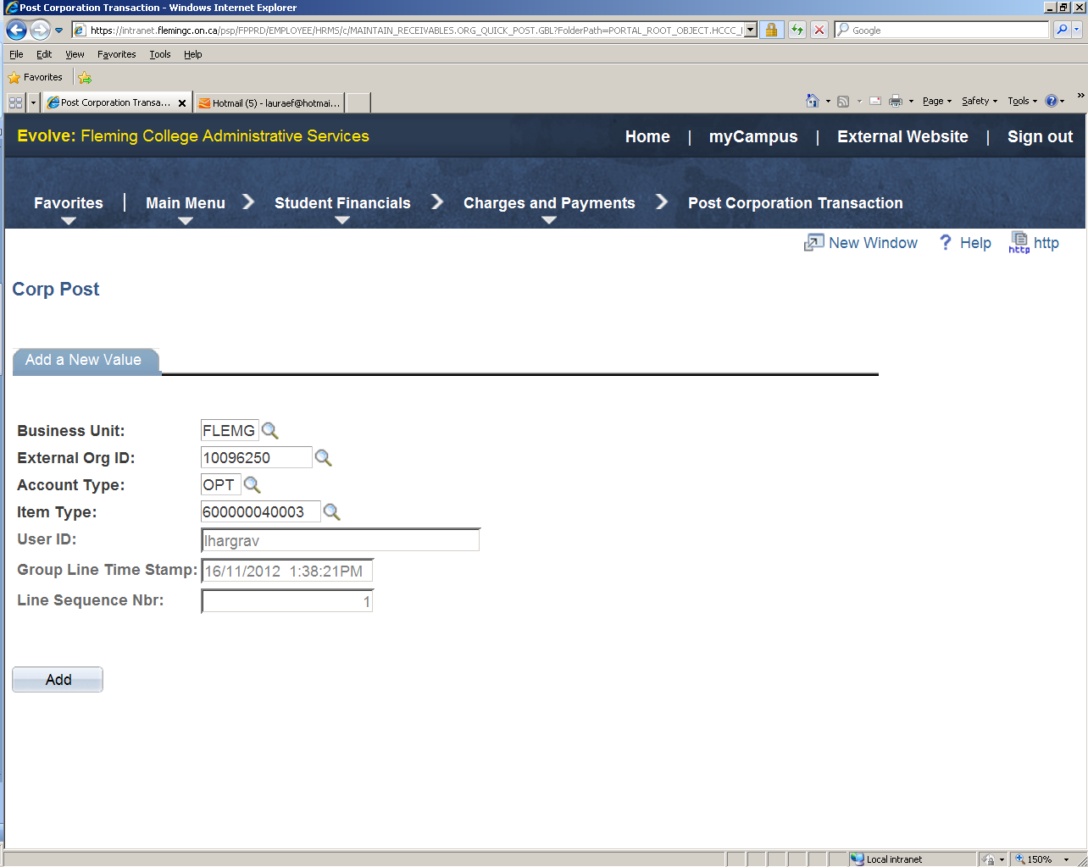

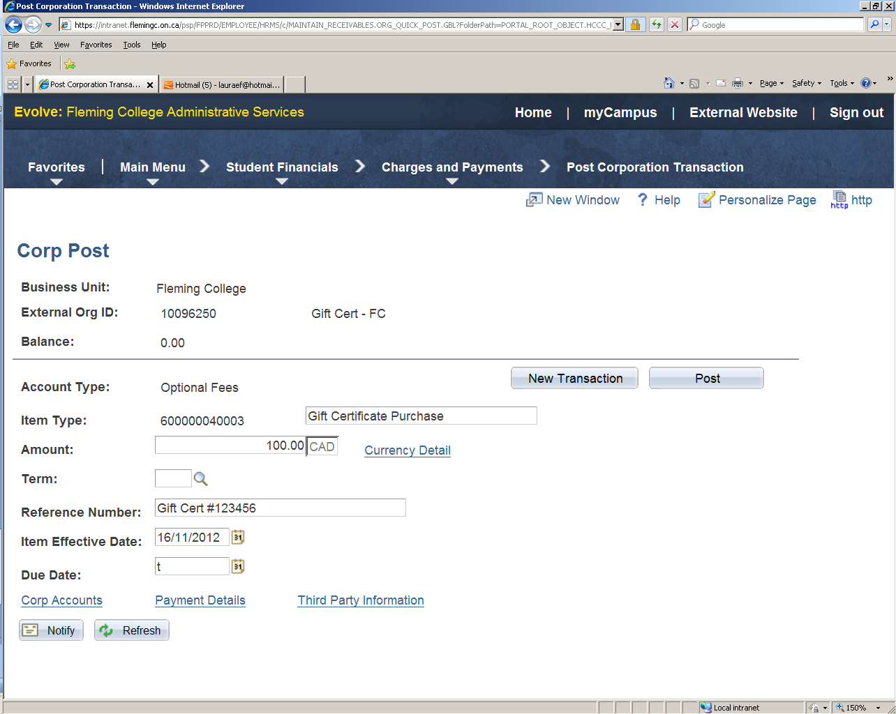

Gift Certificate Redemption

When a gift certificate is redeemed the process in Evolve to be followed is as follows:
- the applicable course/etc charge would go on student's account
- when the gift certificate is provided to the cashier, item type “800010000098 - Gift Certificate Redeemed” is entered on the student’s account for the full amount of the gift certificate (regardless if the gift certificate amount is more than the course/etc amount, if results in credit balance this remains on student account), the gift certificate number is to be entered in the Ref Nbr field
- if the gift certificate amount is less than the charges for the applicable course/etc, a payment from the student is required

The excel “log” file will be updated by the Intermediate Accountant in the Finance department to indicate when the gift certificate was redeemed when completing the monthly 36102 GL account reconciliation.

Navigation: Student Financials > Charges & Payments: Post Student Transaction

