Creating a Visa Expense Report using Access Online

The US Bank offers a reporting system called “Access Online”. With Access Online, there are various ways to accomplish the same task. These instructions present you with one of the more straightforward ways to complete your reporting.

To log in: Navigate to the URL: https://access.usbank.com
As you will be using this website often, it is suggested you bookmark this link

Enter the:

Organization Short Name: SSFC

User ID: Personalized by you

Password: Personalized by you

Click on the Login link.

The home page looks like this:

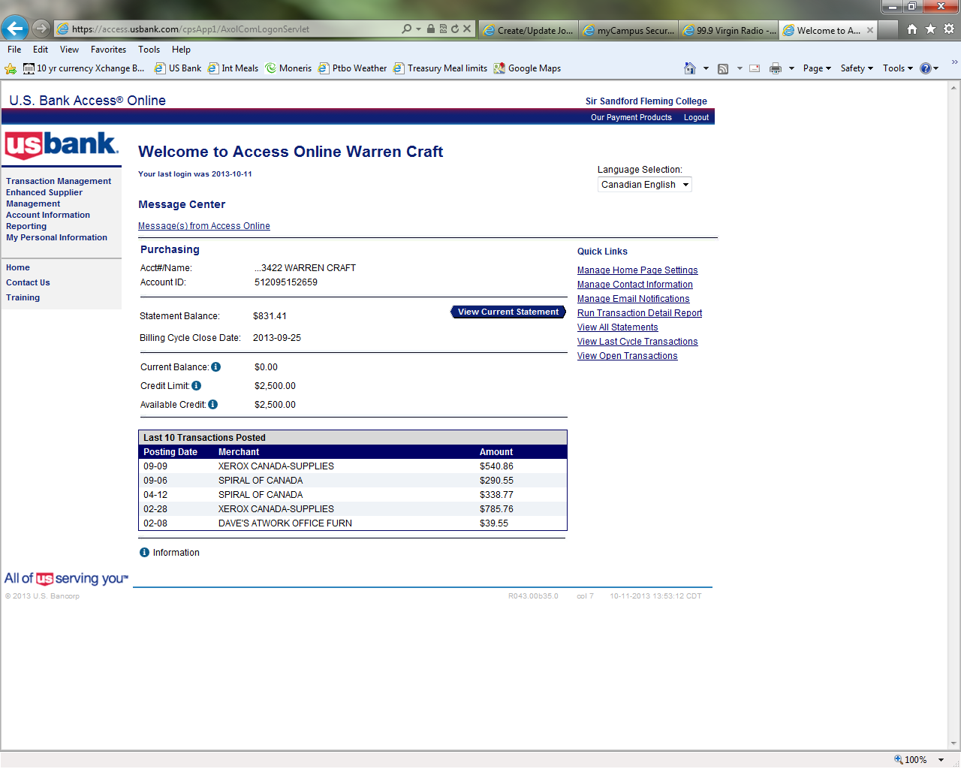

To allocate your expenses for a particular cycle, click on “Transaction Management”
Transaction Management

To begin your reporting, navigate to: Transaction Management / Transaction List.

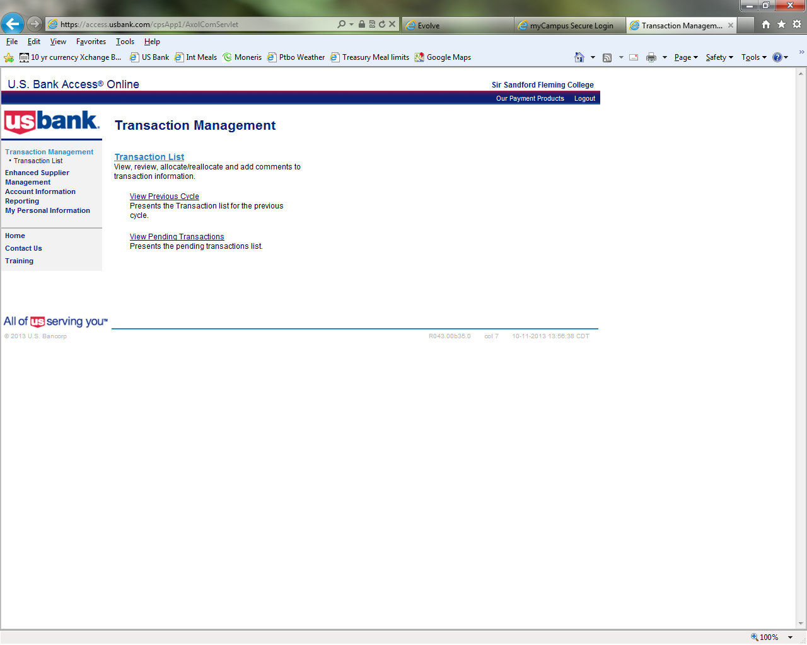

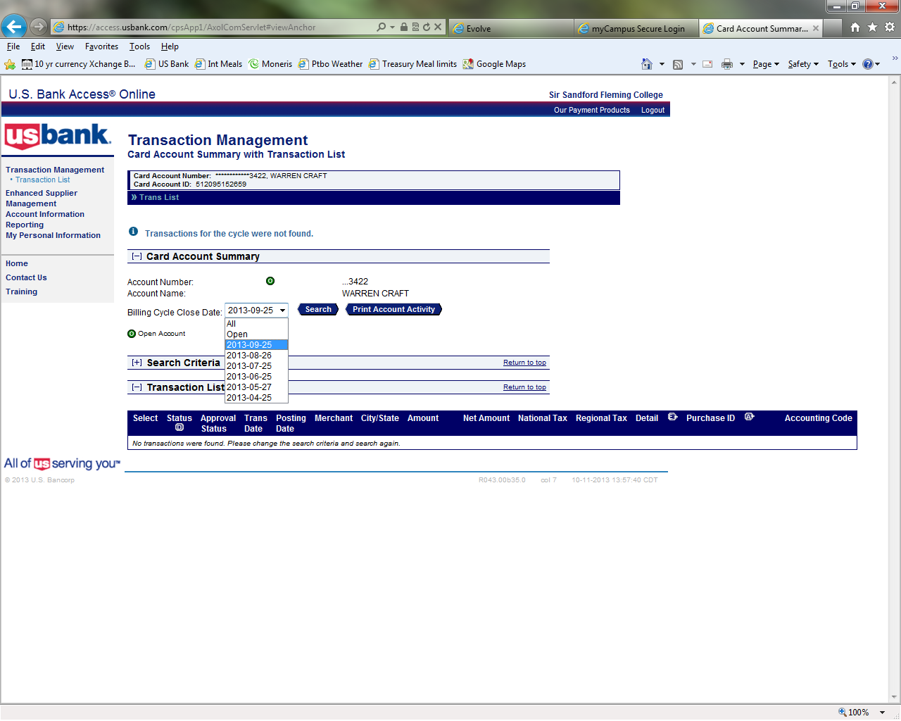
Click the down arrow to select the cycle date desired, and then hit SEARCH.

For this example I’ve selected the 2013-09-25 cycle date.

DO NOT USE:

“All” which will show you all your transactions from the last 6 months.

“Open” which will display all items purchased since the last cycle date.

Select the reporting cycle date you want to work on. The US Bank will allow you access to the last 6 months of transactions. Be sure you are in the correct month.

Want to Report Early?
If you are going on holidays and wish to report on all items that are current, select “Open” cycle date. This will show you all items purchased since the last cycle date. Now follow the instructions as you would for a regular month.

To Allocate Expenses:

“Select All” transactions, then hit “Reallocate”. This will show all expenses at once for easy reporting.

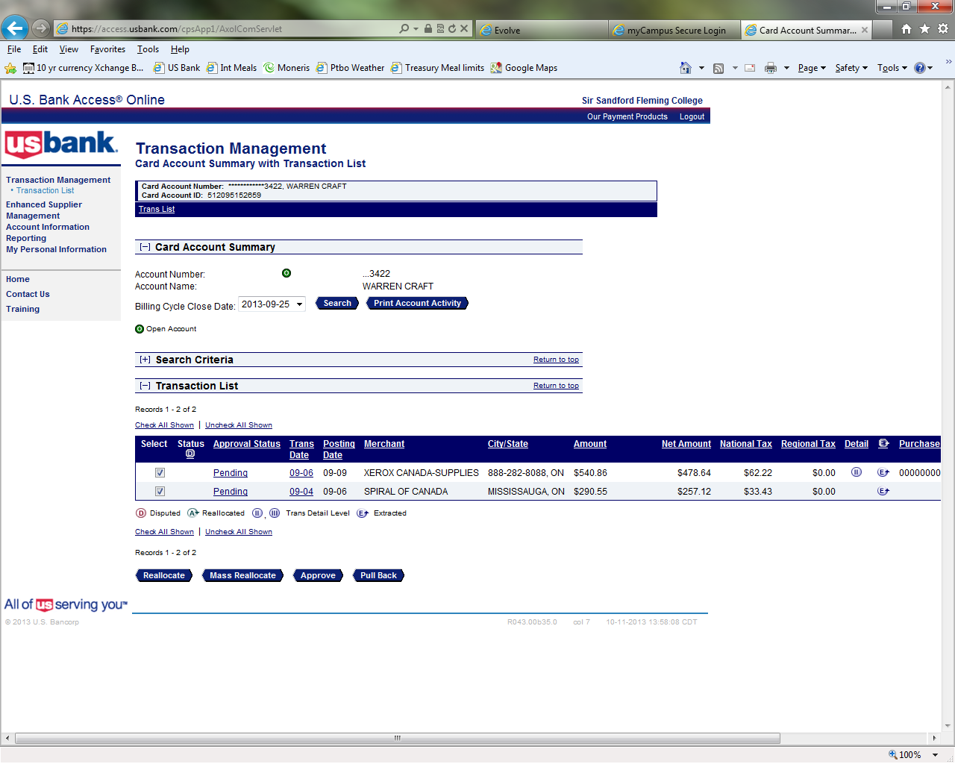
Select all expenses and hit “Reallocate”.

Note: If one of these transactions is a Payment from the Royal Bank, please “unselect” this transaction or you will get an error.

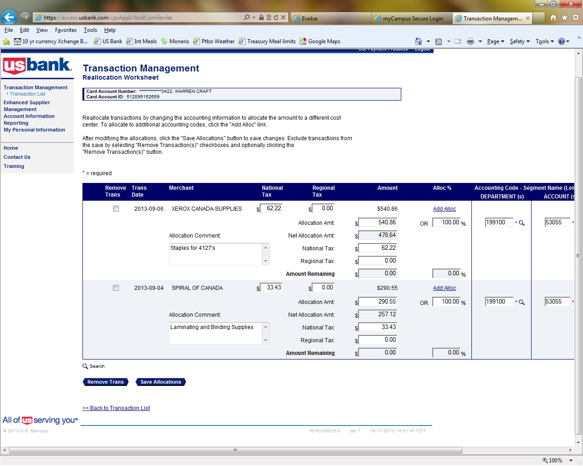
Comments:

Meals, accommodations and travel expenses must be documented with the purpose and include who attended.

Goods and services must have a brief description
Allocate taxes
National = HST &
Use Regional for GST only purchases
Allocate Department & Account

All your transactions will show up on one screen unless you exceed 25 transactions. Now simply update all comments, National tax (HST), Department and Account code for each transaction. When complete, be sure to hit “Save Allocation”.

After saving click on the “<<< Back to Transaction List” link.

Tip: Save Often:
It’s a good idea to save often, as the US Bank will “Time out” if you don’t stay active on their site. This will result in your work since the last save, being lost.
Splitting an Expense between Cost Centres:

For transactions that require charging more than one account and/or department you will need to go into the individual transaction’s “Tax and Allocations” tab.

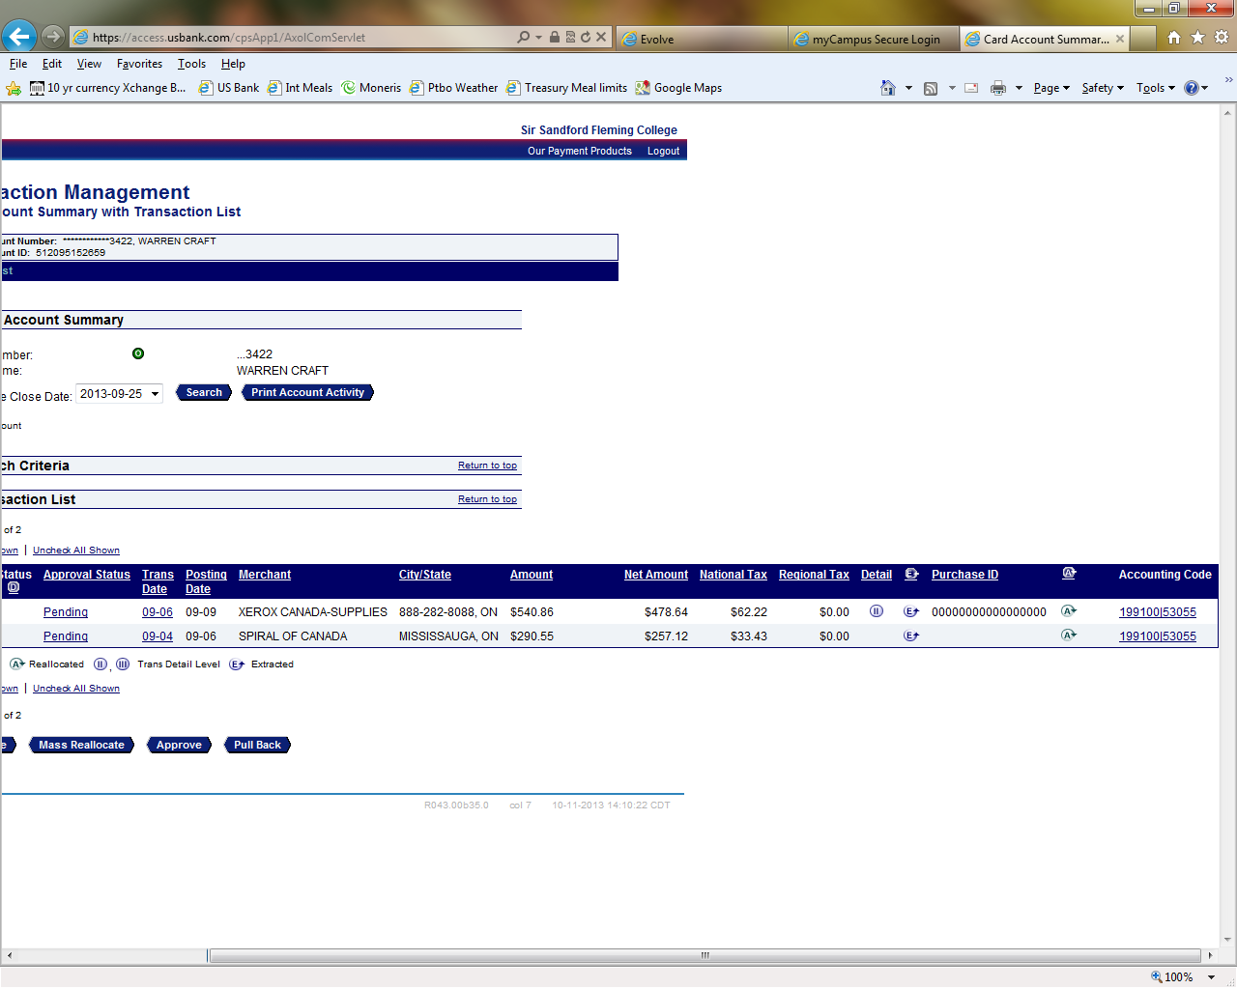
To begin the expensing of items requiring split cost centres, click on the blue link “Accounting Code” of the item you wish to expense.

You may have to scroll right to see these Accounting Codes.

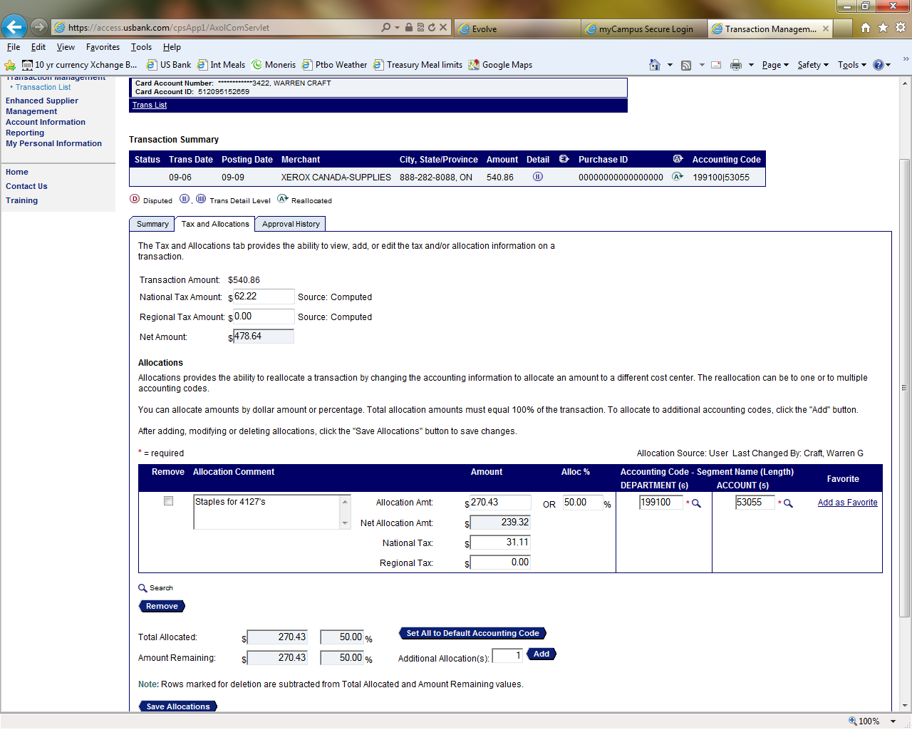
Splitting an Expense:
If you want to split an expense 50/50 over two Departments, you can change the original allocation % to 50, and then add one additional lines here…. click “Add”.
In order to split a transaction, you must:

Verify the transaction’s Tax, Department and Account allocations and enter the comment for this transaction. Be sure to hit “Save” after all your changes have been entered.

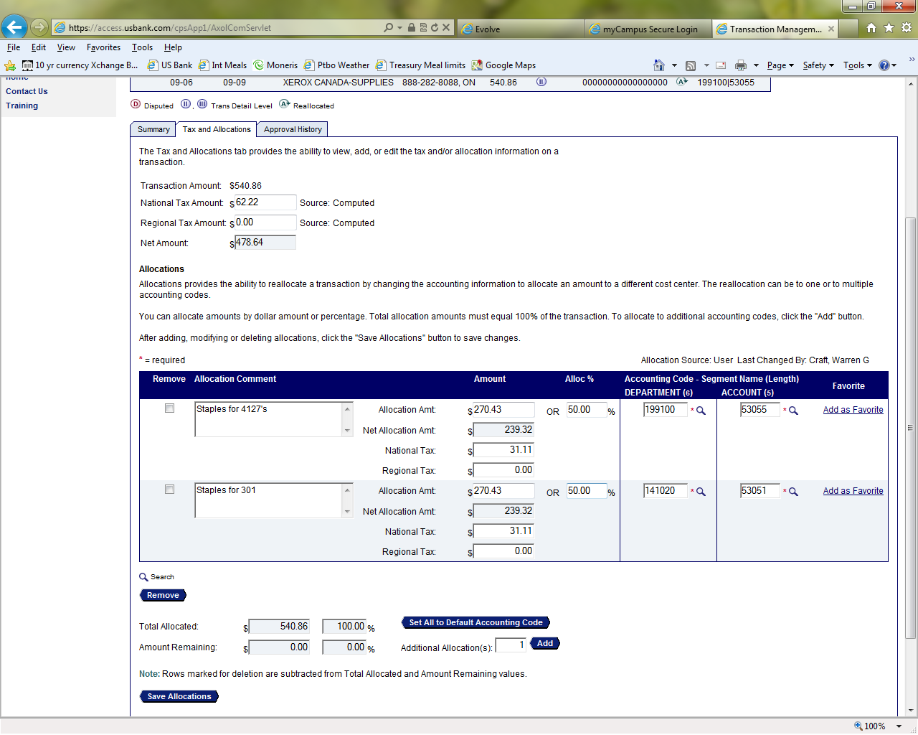

Printing your Report

Once you have updated all your expenses and SAVED your work, return back to the Transaction Management List Screen and hit “Print Account Activity”. A PDF document will “pop up”.

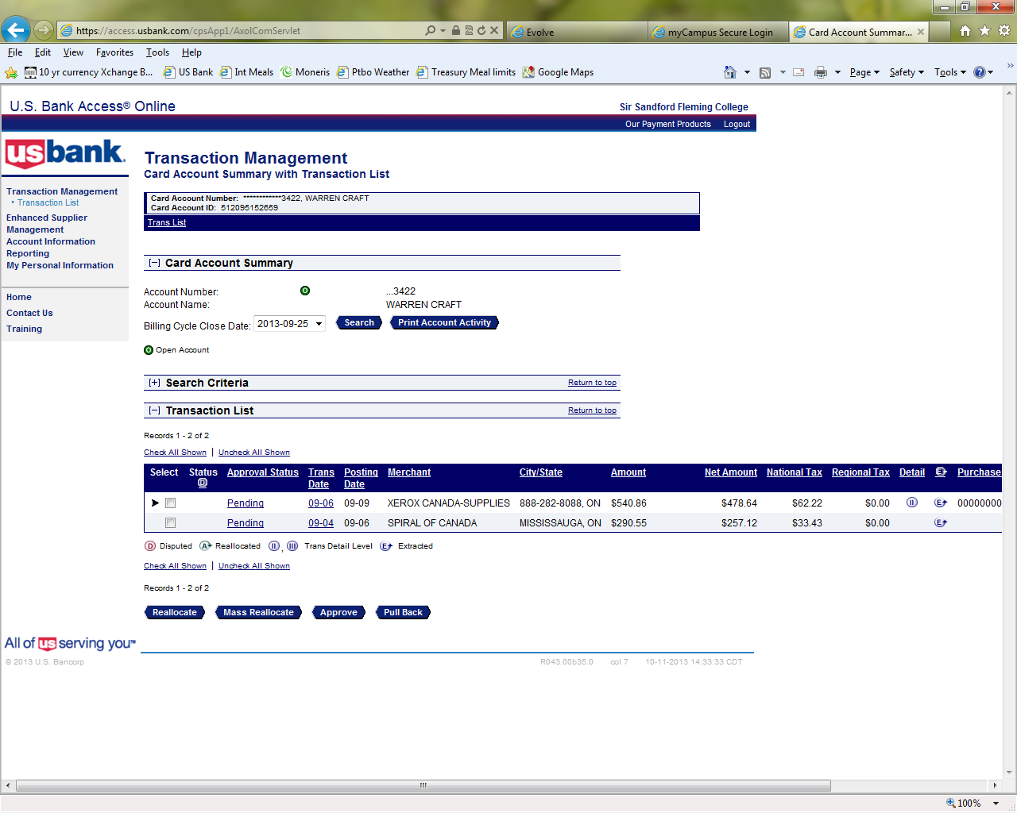
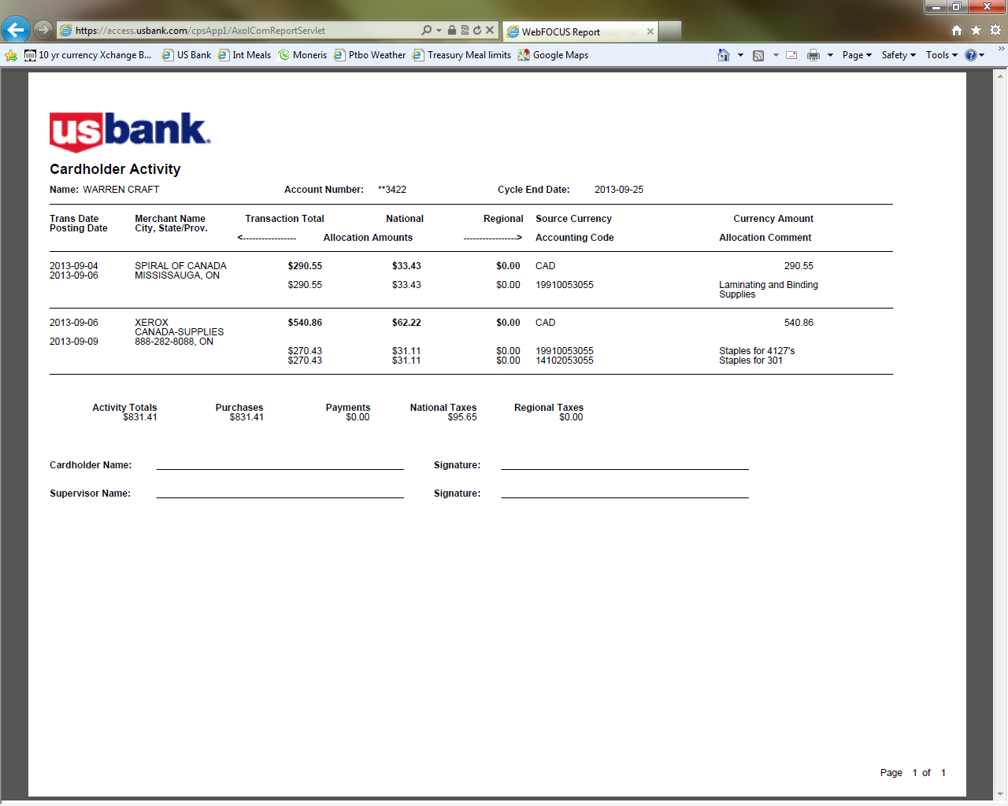
Print this report.
Please ensure that your web browser prints this document in landscape orientation

Putting it All Together:

Staple together the “Cardholder Activity Report” & all original Itemized Receipts

Cardholders please sign your report and forward to your supervisor for their review and signature.

Upon completion, please forward to Accounting by the 10th. For example….September 25th visa report is due to Accounting by October 10th.

This completes the reporting process

Pop-up Blocker Error:
If you receive this error when generating your report, right click on the error and select the:
“Always Allow Pop-ups from this Site”

Adding the Report Server as a Trusted site:
The US Bank restructured their report server on August 30, 2011. If you are not able to print your report due to “not a trusted site” follow these instructions:

Please add the URL, https://report.access-online.com/, to your Trusted Sites and Managed Websites. Clicking on this link will result in an error message; it is not a site to access directly, only one used by Access Online.
Internet Explorer instructions:
- Step 1 – Open Internet Explorer
- Step 2 - Choose Tools - Internet Options and click the Security tab
- Step 3 - Click the Trusted Sites icon and then click the Sites button
- Step 4 - Enter https://report.access-online.com/ in the Add this website to the zone text box and check the Require Server Verification (https:) check box
- Step 5 - Click Add and then Close
- Step 6 - Click the Privacy tab
- Step 7 – On the Privacy tab click the Sites button
- Step 8 - Enter https://report.access-online.com/ in the Address of website text box
- Step 9 - Click Allow and verify the new URL is in the Managed Websites box
- Step 10 - Click OK, then click OK again

Are you reporting on more than one card?

To add another card to your log-in, navigate to:

“ My Personal Information / Account Access / Add Accounts ”
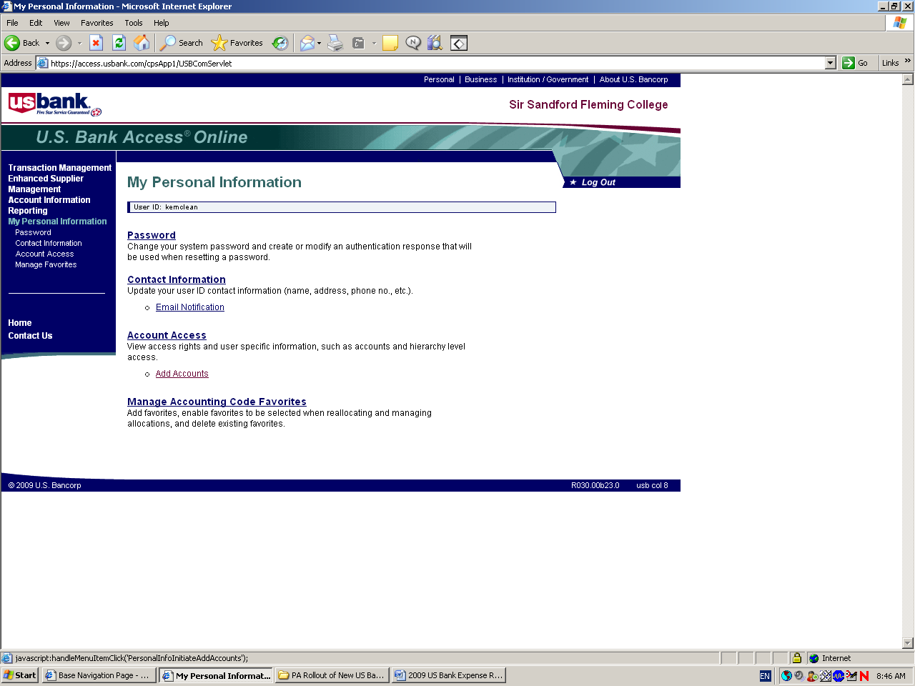

To add an additional card to your User ID navigate to:

My Personal Information \ Account Access

Select “Add Accounts”

To set-up Email Alerts from the US Bank for New Statements:

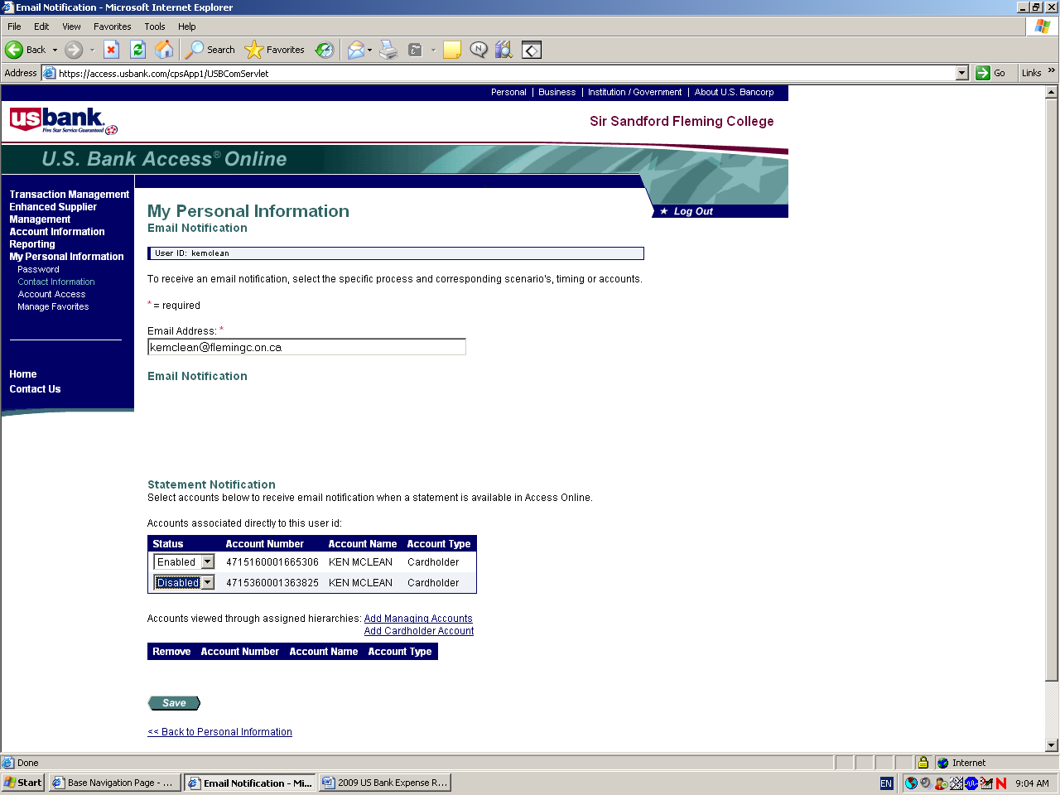
To have the US Bank email you when there is a new statement needing reporting navigate to:

My Personal Information \ Contact Information

Scroll down to “Statement Notification”

Change the Status from “Disabled” to “Enabled”

