MEMORANDUM

To: All Employees
From: OEHR – Payroll
Date: February 24, 2021
Subject: Extension and Amendment - Information regarding the T2200S - Declaration of Conditions of Employment for Working at Home Due to COVID-19

To: All Staff

A number of people have asked for clarification about what information and documents employees are required to provide when requesting a Form T2200S (see original memo here).

You need a T2200S only if you will be submitting a detailed claim. The detailed calculation requires that you complete a T777 form (Statement of Employment Expenses for Working at Home Due to COVID-19 -Canada.ca) and submit that with your tax return – you do not, however, need to submit your T777 to HR. To request a T2200S, once you have determined that you will be making a detailed claim, you can submit either one of these options:

- A screenshot of only lines 1-5 of your completed Form T777
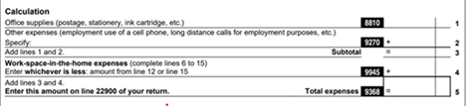
Or
- A screenshot of the completed CRA calculator, which confirms you will be using the detailed calculation.
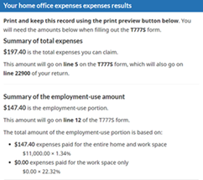
Or
- Email the below attestation to CRArequest@flemingcollege.ca:
  - I certify that I have worked from home in 2020 due to COVID-19 and was required to pay some or all of my own home office expenses used directly in my work while carrying out my duties of employment. I have reviewed the criteria for the Working at Home Due to COVID-19 tax deduction and reasonably believe that I am eligible for the deduction. I have carefully considered my eligible expenses for the Working at Home Due to COVID-19 tax deduction and reasonably believe that I will be submitting my claim using the detailed method for the 2020 tax year. I kindly request that you provide me with a completed T2200S.

Please note that we have extended the deadline for T2200S requests to March 5, 2021.

Please consult a financial or tax advisor, or the CRA website for questions about your specific situation.

