PROGRESSIVE DISCIPLINE PROCEDURES
PURPOSE:
To provide consistent guidelines for all supervisors to determine when disciplinary action is warranted and what appropriate disciplinary action should be taken. This procedure applies to all full-time and regular part-time (whose contracts have no end date) employees of Fleming.
DEFINITIONS:
Discipline:
The method by which management maintains the standard of conduct and performance necessary to ensure orderly and efficient discharge of the business of the College.
Progressive Discipline:
A series of progressively more severe sanctions imposed against an employee to correct inappropriate behaviour and/or poor performance.
RATIONALE:
This procedure seeks to provide guidelines for the fair, consistent and predictable management of employee misconduct and/or unsatisfactory employee job performance that has been identified as justifying disciplinary action or termination of employment. Disciplinary action may also result from behaviour contrary to Information Technology Equipment/Resources/Services/Facilities Appropriate Use Policy. Supervisors must employ existing performance management procedures, including counselling and offering positive, developmental assistance to employees with performance problems, in order to minimize the frequency of situations where formal disciplinary action is appropriate.
This procedure includes a progressive series of actions based on confidential, candid communication with an employee. Each step in the procedure serves to increase the employee’s awareness of the need for improvement. Initial disciplinary action may range from a written warning up to and including immediate termination, depending upon the severity of the incident and/or the performance problem (i.e. severe incidents minimize or may even eliminate the number of disciplinary steps taken prior to termination.)
Collective Agreement and Terms and Conditions of Employment provisions apply throughout this procedure. The procedure includes all college employees, except the President who is accountable to the Board of Governors. If the action warrants, the Fleming’s Harassment and Discrimination Prevention Policy will prevail.
PROCEDURES:
Preliminary:
There are some performance management steps that must be completed before the progressive disciplinary procedure is initiated. Supervisors should be consulting with their HR Consultant during this performance management process.
1. Supervisors should have clearly identified the problem. This fact finding step should ensure the supervisor has met with the employee in a problem-solving meeting, where the appropriate rule or job requirement is communicated, the facts as known to the supervisor are discussed and the employee has had an opportunity to present his/her version of the situation. The supervisor should document and maintain this information. Refer to Appendix A.
2. Supervisors should review the human resource file of the employee, to understand the employee’s performance in the past and to determine whether the present situation represents a set pattern or a change.
4. The decision to commence the progressive discipline procedure would depend on the severity of the action and the length of time that the problem has been a concern during performance management with no substantial improvement. This decision would be made in consultation with the HR Consultant.
Written Warning(s):
In situations where there has been no substantial improvement in performance at the end of a previously established time limit between the supervisor and the employee, or where an act of misconduct causes the employee’s entire disciplinary record to be reviewed, or where a single incident of misconduct warrants a more serious disciplinary response, the supervisor will meet with the employee. The supervisor will inform the employee that they have the right to union representation (where appropriate). If an employee chooses to have a union representative present, the HR Consultant should also be present. Ideally the HR Consultant should be present at all disciplinary meetings. There will be no external representation.
The unsatisfactory performance or incident(s) will be verbally identified by the supervisor, and the employee will be afforded an opportunity to explain his/her actions.
If in the opinion of the supervisor the employee’s actions or performance cannot be justified, then the employee will receive a written disciplinary memo following the review meeting, outlining the unacceptable performance or incidents. This disciplinary memo will be prepared by the supervisor in consultation with the HR Consultant, and will include the fact that this step is the beginning of a formal procedure which may lead to further disciplinary action, up to and including dismissal if such unsatisfactory performance continues.
The original copy of the disciplinary memo will be given to the employee and a copy will be placed in his/her human resource file in the Human Resources office. In the case of unsatisfactory performance, a time schedule will be established during which the desired improvement and measurement of accomplishment will be outlined. Supervisor’s notes documenting the meeting, including the date, time, facts (including the employee’s response, if any) and outcomes, will be placed in the employee’s human resource file.
In some cases where progress is being made, this step may be repeated over a period of time. Where no progress is being made, the next stage of the procedure should be accessed. However, there is a limit to how often this approach may be applied before the College will have been deemed to have condoned the conduct in question.
Suspension(s):
Suspension may not be appropriate in all situations, depending on the severity of the incident and the risk involved, and may be by-passed. In situations where, in the opinion of the supervisor, there has been no substantial improvement at the end of a previously agreed upon time limit, or where a second act of misconduct causes the employee’s entire disciplinary record to be reviewed, or where a single incident of misconduct warrants a more serious disciplinary response, the supervisor will request a new review meeting with the employee, a union representative if desired (where appropriate) and the HR Consultant. There will be no external representation.
The Supervisor will verbally outline his/her concerns and the employee should be afforded an opportunity to explain his/her actions. If in the opinion of the supervisor the employee’s actions or performance cannot be justified, then suspension from work without pay from one to five days is warranted.
The employee will subsequently receive a written memo following the review meeting outlining the reasons for and the length of the suspension. The original copy of the disciplinary memo will be given to the employee and a copy will be placed in his/her human resource file in the Human Resources office. Supervisor’s notes documenting the meeting, as outlined above, will also be placed in the employee’s human resource file in HR.
More than one suspension may be imposed, following the procedures outlined above, before any decision is taken on termination of employment, depending on the severity of the situation. These subsequent suspensions without pay may exceed five days. Typically, progressive levels of suspension are appropriate, i.e. 1 day for the first incident, 2 or 3 days for the next, then 5 days, and so on.
Termination:
In situations where, in the opinion of the supervisor, there has been no substantial improvement at the end of a previously established time limit and progressive suspensions have been ineffective, or where an act of misconduct causes the entire employee’s disciplinary record to be reviewed, or where a single incident of misconduct warrants a more serious disciplinary response, termination of employment will result.
Immediate termination from employment is warranted for serious misconduct. Such behaviour is not limited to, but may include, serious policy violations, theft, violence, and wilful damage to property. Dismissal may also be warranted if previous progressive discipline steps have been taken without effect or improvement.
The supervisor and the HR Consultant will review the circumstances surrounding his/her recommendation to dismiss an employee with the Vice President, HR, the Executive Leader of the employee’s department, and the President (or designate). The supervisor and the HR Consultant will prepare a termination letter and a termination procedure.
The supervisor will request a new review meeting with the employee, a union representative if desired (where appropriate) and the HR Consultant, to give the employee an opportunity to respond, and if appropriate, to present the letter. There will be no external representation. The original copy of the letter will be given to the dismissed employee and a copy will be placed in his/her human resource file in the Human Resources. The HR Consultant’s notes documenting the meeting will be placed in the dismissed employee’s human resource file in HR.
Appeals:
A non-probationary employee may appeal a disciplinary action decision that has been made against him/her. Unionized employees may appeal the decision to impose discipline through grievance procedures as outlined in the appropriate collective agreement (probationary limitations apply).
The appeal procedure for full-time, post-probationary administrative staff members who have been dismissed will be consistent with the Terms and Conditions of Employment for Administrative Staff.
Other non-unionized employees may appeal a disciplinary action decision by lodging a complaint, in writing, to the President (or designate) within fourteen (14) calendar days after the action has been taken. A meeting will then be held between the President (or designate) and the employee. Both parties may have other individuals internal to the College assist them during this meeting, as long as advance notice is given. No legal representation will be allowed. The President’s (or designate’s) decision will then be issued, in writing, to the employee within ten (10) calendar days of the meeting. The decision of the President (or designate) will be final.

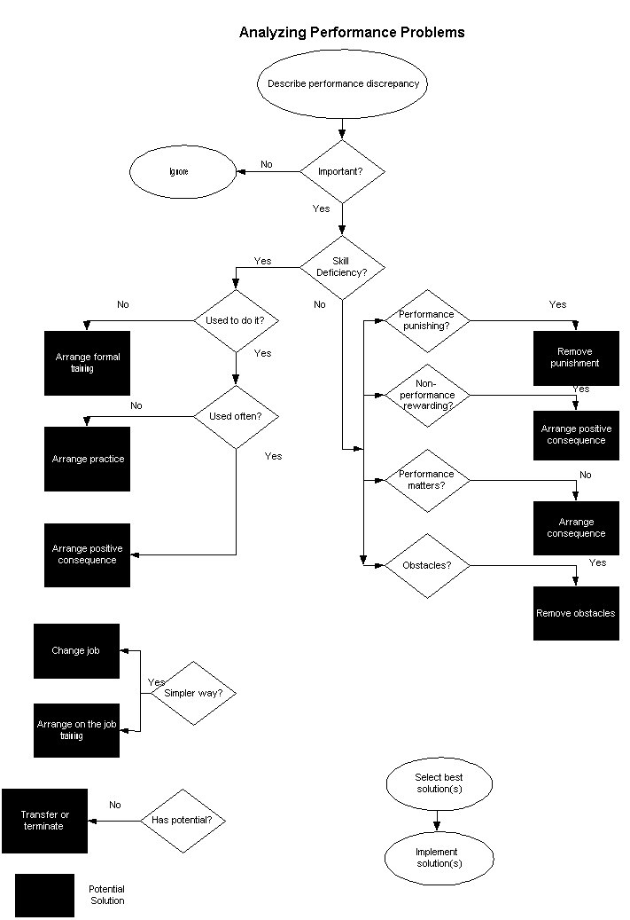
ANALYZING PERFORMANCE PROBLEMS
Employee isn’t doing what is expected:
1. What is the performance discrepancy? | • Why do I think there is a training problem?  • What is the difference between what is being done and what is suppose to be done?  • What is the event that causes me to say that things aren’t right?  • Why am I dissatisfied?
2. Is it important? | • Why is the discrepancy important?  • What would happen if I left the discrepancy alone?  • Could doing something to resolve the discrepancy have any worthwhile results?
3. Is it a skill deficiency? | • Could the employee do it if s/he really had to?  • Could the employee do it if their life depended on it?  • Are the employee’s present skills adequate for the desired performance?
Yes. It is a skill deficiency.
4. Could the employee do it in the past? | • Did the employee once know how to perform as desired?  • Has the employee forgotten how to do what I want done?
5. Is the skill used often? | • How often is the skill or performance used?  • Does the employee get regular feedback about how well s/he performs?  • Exactly how does the employee find out how well s/he is doing?
6. Is there a simpler solution? | • Can I change the job by providing some kind of job aid?  • Can I store the needed information sone way (written  instructions, checklists) other than in someone’s head?  • Can I show rather than train?  • Would informal, on-the-job training be sufficient?
7. Does the employee have what it takes? | • Could the employee learn the job?  • Does the employee have the physical and mental potential to perform as desired?
It is not a skill deficiency.
8. Is the desired performance punishing? | • What are the consequences of performing as desired?  • Is it punishing to perform as expected?  • Does the employee perceive desired performance as being geared to penalties?
9. Is non-performing rewarding? | • What is the result of doing it their way instead of my way?  • What does the employee get out of their present  performance in the way of reward, prestige, status, jollies?  • Does the employee get more attention for misbehaving  than for behaving?  • What event supports (rewards) the employees present  way of doing things?  • Is it that the less s/he does, the less there is to worry about?  • Is it that s/he gets less tired if they do less?
10. Does performing really matter? | • Does performing as desired matter to the employee?  • Is there a favourable outcome for performing?  • Is there an undesirable outcome for not performing?  • Is there a source of satisfaction for performing?  • Is the employee able to take pride in their performance,  as an individual or as a member of a group?
11. Are there obstacles to performing? | • What prevents the employee from performing?  • Does the employee know what is expected?  • Does the employee know when to do what is expected?  • Are there conflicting demands on the employee’s time?  • Does the employee lack the authority? The tools? The time?  • Is the employee restricted by policies or by the “right way of doing it” or “we’ve always done it this way” that ought  to be changed?  • Can I reduce interference by improving lighting? Changing  colours? Increasing comforts? Modifying the work station?  Reducing visual or auditory distractions?  • Can I reduce the phone calls, “brush fires”, and other  demands of lesser importance that demand attention?
What should I do now?
12. Which solution is best? | • Are any solutions inappropriate or impossible to implement?  • Are any solutions plainly beyond our resources?  • What would it “cost” to go ahead with the solution?  • What would be the added value if I did?  • Is it worth doing?  • Which remedy is likely to give us the most result with the least effort?  • Which are we best equipped to try?  • Which remedy interests us most?  • Which remedy is more visible to those who must be  pleased?

