Hiring Manager Training Guide

Applicant Tracking System:
How to Screen Applicants

Table of Contents
Introduction to Job Opening 2
Introduction to Applicant 5
Reviewing Applications and Resumes 7
Marking Applicants’ Status 8
Routing Applicants to Interested Parties 10
Making Notes on Applicants 11

Introduction to Job Opening

The job opening is the heart of Recruiting Solutions. Job Openings are essentially competitions; they allow us to move from a paper file to a digital format that can be accessible to only people that have rights to see it in the system.

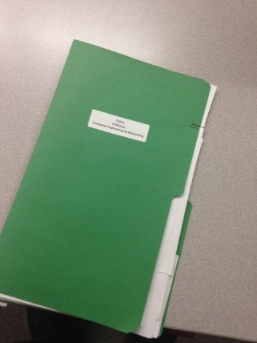 | = | 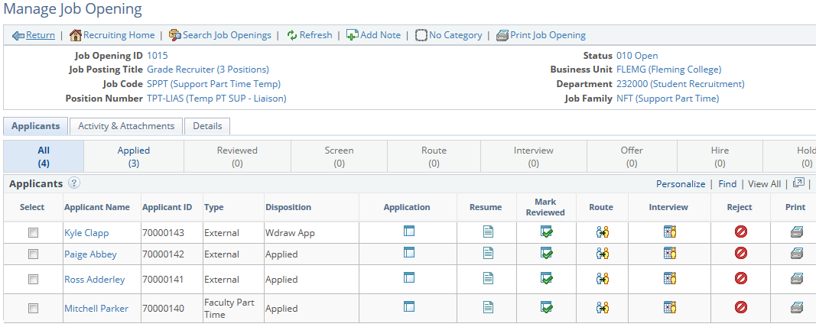

From this page you are able to manage all aspects of the job opening, including:
- Seeing all applicants for the job opening including their bargaining unit status
- Reviewing applications (resumes, cover letters and any other details)
- Performing actions on applicants, such as rejecting them

To see all of the job openings you are attached to you need to go to Recruiting > Browse Job Openings. To access this page, start by logging into Evolve from My Campus.
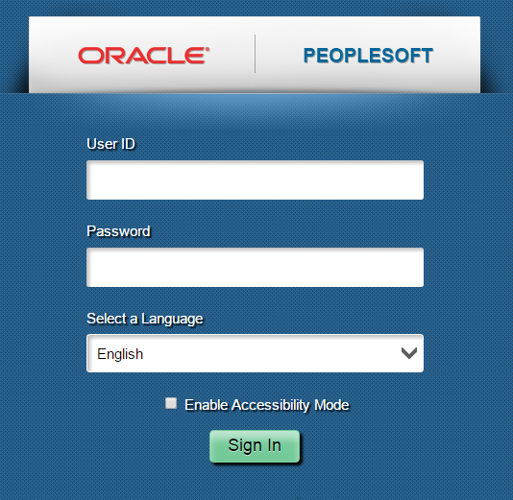
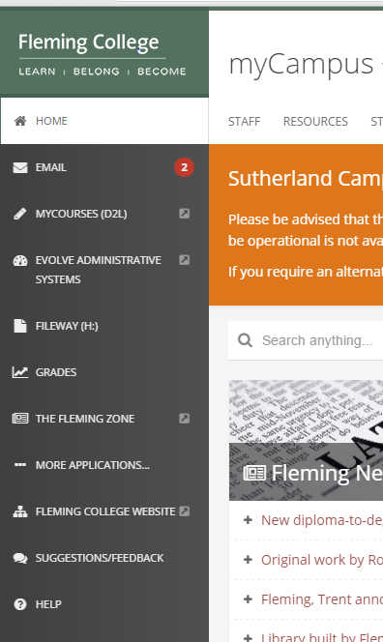
Once you are logged into Evolve select ‘Main Menu’ from the top bar menu > Recruiting > Browse Job Openings.
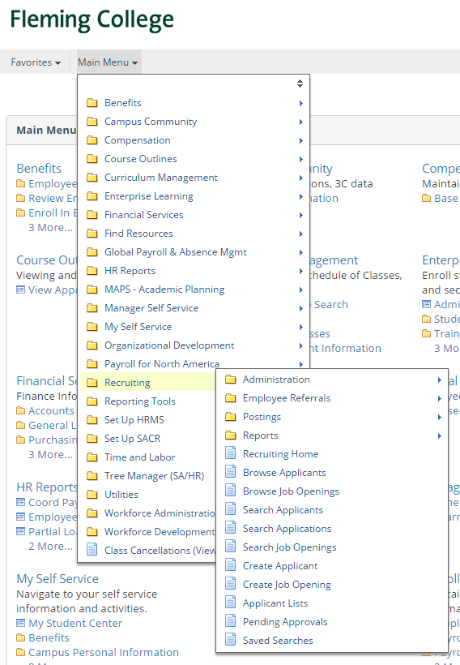

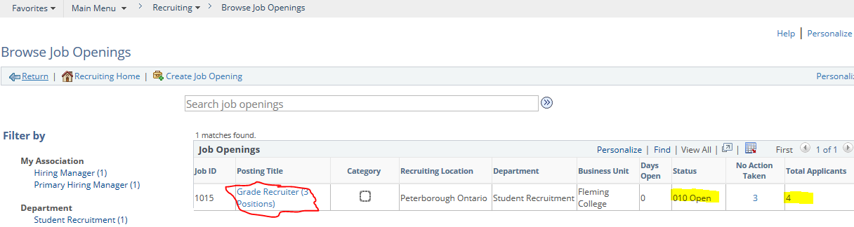

You can see the total number applicants who have applied to your job opening.

You can see the Status of your Job Opening:
“Open” means it is posted and available to applicants to apply
“Draft” means that the posting is still being developed
“Pending Approval” means the posting is complete and all that is left is for the HR Consultant to approve it before it gets posted.

Introduction to Applicant

Click on the posting title, “Grade Recruiter (3 positions)” to be taken to your list of applicants.

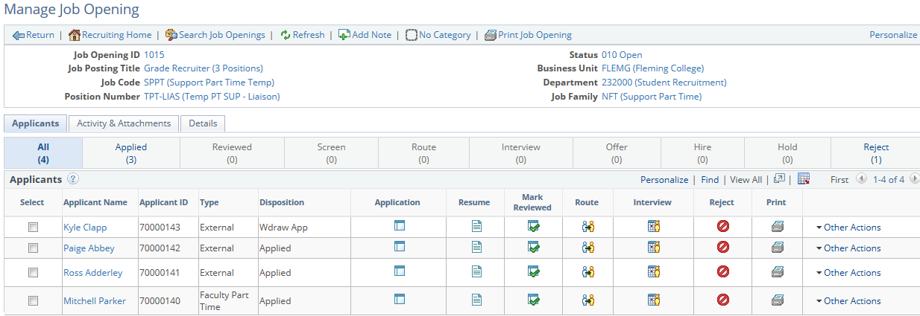

In your list of applicants, under Type you can see at a glance what type of applicant anyone is:

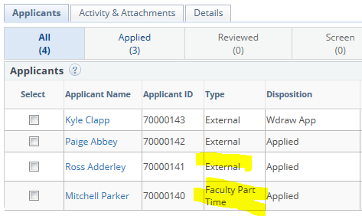

You can also see what status they are in for this competition, such as applied, withdrawn, rejected, etc.

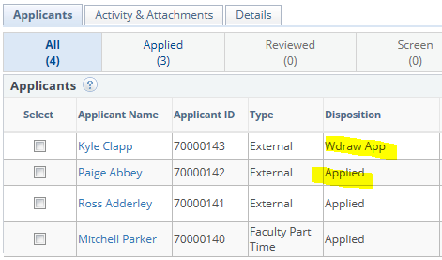

Reviewing Applications and Resumes

View the applicant’s Application by clicking on the icon.
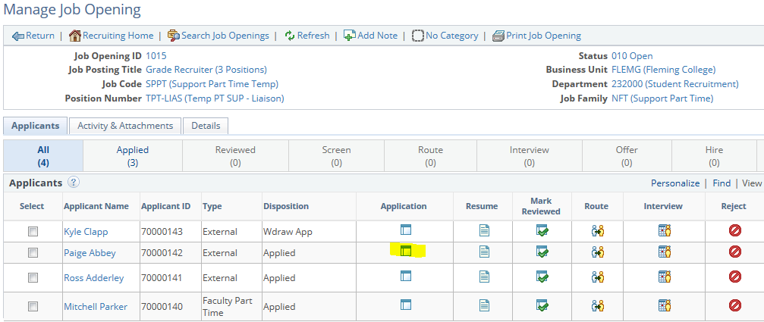

This will take you to a page that you can then get to the applicant’s resume and cover letter.
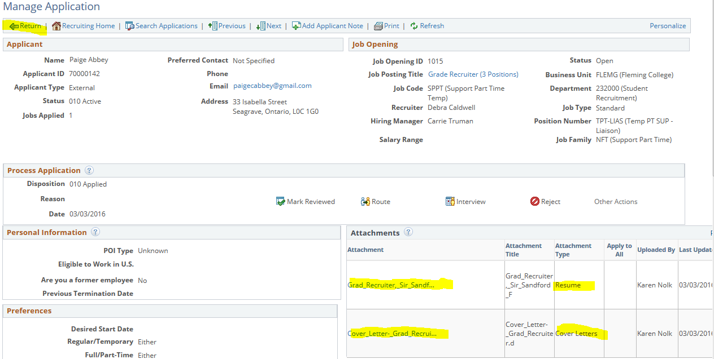

You are able to open the documents and view them from here. Once you have reviewed their documents, you will make a decision to interview, reject or keep in consideration. Return to the previous page by clicking on “Return”.

Marking Applicants’ Status

You can now change the applicant’s disposition:

- To keep in consideration, click on “Mark Reviewed”.
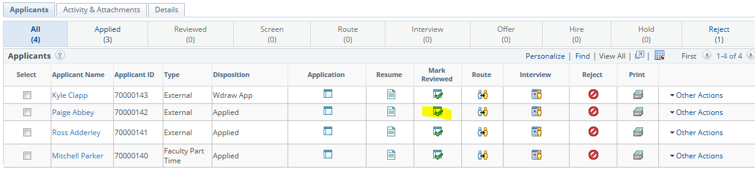

- To reject, click on “Reject”.
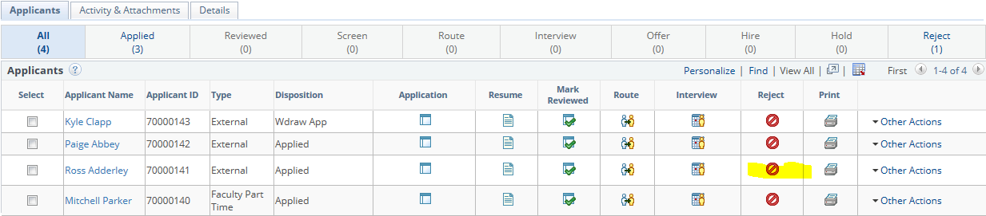

- To interview, click on Other Actions > Recruiting Actions > Edit Disposition.
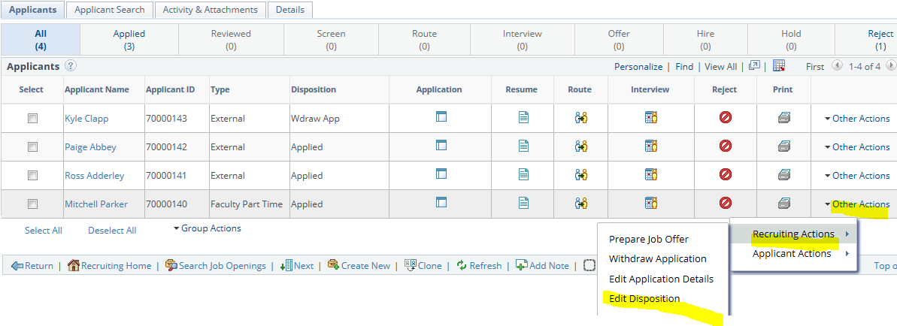

Change the “New Disposition” to Interview.
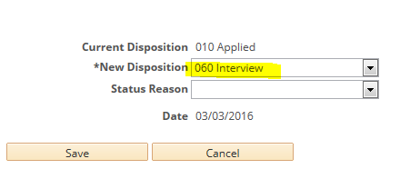
You will notice that the applicant disposition changes with each of the above actions:
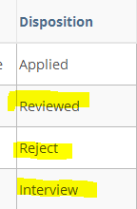

Routing Applicants to Interested Parties

You may have a need to send the applicant’s resume and cover letter to another party. This could be for the purpose of reviewing the resume to get a second opinion on the candidate or it could be to ask someone to contact the applicant on your behalf. The route function allows you to send an email to an employee in the system with the resume and cover letter as an attachment.

To route, click on “Route”:
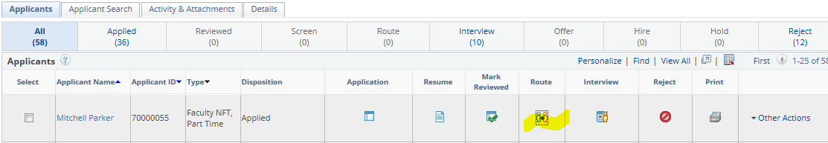

Click on the magnifying glass for the “Name” field and enter the name of the recipient of the email:
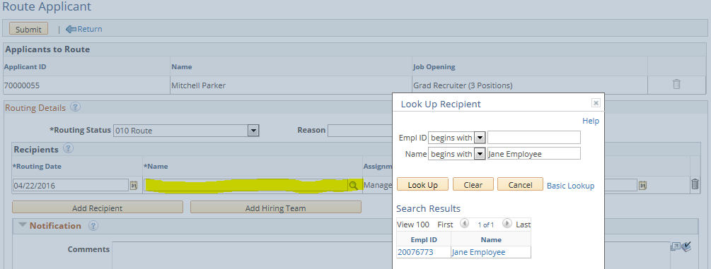
Add any comments you which to have included in the email and then click on “Submit”.
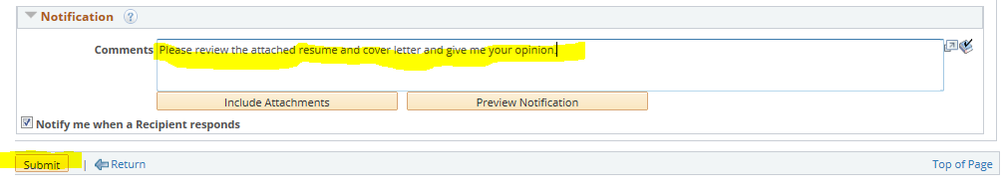

Making Notes on Applicants

You can add notes to an applicant. When you are viewing an applicant’s Application, click on “Add Applicant Note”.
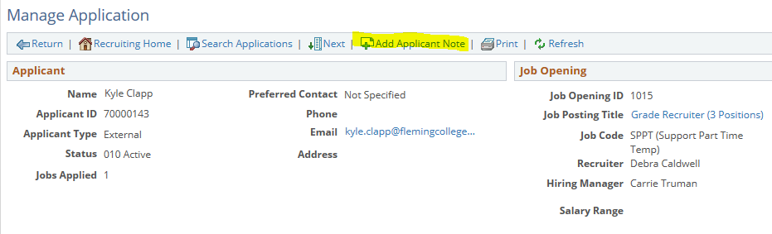
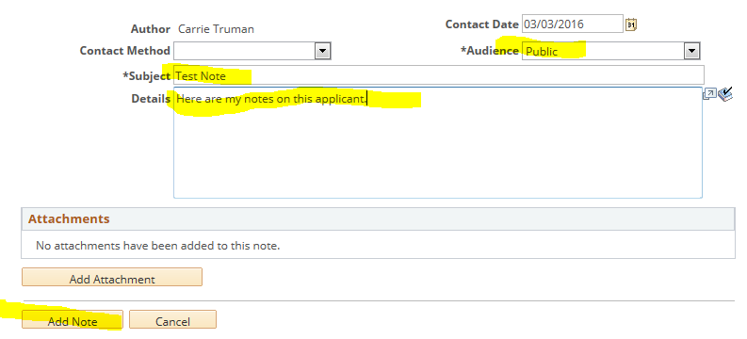

Please be aware that the note is at the applicant level and not the job opening level. If the applicant applies to another job opening, other hiring managers will see your public notes. You can use private notes to make notes that only yourself can see, please note that these private notes can be seen by the administrators and HR Consultants. These notes are there permanently!

