MODIFIED WORKLOAD AGREEMENT – Article 11.09
Academic Employees Collective Agreement

Teacher(s) Name(s): | School:
Modified Workload Start Date: | Modified Workload End Date (not to exceed one academic year):
Program/Discipline/Course:

NOTE: Either attach a mock SWF or complete the tables below. Also provide a description of the workload particulars and rationale.

Workload Particulars/Rationale:

List all courses for this semester/workload:
Course Name/code | TCH | Prep factor | Eval factor | Total hours
Total:

Below the line activity
Comp hours (allowance)/week | 6
Total:

Cumulative Totals | # Weeks  (max 36 weeks post-sec) | TCH  (max 648 post-sec) | Total Contact Days  (max 180 post-sec)
Previous Workloads/SWFs (include year-to-date totals up to the start of this MWA)
Current Workload (in this MWA)
Totals to Date

- I have read, understood and consented to all details contained in this Assignment including the waiving of the Collective Agreement articles that are checked below.

Teacher _________________________ Date: ___________________

Teacher _________________________ Date: ___________________

Teacher _________________________ Date: ___________________

Teacher _________________________ Date: ___________________

- I do not consent to a Modified Workload:

Teacher _________________________ Date _____________________

Teacher _________________________Date______________________

Supervisor Consent ___________________________ Date: __________________

Union Consent ___________________________ Date: __________________

Distribution:

- Teacher(s)
- Supervisor
- AO
- HR
- Union President

A modified workload arrangement may be agreed to instead of the workload arrangements specified in any or all of the following articles. Place an “X” in the box beside the provisions of Article 11 that do not apply to this workload assignment.

Place an “X” beside the articles that do not apply | Article | Description
 | 11.01 B1 | Total workload assigned and attributed by the College to a teacher shall not exceed 44 hours in any week for up to 36 weeks in which there are teaching contact hours for teachers in post-secondary programs and for up to 38 weeks in which there are teaching contact hours in the case of teachers not in post-secondary programs.  The balance of the academic year shall be reserved for complementary functions and professional development.  Workload factors to be considered are:  (i) teaching contact hours  (ii) attributed hours for preparation  (iii) attributed hours for evaluation and feedback  (iv) attributed hours for complementary functions
 | 11.01 C | Each teaching contact hour shall be assigned as a 50 minute block plus a break of up to ten minutes.  The voluntary extension of the teaching contact hour beyond 50 minutes by the teacher and any student(s) by not taking breaks or by re-arranging breaks or by the teacher staying after the period to consult with any student(s) shall not constitute an additional teaching contact hour.
 | 11.01 D1 | Weekly hours for preparation shall be attributed to the teacher in accordance with the following formula:  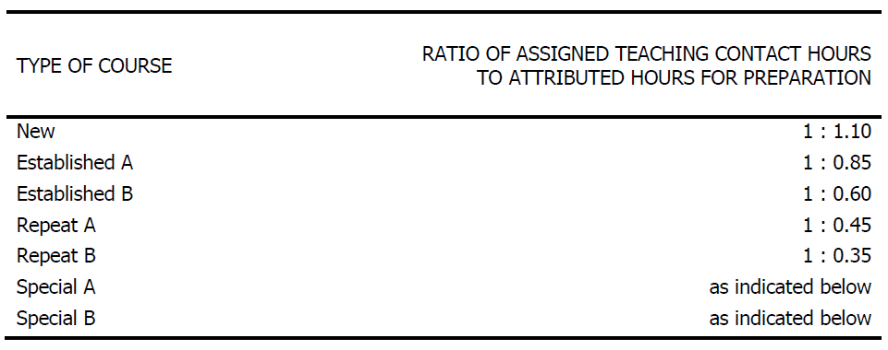
 | 11.01 D2 | No more than four different course preparations shall be assigned to a teacher in a given week except by voluntary agreement which shall not be unreasonably withheld.
 | 11.01 D3 | For purposes of the formula:  (i) "New" refers to the first section of a course which the teacher is  - teaching for the first time. (This definition does not apply to a new full-time teacher who has previously taught the course as a Partial-Load, Sessional or Part-time employee, nor to courses designated as "Special" as defined below); OR  - teaching for the first time since a major revision of the course or curriculum has been approved by the College.  (ii) "Established A" refers to the first section of a course which the teacher has previously taught but not within the previous three academic years.  (iii) "Established B" refers to the first section of a course which the teacher has taught within the previous three academic years.  (iv) Where a non-language course is to be taught in more than one language the first section taught in a second language shall be regarded as "New" or "Established".  (v) "Repeat A" refers to another section which the teacher is teaching concurrently with the same course for which hours of preparation have been attributed under "New" or "Established", but to students in a different program or year of study.  (vi) "Repeat B" refers to another section which the teacher is teaching concurrently with the same course for which hours of preparation have been attributed under "New" or "Established" or "Repeat A" to students in the same program and year of study.  (vii) "Special A" refers to sections of courses in which students may enter on a continuous intake basis or courses which have been organized into individualized self-learning packages.  The first section of a "Special A" course which the teacher has not taught before or which the teacher has not taught within the previous three academic years attracts the numerical value in "Established A" (1:0.85).  The first section of a "Special A" course which the teacher has taught within the previous three academic years attracts the numerical value in "Established B" (1:0.60).  Repeat sections of a "Special A" course attract the numerical value in "Repeat A" (1:0.45).  (viii) "Special B" refers to preparation for sections of a course in which the objectives describe the students' application of knowledge in actual work settings.  The first section of a "Special B" course which the teacher has not taught before or which the teacher has not taught within the previous three academic years attracts the numerical value in "Established A" (1:0.85).  The first section of a "Special B" course which the teacher has taught within the previous three academic years attracts the numerical value in "Established B" (1:0.60).  Repeat sections of a "Special B" course attract the numerical value in "Repeat B" (1:0.35).  Additional time necessary to arrange and prepare for student placement in such learning situations shall be attributed on an hour for hour basis and recorded on the Standard Workload Form (SWF), as referred to in 11.02.  (ix) Hours for curriculum review or course development assigned to a teacher on an ongoing basis, in lieu of teaching or in a non-teaching period, shall be attributed on an hour for hour basis and recorded on the SWF.
 | 11.01 E1 | Weekly hours for evaluation and feedback in a course shall be attributed to a teacher in accordance with the following formula:  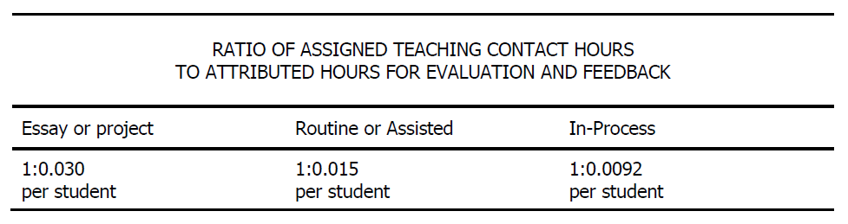
 | 11.01 E2 | For purposes of the formula:  (i) "Essay or project evaluation and feedback" is grading:  - essays  - essay type assignments or tests  - projects; or  - student performance based on behavioral assessments compiled by the teacher outside teaching contact hours.  (ii) "Routine or assisted evaluation and feedback" is grading by the teacher outside teaching contact hours of short answer tests or other evaluative tools where mechanical marking assistance or marking assistants are provided.  (iii) "In-process evaluation and feedback" is evaluation performed within the teaching contact hour.  (iv) Where a course requires more than one type of evaluation and feedback, the teacher and the supervisor shall agree upon a proportionate attribution of hours. If such agreement cannot be reached the College shall apply evaluation factors in the same proportion as the weight attached to each type of evaluation in the final grade for the course.
 | 11.01 E3 | Before the method(s) of evaluation and feedback are established for a course, the supervisor will consult with the affected teachers, as a group. Normally, the group will consist of the teachers working within the affected program. The group may consist of teachers teaching a course that is being taught across programs.  If only one teacher is assigned to a program, that teacher shall be deemed to be “the group” for purposes of this Article.
 | 11.01 E4 | The number of students in a course or section shall be determined initially by the College's planning estimates and recorded on the SWF as provided for in 11.02.  The number of students in a course or section shall be reviewed after the enrolment audit dates and not later than the completion of the course or section or, at the request of the teacher, following the last day for withdrawal of registration by the student(s), and revised where appropriate.  The number of students in a continuous intake program, course or section shall be reviewed every three months at the request of either the College or the teacher and determined as the weighted average of the number of students formally registered over the duration of the program, course or section. The weighted average shall be calculated by summing the number of formally registered students in each week of the program, course or section and then dividing the sum by the number of weeks in the duration of the program, course or section.
 | 11.01 F1 | Complementary functions appropriate to the professional role of the teacher may be assigned to a teacher by the College. Hours for such functions shall be attributed on an hour for hour basis.  An allowance of a minimum of six hours of the 44 hour maximum weekly total workload shall be attributed as follows:  four hours for routine out-of-class assistance to individual students  two hours for normal administrative tasks.  The teacher shall inform his/her students of availability for out-of-class assistance in keeping with the academic needs of students.
 | 11.01 F2 | The attribution of four hours of out-of-class assistance for students may not be sufficient where a teacher has unusually high numbers of students in his/her total course load. When a teacher who has more than 260 students in his/her total course load considers that he/she will not have sufficient time to provide appropriate levels of out-of-class assistance, the teacher will discuss the issue with his/her supervisor. Possible means of alleviating the concern should be considered such as additional types of assistance being provided or additional hours being attributed. Failing agreement on how to best manage the situation the teacher shall be attributed an additional 0.015 hour for every student in excess of 260.
 | 11.01G2 | Where there are atypical circumstances affecting the workload of a teacher or group of teachers which are not adequately reflected in this Article 11, Workload, additional hours shall be attributed, following discussion between each teacher individually and the supervisor, on an hour for hour basis.
 | 11.01 I | Teaching contact hours for a teacher in post-secondary programs shall not exceed 18 in any week. Teaching contact hours for a teacher not in post-secondary programs shall not exceed 20 in any week.
 | 11.01J1 | Notwithstanding the above, overtime worked by a teacher shall not exceed one teaching contact hour in any one week or three total workload hours in any one week and shall be voluntary.
 | 11.01J2 | Such teaching contact hour agreed to in excess of the respective weekly teaching contact hour maximum shall be compensated at the rate of 0.1% of annual regular salary. Such workload hours agreed to in excess of the 44 hour weekly workload maximum shall be compensated at the rate of 0.1% of annual regular salary. Such overtime payments shall be for the greater amount but shall not be pyramided.
 | 11.01J3 | All such voluntary overtime agreements, which shall not be unreasonably withheld, shall be set out in writing on the SWF for that period by the College and filed with the teacher and the Union Local within ten days.
 | 11.01J4 | Probationary teachers shall not be assigned teaching contact hours or total workload hours in excess of the maxima under any circumstances.
 | 11.01L1 | The contact day shall not exceed eight hours from the beginning of the first assigned hour to the end of the last assigned hour except by written voluntary agreement. The Union Local shall receive a copy of such agreement within seven days.
 | 11.01L2 | Every effort shall be made to ensure that work will not be assigned to begin less than 12 hours after the end of the previous day's work assignment.
 | 11.01L3 | A teacher shall not normally be assigned work on calendar Saturdays or Sundays. Where a teacher is assigned to work on a Saturday or Sunday, the teacher shall be credited with one and one-half times the credit hours normally given for hours so assigned and attributed.
 | 11.01L4 | A teacher may agree in writing to waive the premium credits provided for in 11.01 L 3 for a specified period of time.
 | 11.01M | Where a Union Local and a College agree in writing on terms governing workload assignments at the College, such agreements shall be binding on the College, the Union Local and the teachers and timetables shall be established in accordance with such local agreements.
 | 11.02 A1(a) | Prior to the establishment of a total workload for any teacher the supervisor shall discuss the proposed workload with the teacher and complete the SWF, attached as Appendix I, to be provided by the College. The supervisor shall give a copy to the teacher not later than six weeks prior to the beginning of the period covered by the timetable excluding holidays and vacations. It is recognized that if the SWF is subsequently revised by the College, it will not be done without prior consultation with the teacher.
X | 11.02 A2 | The SWF shall include all details of the total workload including teaching contact hours, accumulated contact days, accumulated teaching contact hours, number of sections, type and number of preparations, type of evaluation/feedback required by the curriculum, class size, attributed hours, contact days, language of instruction and complementary functions.
X | 11.02 A3 | Following receipt of the SWF, the teacher shall indicate in writing on the SWF whether in agreement with the total workload. If not in agreement the teacher and the supervisor may add such other comments as is considered appropriate and may indicate in writing that the workload should be reviewed by the College WMG.
 | 11.02 A4 | In the event that the teacher is not in agreement with the total workload and wishes it to be reviewed by the WMG, the teacher must so indicate in writing to the supervisor within five working days following the date of receipt of the SWF. The completed SWF will be forwarded by the supervisor to the WMG within three working days from date of receipt from the teacher with a copy to be given to the teacher.  Absent such indication, the teacher shall be considered to be in agreement with the total workload.
 | 11.02 A5 | The timetable shall set out the schedule and location of assigned workload hours reported on the SWF, on a Timetable Form to be provided by the College, and a copy shall be given to the teacher no less than two weeks prior to the beginning of the period covered by the timetable, which shall be the same period as that covered by the SWF.
 | 11.08 | In keeping with the professional responsibility of the teacher, non-teaching periods are used for activities initiated by the teacher and by the College as part of the parties' mutual commitment to professionalism, the quality of education and professional development.  Such activities will be undertaken by mutual consent and agreement will not be unreasonably withheld.  No SWF will be issued but such activities may be documented. Where mutually agreed activities can be appropriately performed outside the College, scheduling shall be at the discretion of the teacher, subject to the requirement to meet appropriate deadlines.

Workload Limit Protections: The following limits must not be exceeded:

Article | Description
11.01 K1 | Contact days (being days in which one or more teaching contact hours are assigned) shall not exceed 180 contact days per academic year . . . .
11.01 K2 | Weekly contact hours assigned to a teacher by the College may be scheduled into fewer than five contact days and such compressed . . . .
11.01 K3 | Teaching contact hours shall not exceed 648 teaching contact hours per academic year for a teacher in post-secondary programs or 760 . . . .

Last Revised: April 2, 2015

