RENEWING
THE
FACULTY EVALUATION PROCESS

We cannot hold a torch to light another's path without brightening our own.
Ben Sweetland

JANUARY 2009
Contents
Contents 2
Introduction 3
Purpose 3
Assumptions 4
Guiding Principles 4
Frequency 5
Full-time Faculty 5
Evaluation Frequency 6
Components of the Faculty Evaluation Process 6
Faculty/ Course (formative) 6
Peer (Classroom & Team) (formative) 7
Peer Evaluation 8
Team Evaluation 8
Self (formative) 8
Overall Evaluation Process 10
Dean’s Administrative Summary 11
Individual Development Plan (3-year Plan) 11
Where do I go to learn more about teaching and teaching effectiveness? 11

Faculty - Evaluation Process

We make a difference by …
Stepping up and taking action
Building strong, collaborative relationships
Achieving sustainable results
Learning and growing
Innovating and taking risks

Introduction
Teaching and learning is the core of what we do at Fleming College, but often the ability to teach is taken for granted. While there is no doubt that superior teaching occurs in the College, everyone agrees that it could be improved and that even the teaching performance of our best faculty could be better supported.

To this end, the College has implemented faculty evaluation processes and tools, specifically designed to continuously improve teaching effectiveness.

Purpose
First and foremost, the primary focus of the faculty evaluation process at Fleming is on formative evaluation, and on the on-going development of each faculty member that supports them in being the best they can be.

We have been asked by faculty about the difference between the kinds of evaluation processes that occur and why they are different. There are two different purposes for establishing faculty evaluation processes:

Formative – to develop or improve teaching effectiveness and the quality of student learning (this is Fleming’s focus)

Summative – to provide documentation of teaching effectiveness for formal review (used on rare occasions when formative processes have failed to improve identified areas of development)

At Fleming, we want to provide support, feedback and development on the capabilities needed for faculty to successfully perform their roles in delivering quality learning to students and to contribute to the strategy and character of the College. This process is one of the enablers of effective student learning and contributes to strong student faculty interaction; a hallmark of learning at Fleming.

Assumptions
Our approach to faculty evaluation is guided by several underlying assumptions. We believe that:

- Faculty members are interested in, and motivated by, professional learning, growth and improvement in their skills and knowledge.

- Fleming has a responsibility to create growth opportunities that enhance individual strengths and assist the organization in continuously improving the education and learning experience for students.

- Individuals want, expect and are motivated by, meaningful feedback on their performance.

- Each faculty member is ultimately responsible and accountable for his/her development and success.

- When Deans and faculty meet at set times to collaboratively discuss professional strengths, performance and growth, this results in mutual respect, communication and a sense of shared accomplishment.

- The process should focus on the critical teaching and learning capabilities required to deliver an excellent learning experience to students and those team skills that will help the School and College excel. The process should consist of a student evaluation, a team evaluation, and classroom observance, all designed to support individual faculty members to be the best they can be. There should also be an opportunity for self reflection by completing the self evaluation questionnaire. This work can be of assistance in the creation of individual development plans.

- The Faculty Evaluation process, in keeping with the spirit of encouraging and enhancing capabilities will include a personal development plan agreed to by both the Dean and faculty member. When the other elements of the process are discussed at a set meeting, the Dean and faculty member will mutually decide and agree to a development plan. These plans will also form the basis for articulating School development needs and cross-School development needs.

Guiding Principles
- This process will be used to reinforce/enhance the capabilities of faculty to deliver the best possible educational experience for students. The Guidelines for Professional Practice will serve as the basis for developmental feedback to faculty.

- This developmental process is one by which the contribution, strengths, future training/support and personal development of each member of faculty is discussed with his/her Dean in an informal setting and documented on a formal basis.

- The process should be simple and easy to use.

- The process will lead to the designing of individual development plans that can be translated into broader development plans for both the School and the College.

- The process focuses on development of critical behaviours necessary to achieve a quality educational experience in the formal learning setting and those behaviours that foster student engagement and teamwork within both the School and college; which is part of what we believe is the hallmark of a total educational experience at Fleming.

Frequency
The full Faculty evaluation process (both formative and summary) will be performed according to the following timelines, unless circumstances warrant otherwise:

- Full-time faculty – every 3 years – Faculty/Course; Peer – Classroom & Team; Self; Dean’s Summary; every year - Faculty/Course; Peer – Classroom & Team; and Self.
- Partial load faculty – required: faculty/course – annually; optional: peer (classroom and team), self. If desired by the faculty member, a meeting with the Dean and/or designate may be requested to discuss faculty evaluation results, developmental opportunities, etc. If faculty/course results indicate possible challenges with teaching effectiveness, the Dean and/or designate will engage in a full faculty evaluation process. In addition, the Dean and/or designate will visit the classroom of each new partial load faculty member to assess teaching effectiveness and provide developmental feedback.
- Part-time/Sessional faculty – required: faculty/course – annually; optional: peer (classroom and team), self. If desired by the faculty member, a meeting with the Dean and/or designate may be requested to discuss faculty evaluation results, developmental opportunities, etc. If faculty/course results indicate possible challenges with teaching effectiveness, the Dean and/or designate will engage in a full faculty evaluation process. In addition, the Dean and/or designate will visit the classroom of each new partial load faculty member to assess teaching effectiveness and provide developmental feedback.

Full-time Faculty
Annually
- Review of the faculty member’s goals and objectives, and professional development progress and upcoming plans.
- Faculty/course evaluation as randomly selected by FDR.
- Peer evaluation (including classroom observation and team-based assessment).
- Self-evaluation

Every 3 Years
All of the above mentioned annual activities will occur, in additional to the following:

- Pre-observation form completed by the faculty member and reviewed by the Dean designate to outline components of a planned classroom visit (1 week prior to the classroom visit).
- Dean designate observation of one class for a minimum of 50 minutes.
- Dean to complete the Classroom Observation form and share with faculty member.
- At Dean’s discretion, an announced follow-up classroom visit.
- Formal review completed by the Dean using the “Summary Evaluation” form.
- Dean will complete and sign the Summary Evaluation form and forward to the faculty member within 2 weeks.
- Discussions will occur between the Dean and faculty member within 2 weeks.
- The faculty member will review and sign the form and return to the Dean.
- The form will be filed with H&OD and a final copy will be sent to the faculty member by the Dean.

NOTE: In some situations, the Dean may assign a designate to assist in classroom observations. It is anticipated that such circumstances will be unusual, and typically required as a result of extraordinary workload volumes. Designees shall be individuals with the expertise and experience required to effectively evaluate teaching performance.

Selection of Faculty for 3-year Cycle
In establishing the one-third of faculty who will participate in the faculty evaluation process, Deans will give consideration to:

- Length of time since last formal evaluation conducted
- Faculty/course evaluation historical trends
- Degree of curricular change in courses taught
- General information related to student satisfaction (program coordinator, class presidents, anecdotal commentary)
- Random selection

Evaluation Frequency
 | Faculty/Course | Peer (Classroom/Team) | Self | Dean’s Summary
Full-time Faculty (annually) | X | X | X
Full-time Faculty (every 3 years) | X | X | X | X
Partial Load Faculty | X | X (voluntary) | X (voluntary_ | X  (on request)
Part-time/Sessional Faculty | X | X (voluntary) | X (voluntary) | X

Components of the Faculty Evaluation Process

Faculty/ Course (formative)
Survey instruments are distributed to students in the fall and winter terms. Included in the Faculty & Course Evaluation survey are questions related to the Professor. There are thirteen (13) questions that relate to the performance of the Professor linked to the Professional Standards of Practice for Faculty. Behaviours assessed include respectfulness, level of expectations and standards, professionalism, engagement, connection with students, communication and consistency.

Included in the Faculty & Course Evaluation survey are questions related to the course. There are eight (8) questions that focus on the course including the course structure, clarity of outcomes, appropriateness of assessments/evaluations, relevance of learning resources, degree of challenge in the course, suitability of physical space and use of educational technology.

One section of one course per faculty is randomly selected by Fleming Data Research (FDR) to be evaluated in class during week 10 or 11. (Note: For Probationary Faculty, one section from each course is surveyed). Student responses are compiled by FDR and results are distributed to faculty at the end of each term surveyed. Summary reports are distributed to Deans and the Vice President, Academic for review and follow-up where consistent trends indicate areas of excellence worthy of recognition, or areas of potential development. Information related to the course, its content, and existing design can also be gleaned from the evaluations, giving faculty, coordinators and Deans insight into successful course design, as well as those that could benefit from review and/or re-design.

This survey is administered by faculty to students in one course section being taught by the faculty, as randomly selected by FDR. It takes about 15-20 minutes for students to complete the survey and the results are collected by FDR. They then compile and consolidate results which are sent confidentially to the faculty member prior to the end of the term (assuming established timelines are met for survey completion). Comments made by students are shared only with the faculty member and his/her Dean. No one else has access to full individual survey results.

Faculty receive specific instructions from FDR with a supply of surveys for the class randomly selected. Faculty or peers distribute the surveys to students, encouraging their participation and responding to any questions.

Samples of faculty and course evaluations, as well as instructions sent to individual faculty from FDR, are attached in the Appendices.

Faculty/Course Evaluation – Standard Dates
Faculty/course evaluation surveys are typically sent to faculty in week 8 of both the fall and winter term. Summer faculty/course evaluations are not conducted typically.

For faculty who teaching in programs where the intake is other than the standard Sept. 1st or Jan. 1st, it is expected that faculty/course evaluations will be conducted to ensure feedback mechanisms are in place between faculty and students.

When faculty receive their results? This is your opportunity to receive feedback from your students and it’s important. No one can function and continuously improve in the absence of feedback from those they work closest with. This is your opportunity to demonstrate your commitment to life-long learning by keeping current in your field and continuing to improve and refine your teaching skills. The feedback you receive on your teaching and your course reflect the students’ experience, one that we want to ensure is the best it can be.

How are my faculty/course survey results used in the college?
(this section under construction)

Peer (Classroom & Team) (formative)
Peer evaluation is an important component of faculty evaluation, and it puts faculty in charge of the quality of their work as faculty. Teaching involves learning from and through experience and can often feel very lonely. Collaboration among faculty can result in higher morale and overall improvements in teaching and the student experience.

The peer evaluation is composed of two primary parts: Classroom observations and Team-based observations. Classroom based peer evaluation provides an opportunity for developmental feedback from experienced peers related to faculty performance in the classroom setting. The team-based aspect of the evaluation provides faculty with feedback from peers based on their interactions with and observations of the individual in a team-based environment. The Peer Evaluation forms (Classroom and Team-based) can be found in the attached appendices.

Ideal peers include Academic Leads, Program Coordinators and program faculty. They know the curriculum best, have established recognition for teaching excellence and are committed to your success as a faculty member.

Peer Evaluation
A number of methods can be employed in a formative peer evaluation process. These could include:

- Direct classroom observation
- Videotaping of classes
- Evaluation of course materials
- Reviewing the faculty’s evaluation/assessment techniques and feedback

It is important for the peer and the faculty being evaluated to meet prior to any observational event to ensure there is an understanding of what is to be delivered, where, how, the intended learning outcomes, particular challenges with the students in the class, behavioural challenges, intended teaching techniques and approaches, etc. This background and contextual information then better positions the peer evaluator to provide meaningful feedback related to the faculty’s plans.

A Peer Evaluation form is available to assist Peer evaluators in providing meaningful feedback to the faculty being evaluated. A sample of the form is contained in the appendices. In addition, a summary of the kinds of questions that would help guide a pre-evaluation meeting, as well as a post-evaluation meeting are contained for reference.

Team Evaluation
This part of the peer evaluation process provides formative feedback for faculty related to their team based skills and abilities. While performance in the classroom is important, so too is the quality of the interactions and relations between faculty and staff, in course, program and school teams.

Creating and developing meaningful learning opportunities for our students requires faculty to think creatively, express their ideas, persevere, support one another, and accept constructive criticism. Faculty need to be nimble problem solvers, open to sharing resources, and to demonstrate their knowledge and appreciation for larger college challenges and opportunities.

Peers chosen to provide this feedback must have had the opportunity to observe the faculty member over a period of time. Observations based on one interaction are not reliable, so a longer-term relationship with a peer who can provide meaningful feedback is important.

Self (formative)
The self-evaluation component is designed to facilitate reflective inquiry about one’s own performance, and then is used to enrich the dialogue between faculty and Deans when meeting to reviewing overall performance. Candour and realism are important elements of this self-evaluation, especially as it relates to faculty-student interactions and teaching quality.

After reviewing your faculty/course evaluations, and the feedback received from your peers, it’s time to reflect and complete the self evaluation. A self evaluation form (as contained in the appendices) has been developed to facilitate reflective inquiry. Self evaluation serves to foster your continuous improvement as a faculty at the College, and ultimately improve teaching effectiveness and the student experience. It also informs the content of your professional development plan, and dialogue with your Dean.

The self-evaluation form is shared with your Dean to assist him/her in helping you with your continuous growth and development.

Overall Evaluation Process
Formative
Professors & Instructors
(non probationary)

(non

1/3 of all FT faculty each year

(identified by Deans annually)

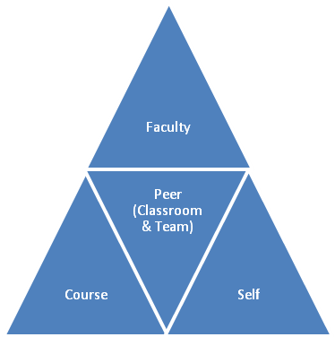
Developmental Opportunities

Summary
(with Dean)

Individual Development Plan

Dean’s Administrative Summary
An important element of any evaluative process is the capture of summary results that serve as a reference point for on-going dialogue, faculty development, historical feedback and performance trends, as well as required administrative recordkeeping.

As outlined above, the Dean is responsible for completing an evaluation summary for probationary faculty (once every 4 months and then just prior to probation ending) and once every 3 years for full-time faculty.

The Faculty Evaluation Summary Form, as contained in the appendices, is completed by the Dean, signed by the faculty being evaluated, and forwarded to H&OD with all back-up documents (faculty/course results, peer and self evaluation results). The documentation is held permanently in the faculty member’s HR file.

Individual Development Plan (3-year Plan)
Guidelines and a professional development template have been developed to assist individuals with both content and format of their plan. The guidelines and recommended template format are included in the appendices attached.

Faculty are responsible for developing a draft plan that is discussed with their Dean and then finalized. The 3-year plan not only guides the continuous development of the faculty member, but also provides information for the College to develop workshops and training opportunities for faculty.

The 3-year plan, once finalized, is held by your Dean and accompanies the summary evaluation form (package) that is retained on file in H&OD. The Dean and faculty member shall determine timelines and appropriate release necessary to pursue the developmental strategies agreed upon.

Where do I go to learn more about teaching and teaching effectiveness?
There are numerous resources available to faculty who would like to learn more about teaching, and to improve their teaching effectiveness overall.
Faculty Development Facilitator
Janet Honsberger is the College’s Faculty Development Facilitator, with overall accountability for developing and delivering comprehensive faculty development strategies, including workshops and seminars that will sustain and increase the College’s renowned reputation for teaching excellence and student/faculty interactions.
jhonsber@flemingc.on.ca
Ext. 1346
Visit the CLT website and access the “Faculty Development” category.
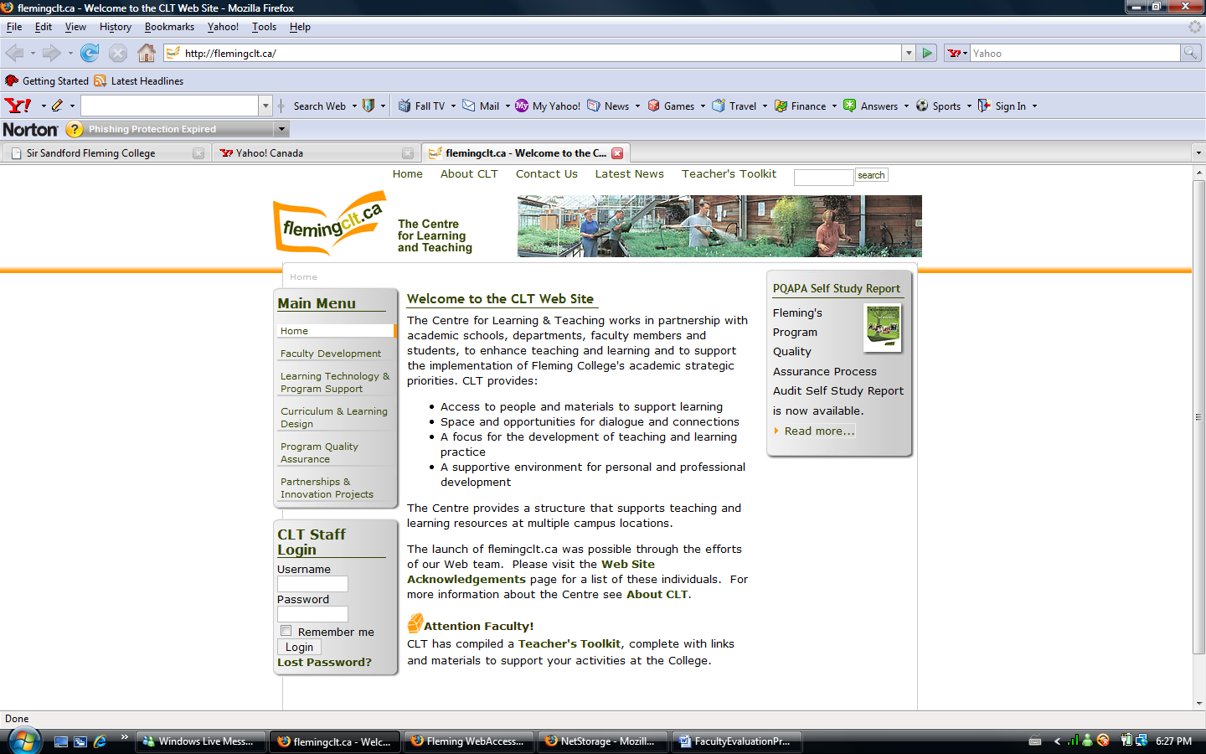

You will have access to an immediate and rich source of information to assist you.
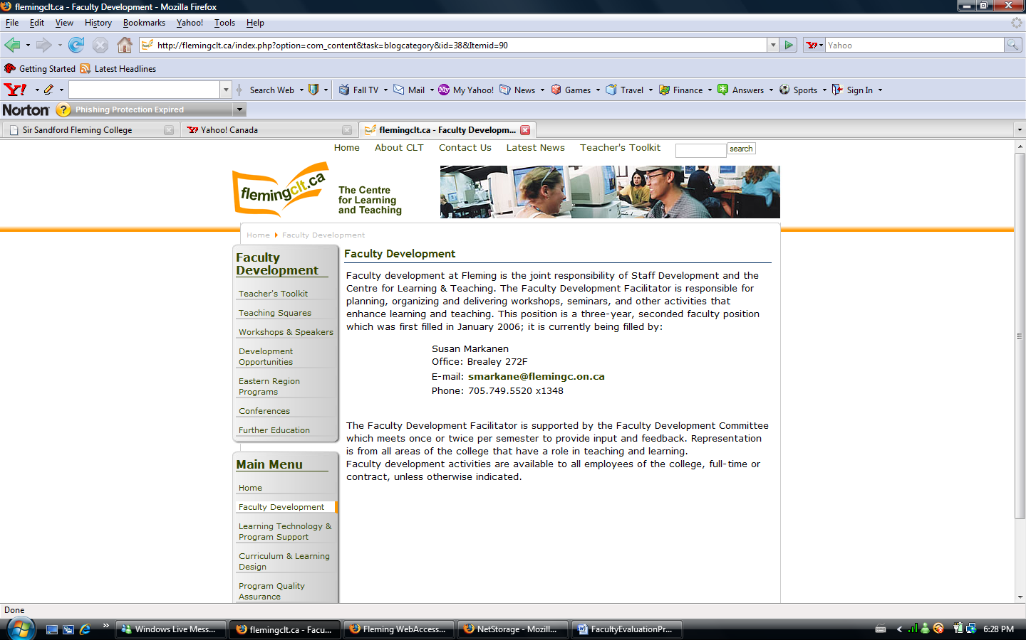
Helpful resources for faculty
CLT
The Centre for Learning & Teaching has developed a comprehensive site to assist faculty in their pursuit of teaching excellence. Their site also relays the curriculum quality review cycle to ensure we are delivering vibrant curriculum content in ways students learn best.
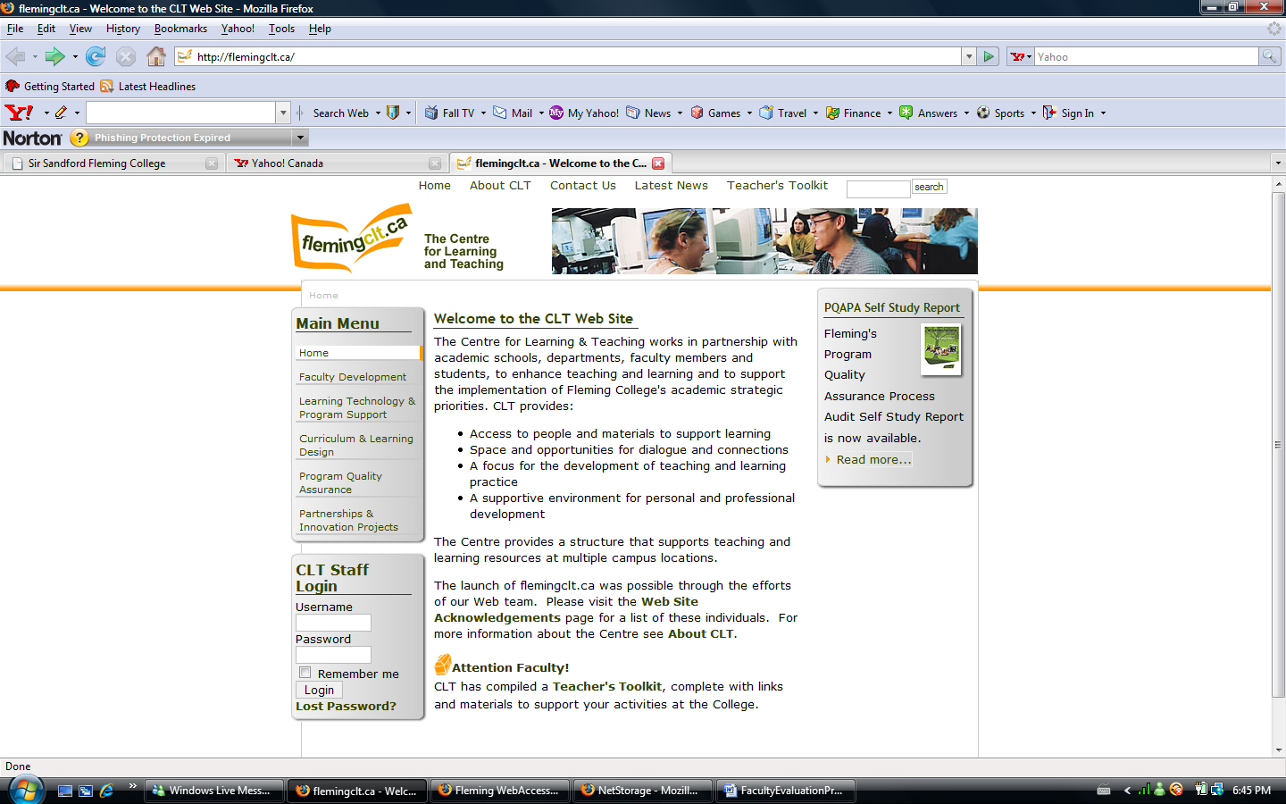
Helpful resources for faculty

Mentor
Faculty can request a Mentor to provide them with peer guidance as they orient to their role. While this program is primarily focused on new (probationary) faculty, post-probationary faculty can request assignment of a Mentor as part of their individualized professional development plan. Program coordinators, Academic Leads and peer faculty are often selected as Mentors by faculty.
Profile of the Ideal Mentor

This profile has been developed after a review of the research and benchmarking organizations that have successfully launched a formal mentoring program. The characteristics of ideal mentors to consider are as follows:

- Supportive
- Nurturing
- Provides honest and balanced feedback
- Provides guidance
- Listens well to others and asks thoughtful questions
- Maintains a balanced perspective
- Non-evaluative
- Knowledgeable of Fleming and Leadership Competencies

What a Mentor Does
Guide Encourage Counsel Befriend
Model Affirm Listen Accept
Inform Inspire Probe Relate
Confirm Challenge Advise Support

Clarify Referral Agent Contextualize Advocate
Question pen Doors

Role of the Mentor
- Negotiates the mentoring arrangement with the applicant
- Serves as a “sounding board” to the applicant’s learning process by providing effective feedback which both supports and challenges his/her professional development
- Shares his/her own unique experiences and knowledge with the applicant so that she/he may benefit from the mentor’s background
- Guides, counsels, supports, coaches and encourages the applicant in developing his/her talents and skills
- Meets with the applicant on an ongoing basis as specified by the mentoring program

