<EMPTY><EMPTY>

Sir Sandford Fleming College is committed to building an inclusive and accessible learning and working environment.  We believe in and promote the rights of all persons with disabilities as enshrined in the **Canadian Charter of Rights and Freedoms**, the **Ontario Human Rights Code**, and the **Accessibility for Ontarians with Disabilities Act (AODA 2005)** and its related **Accessibility Standards Regulations**.  To meet this commitment, Fleming College will make appropriate accommodations available throughout the full course of your employment with the College should you require it. (see the last page for further information)



For Return to Work and/or

Medical Accommodations including disabilities

The RTW/MA Policy and Procedure has been

developed jointly by the

Human Resources Department and OPSEU Local 351 and 352 - Fleming College

Revised: 23 Oct 2013 - DRAFT

**Complex RTW** means the employee is cleared to return to work but with accommodation(s) required.

**The RTW Team** must meet before the employee returns to the workplace for all Complex RTW cases.

**RTW/MA Action Plan** is documentation prepared to summarize the nature of accommodation including steps that will be taken to accommodate an identified disability, assist the employee during the recovery phase, timelines for action steps, responsibility for who will do what in the plan, a RTW/MA schedule and reference to communication needs or issues, as appropriate.

**Functional Abilities** are a medically supported , quantified assessment of capabilities & restrictions (temporary or permanent) that directly relates to an employee’s physical and/or mental capabilities in reference to the job duties.

.

**Workplace Accommodation for Medical Restrictions**



Return-to-Work (RTW) Team

Consists of the employee, the supervisor, the employee’s Union representative and the HR Consultant. Implements the RTW plan.

Employee

Responsible for maintaining contact with his/her supervisor throughout the medical absence. Cooperates in the RTW process by attending RTW Team meetings and providing information necessary for effective RTW planning.

Supervisor

Responsible for maintaining contact with his/her employee and HR Consultant during the employee’s absence. Identifies RTW options based on the employee’s abilities and limitations.

Union or Association Representative

Acts as an advocate for the employee (is optional for non-union employees) and assists the employee with understanding his/her responsibilities for RTW. Participates on the RTW Team and RTW planning.

HR Consultant

Provides overall coordination of the RTW process and is a resource to the employee and the supervisor. Ensures RTW documentation is maintained, RTW procedures are followed and liaises with relevant stakeholders as required.

Roles

&

Responsibilities

**DID YOU KNOW….**

[**www.web**](http://www.web) **address here**

DELETE BOX, OR PLACE TEXT OR LOGO HERE

**Ph 555.555.5555 Fx** 555.555.5555

**5555 Street Address City, US, 55555**

**www.webaddress.com**

*Delete box or place a tag line or quote here. Delete box or place a tag line or quote here. Delete box or place a tag line or quote here. Delete box or place a tag line or quote here.*

*Delete box or add photo caption here.   
Delete box or add photo caption here.  
Delete box or add photo caption here.   
Delete box or add photo caption here.*

*Delete box or place a tag line or quote here. Delete box or place a tag line or quote here. Delete box or place a tag line or quote here. Delete box or place a tag line or quote here.*

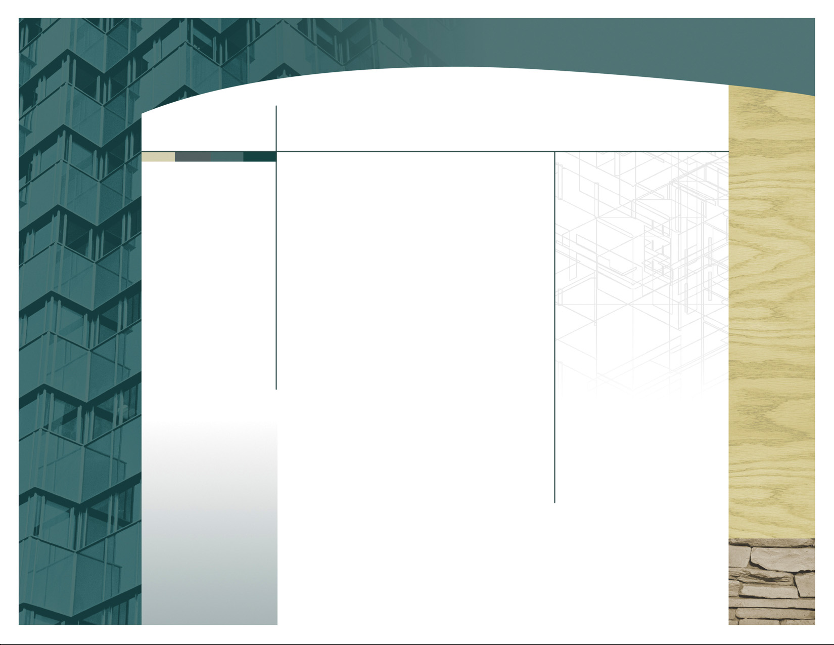

Appropriate accommodation will include, but is not limited to, recruitment, onboarding and orientation, career development and advancement, performance management, the return to work process, and transfers, reassignments and redeployment.

Should you at any time require an Individualized Workplace Emergency Plan due to a disability or an Individual Accommodation please speak directly with your manager or Human Resources in confidence. This plan will need to be updated yearly, or whenever there are changes to your role or work location.

Fleming College offers accommodation to its employees with disabilities who require accommodation in accordance with Policy # 3-341, Accessibility for Persons with Disabilities, located on the HR website..

For more information on accommodation please contact your manager or your HR Consultant

Need More Information?

Please refer to the HR webpage for:- Absence Due to Illness / Injury Procedure

- RTW / MA Policy

- RTW / MA Procedures

Key Steps

* Notification
* Assessment
* Planning
* Implementation
* Follow-Up

**LEARN**

**BELONG**

**BECOME**

Confidential

Informed

Supported

Timely

Encouraged

Accommodated

Accommodation:

Change, adaptation, or adjustment to an employee’s work and/or workplace environment to enable the employee to perform the regular duties of a job in a healthy and safe manner, including accessible formats and communications supports for job or workplace information.

Health Care Provider:

An individual who is licensed and in good standing with a regulated health care profession and who possesses the knowledge, skills and experience to accurately assess an individual’s disability, injury, illness or condition.

Restriction:

Anything related to an identified disability, illness, injury or condition that prevents an employee from completing a particular job task, duty or schedule of work hours as outlined and supported through medical evidence.

*What else should I know?*