Indigenous Academic & Student Services Report

September 2023 (2022/23 Academic Year)
Indigenous Fleming Report – May 2022

Prepared by:
Liz Stone, Vice President Indigenous Knowledge & Relations

Background
Indigenous Fleming, identifies the Academic & Service initiatives, projects and commitments that Fleming College is currently engaged in to meet the commitments identified in the Strategic Plan, Business Plan, Academic Plan and Indigenous Education Protocol and the Truth & Reconciliation Calls to Action, respectively. Specifically identified in the strategic plan:

We will be a welcoming place for all.
Strengthen our relationship with Indigenous Peoples by helping to create opportunities in post-secondary education, and actively participating in the process of reconciliation by ensuring all students and staff gain a deeper understanding and appreciation of Indigenous Peoples, their ways of knowing and histories.

We will be true partners in our communities.
Establish a Student Experience Strategy to ensure an outstanding experience and success for students upon graduation. We will improve career and support services, renew our facilities and a focus on student life and well-being on campus and in our communities.
As a result of Fleming’s commitment to Honouring the Rights of Indigenous People, Colleges & Institutes Canada, Indigenous Education Protocol and the TRC Calls To Action, the college has introduced the new Senior Management Team position of Vice President, Indigenous Knowledge & Relations. Indigenous Academics and Student Services report directly to the VP, IKR whom in turn reports directly the President.

Joint objectives for 2022-23 have been identified by Indigenous Academics and Indigenous Student Services (ISS) to meet the commitments identified in the Strategic Plan, Business Plan, Academic Plan and Indigenous Education Protocol, and ensure that college continues to be recognized as a leader in Indigenous post-secondary education. The objectives outlined will ensure that Fleming is meeting its core commitments of being a welcoming place for all and a true community partner.

Fleming College’s commitment to the Indigenous Education Protocols, specifically #5 – the commitment to increasing the number of Indigenous employees with ongoing appointments throughout the institution, including Indigenous senior administrators is demonstrated in our current Organizational Structure & employee compliment.

Indigenous voices and perspectives are important to successfully meet objectives. The College continues to focus on diversifying and better balance our workforce with Indigenous voices across the organization. Indigenous Academics and ISS specifically focus on the recruitment and hiring of Indigenous peoples.

Current staffing compliment includes:

Student Experience 5 employees

- 2 FT ISS Coordinator
- 1 ISS Manager
- 2 Bishkaa Student Ambassadors

Academic Experience 27 employees (4 Schools)

- 9 FT Faculty
- 18 PT Faculty
  - 1 Academic Chair

Fleming College also relies on support and guidance from our Indigenous Education Council (IEC). The IEC represents the interests and concerns of local Indigenous communities and is committed to developing and supporting Indigenous education aspirations through curriculum, programs, services and research, that meets the needs of Indigenous and non-Indigenous students, faculty and staff at the college. IEC meets four times a calendar year and are important to ensuring we meet our objectives.

The IEC has completed a review of their Terms of Reference and ratified the following changes;
- Implementation of Co-Chairs, 1 external & 1 internal
- Implementation of 2-year terms for external Co Chair & Vice Chair
- Community membership descriptions

Objective #1 – Incorporating Indigenous Perspectives

Target: 5 NEW Indigenous Perspectives Designation Programs

These activities align with Academic Action Plan Objectives (12), Business Plan (5.2.1) by being collaborative as well as including accountability. Aligning with the recently approved Indigenous Perspectives Designation (IPD) policy, expanding programs ensures that the needs of students and employers are met while empowering faculty with thoughtful and authentic Indigenous curricular content. Providing quality education for students while honouring Fleming’s commitment to the CICan Indigenous Education Protocol.
- 45 Indigenous Perspectives Designated Programs end of 2023/24 Academic Year
- First graduating class of PRK, Kenjigewin Teg, Manitoulin Island, June 2023

Objective #2 – Increase Academic Partnerships focused on Indigenous Knowledge

Target: 1 NEW Academic Agreement 2023/24

These activities support the Strategic Plan and Business Plan (5.2.2), the incorporation of Indigenous Academic opportunities for all students will not only provide a welcoming place for all, but also support active contribution to reconciliation. Providing quality education for students while honouring Fleming’s commitment to the CICan Indigenous Education Protocol.

- Continued Spring intakes of Practical Nursing Program, Kenjigewin Teg
- New Program Delivery at Kenjigewin Teg, Winter Semester 2024, GHS Program which will feed into the PRK Program.
- 100% of Fleming Students will have Indigenous content incorporated into their Fleming Experience by end of 2024 Academic year.
- Indigenous Perspectives Designation
- Indigenous Content within their Program course curriculum
- Indigenous Course inclusion in their Program of study
- First graduates of new Aquaculture Foundation Program
- Inclusion of Knowledge Keepers & Indigenous Knowledge in the classroom – 45 unique Indigenous Knowledge Keepers & Elders have visited Fleming classrooms in 2022/23.
- Partnership with Everlasting Tree School, Six Nations of the Grand River

Objective #3 – Develop Indigenous Student and Indigenous Perspectives Designation Recruitment Plan in partnership with Marketing Department.

Target: Create recruitment opportunities for Indigenous students with the goal of increasing Indigenous student enrolment to match or better the provincial Indigenous population each year and increase Indigenous Perspectives Designation enrolment

This objective supports the Strategic Plan and Business Plan (5.2.2 & 5.2.3), the incorporation of Indigenous specific recruitment activities will not only provide a welcoming place for all, but also support active contribution to reconciliation. Providing quality education for students while honouring Fleming’s commitment to the CICan Indigenous Education Protocol.

- 542 Indigenous students registered for 2022/23 Academic Year
- 6.5% of Domestic enrollment, 2.9% Provincially & 5% Federally (STATS CAN)
- NEW - Indigenous and Marginalized Student Outreach Facilitator, Access Programs in Ontario: OPAIP & Pathways to Education
  - North American Indigenous Games, Halifax Nova Scotia
  - Masters Indigenous Games, Ottawa Ontario
  - The Aboriginal Post-Secondary Information Program (APSIP) recruitment activities
- Internal self-identification campaign to better track Indigenous enrolment.

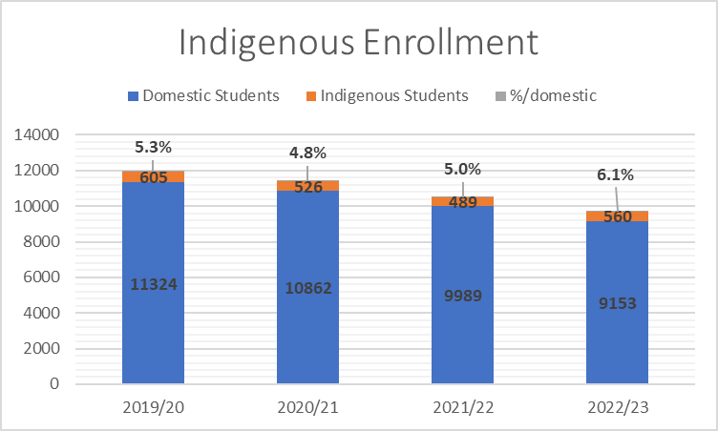
6.5%

Objective #4 - Increase Indigenous representation on Program Advisory Committees.

Target: Develop a Recruitment to plan to increase Indigenous representation on five Program Advisory Committees and include Indigenous representation within the New Program Development process

These activities support the Strategic Plan and Business Plan (5.2.4), an initiative to increase employment rates among Indigenous student population, including appropriate representation on Program Advisory Committees. Activities provide a welcoming place for all, as well as support active contribution to reconciliation. Providing quality education for students while honouring Fleming’s commitment to the CICan Indigenous Education Protocol.

Creation of External Indigenous-Led Community Council comprised of Indigenous Academic & Professional Leaders. First Meeting scheduled for October 2024, with support of Indigenous Education Council.

Objective #5 – Create, Deliver & Maintain Programs that support Indigenous Learners.

Target: Transition and expand Indigenous Student Services programs to support learners at all campuses. Creation of Indigenous student spaces on all campuses.

These activities support the Strategic Plan, Academic Plan (23) and Business Plan (5.2.2,), the incorporation of Indigenous Academic opportunities for all students will not only provide a welcoming place for all, but also support active contribution to reconciliation. Providing quality education for students while honouring Fleming’s commitment to the CICan Indigenous Education Protocol and the Truth & Reconciliation Calls to Action.

- All services successfully delivered in person:
- MIIWGT2S Awareness Week – included an on-campus red-dress exhibit
- Honouring the Children lost at Indian Residential Schools
- Hand Drum making workshops
- Drop-ins with ISS staff and peer mentors
- Métis programming in collaboration with Métis Nation of Ontario
New programs include:
- 2 Spirit Awareness Presentation and Panel
- Elder and Knowledge Keeper visits in the classroom
- New Indigenous Student Lounge “Biindigehn” in Haliburton
- New Teaching lodges completed at Sutherland & Haliburton; Frost scheduled for Fall 2023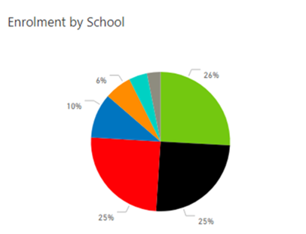
GAS 3%
HSAD 4%
SoBIT 6%
TT 10%
Health 25%
Community Services 25%
SENRS 26%

Objective #6 – Internal & External Partnerships

Target: Creation of new Internal and external partnership initiatives

These activities support the Strategic Plan, Academic Plan (20) and Business Plan (1.1.2. 5.2.2), the incorporation of Indigenous Academic opportunities for all students will not only provide a welcoming place for all, but also support active contribution to reconciliation. True and authentic partnerships have made a positive impact in both the Indigenous, non-Indigenous communities as well as internally and externally.

New partnerships demonstrating Fleming’s commitment to Honouring the Rights of Indigenous Peoples include:
- Carpentry Program & Facilities – building of Semi permanent Teaching Lodges at each campus.
- Marketing & Recruitment: creation of new Recruitment position and resource collaborations for larger reach.
- Applied Research & Innovation: Aquaculture Research Project – team travelled to far north Indigenous Community
- Business Intelligence and Research Services, Presenting at Economic Development Association of Canada Conference (Sept/Oct)
- Partnership with Research & Innovation – membership on EaRTH District

