Add Museum Annex Printer on Windows

1. Click start menu bottom left.
2. Type “Printers” to bring up the “Printers & Scanners” settings

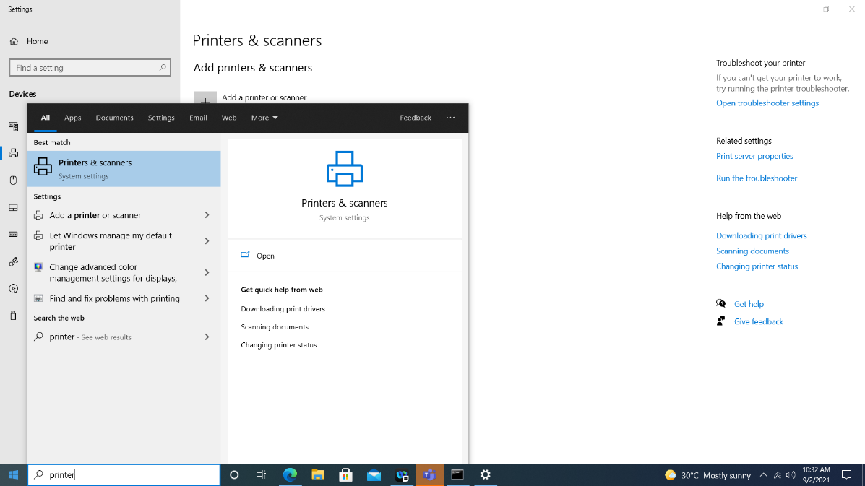

1. Click “Add a printer or scanner”

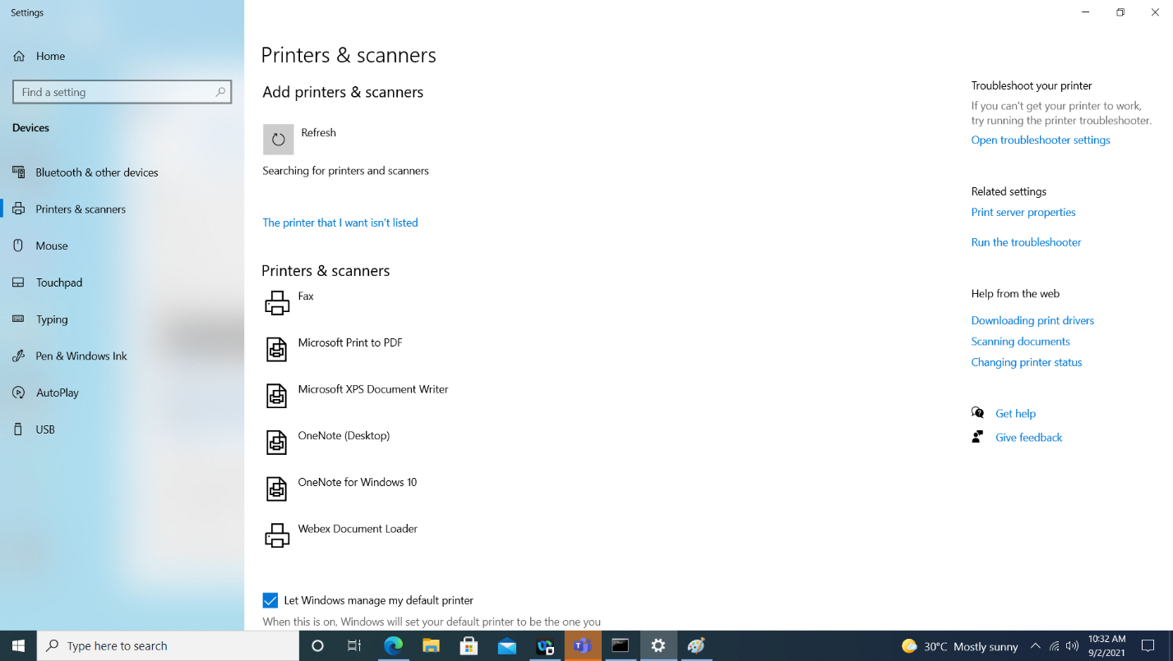

1. Click “the printer that I want isn’t listed”
2. Add a printer using a TCP/IP address or hostname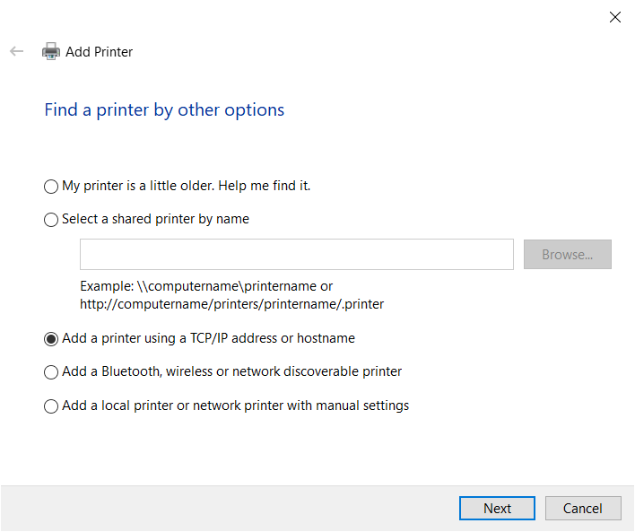
3. For hostname/ip address you can type “printer” the port name will auto fill and you can leave it as is. If you cannot add the printer by that name you can enter the address: 192.168.128.72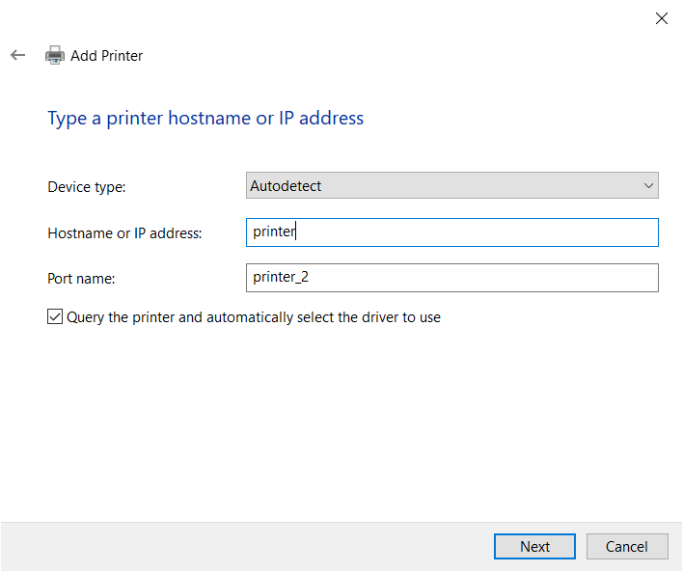**OR** 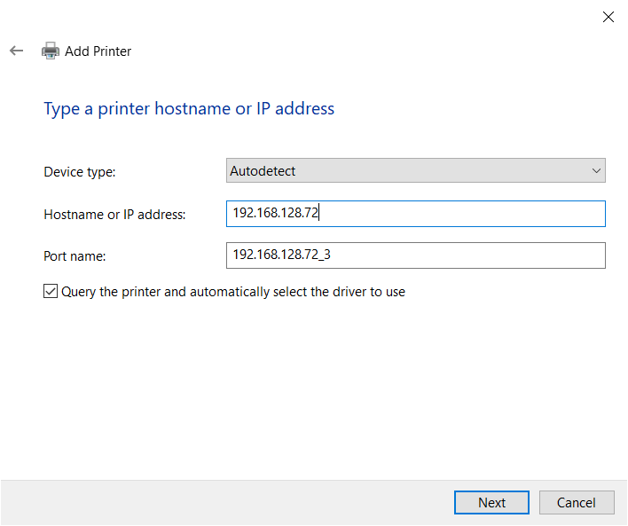
4. You will see the printer driver box come up. In the left side select “Microsoft” and then select “Microsoft PCL6 Class Driver” in the right column then click “Next”  
   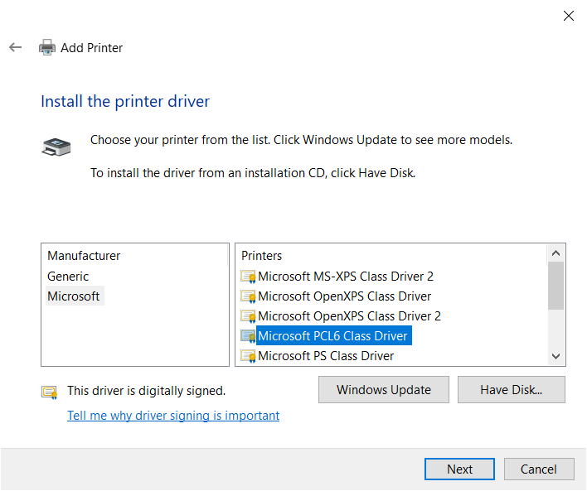
5. The next screen will install the driver, if it asks you to replace or use current driver you can select replace.
6. You will be asked to name the printer; you can name it anything that helps identify this printer for you. By default, It will be the name of the driver. Click “Next” after naming the printer  
   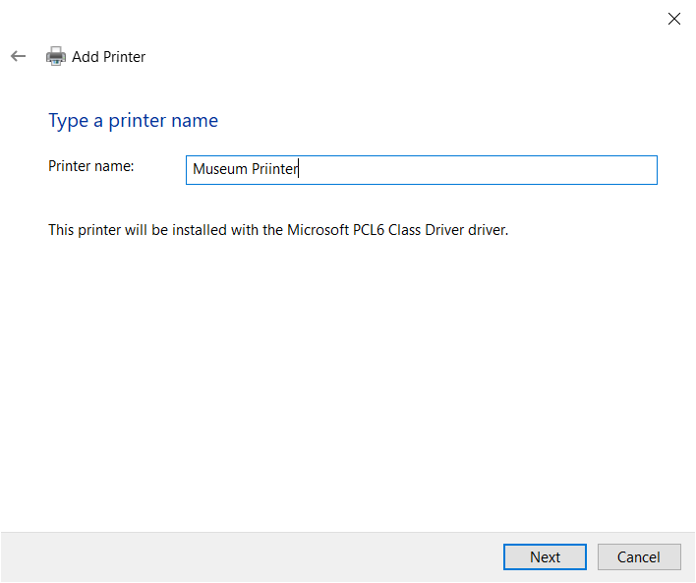
7. Select “Do not share” when asked about sharing the printer  
   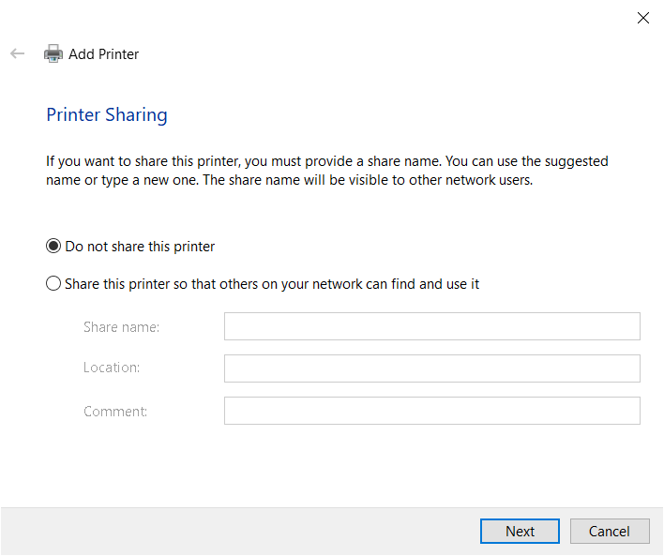
8. You can now print a test page or return to your document and select the named printer to send a job to it.