Checklist Tool Guide

what is the checklist tool?
The Checklist tool enables you to create checklists to highlight important or required assignments, readings, or other items to complete. Checklists can be used as requirements to control access to other materials using release conditions. Each checklist contains one or more categories, into which checklist items are organized. For example, you might have an Assignments Checklist with categories for written assignments and quizzes, both of which could have multiple items that students need to complete.

why use the checklist tool?
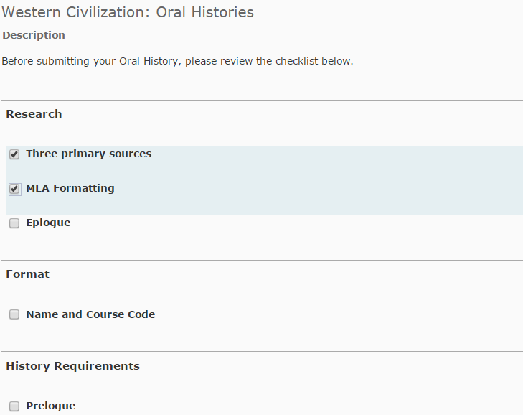
The Checklist tool allows instructors to make use of an organizational tool to improve effectiveness of groups and individuals performing complex tasks. Instructors can create checklists that:
- Account for tasks to be completed in a particular order.
- Allow for review of completed course content.
- Allow for assignment-based checklists to ensure that the appropriate items are covered in the assignment.
- Allow for a method of assessment by evaluating and assessing with checklists.

You can create a checklist that lists the activities users should complete throughout the course. For example, a checklist for the first week might include reading the course’s introductory content, posting a message to an introductory discussion topic, and submitting a list of learning goals to a dropbox folder. You can set release conditions based on users checking off items from their checklist. For example, you might release a news item on your course’s homepage once users check off that they have completed the first week’s activities.

user story
Professor Greenville teaches a Western Civilization class and likes to have students do interviews and oral histories as class assignments. He finds that students sometimes omit essential elements of the oral histories because they forget to go back and review the detailed instructions that he provided. Professor Greenville decides to turn his instructions into a checklist and to put a condition on the dropbox folder that forces the students to check off the items on the Project Checklist before submitting.
Gary Ball is a student. In the past he has forgot to include some elements of assignments for his course which resulted in penalization. He finds that by completing a checklist prior to submission of his assignment, he is able to catch any items he may have overlooked.

This example of a mandatory checklist can be associated with release conditions. Learners are required to complete the checklist items in order to access the dropbox folder to submit their assignments. Once completed the checklist provides a record (date and time stamped) for each criteria checked, creating a kind of learner contract.

creating a checklist
Access the Checklist tool via Edit Course. Select New Checklist and enter the name of the new checklist in the Name field. You can enter an optional description to identify what the checklist contains. By default, checklists open in the current window, but you can select Open this Checklist in a New Window to override this default. Select Save to save the new checklist.

creating a category
On the Checklists page, select the checklist you want to add a category to:
- On the Edit Checklist page, select New Category, enter a name and an optional description for the new category.
- Click Save to save the new category or Save and New to save it and create another one.
You must have at least one category.

creating an item
Users check-off the items on a checklist. Noting that each item you create must belong to a category, select the checklist where you want to add an item. On the Edit Checklist page select New Item. On the New Item page:
- Select a category for the item in the category drop-down list. Enter a name and description for the new item.
- Optional — Set a due date by selecting the due date check box and choosing the appropriate date and time from the drop-down lists. Select Display in Calendar to make the item visible in the calendar for students.
- Click Save to save the new item or Save and New to save it and create another one.

managing a checklist
To edit a checklist:
- On the Checklists page, select the checklist you want to edit (you can edit multiple checklists using bulk select).
- On the Edit Checklist page, make the changes you want to the Checklist Properties area, or click on a category or item in the Categories and Items area to edit those.
- Make your changes and click Save.

release conditions for a checklist
Select the checklist you want to add release conditions to. On the Edit Checklist page, select the Restrictions tab.
- Select Attach Existing if you already have a release condition that you want to attach to the checklist, or select Create and Attach to create a new release condition.
- Choose whether access to the checklist is dependent on meeting all or any of your conditions. Select Save. The checklist is now available to users based on the conditions that you define.

what tools interact with checklist?
Many tools interact with the Checklist tool. Some common tools include:

want more informatioN?
Visit the Brightspace Community (https://community.brightspace.com) or D2L Resource Centre (https://documentation.desire2learn.com) for videos, documents and other resources.
About D2L

A global leader in EdTech, D2L is the creator of Brightspace, the world’s first integrated learning platform. The company partners with thought-leading organizations to improve learning through data-driven technology that helps deliver a personalized experience to every learner, regardless of geography or ability. D2L’s open and extensible platform is used by more than 1,100 clients and 13 million individual learners in higher education, K–12, healthcare, government, and the enterprise sector—including Fortune 1000 companies.
The company has operations in the United States, Canada, Europe, Australia, Brazil, and Singapore.
© 2014 D2L Corporation.
The D2L family of companies includes D2L Corporation, D2L Ltd, D2L Australia Pty Ltd, D2L Europe Ltd, D2L Asia Pte Ltd, and D2L Brasil Soluções de Tecnologia para Educação Ltda.
Brightspace, D2L, and other marks (“D2L marks”) are trademarks of D2L Corporation, registered in the U.S. and other countries. Please visit D2L.com/trademarks for a list of other D2L marks.

