Overcoming the grips of Procrastination​!
Did you know that between 80-95% of College students procrastinate on their schoolwork?? Do not fret - you are not alone!
​​​​The first step is to better understand why and how you procrastinate and then you can determine the strategies that will help loosen the grip it has on your time.

Why do I procrastinate?
- Not sure how to do the task or where to begin
- Feeling overwhelmed or helpless
- Think there is plenty of time to complete task
- Fear of the outcome or imperfection
- Fear of being evaluated
- Lack of motivation
- Stress/ anxiety

How do I procrastinate?
- Using electronics (phone, TV, video games, etc.)
- Going online (surfing the net, social media, watching videos, etc.)
- Environmental distractions (noise, friends, etc.)
- Emotional distractions (boredom, stress, mood, feelings)
- Negative thinking (don't have enough time, won't be good enough)
- Avoidance

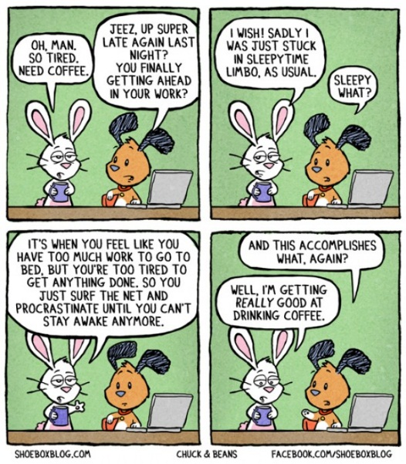

Strategies for reducing procrastination
Remove distractions. Turn off your phone. Work away from the TV. If possible, turn off the internet or work away from the computer. Install a social media blocker like "AntiSocial". Work in quiet area or wear headphones. Designate "Do Not Disturb" study time and let your friends know when it is.
Rational Self-Talk. Write down all your excuses on the right side of a paper. Write down your realistic thoughts on the opposite side of each excuse.
Positive Self-Statements. "There's no time like the present." "The sooner I get done, the sooner I can play."
Design Clear Goals. Think about what you want and what needs to be done to get it. Keep your sights realistic. Having goals too big can scare you away from starting.
Set Priorities. Write down all the things that need to be done in order of their importance. The greater the importance, the higher the priority. Start at the top and work your way down.
Break down the task. Big projects feel overwhelming. Break them down into smaller, more manageable parts. You'll get more done if you can do it piece by piece.
Get organized. Have all the materials you need ready before you begin the task. Use a planner and message board.
Use prompts. Write reminders to yourself and put them on places like the TV, refrigerator, bathroom mirror, front door, and in your car.
Don't be afraid to say "No". When friends or family ask if you are available, first assess if the event is important and whether it fits into your schedule. If not, you can say "no" or ask to reschedule for a more convenient time.
Have a motivation buddy. It can be helpful to have a classmate or friend that can remind you of deadlines, offer positive reinforcements, and suggest strategies to keep you on track.
Go somewhere to do your schoolwork. If it is too distracting to do schoolwork at home, go to the library or computer lab. You may find that it is easier to focus and accomplish your tasks in these quiet, distraction-free spaces!
Reward yourself. Celebrate! Let yourself enjoy the completion of a task, particularly a difficult or boring one. Don't minimize your accomplishments!

