Contributed by Nicole Grady, Annual Giving and Communications Officer:
On behalf of the Fleming College United Way Campaign Team – Thank you to all of the staff and students who came out in support of our 1st annual Chili Showdown and Live Auction. The event raised over $1,400 in support of United Way of Peterborough and District!

We would like to take this opportunity to thank the volunteers who helped to organize the event – Kara Rutherford, Becky McFayden and Arla Whalen. Thank you for your hard work and dedication in planning and making the event a real success. Thank you to the teams who entered their delicious chilis – Nuts and Bolts (Facilities), Fumin’ Human Resources (HR), Jeans and Beans, (Fleming Data Research), The Farmhouse Femmes (Advancement and Alumni Relations) and the mystery team, Frank and Friends! Congratulations Nuts and Bolts on your winning entry!

Thank you also to our auction donors: Facilities, Student Administrative Council, Follett, The Sporting Goods Business Program , Student Services and Parking and Security. And of course to our auctioneer, Mike Davidson. Your contributions really added some extra fun and excitement to the event.

Thank you to our judges, United Way Board Chair, Suzanne Hooke, Honourary Campaign Chairs, Alex Smith and Warren Craft, Chef Marty from Aramark and Jesse Gabai-Garle from the Student Administrative Council.

The event would not have been complete without the fabulous entertainment provided by Lorinda Frudd. Thank you for graciously offering your time and talent to this event.

And last but certainly not least, a big thank you to Mike Wood and Chef Marty of Aramark who provided the delicious chili lunches that were enjoyed by those in attendance.

Thank you again to all who made this event such a great success!

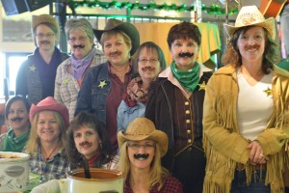
Fumin’ Humin’ Resources Team
placed second in the Chili competition.

