New fundraising record for the Souper Bowl
The Cobourg Campus’ Souper Bowl set a new fundraising record at this year’s event – $1,910.35.

This is the 10th year for the event, which raises money for the Northumberland United Way. The campus, along with Community Living Northumberland West and the Help Centre, invites the community in to the campus to enjoy a hot bowl of soup or chili, bottled water and a bun for $10.

Karen Foster, who helps to coordinate the event each year, offered thanks to a number of individuals and businesses.
“Huge thanks to our event planning team, Pat Sheldrick, Beth Bellaire, Colleen Johnston, Tracy Partridge & Gwen Bennet from the Cobourg Campus, Jenn Lean from Community Living, Patricia Crowe from the Help Centre along with Dianne Turk from Northumberland United Way, for their efforts in pulling all the details together; to our Cobourg staff members (and a couple of hard-working retirees, Brenda Liston-Hanley & Beej McNamara!) who helped out behind the scenes, and to our Academic Upgrading & Esthetician students who all worked very hard setting up, tearing down, and acting as a fantastic sales team at the ticket, spa raffle and bake sale tables!

“Many thanks also to all our Fleming, Community Living & Help Centre volunteers, staff members and students who provided soups, apple cider and baking for our sale; to Tracy Partridge, who againdonated an Essentials spa package prize to be raffled; to our local Dutch Oven Catering (Cobourg), and Aramark Food Services (Peterborough), who supported us with donations again this year – we couldn’t have put this event on without your help!”

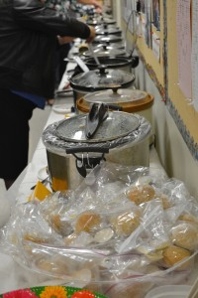
*Photo by Leigh McEachran

