Instructions for completing the Step Calculation Input Form

The electronic data you fill in on this form will be uploaded and used for determining your starting faculty salary at Fleming College. It is, therefore, very important for you to complete the form thoroughly and accurately. Inaccurate or incomplete information will delay our ability to complete processing of your pay and may result in an inaccurate salary calculation. Using Microsoft Excel, please fill in all coloured sections.

Where dates are requested, please use chronological order, starting with most recent. From dates should be from the beginning of a month, and To dates should be listed as the end of a month. All dates should be entered in the format indicated on the spreadsheet, i.e. From 9/01/2006 To 4/30/2008. If you have not completed education or continue to work for an employer, please specify today’s date in the To field.

- Relevant Education – Education credit for the purposes of determining starting salary may be provided for relevant :
- Certificates, diplomas, degrees from an accredited post-secondary institution
- Certified journeyman licence(s)
- Professional accreditations/formal work-study programs (e.g. P.Eng, C.A., C.G.A, C.M.A)
- NFPA 1041 Fire Service Instructor certification

. If you have other education such as seminars, courses or workshops, include them on your resume only.

Indicate full-time length of (not time taken to complete)
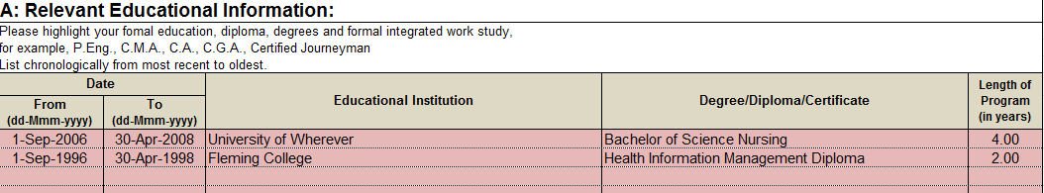

- Relevant Work and Volunteer Experience – Please list all relevant work and volunteer experience, no matter how long ago it took place. Under the column “Type of Experience” select the most appropriate description from the drop-down menu for every line of experience. If the experience was part-time, indicate the average number of part-time hours worked per week. Missing or inaccurate information may negatively impact the results of your starting step.
Drop Down Menu

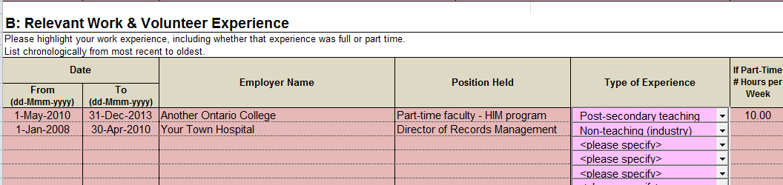

Once you have completed and reviewed the form, please return an electronic copy by e-mail as soon as possible (ideally within 1 – 3 days) to the person who provided the form to you.

