Program and Curriculum Review Template

Instructions: Review all information that is stored on your program and curriculum review web page.

https://department.flemingcollege.ca/pcr

Program Coordinator: | Kelly McKnight | Chair: | Nick Stone
Review Facilitator: | Kelly McKnight | Date Completed: | June 21, 2018
Program Name: | OTA & PTA | Program Code: | POA
1.0 Industry Trends and Employment |  | Summary of Key Findings
- Labour Market & Occupational Standard Trends  - Review and discuss the following:  - Industry / sector changes or issues identified by the Program Advisory Committee  - Recent labour market data or sector reports as provided by the Fleming Library Researchers.  - Recent or anticipated changes in occupational standards, level of entry and credential and / or standards of accreditation  - Based on the above, do these changes or issues necessitate changes to your program, either immediately, or in the next few years? |  | - An increasing number of OTs working in Ontario are employed in the private sector (community health), OTAs are not yet integrated into this area of practice  - Not all graduates are finding jobs, it is taking longer to secure employment  - Fewer full time jobs, new graduates will be seeking part time and casual employment, particularly if attempting to stay in the Peterborough area  - More graduates than job opportunities will continue as a trend over the next few years  - Graduates will be required to have a two year, combined OTA & PTA diploma from a nationally accredited college for majority of positions (especially in the hospital sector)  - Local Health Integration Networks are now responsible for regional health care delivery, too early to determine the impact this will have on Assistants in terms of access to community jobs, pay, etc.  - Loyalist College is slated to open an OTA & PTA program this fall (2018), this will result in increased competition for placements i.e. This spring (2018) we had 8 students in the Kingston, Belleville area out on 8 week placements.  - May see declining program enrollment due to increased number of competing colleges and fewer job opportunities  - The Fleming OTA & PTA program will be engaging in the National Accreditation Self Study and onsite review process over the next two years, a number of changes have been made to the accreditation standards which we will need to reflect in our report  - PAC members report: that physios are using more one to one exercise and fewer machines. Both hospitals and clinics are looking for graduates with a strong exercise background and skills  - Community OTs and PTs report fewer referrals to community care (OTs and PTs), more complex issues with fewer visits resulting in less demand for Assistants  - Dementia and other cognitive issues are being addressed by OTs in the home  - PAC Committee also stated that aggressive behavior in residents of LTC and in the Community is increasing, students need to be prepared to de-escalate situations

1.2 Graduate Employment & Employment Trends  Review and discuss the following:  - Graduate employment statistics over the last few years, including those of students employed in the field, in a related field, outside the field, or unemployed, and any emerging patterns in this data.  - Emergent employment trends such as new types of positions, changing job market, regional distinctions, changing employer profile, or emerging skill shortages | 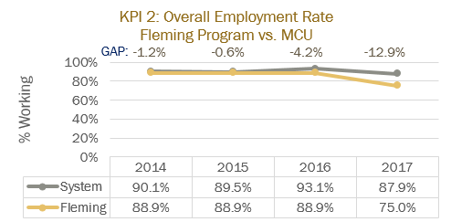  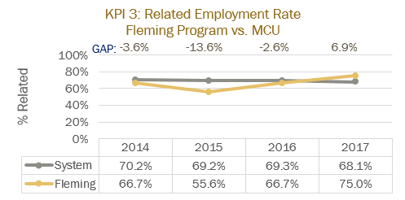  - Difficult to extrapolate data from statistics gathered, not specifically looking at OTA & PTA jobs  - KPIs for graduate employment statistics:  - Overall employment rate: 2014-88.9%, 2015-88.5%, 2016-88.9%, 2017-75% (2017 is 12.9% below system)  - KPIs for related employment rate: 2014-66.7%, 2015-55.6%, 2016-66.7%, 2017-75% (2017 is 6.9% above system)  - Majority of similar health care jobs are found in hospital (51%), private clinic sector (16%) and LTC (8%)  - Very few community jobs for Assistants at this point  - Health care is seeing a rise in use of health care teams, increase in technology for assessment, treatment, communication and client tracking  - Prediction: Unemployment will rise in this sector, along with the number of part time and casual positions  - Although the outlook for jobs in the health care sector in Peterborough is fair, the number of full time jobs is decreasing
2.0 Key Performance Indicators  Review and analyze the formal Key Performance Indicator (KPI) results for your program. | Summary of Key Findings
2.1 Student Satisfaction  - In addition to the formal Student Satisfaction KPI results, comment upon any other formal or informal discussions with students and graduates such as student focus groups, class councils, class representatives, individuals or delegations, or debriefing sessions following a field placement, clinical placement, or practical work integrated learning experience.  *Please see folder entitled “POA Accompanying Documents PR2018” for documents related to student feedback and analysis. | 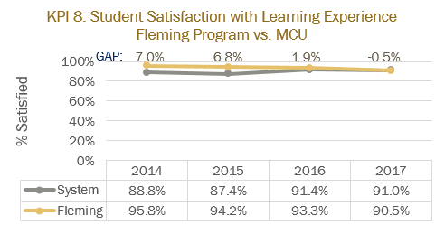  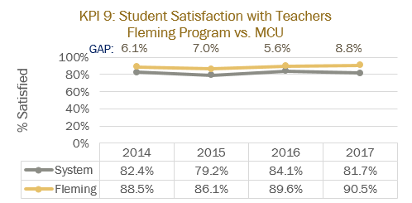  - KPIs for Student Satisfaction Rate for program: 2014-95.8% (+7%), 2015-94.2% (+6.8%), 2016-93.3% (+1.9%), 2017-90.5% (-0.5%)  - Satisfaction with teachers: 2014-88.5% (+6.1%), 2015-86.1% (+7%), 2016-94.1% (+7.8%), 2017-90.5% (+8.8%)  - KPIs for Student Satisfaction with VLOs: 2014-95.7% (+1.3%), 2015-97.2% (+4.8%), 2016-96.3% (+4%), 2017-95.2% (+4.1%)  - Placement feedback indicates satisfaction with placements and the level of knowledge students have prior to starting placement.  - We collect feedback on a yearly basis from fourth semester studies prior to commencing their final placement, the following is a summary of 2018 feedback  - Our graduates feel well prepared for final PSE and working in the field  - Themes on highlights of the program included placements, lab time, classmates, PSEs and faculty  - Placement feedback included themes of wanting more variety of placement settings, want to start going out on placement earlier than third semester, longer initial placement, overall-students were content with the placement structure and, in particular, the final 8 week placement starting in week 9  - Recommendations: eliminating community project in semester four, increasing amount of time spent on modalities, increasing lab time in general and adding a lab assistant and/or student led practice labs  - PSE recommendations: case study format for all PSEs, clearer expectations of marking criteria should be outlined prior to PSE, not one student suggested instituting a ‘re do’ policy regarding PSEs which is important to note  - The OTA & PTA program maintains an Alumni Group on Facebook which we use to poll grads around a number of issues including course content, where they work, if they will support us by taking a student for placement, etc.  - The Student Representative Council: program coordinator is not always aware of when these meetings are occurring, therefore class time given to student reps to discuss upcoming meetings or providing feedback from the meetings has been sporadic  - National program accreditation collects feedback from students  - Feedback from Student Focus Groups (Winter 2018, led by Nick Stone)  Strengths and Highlights of the OTA & PTA program  - Students enjoy the hands on learning (labs)  - Full time OTA & PTA faculty are approachable and available  - PSEs are a good opportunity for learning and receiving feedback  - Students expressed that the skills learned are relevant to their chosen career  - Accreditation of the program is an asset  Fleming’s OTA & PTA program evaluates curriculum, student engagement and faculty performance on an ongoing basis. We consider and act on feedback from all partners as appropriate. The curriculum and program structure has evolved over the years as a result of input from students, our Program Advisory Committee, national Accreditation process and placement facilitators.  Teaching Methods used in the OTA & PTA program  - Students appreciate the variety of teaching methods used in the Program  - Web based delivery is challenging for students  - Students reported that they would benefit from additional lab time  - Want lecture material posted earlier and do not want blanks in Powerpoint slides  - Students would like a greater focus on the role of the Assistant in lectures  - 7 Week courses seem rushed/crammed  - Would like more advanced notice of placement assignments and would the placement system to be more organized  - Students felt that the Therapeutic Exercise Friday lab should be more practical and clearer expectations for Bell Ringers should be outlined  Faculty in the OTA & PTA program attempt to use a wide variety of teaching methods in order to provide students with ample opportunities to acquire knowledge. We agree that students struggle with online curriculum, often ignoring it all together or not performing well with posted content. The program has lost lab time and would agree that additional lab time would be beneficial. Faculty will continue to make efforts to post material in a timely fashion. Modifications were made following student feedback to the content and length of two courses in fourth semester in order to allow students earlier entry into their consolidation placements and into the job market. There were issues this past academic year with the NARs process and the assigning of placements in semester three and four, as well as with shadowing placements in semester two. We feel these issues were due to the strike, faculty illness and a new person becoming responsible for NARs. Again, Therapeutic Exercise Anatomy’s Friday lab was an issue this year due to new faculty being assigned to the course.  Evaluation, Assessment and Feedback  - Students questioned the validity of being evaluated outside the scope of OTA & PTA  - Students would like more time scheduled for PSEs (to account for accommodations)  - The amount and quality of feedback is not consistent across the program  - Common courses seem unrelated to OTA & PTA  - Students, overall, reported dissatisfaction with this year’s Clinical Pathology course  Faculty feel that the time allotted for each student’s PSE is reflective of ‘real time’ in the working world. Students are allowed to re-start their scenario and are given additional time when requested. Additional testers and more lab time allotted to clinical courses would also assist with this.  Summary of Student Suggestions  - Increase video resources  - Better organization of the NARs process  - Increase amount of feedback given on how to improve performance  - Increased lab time  - Mentoring program or self-directed lab time would be beneficial
2.2 Retention Rate  - Use the IPP (Integrated Program Planning) data that focuses on Retention.  - Review patterns of retention on a semester by semester basis over the last five years.  - Comment on the effectiveness of any strategies adopted to improve student retention.  Refer to ‘POA Accompanying Documents PR2018’ for visual chart of retention rates (PRRetentionRates) | 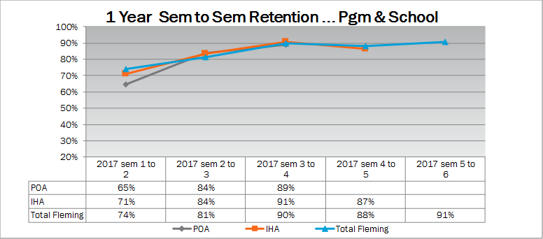  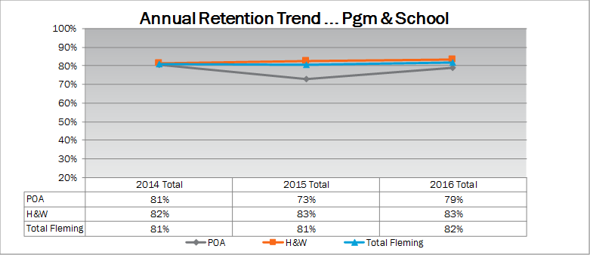  - KPI Graduation Rates: 2014-65.8%, 2015-72.2%, 2016-67.6%, 2017-65.8% (-6.9% below system rate for 2017)  - Continue to have between 30-50% loss of students over the four semesters  - Largest percentage of attrition occurs between first and second semester, followed by a smaller percentage between second and third semester  - To date, no formalized strategies for improving student retention have been instituted outside of the College’s strategies (increased access to tutoring, workshops on taking tests, decreasing test anxiety, etc.)  - Possible causes of lower than School retention rate from semester one to semester two:  - Loss of weekly one hour lab in semester’s one and two clinical skills courses?  - Increasing number of young students (not prepared for rigor of 8 course semester)  - Lack of anatomy/physiology knowledge prior to beginning college  - Students unclear as to the expectations of the OTA & PTA profession prior to starting the program  Fleming’s OTA & PTA program has similar retentions rates to other OTA & PTA programs across the Province as well as several other health care professions  Fleming is not the first choice of OTA & PTA programs for many applicants, this, coupled with no entrance exam, may impact retention rates
2.3 Graduate Rate  - Review patterns of graduation rates on a semester by semester basis over the last five years. | 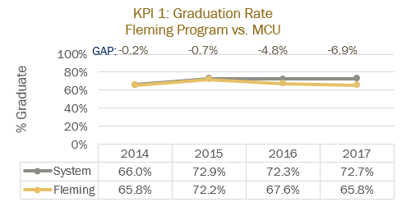  - Fleming OTA & PTA program graduation rates are lower than system averages  - Potential explanations for this could include a different student demographic (young, rural), rigorous curriculum and high expectations versus the high school experience, few entrance requirements for the program, Fleming tends not to be the student’s first choice of colleges/programs
2.4 Graduate Satisfaction  - Review patterns of graduate satisfaction and provide comment. | 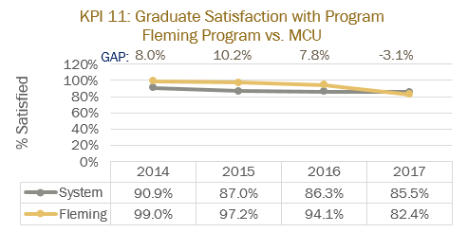  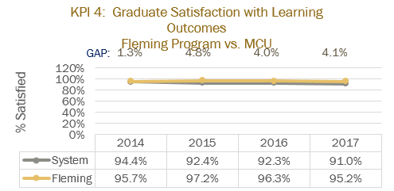  - Graduate satisfaction in Fleming’s OTA & PTA program has always been above provincial average until 2017  - However, grad satisfaction with teachers has actually improved (88.5% in 2014 to 95.8% in 2017  - As well, satisfaction with overall learning experience declined from 95.8% to 90.5% over the same time period but still remains above system average for OTA & PTA programs  - It should be noted that KPIs are based on small sample sizes, for example, in 2017, 8 grads submitted data  - May be a ‘blip’, system average was also down in 2017  - Other possibilities for this decline could be issues in finding 6 week placements in spring 2016, and fewer jobs being available for graduates  - Graduate satisfaction with learning outcomes is quite high, in keeping with the system results
2.5 Enrolment Trends and Demand  - Your team will review and analyze the patterns in the number of program applicants, confirmations and actual registrants over the past 5 years. You will also examine changes, if any, in the student demographic profile and the impact, if any, of this changing student profile on program curriculum.  - Assess whether the program curriculum needs to change based on the above analysis.  - Use the FDR excel spreadsheet that provides Day 10 enrolment numbers for Fleming for the last 10 years, to assist you with your analysis.  - Please review the IPP (Integrated Program Planning) data that focuses on trends related to student demand, and the related ‘Situational Analysis’ information included for your program – select the Demand Trending Tab and Situational Analysis Tab. | 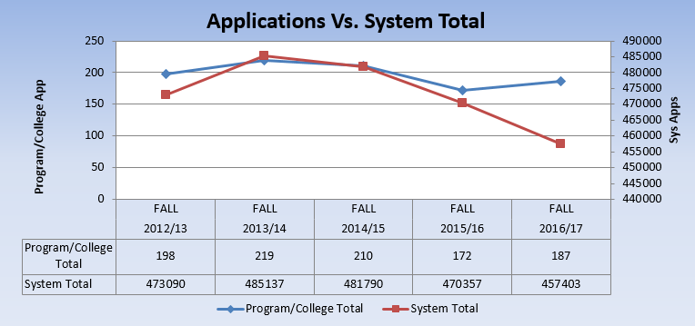  - Applications to Fleming’s OTA & PTA program remain fairly consistent and have fluctuated in line with the system total  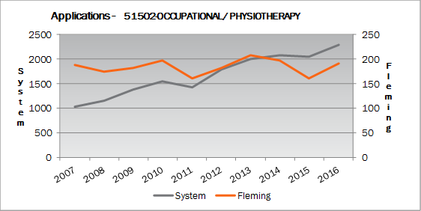  - Fleming OTA & PTA program has lowest number of applicants in southern Ontario Colleges of similar size with the exception of St. Clair for past five intakes  - Application numbers for Fall 2018 to the OTA & PTA program are down by 4.1%, the School of Health & Wellness applications are down by 6.6%, Fleming College applications are down 7.7% overall  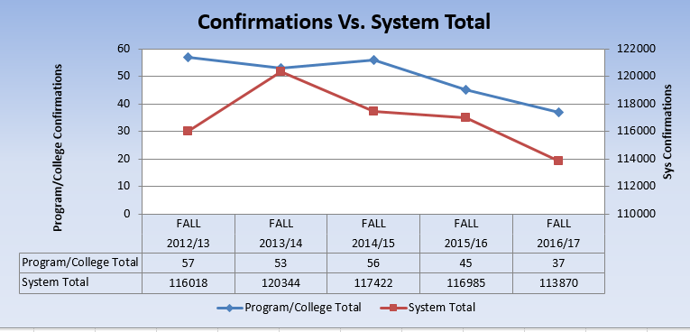  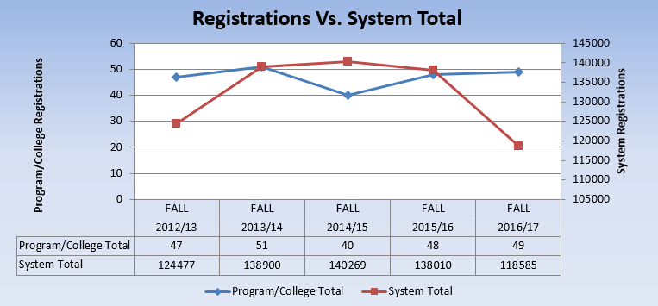  - Our target intake is 48, 2014/2015 acceptances went out late-affecting total numbers  - Actual numbers of students in the program are typically at least a few over this recorded target, as part time students are not captured in these statistics  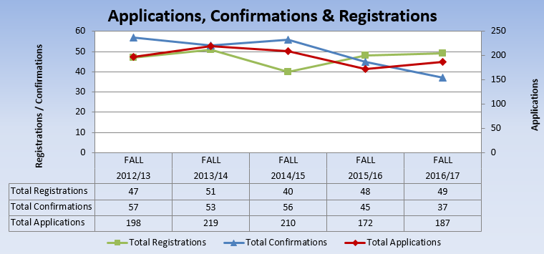  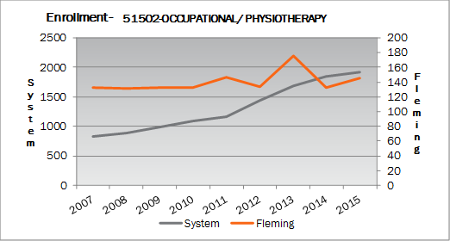  - A target of 8 international students has been included in the overall 48  - The OTA & PTA program, over the past few years, consistently has a number of Indian trained physiotherapists  - Other countries represented in the OTA & PTA program include South Korea, China and Vietnam  - At this time, no changes to the curriculum are warranted by inclusion of these students  - Other demographic changes include a higher proportion of younger students (straight out of high school)  - We continue to have 80-90% female students, attrition is higher amongst male students
3.0 Program Curriculum | Summary of Key Findings
3.1 Program Learning Outcomes and/or Sector Standards  - Review program level learning outcomes in preparation for curriculum mapping (vocational, essential employability skills, general education)  - Where applicable review sector standards to ensure program is keeping up with new trends, developments and requirements. | - Same vocational learning outcomes as when previously went through Program Review, the MAESD will be reviewing and updating the OTA & PTA program VLOs in fall of 2018  - Curriculum is constantly updated based on PAC, student and preceptor feedback as well as through research by faculty members  - The National Accreditation program also informs changes/updates to curriculum

3.2 Program of Study, Course Outlines, Delivery and Program Map  - Review the feedback and suggestions received from Course-level survey completed by faculty at the end of each semester.  - Review the balance and frequency of assessment types across the curriculum and their appropriateness to learning outcomes for the course and program level outcomes.  - Collect a cross section of samples of student work as evidence of achievement of learning outcomes.  - Reflect and comment upon the variety of methods used to demonstrate program outcomes.  - Reflect and comment upon the degree of technology-enhanced delivery of the program outcomes.  - Discuss the degree and depth to which the program is providing work integrated learning experiences.  - Discuss the degree and depth to which the program includes Indigenous perspectives and record the courses in the curriculum in which Indigenous perspectives are covered  - Record the course in the curriculum that covers the college-wide sustainability learning outcome  - Review (or create) Program Curriculum Map(s) to ensure that there is alignment of current courses to the overall program outcomes, including the Vocational Learning Outcomes, the Essential Employability Skills, and adherence to the General Education Policy.  - Review pre and co-requisites to ensure that they do not hinder progress in the program, unnecessarily.  - Make recommendations to address any gaps identified or improvements required.  - Review the program’s current admission requirements and their suitability in relation to program rigour and student preparedness.  - Include an updated program curriculum map on your program and curriculum review web page.  - Please see folder entitled “POA Accompanying Documents PR 2018” for samples of student work and discussion of relation to learning objectives and VLOs | - Indigenous Perspective: Limited throughout the program, HLTH65 (Concepts in Health Care) has a module (4) that addresses rural health care issues, Indigenous populations, traditional medicines and complementary medicines. The mother & daughter in the case study are Indigenous.  - SCIE61 (Clinical Pathology) addresses indigenous health issues throughout the course but not through a specific Indigenous lens.  - HLTH43 (Clinical Case Studies) contains a case study with an Indigenous male living outside a reserve.  - Sustainability learning outcome: The College wide sustainability learning outcome is contained in the semester one course: HLTH65 (Concepts in Health Care).  - Technology-enhanced delivery of program outcomes:  - There are instructional videos in all practical skill courses throughout the program  - All Practical Skills Evaluations (PSEs) incorporate simulated patients into the testing process  - HLTH65 is an online course that utilizes learning modules with animated scenarios  - FLPL85 & HLTH41 utilize online learning to augment/assess curriculum  - Discussion boards on D2L are used in FLPL88 and the plan is to add a chat function to FLPL86 this coming fall  - Students have the opportunity to take their gen ed online  - SCIE157 & SCIE158 contain online learning activities as part of their curriculum  - Pre-requisites and Co-requisites:  The OTA & PTA program has a lock-step progression through the four semester, hence, there are many pre and co reqs. This prohibits students who fail mandatory pass courses in one semester from proceeding to the next. Please refer to accompanying document in folder and recommendation section for details.  ADMISSION REQUIREMENTS  OSSD with the majority of credits at the College (C) and Open (O) level, including:  2 College (C) English courses (Grade 11 or Grade 12)  2 College (C) Science courses (Grade 11 or Grade 12)  When (C) is the minimum course level for admission, (U) or (U/C) courses are also accepted.  Recommended:  Grade 11 and 12 University/College (UC) Science.  Although not required for admission, recommended courses will help prepare you for this program.  - The issue of adding admission requirements used by other OTA & PTA colleges in Ontario has been discussed over the years, including Niagara College who uses the Health Occupations Aptitude Test and Algonquin who charges $50 for their Health Program Assessment  - Fleming is committed to providing open access to its college programs and, as such, additional admission criteria for the OTA & PTA program is not compatible with this philosophy  - A review of the other OTA & PTA public college programs across Ontario reveals that Fleming’s admission requirements are in line with the majority of the programs  - Conestoga and Algonquin require a grade 12 math  - Conestoga and Centennial can substitute Exercise Science (U level) for the grade 12 science course requirement  - Sault College recommends Intro to Kinesiology  - We do feel that the high school cohort is unprepared for the rigor of an 8 course first semester and attrition, therefore, is significant during the first two semesters  - Anatomy and Physiology I (Semester One) and Anatomy and Physiology II (Semester Two) have the lowest rate of academic success. The clinical courses, Basic Clinical Skills I and II and Therapeutic Exercise Anatomy have fairly consistent pass rates of 74-77%  - Research does suggest that entrance testing/interviews ensures that incoming students have an awareness of the program and their commitment to the learning process (Attrition, Canadian College Attrition)  - Work Experience: OTA & PTA students must complete a minimum of 500 clinical placement hours in order to graduate, at least 150 hours must be in one discipline  - Our curriculum includes two shadowing experiences in second semester (those hours are not counted as placement hours), one two days a week for the last seven weeks in semester three and one two day a week in the first seven weeks of semester four. Students then commence an 8 week, full time placement in week nine that allows them to accumulate 500 or more clinical hours.  - Faculty attempt to secure at least one OTA and one PTA two day placement in semesters 3 & 4, an attempt is made to offer the student placements in a variety of settings  - Due to the limited availability of OTA placements, Fleming hires an OT to supervise students in a LTC facility for the two, two days a week placement blocks  - Ensuring work integrated learning continues to be a challenge, particularly for the OTA hours  - The OTA & PTA program uses a variety of methods to assess student’s acquisition of knowledge (see folder “POA Accompanying Documents PR2018” for assessment map). We base assessment methods on the learning outcomes in order to determine appropriateness of the assessment method.  - Throughout each semester, there are times when the frequency of assessments is high (ex. Weeks 7 and 15). Faculty use the assessment map in an attempt to stagger assessments whenever possible. (see folder “POA Accompanying Documents PR2018” for assessment map).
4.0 Strategic Positioning and New Opportunities | Summary of Key Findings
4.1 College and School Alignment  - Review program alignment with college priorities such as vision, mission, values, strategic plan, academic plan and the educational mandate, and / or academic priorities of the School.  - Review program webpage and promotional messaging to ensure accuracy and currency. | - Faculty developed program specific vision, mission and philosophy statements that reflect Fleming’s overall vision, mission and values. OTA & PTA statements mirror those found in the College’s strategic plan and are contained in our student and preceptor manuals.  - Program web page contains one error with curriculum (wrong course listed)  - No student/grad statements on page, one employer only  - ‘Fleming staff is committed to surpassing national accreditation standards by ensuring that students accumulate 540 clinical hours, with no less than 30% of these hours being in one discipline.’ This last statement is misleading and will need to be changed.  - ‘As with other health-care professions, OT and PT Assistants have to be compassionate, empathetic, and have a genuine concern for people.’ Incorrect title, needs to be written out in full.  - ‘respect for diversity (age, gender, ethnicity)’, need to omit the info in the brackets  - ‘Students will be required to acquire CPR (C level) and Standard First Aid Certification prior to classes.’ This sentence needs to come out and the NARs section needs  - Under related programs, ‘Fleming College has reserved space in the Occupational Therapist and Physiotherapist Assistant program for students who successfully complete one year of study in this program.’ Should read ‘Occupational Therapist Assistant and Physiotherapist Assistant’  - ‘Upon graduation from the OTA and PTA program, you might also consider taking more education at the university level to become a physiotherapist or occupational therapist.’ Omit
4.2 Competitor Programs  - Analyze key parallels and differences between this program and those of its closest competitors, where applicable.  - Comment on the ’Value-added’ program distinctions and their attractiveness to prospective students. | - There are currently 14 public OTA & PTA programs in Ontario (including 2 programs offered in French), Loyalist will begin their OTA & PTA program in fall 2018  - 10 Ontario public OTA & PTA programs are either accredited or in the process of becoming accredited through the national OTA & PTA Education Accreditation Program  - There are also 3 accredited programs through the private college TriOS  - https://otapta.ca/english/index.php  - The two geographically closest public Colleges offering the OTA & PTA program are Centennial and Durham  - Both programs have fall intakes, are four semesters in duration, offer a stand-alone mental health course, teach OTA and PTA skills separately (although Durham offers a combined course in fourth semester), anecdotally Centennial has a higher number of international students than Durham  - Durham’s program is situated on UOIT’s campus, it began in 2014 and has all the ‘bells and whistles’ of a new program. It has been oversubscribed since its start, closing applications early in the cycle. Durham has established formal partnerships with Lakeridge and Grandview Children’s Centre which, along with its proximity to Toronto, gives them a significant edge when placing students for clinical experience. Their marketing department has committed significant resources to assist the OTA & PTA program in assuring large numbers of applicants and placements  https://durhamcollege.ca/programs/occupational-therapist-assistantphysiotherapist-assistant  - Centennial offers their OTA & PTA students a second semester long term care placement supervised by OTs paid by the College. Thus, they can almost meet the required number of OTA placement hours in this clinical setting alone  https://www.centennialcollege.ca/programs-courses/full-time/occupational-therapist-assistant-physiotherapist-assistant/  - Algonquin College opening their OTA & PTA program in 2016 has affected the number of placements we can offer in the Ottawa area, it also seems that the number of applicants from that area (which used to be significant) is down at our College, currently they are waitlisted for Fall 2018, we are not  - In general, curriculum of the Ontario OTA & PTA programs is similar, the size of the intake varies but the Colleges closest to us geographically have similar numbers  - High attrition is common across the province, a common evaluation form for Practical Skills Evaluations has been developed by national educator’s group  - Currently, the OTA & PTA program does not have a ‘value added’ program distinction
4.3 Learning Pathways  - Comment on recent or anticipated initiatives that promote student pathways including secondary school partnerships, dual credits, program laddering, dual diplomas, and university transfer, articulations, and partnerships.  - Review all transfer credits.  - Identify any new pathways that could be developed. | - Currently the OTA & PTA program has no formal dual credits or secondary school partnerships  - No program laddering, dual diplomas  - Possible partnerships for dual diploma could include the therapeutic recreation program, the PSW program could be examined for laddering into the OTA & PTA program, A & PI (SCIE157), Healthcare Concepts (HTLH65) could be considered for a dual credit (Human Growth & Development (SOCI25) is already offered to high school students at Crestwood)  - One formalized specific pathway for our program into university (UOIT), students can usually negotiate approximately one year’s worth of credits at the university level  - Attempt was made to partner with a Scottish university, they changed requirements for entry into their program  - Challenging to develop pathways as OTA & PTA students cannot bridge into OT or PT programs, in fact, OTA & PTA diploma may hamper efforts to apply for Masters programs  - Other Ontario OTA & PTA programs have established partnerships with universities in different countries with varying success  - Faculty are open to developing pathways with university or college level programs
4.4 New Program or Redesign Ideas  - Are there opportunities for new program initiatives based on Program, School, or community strengths and alliances? | - Based on current data, it does not appear that any new program initiatives are warranted at this time
5.0 External Relations | Summary of Key Findings
5.1 Community Partnerships  - Does your program have significant partnerships, relationships, connections, or offers of support from the community that help to enrich the program and the student experience?  - Are faculty, staff, and student involved in volunteer projects and events? | - Currently our program has partnerships with number of physio clinics, hospitals, Long Term Care Facilities who offer placements to our students  - PAC composed of physiotherapists and occupational therapists from the community, hospital, Children’s Treatment Centre, and LTC facilities  - Strong partnership with Cathy Mitchell, Rehab Assistant at PRHC, who advocates for placing OTA & PTA students throughout the year  - It is becoming increasingly challenging to place students in second, third and fourth semester: number of hospital placements prior to the final 8 week placement is down -Ross Memorial did not take on student this past academic year despite many phone calls, emails, etc. on the part of Fleming faculty  - Likewise, Northumberland Hills only offers final placements, they do not like the two day a week placement structure  - PRHC instituted a full day orientation process for students which is extremely difficult to organize and execute (we have no placement offers when the sessions run and students must miss a day of classes, which we can’t support)  - Students raise money and/or awareness for an organization of their choosing in a semester four course: Selected Topics in Rehab  - Otherwise, they independently may participate in volunteer projects and events but we don’t track those  - Currently full time faculty in the OTA & PTA program are not involved in volunteer projects or events in the Peterborough area
5.2 Program Advisory Committee  - Comment on the distribution of Committee membership by constituency, sector, and / or region.  - Comment on the vitality of the Committee (frequency of meetings, members’ level of participation, engagement, and turnover) | - Active PAC OT, PT and Assistant members include:  - 2 hospital liaisons (one Rehab Assistant-PRHC, one OT-Ross Memorial/KTS)  - FCCC-OT (does not attend regularly)  - Alumni: 2 PTAs working in clinics and 1 PTA working at Children’s Hospital  - 2 Clinic PTs  - 1 Kawartha Therapy Services OT  - 1 private practice OT  - 2 student reps (1st and 2nd yr.)  - Members provide useful feedback and all have been on the committee for at least two years  - They are not active or engaged with the program outside of taking students and attending meetings. I.e. No special projects
5.3 Alumni Relations  - Describe the type and range of alumnae involvement in the program.  - Current and future strategies to engage alumnae in the program. | - Currently we have two Alumni on the PAC  - Two Alumni are hired to assist in the lab and with practical tests  - Alumni are active in a Fleming OTA & PTA Alumni Facebook page, posting jobs and interesting, relevant articles  - Alumni donate used program shirts for current students  - Alumni volunteer to act as simulated patients for Practical Skills Evaluations  - Alumni act as preceptors for many of our current students  - We did attempt to hold a reception for preceptors but had very poor attendance  - Currently we have no strategies to increase alumnae engagement in the program
6.0 Program Resources | Summary of Key Findings
6.1 Program Revenue and Expenses  - Please review Integrated Program Planning (IPP) information for your program.  - Are program resources adequate, in the context of program currency and student numbers? (e.g. laboratory equipment, software, library holdings, or tools essential to program delivery and student learning.  - Are there opportunities for further program specific external revenue such as sponsorship, grants, donations or gifts-in-kind?  - Review the existing revenue and expenses associated with your program using the IPP tool and provide comments below.  - Review all textbooks for cost, format (hard-copy, e-book, rental), use in multiple semesters, content (curriculum alignment, Canadian content, readability, engagement level), ancillary materials (question bank, Powerpoint, online support, image bank), publisher support, AODA compliance, and conflict of interest. | 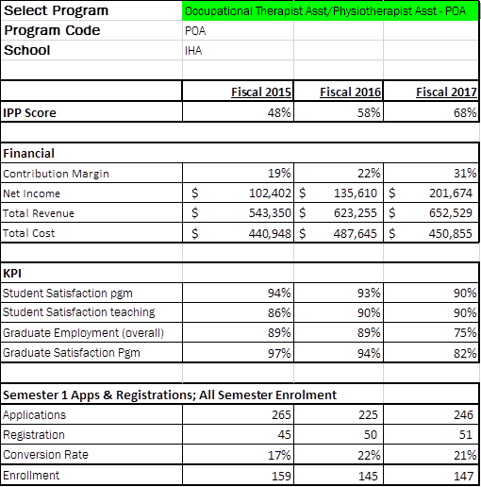  - Physical program resources are currently adequate for the number of students in the program  - Equipment is aging and showing signs of wear and tear e.g. the wheelchairs purchased by a donor several years ago are in poor shape due to lack of proper storage and poor handling by students in various College programs  - Faculty continue to purchase and/or use their own equipment and supplies for lab purposes  - Current resources associated with the program are being reviewed to coincide with the renovation of A-Wing Lab space (use of lab to commence Fall 2018)  - New equipment will replace aging equipment or will be added to current inventory  - The OTA & PTA program has contributed positively to the College over the past three years, however, it has not met the college target of 35% CTO  - Reasons for improved contribution margin include the increasing number of international students in the program, reduction of curriculum hours and removal of a technician in core first and second semester courses  - Please see folder “POA Accompanying Documents PR2018” for overview of textbooks used in the OTA & PTA program. Faculty review core subject textbooks on an ongoing basis. Books are selected for readability, use over a number of semesters and to ensure that content is aligned with course learning outcomes and program VLOs.
6.2 Faculty and Staff Resources  Please comment on:  - The number and distribution of all faculty, technicians, and technologists associated with the program including full-time, part-time, sessional, and cross-appointments.  - Profile of the faculty, and staff associated with the program including cumulative credentials, scholarship, work-related and teaching experience, and expertise in education.  - Significant faculty or staff accomplishments such as professional recognition and awards, achievement of credentials, and appointments.  - Hiring priorities over the next few years based on the above. | - There are 2 full-time professors dedicated to the OTA&PTA program who teach the majority of the hours in the program  - Currently, there is one full-time faculty member who is a registered Occupational Therapist and one who is a registered Physiotherapist  - National Accreditation standard dictate that faculty teaching core courses containing OT and/or PT content must be registered with either the College of Occupational Therapists of Ontario (COTO) or the College of Physiotherapists of Ontario (CPO).  - The contract faculty membership has remained steady over the years with three specialist faculty members used to teach specific courses within the program  - Recently the contract faculty membership was increased to five with the hiring of two registered Occupational Therapists  - Specific courses within the program require specialist designations to teach them, such as Speech Language Pathologists– the same SLP has taught the Communications course since 2003  - The program also uses technicians for skills labs as well as testers to help facilitate the Practical Skills Evaluations (PSEs)  - Hiring priorities over the next 3-5 years are focused on maintaining the current full-time faculty numbers while growing the contract faculty membership
6.3 Program Delivery Capital Assets  - Please review existing program space and equipment  - Determine needs for space and equipment to fulfill future needs | - Current lab space for the program is challenging, primarily due to A-Wing construction and having been displaced for the entire 2017-2018 academic year  - Lab space is less than ideal and is cluttered while sharing with multiple programs during the construction phase  - Moving forward, the OTA&PTA program will have a new lab space to use starting in Fall 2018  - This new lab space will create a clean, organized, and up-to-date contemporary learning and teaching environment for the OTA&PTA students and faculty  - The program has many equipment needs due to the nature of the profession  - Storage space is a challenge given the size and irregular shapes of specialized equipment  - Currently, equipment that is used only occasionally throughout the academic year is stored outside the main building (in a shipping container on campus) and brought in during the duration the equipment is used  - This creates logistical and storage concerns regarding timely access to equipment and additional lack of storage space while the equipment is in the lab  - It is unclear if the storage space assigned to the new lab will be adequate

Program Improvement Plan

Based on the analysis of your key findings, identify areas that require attention and action in the next 1-3 year timeframe. Ensure that you only recommend actions that reflect the program’s priorities and its capacity to achieve them, and record the success of any changes implemented and the means by which they are being evaluated.

To make sure your goals are clear and reachable, each one should be:
- Specific (simple, sensible, significant).
- Measurable (meaningful, motivating).
- Achievable (agreed, attainable).
- Relevant (reasonable, realistic and resourced, results-based).
- Time bound (time-based, time limited, time/cost limited, timely, time-sensitive).

New Recommended Improvements | Timeframe | Person(s) Responsible | Approval: Dean, Chair, or VPA or  Not Feasible, with rationale
The OTA & PTA program webpage will be updated to reflect most current information and to enhance marketability.  Strategies:  - Grad/student statement on webpage  - Explore possibility of promotional video  - Semester One: ‘Across the Lifespan’ SOCI233 needs to be changed to ‘Human Growth & Development’ SOCI25  - Change last sentence under ‘Work Experience’ to “Fleming staff is committed to surpassing national accreditation standards of 500 clinical hours, with no less than 150 hours being in one discipline.”  - Omit ‘Students will be required to acquire CPR (C level) and Standard First Aid Certification prior to classes.’ under ‘This is You’ section | By September 2018 | Nick Stone will make request to appropriate Fleming staff  Deryck will email Laurie Humphries with contact information of grad/student  Deryck will also question Laurie about the idea of a promotional video | Approved by Carol Kelsey (Dean) and Nick Stone (Chair)
Develop and incorporate specific strategies in semester three to support the fourth semester community project.  - Introduce community project (completed in HLTH44) in semester three orientation session (Tuesday after Labour Day)  - Add ‘chat’ function to FLPL86, students will need to engage in online discussions in order to set up community project for fourth semester  - Discuss advocacy in FLPL86 in an online unit | Fall 2018 | Deryck will develop the online community project ‘unit’ and chat outline for FLPL86 | Approved by Carol Kelsey and Nick Stone
Additional strategies for incorporating simulation into curriculum and authentic assessment will be developed.  - Explore possibilities to add technology (videotaping) and increased use of case studies to PSEs  - Discuss ways to utilize sim lab | By Spring 2019 for addition to curriculum Fall 2019 | Deryck and Kelly, with support of Wendy Morgan | Approved by Carol Kelsey and Nick Stone
Enrollment targets for the OTA & PTA program, given the growing number of OTA & PTA programs in Ontario and continued challenges securing placements, will be reviewed.  - Possibly consider target enrollment reduction over the next few years based on identified retention issues and declining enrollment across the system  - Applications to the program will need to be closely monitored  - Consider placement structure in order to increase number of total placement hours | Ongoing | Deryck, Kelly, Nick | Approved by Carol Kelsey and Nick Stone
The 45 hours gained from removing COMP345 in first semester will be reassigned to best support student learning.  - Consider extra hour lab time for HLTH35 and HLTH36  - Possible back 7-1 hr. course in semester 3 (community project, modalities, documenting, therapeutic exercise) | Spring 2019 | Kelly, Deryck with support from Nick as needed | Carol Kelsey and Nick Stone
A thorough review of PSE structure and content will be conducted in order to ensure alignment with the OTA & PTA National Global Rating Scale.  - Increase use of case study format  - Videotape PSEs  - Additional number of marking instructors in PSEs (would also need additional simulated patients)  - Increasing the amount of time given to students in PSEs  - Sequestering students during PSE | Spring 2019 (During Spring Development period) | Deryck, Kelly, assistance from Wendy as needed | Dean Carol Kelsey and Chair Nick Stone
The OTA & PTA course pre-requisites and co-requisites will be updated to allow greater flexibility for student progression.  - Please see “POACoPreReqChanges” in folder | Fall 2018 | Nick Stone | Carol Kelsey and Nick Stone
Previous Recommended Improvements | Timeframe | Person(s) Responsible | Update and Rationale: Proceeding = P  Completed = C  Not Feasible = NF
Section 1.3 – Strengthen focus on Community based projects and professional affiliations |  |  | P: Students continue to be involved in a community based project in semester four. Faculty reached out to Queen’s University in an effort to create a partnership, never heard back. Encourage students to join their professional affiliations (CAOT and CPA).
Section 2.4 - Review content in Clinical Case Study Course to include catheters, IVs and test tubes  Exercise A & P (in FHP): look at FHP’s course to see if it is a better fit than Regional Anatomy |  |  | P: Equipment is now taught in semester two but still need to incorporate into culminating PSE and/or Case Studies  C: Developed a therapeutic exercise anatomy course and students no longer take Regional Anatomy
Section 2.5 – Hybrid or web-based course |  |  | C: HLTH65 is a web based course. HLTH41 is a hybrid as is FLPL85.
Section 2.6 – 60 % pass in all OTA & PTA courses |  |  | NF: Other comparator programs have lowered their 60% course pass requirements
Section 2.7 – Diversity course/content: Assess the need for a stand-alone diversity course or increase the content of diversity throughout the program  Need to increase diversity in clinical case studies rather than just reflecting the local community |  |  | C: Diversity has been included in HLTH65, SCIE61, FLPL85, HLTH269, HLTH41, HLTH44, HLTH43
Section 2.8 – Student preparedness i.e. students not prepared for the rigor of the OTA & PTA program |  |  | P: Faculty discuss program demands at Open Houses, program web page outlines qualities required by an Assistant
Section 2.9 – Dual credit & laddering, Fast Track for FHP |  |  | NF: Possibilities were discussed, one student fast tracked (kinesiology degree), was successful, however changes to program structure precludes this from happening on a regular basis
Section 3.2 – Debriefing sessions following field placement |  |  | Not sure what students were seeking. There is no formal debriefing session following field placements. Students complete a self-reflection journal, evaluation of clinical placement and there is a discussion board for the 8 week placement. There is an Alumni Facebook group available to graduates as well.
Section 4.2 – Post – diploma certificates or Con Ed courses |  |  | NF: This issue has been addressed by Ontario’s public OTA & PTA programs. Numbers of potential students are too small to make this financially feasible.
Section 5.1 – Accelerated POA Program |  |  | NF: Again, too small numbers interested in this option
Section 5.2 – Articulation agreements |  |  | P: Articulation agreements have been attempted with limited success
Section 7.1 – Reunions  Plan to build alumni support |  |  | P: Alumni Facebook group, attempted appreciation tea (some of whom would have been Alumni), considered asking Alumni to attend Open Houses, have Alumni representatives on PAC

