

***STRICTLY CONFIDENTIAL***

**APDC/ASA EXECUTIVE SUMMARY TEMPLATE**

**FOR PROGRAM REVIEW**

|  |  |  |
| --- | --- | --- |
| **Subject:** | **School of Justice and Business Studies** **Program Review Report** |  |
| **Program** | **Pre-Service Firefighter Education and Training** | |
| **Presented by:** | **Jim Drennan** | |
| **Action:** | **For Discussion / Information** | |

**SOURCE**

• Fleming’s Quality Assurance Process (College Policy 2-207)

• ASA Committee mandate (Board Policy 1-102J) to conduct reviews of existing programs of instruction on an ongoing basis, subject to current regulation, legislation and policy directives

**PROGRAM DESCRIPTION**

*Note: The Ontario Association of Fire Chiefs (OAFC) through the Endorsement Review Board (ERB) endorses the program content of the Pre-Service Firefighter Education and Training program. This curriculum is based on the Ontario Fire Marshal's "Ontario Standardized Curriculum for Firefighters (2008)" which meets the body of knowledge and practical skills required to meet the job-related performance objectives specified in the Ontario Fire Services Firefighter Standards. Graduates of the Pre-Service Firefighter Education and Training program are eligible to write the OFM Provincial Firefighter Test.*

* *In 2012, the Pre-Service Firefighter program at Fleming was re-endorsed through this process, immediately following a Program Review. For this reason, some elements of this template have been modified to reflect the external endorsement process.*

Created and taught in partnership with the Peterborough Fire Department, the Pre-Service Firefighter program offers theory and practical experience in the field of firefighting, fire prevention, and emergency rescue and operations. The curriculum adheres to the requirements of the Endorsement Review Board and stays current in its offering.

The office of the Ontario Association of Fire Chiefs and the Ontario Fire Marshal (OFM) have indicated they want municipal fire services (like Peterborough's) to work in partnership with community colleges to provide well-rounded training for firefighters. As a result, Fleming's innovative firefighter program combines practical training integrated with theory at a fully equipped training centre.

Successful completion of this program prepares graduates to write the OFM Provincial Test leading to the Ontario Fire College (OFC) Certificate of Achievement. Courses will cover such diverse areas as fire behaviour and extinguishment; emergency medical skills; hazardous materials; extrication; rescue techniques; communications; physical fitness; risk assessment; public education, and more.

This program is delivered in three consecutive semesters and therefore can be completed in twelve months. During the summer, for an additional cost, students will have the opportunity to qualify for a DZ license. Students can also take advantage of Fleming’s partnership with the seasoned professionals of the Peterborough Fire Department. In addition to classroom time, students are provided with many opportunities to work with and learn from firefighters working in this community, dealing with real-life situations. Upon successful completion of the OFM provincial exam, students also receive NFPA 1001 Firefighter level 2 accreditation.

The culminating Pre-Graduate Experience allows students to practice the skills and use knowledge gained throughout the program. This consolidated experience occurs at a variety of training locations at the end of semester three. In addition to the opportunity to work with North Kawartha Emergency Services, the program is hoping to expand options for students to work as paid volunteers with other fire departments.

**KPI RESULTS**

Note: Please see Appendix 1 for originating data.

**KPI 1 Graduation Rate**

* The graduation rate of 86% is significantly higher than the college rate of 66%, but as a program with an external affiliation, the more important comparison is with other programs in the system, and Fleming’s FF program has been consistently within a few points above or below the system. The current system average is 87%

**KPI 2 Overall Employment Rate**

**KPI 3 Related Employment Rate**

* The overall employment rate of 90% is above both the college and system scores of 84% and 90% respectively.
* The related employment rate of 23% is well below the college rate of 54% and just below the system rate of 25%.
* The overall employment rate provides strong evidence that graduates of this program are ready and able to work, and while the lower related employment rate may at first seem low, it is merely an indication of how specialized the field is—there are not many “related” work opportunities.
* There is also a strong tendency for graduates to pursue work in other areas while participating within the strong volunteer firefighter system. In this way, they continue to gain experience for future employment in the field, but when presented with a question about paid employment, they would indicate that they were not in a related field.

**KPI 4 Graduate Satisfaction with Generic and Vocational Learning Outcomes**

**KPI 11 Graduate Satisfaction with Program**

* The graduate satisfaction rates for both the outcomes and the program have been consistently above both the college and system rates. This is a very positive result.

**KPI 8: Student Satisfaction with Learning Experience**

**KPI 9: Student Satisfaction with Teachers**

* The overall rate for student satisfaction with teachers in the program is 88%, higher than both the college and system scores of 76% and 86% respectively.
* Scores for student satisfaction with the learning experience have been very strong, showing steady improvement since the program’s inception.
* Scores for student satisfaction with teachers are similarly positive—consistently above both college and system scores. This is a testament to the many committed faculty who make this program a reality.

**STUDENT DEMAND**

Note: Please see Appendix 2 for program excerpts from the Enrolment Trend Report

* The student demand for the program has remained steady since its inception. With regulations around student-to-faculty ratios, the program consistently runs two sections of between 22-25 students, with an average of 46 students overall per intake across the last five years.

**COMPETITOR ANALYSIS**

Note: Please see Appendix 3 for program excerpts from the Conversion Report

* Fleming has been steadily improving in terms of its conversion ratio (number of applicants needed to equate to a student registration) over the last five years, from a low of 7:1 in 2009 to a high of 5:1 in 2012.
* Other colleges running a winter intake (including Conestoga, Georgian, Humber, and Seneca) have similar results, with a low of 14:1 at Seneca in 2010, with 5:1 being the best conversion ratio achieved by both Fleming and Georgian in 2012.

.

**FINANCIAL ANALYSIS**

* The financial analysis Pre-Service Firefighter is strong.
  + Contribution to overhead: 39.5%
  + Program Weight: 1.90
  + Funding Unit: 1.3

Source: Program Costing Analysis from the ‘Key Research Findings Report’ on the FDR website. <http://fleming0.flemingc.on.ca/SEM/FlemingDataResearch/Enrollment/Enrollmentwelcome.html>

**SUMMARY OF RECOMMENDATIONS**

* In order to address recommendations for curriculum changes based on requirements from external endorsement, there was a revision made to the program of study.

Please see Appendix 4 for documentation regarding revised program of study

**PROGRAM REVIEW PANEL**

**Meeting Date: January 21, 2013**

**Program Review Panel Participants**:

Dean: Jim Drennan

Chair: Deb Holts

Program Co-ordinator: Jamie Cowan

Curriculum Consultant: Wendy Morgan

Program Faculty/Support: David Gillespie

External Members: Doug Borton (Commander, Northumberland OPP), John Bowker (Peterborough Fire Services), Rob Browning (ED, Eastern Ontario Fire Academy), Ray Lazarus (Program Manager, Emergency Management Ontario), Max McCauley (Fire Chief, North Kawartha Emergency Services), Doug Tennant (Fire Chief, Peterborough Fire Services), Mike Villneff (Deputy Fire Chief, Cobourg Fire Department)

**Appendix 1: KPI – 5 YEAR HISTORICAL OVERVIEW**

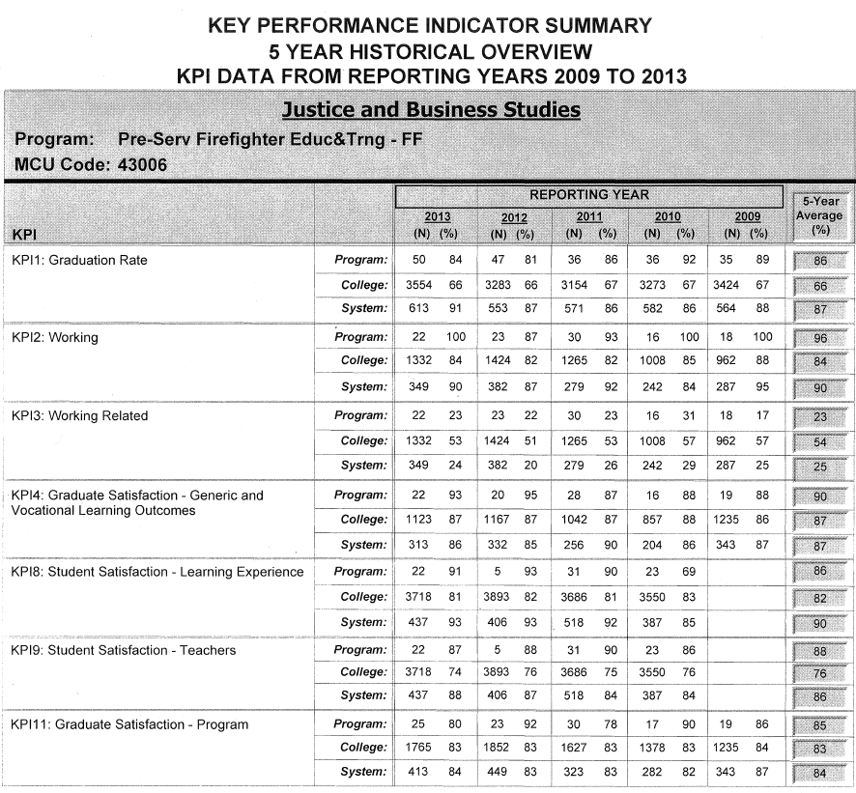

**Appendix 2: STUDENT DEMAND**

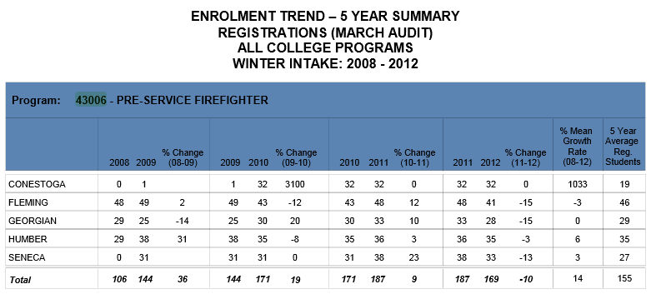

**Appendix 3: COMPETITOR ANALYSIS**

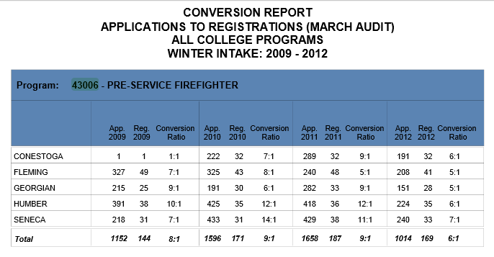

**Appendix 4—Program of Study Revision**

**COMPARISON OF CURRENT PROGRAM AND NEW PROGRAM PROPOSED FOR JANUARY 2013 (revised July 18, 2012)**

| **Current Program** | | | **Proposed Program** | | |
| --- | --- | --- | --- | --- | --- |
| **SEMESTER ONE** | | | **SEMESTER ONE** | | |
| **Code** | **Course Name** | **Hours** | **Code** | **Course Name** | **Hours** |
| COMM8 | Communications for Firefighters | 45 | COMM8 | Communications for Firefighters | 45 |
| ESRV4 | EPC Firefighter Emergency Patient Care | 36 | ESRV4 | EPC Firefighter Emergency Patient Care | **45** |
| REC4 | Fitness and Wellness | 45 | REC4 | Fitness and Wellness | 45 |
| ESRV9 | Fundamentals I | 22 | ESRV9 | Fundamentals I | 22 |
| ESRV10 | Fundamentals II | 23 | ESRV10 | Fundamentals II | 23 |
| ESRV12 | Incident Management System | 30 | ESRV12 | Incident Management System | **46** |
| SOCI36 | Introduction to Psychology (general education course) | 45 | SOCI36 | Introduction to Psychology (general education course) | 45 |
| COMP345 | Introductory Computing (was a 45 hr course; revised for September 2012) | 14 (45) |  |  |  |
| **Total Semester Hours** | | 260 (291) |  | | 271 |
| **SEMESTER TWO** | | | **SEMESTER TWO** | | |
| ESRV7 | Fire Fighting Tools, Equipment and Apparatus | 28 | ESRV7 | Fire Fighting Tools, Equipment and Apparatus | 28 |
| ESRV8 | Fire Related Operations | 50 | ESRV8 | Fire Related Operations | 50 |
| ESRV11 | Fire Suppression | 74 | ESRV11 | Fire Suppression | 74 |
| RECR18 | Physical Fitness I | 28 | RECR18 | Physical Fitness I | 28 |
| SOCI138 | Issues in Diversity | 45 | RECR19 | Physical Fitness II | 28 |
|  |  |  | ESRV22 | Education and Fire Prevention in the Community | 70 |
| **Total Semester Hours** | | 225 |  | | 278 |
| **SEMESTER THREE** | | | **SEMESTER THREE** | | |
| ESRV22 | Education and Fire Prevention in the Community | 70 | ESRV6 | Environmental Protection and Rescue Operations | 37 |
| ESRV6 | Environmental Protection and Rescue Operations | 37 | ESRV73 | Specialized Rescue I | 26 |
| RECR19 | Physical Fitness II | 28 | ESRV74 | Specialized Rescue II | 78 |
| ESRV73 | Specialized Rescue I | 26 | FLPL148 | Pre-Graduate Experience | 172 |
| ESRV74 | Specialized Rescue II | 78 |  |  |  |
| FLPL148 | Pre-Graduate Experience | 172 |  |  |  |
| **Total Semester Hours INCLUDING Pre-Grad Experience** | | 411 | **Total Semester Hours INCLUDING Pre-Grad Experience** | | 313 |
| **Total Program Hours ( three semesters)** | | 896 | **Total Program Hours ( three semesters)** | | 862 |
| **ADDITIONAL:** Practical Testing Scenarios | | 30 | **ADDITIONAL:** Practical Testing Scenarios | | 30 |
| **TOTAL OF ALL HOURS** | | 926 |  | | 892 |