Police Foundations - Program and Curriculum Review 2018

Instructions: Review all information that is stored on your program and curriculum review web page.

https://department.flemingcollege.ca/pcr

Program Coordinator: | Christine O’Neill Hawthorne | Chair: Martha Jansenberger
Review Facilitator: | Heather Sago | Date Completed: 5-07-2018
Program Name: | Police Foundations | Program Code: PF
1.0 Industry Trends and Employment |  | Summary of Key Findings
- Labour Market & Occupational Standard Trends  Review and discuss the following:  - Industry / sector changes or issues identified by the Program Advisory Committee  - Recent labour market data or sector reports as provided by the Fleming Library Researchers.  - Recent or anticipated changes in occupational standards, level of entry and credential and / or standards of accreditation  - Based on the above, do these changes or issues necessitate changes to your program, either immediately, or in the next few years? |  | PAC identified industry/sector changes:  - 2014 PAC minutes do not reflect any input from the industry  - 2015 PAC minutes, industry input:  - students on placement should not wear a uniform shirt with a flash on it and should wear black lace up shoes that they can run in.  - “Fair & Impartial Policing” workshop anti-bias training may become mandatory for officers.  - competition for police jobs is stiff  - cyber-crimes are crimes of the future; want applicants with computer and IT skills  - trend toward civilianization, in forensics and court security  - students need to be prepared for the public’s negative attitude towards police  - agencies want life/field experience, hands-on experience and practical learning based scenarios are important  - volunteer work is important  - students need to keep up fitness level after grad  - students need to demonstrate continued education after grad  - mental health issues are on the rise  - need more female officers  - policing is changing to a community security Hub Model  - 2016 PAC minutes, industry input:  - cybercrimes are a huge problem, police may contract out investigations in the future  - Situation tables are becoming common in communities  - PTSD for first responders is recognized under Presumptive Legislation  - students need to know how to manage their stress  - be professional and respectful  - wear proper attire  - face-to-face communication skills and the ability to speak ‘off the cuff’ is important  - recommended students view “Why you should talk to strangers TED talk”  - writing, spelling and grammar are important  - more of soft skills and less on legislation  - resiliency is important when hiring, develop and foster resiliency  - Myer Briggs personality testing may be helpful  - technology skills such as Cellebrite (capture evidence from cellphone); problem solving with computer technology; ability to navigate through Excel, Word, PowerPoint and Social media is needed  - fentanyl is killing people  - interdisciplinary approach at situational tables to solve community problems, teach how to work at a situation table  - community engagement skills  - leadership skills  - Twitter feed good news about police @goodnewsclips is a positive tool  - 2017 PAC minutes, industry input:  - communications skills are very important, students should be able to read a long article and condense it  - Indigenous studies should include, restorative practices, sentencing circle, Gladue and Truth and Reconciliation report  - emphasis on resiliency  - emphasis on interprofessional work with a debriefing component  - guest speakers with PTSD  - Police Team Dynamics emphasize partnership building and sustaining community relationships  - Diversity should be woven into other courses  - Field placement 100 hours is good value  - Civilian policing should not be a whole course  Labour Market Data from Fleming Library Researchers report:  - Labour market trends for Region (Ptbo, Kawartha, Northumberland & Durham) projects an increase of jobs in this region by 6.1% by 2024.  - Local Outlook for 2016-2018 is relatively stable with a large number of people expected to retire, 9% of local officers are 55 years or older.  - Provincial Outlook 2016-2018 is variable across the province with impending retirements in OPP expected to generate job openings.  - Education of police officers in the province 5% do not have a high school diploma; 16% have a high school diploma; 5% have a trade; 52% have a college diploma; 23% have a bachelor’s degree; 5% have further education beyond a bachelor’s degree.  - Gender ratio in province is 79% male; 21% female.  - Pay range for police officers in Ontario is $25.00-53.00/hour.  - Pay range for sheriffs and bailiffs in Ontario is $18.00-46.15/hour.  - National median age of police officers is 40.4 years; estimated median age of retirement in 2014 is 59 years.  - National projections for 2015-2024 period for police officer new jobs (from expansion demand and replacement demand) is 23,000; with available job seekers (from school leavers, immigration and mobility) is 21,800. Therefore, labour supply and demand projections are expecting a balance.  - National Projections for 2015-2024 for sheriffs and bailiffs new jobs 9700; with available job seekers 9,200 is also projected to be balanced.  Changes to occupational standards:  - Safer Ontario Act passed March 8, 2018, hi-lights:  - https://www.mcscs.jus.gov.on.ca/english/Policing/BuildingStrongerandSaferCommunities.html  - Safer Ontario Act passed March 8, 2018, full legislation:  - https://www.ontario.ca/laws/statute/s18003?_ga=2.269108274.292586442.1526396251-2006515241.1507832379  - Section 35 (2) prescribed training for police service board  - complete prescribed training with respect to the role of a police service board;  - complete the prescribed training with respect to human rights and systemic racism;  - complete the prescribed training that promotes recognition of and respect for,  - the diverse, multiracial and multicultural character of Ontario society, and  - the rights and cultures of First Nation, Inuit and Métis Peoples; and  - complete any other prescribed training  - Section 111 (1) police officer requirements:  - has completed the prescribed training regarding techniques to de-escalate conflict situations;  - any other prescribed matters; and  - meets one of the following conditions:  - a university degree, or  - a degree from a college of applied arts and technology authorized to grant the degree,  - he or she has a diploma or advanced diploma granted by a college of applied arts and technology following successful completion of a program that is the equivalent in class hours of a full-time program of at least four academic semesters,  - he or she has been granted a certificate or other document by a post-secondary institution evidencing successful completion of a program that the regulations prescribe as being equivalent to a degree or diploma described in sub clause (i) or (ii),  - if additional criteria have been prescribed, he or she has a secondary school diploma and meets the additional criteria.  - Section 14 (4) areas for privatization:  - crime prevention.  - crime scene analysis,  - forensic identification,  - canine tracking,  - technical collision investigation and reconstruction,  - breath analysis,  - physical surveillance,  - electronic interception,  - video and photographic surveillance, and  - polygraph and behavioural science.  - Explosives disposal in areas where explosive disposal technicians would not otherwise be reasonably available to provide this policing function.  - Assistance to victims of crime.  - Ontario Provincial Police Recruitment presentation at Orillia Headquarters April 17, 2018 a minimum 3 year diploma requirement is under consideration by OPP.  - Ontario Provincial Police Chief Superintendent John Cain at Justice and Public Safety Coordinators conference May 9, 2018 repeated the minimum 3 year diploma requirement is under consideration by OPP.  Recommendations for the program:  - Check course curriculum for spots to imbed certifications, some areas identified to consider:  - anti-bias training, “Fair and Impartial Policing” or other program  - leadership skills  - resilience training  - stress management  - Crisis Intervention training certification and/or conflict de-escalation skills  - PTSD training  - fentanyl/naloxone training  - first aid  - CPR  - public speaking/improv  - judgment/decision making  - Put greater emphasis on hands on experiential and practical learning experiences  - Look to improve field placement so that students are doing rather that watching  - Include Situation Table and interdisciplinary and inter-professional problem solving into program  - Weave diversity and human rights themes into courses throughout program, going beyond just one Diversity course  - Weave character education themes throughout program  - Include problem solving and critical thinking exercises in courses throughout program  - Writing skills need to be emphasized in all courses  - Formalize the volunteer opportunities within program, beyond portfolio letters  - Look to develop a 3rd year option for students to address changes to education standard so we are not only offering the bare minimum requirement for employment  - Ensure Indigenous courses are including restorative practices; sentencing circle; Gladue; and Truth and Reconciliation  - Computer skills, cybercrime, social media, how to extract data from a  cell phone, computer problem solving skills, proficient in Word, Excel, PowerPoint  - Consider civilian policing courses related to list of privatization entities in Safer Ontario Act

1.2 Graduate Employment & Employment Trends  Review and discuss the following:  - Graduate employment statistics over the last few years, including those of students employed in the field, in a related field, outside the field, or unemployed, and any emerging patterns in this data.  - Emergent employment trends such as new types of positions, changing job market, regional distinctions, changing employer profile, or emerging skill shortages | 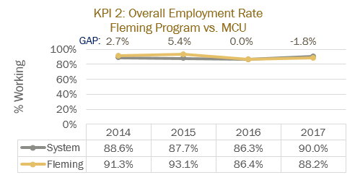  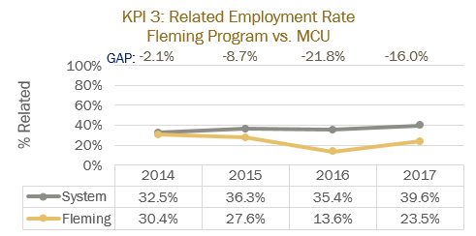  (numbers in brackets indicate the number of students surveyed)  The KPI’s for recent graduate statistics are difficult to interpret effectively due to the low respondent rate (frequently less than 30).  Competitor Programs:  KPI 2 Overall employment is on average is 88.15%  KPI 3 Related employment is on average 35.95%  General Observations:  - overall employment of Fleming grads is consistent with grads from competitor programs at approximately 84%  - the number of graduates directly entering the field are 0  - the number of Fleming grads working in related fields is on average 23.75%, approximately 12% lower than our competitor programs at 35.95%  Interpretation:  - the program needs to identify means to improve the employment rate of grad’s in particular in related employment  Emergent Employment Trends:  - civilianization of police functions  - increase in minimum education requirement for job  - see previous section on labour market  Recommendations for the program:  - Fleming needs to work to build stronger relationships with police employers and to market the quality of the Fleming program and graduates to police agencies  - Fleming has sound police relationships locally but needs to promote the Fleming program with large market police services (i.e. GTA and regional services)  - competitor programs our messaging police leaders promoting the value of their programs over others (including Fleming), if this is not countered Fleming risks further decrease in enrolment
  Fleming Graduate KPI Statistics | 2014 | 2015 | 2016 | 2017
  KPI 1 Grad Rate | 53%(180) | 52%(180) | 46%(161) | 55%(158)
  KPI 2 Overall Employment Rate | 91%(23) | 93%(29) | 86%(22) | 88%(17)
  KPI 3 Related Employment Rate | 30%(23) | 28%(29) | 14%(22) | 24%(17)
2.0 Key Performance Indicators  Review and analyze the formal Key Performance Indicator (KPI) results for your program. | Summary of Key Findings
2.1 Student Satisfaction  - In addition to the formal Student Satisfaction KPI results, comment upon any other formal or informal discussions with students and graduates such as student focus groups, class councils, class representatives, individuals or delegations, or debriefing sessions following a field placement, clinical placement, or practical work integrated learning experience. | 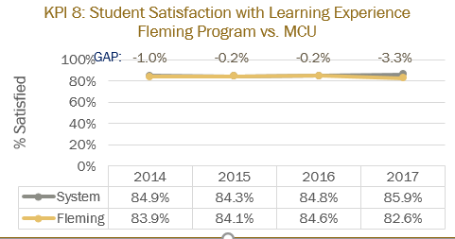  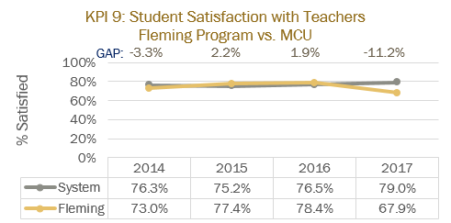  (numbers in brackets indicate the number of students surveyed)  The KPI’s for recent graduate statistics are difficult to interpret effectively due to the low respondent rate (frequently less than 30).  Competitor Programs:  KPI 8 Satisfaction with Learning Experience is on average 82.27%  KPI 9 Satisfaction with Teachers is on average is on average 73.9%  General Observations:  - graduates are satisfied with the Fleming learning experience on average is steadily at 84% which is slightly higher than competitor programs at 82.27%  - graduates are satisfied with Fleming teachers on average 74% which is consistent with competitor programs at 73.9%  Interpretation:  - students tend to rate satisfaction with teachers lower than with the learning outcomes, learning experience and the program. This is consistent with data from competitor colleges and is not a reflection on Fleming faculty. This may be due to seeing the same teachers repeatedly; or because it is easier for a student to recall an interaction with a teacher that they were less satisfied with than it is to identify an abstract concept such as a learning outcome that they were dissatisfied with; or they may be dissatisfied with marks and hold the teacher responsible for the low grades  - this information would indicate that overall the students enjoy the learning experience at Fleming college  Student Focus Groups:  - in winter term 10 Police Foundations students were invited to attend the student focus meeting and none of them attended the meeting  - in spring term 20 Police Foundations students were invited to attend the student focus meeting and 1 attended the meeting, this student wanted health and fitness to be included in first common semester  Students comments from PAC meetings:  - 2014  - would like to see more hands on learning  - like common first semester  - stress management skills would be helpful  - came to Fleming because of field placement  - mental health course is good  - like the scenario lab  - would like self-defence courses  - would like more PF courses in semester 2  - 2015  - like common first semester  - chose Fleming because was told good things about Fleming program by local officers  - like small school experience  - like uniform  - like hands on learning in scenario lab want more of it  - 2016  - like common first semester  - like placement option  - like scenario learning  - like uniform  - students struggle with fitness  - 2017  - fitness should start earlier in the program  - stress management would be helpful  - communications should be more grammar and spelling and essay writing  - would like a seminar in Canadian Justice System course  Student Delegations:  - would like to have PowerPoint slides posted on D2L, not just for short time  - would like to have textbook material discussed in courses felt did not use some textbooks  - same cases in different courses (i.e. Sammy Yatim case covered in multiple courses)  - would like to have more information communicated through D2L newsfeeds and emails  - would like to see different teachers teaching different courses, less overlap  - would like to see Communications II - COMM 201 to include more police reports and narratives rather than doing the narratives in Conflict Management - LAWS 9  Debriefing following field placement:  - students consistently enjoy the learning in field placement and are sad that it must come to an end  - students consistently comment that they cannot believe some classmates chose to miss out on this opportunity  - student evaluations completed by the coach officers/supervisors indicate that student knowledge ranges from mid-high as assessed by coach officers  Recommendations for the program:  - student comments reflect similar themes as PAC  - some student suggestions are in line with best teaching practices  - Fleming program should seek to incorporate student suggestions where possible
  Graduate KPI Statistics | 2014 | 2015 | 2016 | 2017
  KPI 8 Satisfaction with Learning Experience | 84%(160) | 84%(97) | 85%(93) | 83%(75)
  KPI 9 Satisfaction with Teachers | 73%(160) | 77%(97) | 78%(93) | 68%(75)
2.2 Retention Rate  - Use the IPP (Integrated Program Planning) data that focuses on Retention.  - Review patterns of retention on a semester by semester basis over the last five years.  - Comment on the effectiveness of any strategies adopted to improve student retention. | 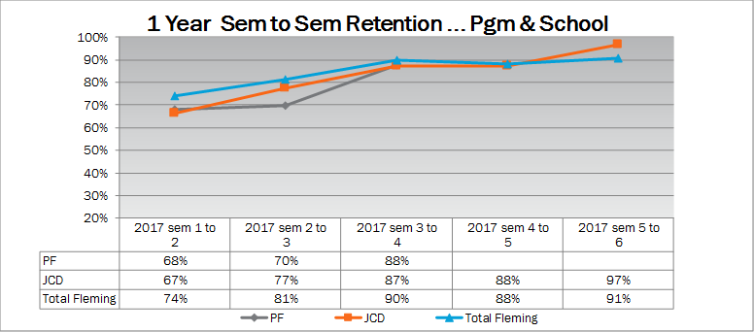  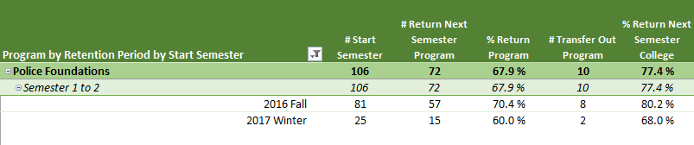  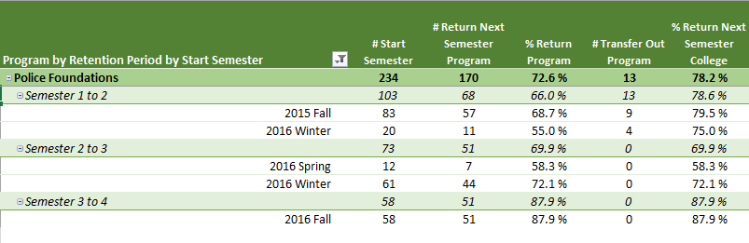  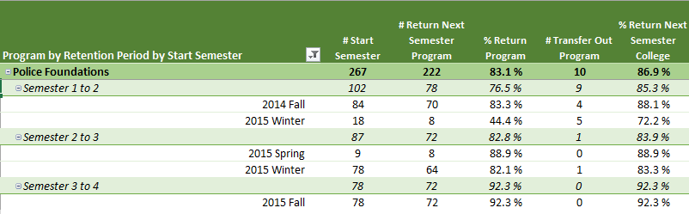  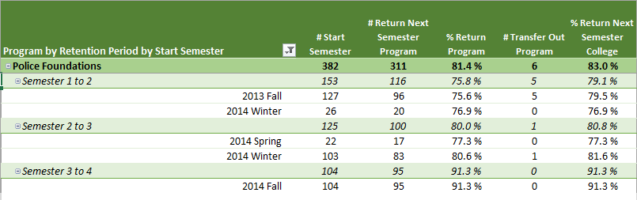  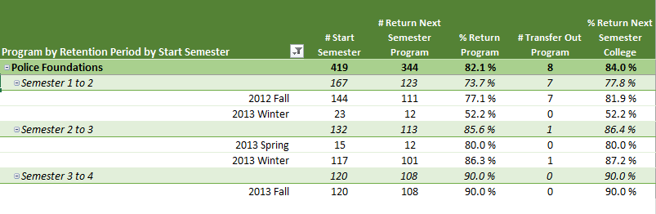  General Observations:  - 2017:  - all JCD courses retain 6-7% fewer students after 1st semester than other programs at the college.  - PF retains 7% fewer students from 1st to 2nd semesters than other JCD programs and 11% fewer than other programs at the college  - PF retains students from 3rd to 4th consistent with other JCD programs and other programs at the college.  Interpretation:  - JCD & PF attract many students who are unable or uninterested in continuing into 2nd semester  - PF loses many students between 2nd and 3rd semester  - Once students commit to 3rd semester a high percentage of those students will enter 4th semester  Previous Retention Strategies:  - The Strategies for Success course implemented in semester 1 may be assisting some students, however, there are not statistics available here to identify the degree of success of that course in retaining Police Foundations students specifically  - There have not been retention strategies implemented to retain Police Foundations students beyond common college retention practices  Recommendations for the program:  - build a strong sense of connection to the program and to classmates through team building experiences outside the classroom setting  - ensure students are getting the tools in semester 1 and 2, that they will need in order to succeed in the program, in particular written communication skills
2.3 Graduate Rate  - Review patterns of graduation rates on a semester by semester basis over the last five years. | 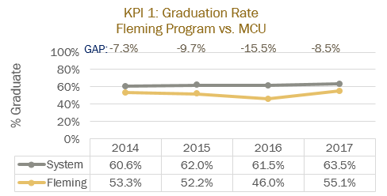  (numbers in brackets indicate the number of students surveyed)  Competitor Programs:  KPI 1, Grad Rate is on average is 61.9%  General Observations:  - the percentage of students who start in PF at Fleming and successfully graduate is on average 51.5% a full 10% lower than our competitor programs at 61.9%  Interpretation:  - the graduation rate of students in this program is low in the 51.5% range  this information would appear to suggest that the program is very attractive to college applicants but not all students are ready or able to succeed in the program, this appears to be both a recruitment and a retention issue  - the explanation for Fleming graduation rate being significantly lower than competitor programs is not readily provided by current data and requires further investigation  Recommendations for the program:  - maintain high academic standards  - ensure appropriate curriculum for current labour market
  Graduate KPI Statistics | 2014 | 2015 | 2016 | 2017
  KPI 1 Grad Rate | 53%(180) | 52%(180) | 46%(161) | 55%(158)
2.4 Graduate Satisfaction  - Review patterns of graduate satisfaction and provide comment. | 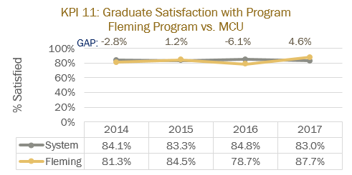  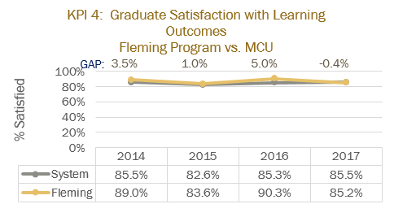  (numbers in brackets indicate the number of students surveyed)  Competitor Programs:  KPI 4 Satisfaction with Generic and Vocational Learning outcomes is on average 84.87%  KPI 11 Satisfaction with Program is on average 82.4%  General Observations:  - graduates are satisfied with the Fleming learning outcomes on average 87% which is slightly higher than competitor programs at 84.87  - overall satisfaction with the Fleming program is on average 83% which is consistent with competitor programs  Interpretation:  - despite the fact that only 23.75% of grad’s are working in a related field there appears to be an overall high degree of satisfaction with the learning outcomes, learning experience and the program as a whole being in the 84-87% range  - this information would indicate that overall the students enjoy learning the material in this program  Recommendations for the program:  - work with Career Services to build a network of potential employers for grad’s  - promote related work opportunities for graduates as stepping stones to a career in policing
  Graduate KPI Statistics | 2014 | 2015 | 2016 | 2017
  KPI 4 Satisfaction with Generic and Vocation Learning Outcomes | 89%(21) | 84%(27) | 90%(19) | 85%(19)
  KPI 11 Satisfaction with Program | 81%(35) | 84%(42) | 79%(25) | 88%(24)
2.5 Enrolment Trends and Demand  - Your team will review and analyze the patterns in the number of program applicants, confirmations and actual registrants over the past 5 years. You will also examine changes, if any, in the student demographic profile and the impact, if any, of this changing student profile on program curriculum.  - Assess whether the program curriculum needs to change based on the above analysis.  - Use the FDR excel spreadsheet that provides Day 10 enrolment numbers for Fleming for the last 10 years, to assist you with your analysis.  - Please review the IPP (Integrated Program Planning) data that focuses on trends related to student demand, and the related ‘Situational Analysis’ information included for your program – select the Demand Trending Tab and Situational Analysis Tab. | 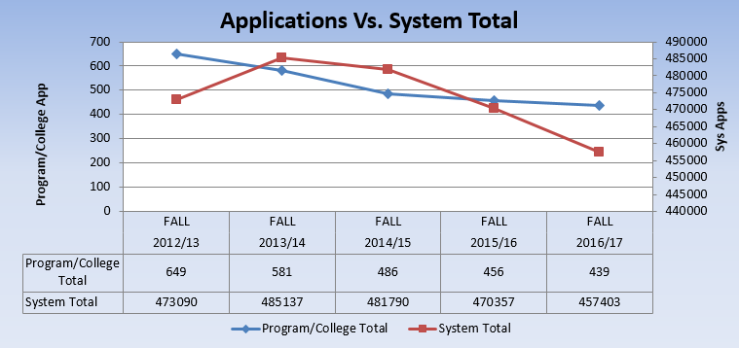  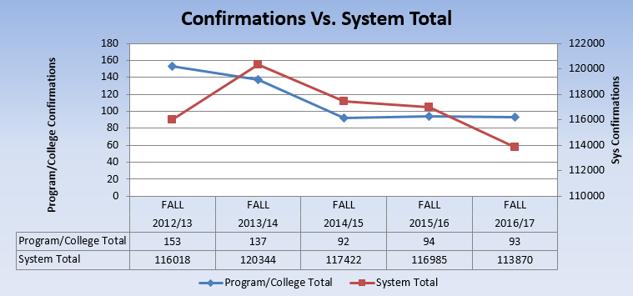  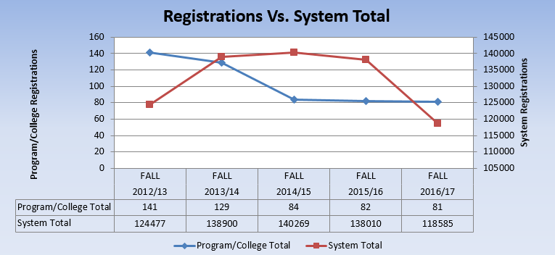  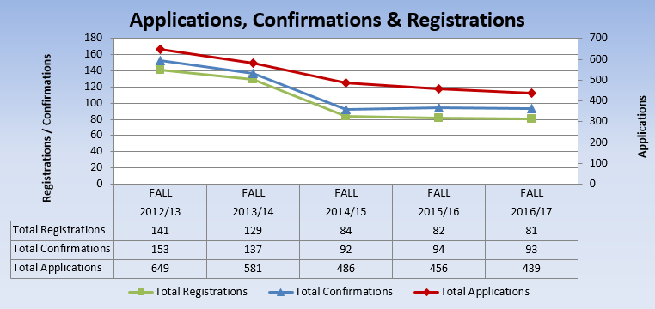  General observations:  - Applications have dropped by 32% from 2012-2017  - Conversion of confirmations to registrations have dropped 10% from 2012-2017 (from 28% to 18%)  - Registrations have dropped 42% from 2012-2017  - Rate of declining enrolment was steep in 2012-2014 and has flattened from 2014-2017  Interpretation:  - Many students are applying to this program but choosing to go to another school/program  - Fleming may have been a 2nd or 3rd choice for students on application, this data does not indicate whether this program was a first choice  - There are more than enough applications to sustain the program but converting the applicants to registered students is the key challenge  Recommendations for the program:  - Marketing of the program may help to ensure Fleming is a first choice for students and increase conversion rates
3.0 Program Curriculum | Summary of Key Findings
3.1 Program Learning Outcomes and/or Sector Standards  - Review program level learning outcomes in preparation for curriculum mapping (vocational, essential employability skills, general education)  - Where applicable review sector standards to ensure program is keeping up with new trends, developments and requirements. | School of Justice and Community Development  Police Foundations CODE: PF  Program Vocational Learning Outcomes  Ministry Standards for Police Foundations:  - Complete all tasks in compliance with pertinent legislation, as well as policing standards, regulations and guidelines.  - Analyze all relevant information and make effective and legally defensible decisions in accordance with ethical and professional standards.  - Be accountable for one’s actions when carrying out all tasks.  - Develop and implement ongoing effective strategies for personal and professional development.  - Ensure the respect of human rights and freedoms in all interactions.  - Work co-operatively in multidisciplinary teams to achieve mutual goals.  - Collaborate in the development and implementation of community policing strategies.  - Monitor, evaluate and document behaviours, situations & events accurately & discreetly in compliance with legal, professional, ethical & organizational requirements.  - Mitigate risks and maintain order by applying effective strategies in crisis, conflict and emergency situations.  - Take positive actions to help crime victims.  - Conduct investigations by collecting, documenting, preserving and presenting admissible evidence.  Recommendations for the program:  - Keep updated on changes to legislation and regulations, in particular Safer Ontario Act  - Be aware that updated Ministry VLO’s should be expected, the last update to the VLO’s was in August 2010.

3.2 Program of Study, Course Outlines, Delivery and Program Map  - Review the feedback and suggestions received from Course-level survey completed by faculty at the end of each semester.  - Review the balance and frequency of assessment types across the curriculum and their appropriateness to learning outcomes for the course and program level outcomes.  - Collect a cross section of samples of student work as evidence of achievement of learning outcomes.  - Reflect and comment upon the variety of methods used to demonstrate program outcomes.  - Reflect and comment upon the degree of technology-enhanced delivery of the program outcomes.  - Discuss the degree and depth to which the program is providing work integrated learning experiences.  - Discuss the degree and depth to which the program includes Indigenous perspectives and record the courses in the curriculum in which Indigenous perspectives are covered  - Record the course in the curriculum that covers the college-wide sustainability learning outcome  - Review (or create) Program Curriculum Map(s) to ensure that there is alignment of current courses to the overall program outcomes, including the Vocational Learning Outcomes, the Essential Employability Skills, and adherence to the General Education Policy.  - Review pre and co-requisites to ensure that they do not hinder progress in the program, unnecessarily.  - Make recommendations to address any gaps identified or improvements required.  - Review the program’s current admission requirements and their suitability in relation to program rigour and student preparedness.  - Include an updated program curriculum map on your program and curriculum review web page. | ADMISSION REQUIREMENTS  OSSD with the majority of credits at the College (C) and Open (O) level, including:  - 2 College (C) English courses (Grade 11 or Grade 12)  - When (C) is the minimum course level for admission, (U) or (U/C) courses are also accepted.  General Observations:  - entrance requirements are minimal  - students often have low written communications skills in this program and a selection of student work from all semesters demonstrates this continuing challenge  - raising the entrance requirement to University level English courses would eliminate the opportunity for higher education of many students, is seems counter-intuitive for a college program  - assessment types are limited to presentations; written assignments and tests  - there is a significant degree of group work in this program  - at this time technology is not being used in this program to any significant degree, there is a phone Application, Fitness PAL being used in the Fitness classes and there are fitbits available for use  - portable radios have recently been purchased for use in this program  - work integrated experiences are limited to field placement where students primarily observe rather than ‘do’  - Indigenous perspectives are taught directly in semester 1 Introduction to Indigenous Studies and students may receive certification if they take Indigenous Knowledges as their semester 2 Gen Ed. Otherwise Indigenous perspective has been addressed in Youth in Conflict, Community Policing and Conflict management  - The program map has been completed and is attached, there were a few areas where E of P’s were not being sufficiently assessed  - areas were noted of weakness and faculty discussed how to ensure these areas are consistently covered and determined in which courses these E of P’s should be assessed  - one key gap was a lack of participation in an emergency training exercise with local emergency services  - Essential Employability Skills are currently sufficiently being assessed in the PF program  - Pre and co-requisites are limited to Communications classes and fitness classes, in part so that students can have flexibility to take courses out of order should it be necessary due to transferring from another college, coming as a direct entry into 2nd year from university or failing a course  Interpretation:  - the program needs to put in place some measures to ensure that all VLO’s and E of P’s are being addressed and do not get removed from the program by faculty who do not understand why certain components are in each course  Recommendations for the Program:  - keep current entrance requirements  - maintain current pre and co-requisites, be mindful of this issue when/if re-organizing courses  - focus of supporting student writing skills development  - imbed standardized writing skills rubrics and assessment tools into all PF courses  - increase the degree of marks allocated to writing skills as the program progresses  - identify and direct students to learning supports for help with writing skills  - create a new program manual that includes in it a list of VLO’s and E of P’s that are required to be assessed for each course  - have faculty provide students with the E of P’s and learning outcomes that are being assessed along with each assignment description  - ensure the assessment rubrics and tools reflect the required E of P’s and learning outcomes  - have faculty work with LDS to update course outlines and learning outcomes for all PF courses  - *see the listed program adjustments described in the attachment which include, removing Civilian Policing courses, removing Communications II, adding a report writing course, adding a new Mental Health course, removing Traffic Management, and adding content to Investigation*
4.0 Strategic Positioning and New Opportunities | Summary of Key Findings
4.1 College and School Alignment

- Review program alignment with college priorities such as vision, mission, values, strategic plan, academic plan and the educational mandate, and / or academic priorities of the School.
- Review program webpage and promotional messaging to ensure accuracy and currency.
4.2 Competitor Programs  - Analyze key parallels and differences between this program and those of its closest competitors, where applicable.  - Comment on the ’Value-added’ program distinctions and their attractiveness to prospective students. | General Observations:  Humber College:  - Technology, simulator for driving and crisis intervention  - Relationship with York Regional police cadet program, some students are cadets while in program with opportunity for full-time employ after words  - PSI pathway  - Serving officers on faculty  - Customs is imbedded in PF program  - Community Development degree option  - Opportunity for 5 days with an Orangeville police officer for some students  - Volunteerism is required for these opportunities  - Toronto Police Service Rover crew opportunity for students to be part of police/scouting initiative  Algonquin College:  - Have the entire PF program available online  - Bring Your Own Device, all textbooks are online  - Require a criminal records checks before volunteering  - Uniform for students  Lambton College:  - London Police Cadet program relationship  - Mobile learning class and experience  - PSI and PF Coordinator is the same role  Mohawk College:  - Common first year with PSI and CJS  - Technology, virtual simulation lab  - Advanced Police Studies, 1 year offers police driving simulator, use of force and firearms training  Georgian College:  - Common first year with PSI and CJS  - Use of force, handcuffing  - Degree in Police Studies option  - Student based problem-solving exercise working with O.P.P.  Durham College:  - Students earn Mental Health First Aid Certificate  - Students complete a post-admission reading and writing skills assessment  - Work under supervision with at risk youth  - Create and present a problem-based learning business plan to industry professionals  - Participate in a homelessness walk in Toronto  - Advanced Law Enforcement and degree options  Loyalist College:  - Offers ride-along field placement to all students in two blocks  - First common year with CJS, PSI and Customs  Conestoga College:  - 3 year police foundations program  - a written agreement with West Region O.P.P. for field placements to exclusion of all programs without a 3 rd year  Fanshawe College:  - 3 year police foundations program  - a written agreement with West Region O.P.P. for field placements to exclusion of all programs without a 3 rd year  Interpretation:  - many colleges have some very innovative programs working with police agencies to offer students work related experience similar to a field placement  - many colleges are taking better advantage of their police relationships than Fleming PF  - Fleming PF is stagnating while other create  - There are many programs and ideas here that Fleming could utilize  - In some cases being in larger urban areas is an advantage for some colleges  - Some colleges are creating relationships with police agencies to the exclusion of other programs  Recommendations for the program:  - Look to some of these other college ideas and adapt and incorporate those that fit our school  - Look to develop a 3rd year program with strong ties to our police agencies offering an opportunity for the police agencies to cross-train with our students and perhaps select Auxiliary Police candidates from our 3rd year program  - Formalize relationships with our existing partners
4.3 Learning Pathways  - Comment on recent or anticipated initiatives that promote student pathways including secondary school partnerships, dual credits, program laddering, dual diplomas, and university transfer, articulations, and partnerships.  - Review all transfer credits.  - Identify any new pathways that could be developed. | General Observations:  - Our students benefit from first common semester and can change justice programs freely into second semester  - After starting second semester the pathways for our students within the justice programs is not smooth, it is currently easier for a Fleming student to go to another school after completing PF than to stay at Fleming in another program  - Fleming PF has articulation agreements with the following universities (PF students can skip 1st year of a degree program):  - Algoma University  - Brock University  - Carleton University  - Charles Sturt University  - Conestoga College  - Georgian College  - Griffith University  - Humber College  - Justice Institute of British Columbia  - Lake Superior State University  - Lakehead University  - Laurentian University  - Royal Roads University  - Trent University  - University of Guelph-Humber  - University of Ontario Institute of Technology  - Many of these agreements are in need of renewal  - Trent University is developing a Police Sciences degree to be offered in Oshawa, this is a direct competition for the Fleming PF program  Recommendations for the program:  - Update existing articulation agreements  - Develop a relationship with the Trent Police Sciences degree program for articulation (2 for 2 would be ideal)  - Advertise these pathways to students and possible future students
4.4 New Program or Redesign Ideas  - Are there opportunities for new program initiatives based on Program, School, or community strengths and alliances? | Recommendations for the program:  - *see attached for suggestions for changes to courses regarding adding some new content, removing some unnecessary content and updating existing content  - develop a 3rd year option for an Police post-grad certificate where students are primarily learning industry skills alongside service officers, work on community policing committees  - the 3rd year option could be a co-training option for local police agencies to select and train Auxiliary officers
5.0 External Relations | Summary of Key Findings
5.1 Community Partnerships  - Does your program have significant partnerships, relationships, connections, or offers of support from the community that help to enrich the program and the student experience?  - Are faculty, staff, and student involved in volunteer projects and events? | Field Placement relationships with local police agencies are critical to our program and our student experience. We place students all over the province but rely heavily on our local police agencies to take students for both LINK and post-curricular field placement and also to vouch for our program to other police services when we are attempting placements with a service that is unfamiliar with our program.  Representatives from these services also sit on our P.A.C.  Key partner police agencies include:  - Peterborough Police Service  - Peterborough County O.P.P.  - City of Kawartha Lakes O.P.P  - Kawartha Lakes Police Service  - Cobourg Police Service  - Northumberland O.P.P.  - Port Hope Police Service  - Durham Regional Police Service  - Haliburton O.P.P.  Serving police officers teaching at Fleming college:  - a member from Peterborough Police, PC Cameron Kenny, who has taught Traffic Management LAWS 79.  - a member from Peterborough County O.P.P., PC Ryan Unsworth, who has taught Traffic Management LAWS 79, Police Team Dynamics LAWS 261, and Intro to Indigenous Studies  - a member from Peterborough Police, Inspector Larry Charmley, taught in CSI program  - a member of Kawartha Lakes O.P.P., PC Carrie Lanning, teaches Community Policing LAWS 250  The Police Foundations program is well known in the community as a resource for student volunteers and many agencies contact the program when they need help. Students are offered these volunteer opportunities as they arise and some of the volunteerism is recorded for students on their Co-Curricular Record. The students are also given letters for their portfolios by the agencies.  Key ongoing volunteer experiences for our students include:  - Pedal for Hope – Battle in the Saddle  - Special Olympics  - Big Brothers  - Telecare  - Peterborough Northumberland Victim Services  - YMCA marathon  - Cavan Monaghan Community Policing Committee  Fleming College Police Foundations Police Memorial and Police Award Tribute Committee:  Students volunteer to be part of this committee and they participate in the police memorial services as needed and the police awards ceremony at the end of 4th semester. These events solidify the relationship between Fleming college and the police community and gives students an opportunity to connect with police culture.  First Responder’s Cup:  Fleming faculty, Jodi Van Engen, has developed and hosts this event for students and the public and serving members of the first responder’s community. This event gives students the opportunity to compete in a fitness related competition with serving police officers, re-enforcing the importance of physical fitness.  Volunteerism by PF faculty in our community:  Joe Hays – board member of Fourcast; board member Peterborough Youth Basketball Association; coach youth basketball  Brian Cowie – board member for Lakers lacrosse; board member at Trent University; Art for Autism; Catholic School Board Indigenous and law guest speaker list  Christine O’Neill-Hawthorne – Cavan Monaghan Community Policing Committee  Recommendations for the program:  - formalize the field placement experience with MOU’s with local agencies  - formalize the volunteer accreditation process or program recognition of the valuable learning experience and commitment to the betterment of our community  - continue to encourage Fleming faculty to seek community volunteer opportunities
5.2 Program Advisory Committee  - Comment on the distribution of Committee membership by constituency, sector, and / or region.  - Comment on the vitality of the Committee (frequency of meetings, members’ level of participation, engagement, and turnover.) | PAC Committee distribution by sector:  - Provincial Police partners:  - regular representation from our O.P.P. partners from Peterborough, Northumberland, Kawartha Lakes, and when possible, Haliburton detachments, usually an Inspector  - recruiters from O.P.P. rank from constable to inspector  - Federal Police partners:  - one RCMP recruiter usually attends although the recruiters have changed over the past, constable rank  - Municipal Police partners:  - Peterborough Police frequently sends an Inspector and/or constable  - Kawartha Lakes PS sends an Inspector and/or a Sergeant  - Port Hope PS sends an Inspector when possible  - Cobourg PS sends the Deputy Chief when possible  - Regional Police partner:  - Durham Regional Police Service sends an Inspector (Fleming alumni)  - Indigenous Policing partner:  - has not been regularly represented  - Local public and Catholic school boards:  - have not been regularly represented  - Fleming College:  - JCD Chair, Dean and Program Coordinator are usually present  - Career Services, Joanne Duffy frequently attends  - Life-long learning or Con-ed frequently attends  - 1 student from first year  - 1 student from second year  Frequency of meetings:  - once per year usually in the fall, in November  Participation & engagement & turnover:  - Police attendees change as officers retire or are re-assigned however there is significant consistency in the membership year to year  - Fleming positions have likewise changed over the past few years, we look forward to future stability in positions moving forward  - Naturally new students attend each year, it is valuable to hear how program adjustments are impacting students  - PAC membership police officer contributions are improved by sending out a pre-questionnaires or by have specific open ended questions prepared for discussion rather than spending our time telling them what we do we are better to spend our time discussing what the industry wants  Recommendations for the program:  - including officers from some of the other regional police services for perspective beyond our part of the province  - include recruiters from larger services (TPS; York; Peel; etc)  - ensure the inclusion of an O.P.P. recruiter from headquarters, preferably of rank  - potential PAC members may be identified through the alumni office  - consider is there value in have a Corrections or Courts or Victim Services representative(s) at the table
5.3 Alumni Relations  - Describe the type and range of alumnae involvement in the program.  - Current and future strategies to engage alumnae in the program. | Alumni Relations:  - many alumni are currently serving with local police agencies in particular PPS  - some alumni reach out to Fleming PF program to stay connected  - some alumni have reached out to Fleming PF program because they are interested in teaching in the program  - Fleming PF program faculty often invite alumni as guest speakers  - Fleming PF program does not currently actively target alumni to maintain relationships  - alumni who have notably supported the PF program include Chief Murray Rodd (retiring) of PPS; and Inspector Chuck Nash of DRPS who has helped facilitate PF student placements with DRPS and serves on our PAC  - Fleming PF program has a facebook page and twitter feed that may offer some communication between recent grads/alumni and the program if they continue to follow these accounts beyond graduation  Recommendations for the program:  - connect with the Alumni office and obtain a list of known PF program alumni those who are/have been police officers or who are working in other fields  - invite those alumni members to follow our PF program on social media  - use Linked In to connect to alumni  - maintain other social media Twitter, Instagram, facebook etc.  - send out questionnaires to alumni to learn what they have experienced after graduation (similar to KPI’s); asking their opinions may re-engage them with Fleming and the PF program  - offer alumni a Con Ed course to re-engage them with Fleming College and the PF program  - consider an Open House/PF Reunion type event for PF alumni once new scenario lab is up and functioning  - explore the possibility of developing an alumni mentorship program where alumni offer a web-based mentorship to current students
6.0 Program Resources | Summary of Key Findings
6.1 Program Revenue and Expenses  - Please review Integrated Program Planning (IPP) information for your program.  - Are program resources adequate, in the context of program currency and student numbers? (e.g. laboratory equipment, software, library holdings, or tools essential to program delivery and student learning.  - Are there opportunities for further program specific external revenue such as sponsorship, grants, donations or gifts-in-kind?  - Review the existing revenue and expenses associated with your program using the IPP tool and provide comments below.  - Review all textbooks for cost, format (hard-copy, e-book, rental), use in multiple semesters, content (curriculum alignment, Canadian content, readability, engagement level), ancillary materials (question bank, PowerPoint, online support, image bank), publisher support, AODA compliance, and conflict of interest. | 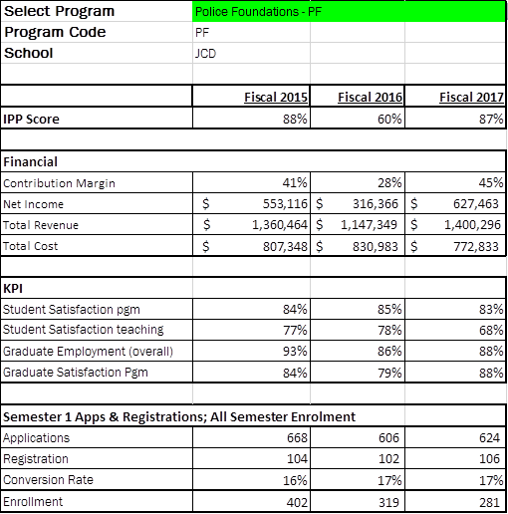  Recommendations for the program:  - Students need to learn how police databases are used to create reports, record data and as investigative tools.  - A police database system is an essential tool for our students experiential learning and employability skills development  - The new scenario lab requires software, cameras and audio equipment designed to facilitate learning and assessment of student progress  - Students could benefit from more radio’s and police gun belt equipment for use during a large scale exercise  - Some full sized vehicles for use on Fleming property would enhance the students experiential learning through exercises such as accident investigations, vehicle stops and vehicle searches
6.2 Faculty and Staff Resources

Please comment on:
- The number and distribution of all faculty, technicians, and technologists associated with the program including full-time, part-time, sessional, and cross-appointments.
- Profile of the faculty, and staff associated with the program including cumulative credentials, scholarship, work-related and teaching experience, and expertise in education.
- Significant faculty or staff accomplishments such as professional recognition and awards, achievement of credentials, and appointments.
- Hiring priorities over the next few years based on the above.
6.3 Program Delivery Capital Assets  - Please review existing program space and equipment  - Determine needs for space and equipment to fulfill future needs | Existing PF program equipment:  - 11 gun belts  - 9 holsters and equipment pouches  - 9 handcuffs with keys  - 9 simulated training handguns for gun belts  - 9 simulated training knives  - 12 portable radios with microphones, belt clip and battery chargers  - 12 flashlights  - 6 used & emptied baton grips  - 4 used Kevlar vests with exterior carriers, two female & two male  - 1 mannequin with movable joints and hands  - 1 mannequin with PPS uniform, including hat and coat  - 1 partial car on rollers  - 4 tabletop display boards  - 1 digital photo frame  Existing space:  - current scenario lab in process of being decommissioned and moved into newly constructed space  - *further detail to follow once space is accessible  Recommendations for this program:  Future Needs:  - plan for a complete set of 12 gun belts, order equipment to complete set for fall 2018  - plan for future purchase of gun belts & equipment & radios to add to inventory up to approximately 20-25 complete sets  - more Kevlar vests in a variety of sizes  - 1-2 operational cars/truck for vehicle exercises  - 10 fitness vests  - Data management system  - Dispatch system  - Legal forms  - Software and recording equipment for simulation lab  - Simulation software equipment (i.e. lazar firearms training)

Program Improvement Plan

Based on the analysis of your key findings, identify areas that require attention and action in the next 1-3 year timeframe. Ensure that you only recommend actions that reflect the program’s priorities and its capacity to achieve them, and record the success of any changes implemented and the means by which they are being evaluated.

To make sure your goals are clear and reachable, each one should be:
- Specific (simple, sensible, significant).
- Measurable (meaningful, motivating).
- Achievable (agreed, attainable).
- Relevant (reasonable, realistic and resourced, results-based).
- Time bound (time-based, time limited, time/cost limited, timely, time-sensitive).

New Recommended Improvements | Timeframe | Person(s) Responsible | Approval: Dean, Chair, or VPA or  Not Feasible, with rationale
Either independently or as a collective with other Police Foundations programs across the province advocate the Ministry for our Diversity, Indigenous Studies, Conflict Management courses to be recognized as being compliant with the regulations of the Safer Ontario Act. | Beginning as soon as possible
Write an updated program manual which includes VLO’s and E of P’s for each PF course. Include directions for inclusion of learning outcomes and E of P’s at the beginning of all PF assignments and direction regarding ensuring rubrics specifically assess the required learning outcomes. Have all PF faculty review their course outlines to ensure compliance with the VLO’s and E of P’s and meet with LDS to update all PF course outlines and marking rubrics. | 3rd semester PF course outlines re-written before fall 2018 start up  2nd and 4th semester course outlines before winter 2019 start up | Faculty for each PF course and PF Coordinator
Explore options for 3rd year post-grad certificate partnership with local police partners | Starting fall 2018 for 1 year
Explore partnership with Trent University Police Science degree program and/or an articulation agreement with this program | Starting fall 2018 | David Baker and PF Coordinator
Formalize current field placement spots with local police agencies with MOU’s. | Starting fall 2018 | Field Placement Liaison and PF Program Coordinator
Change current field placement program to new LINK volunteer/placement program. | Starting fall 2018 | Field Placement Liaison and PF Program Coordinator
Review contents of the Program and Curriculum Review and Appendix A and move to include changes where applicable | Starring fall 2018 | PF Program Coordinator
Change the current courses sequence to new plan articulated in Appendix A. Include development of new courses and new content for existing courses. | Staring fall 2019 | PF faculty and Program Coordinator
Previous Recommended Improvements | Timeframe | Person(s) Responsible | Update and Rationale: Proceeding = P  Completed = C  Not Feasible = NF

