Program and Curriculum Review Template

Instructions: Review all information that is stored on your program and curriculum review web page.

https://department.flemingcollege.ca/pcr

Program Coordinator: | Kristina Lonsberry | Chair: | Nick Stone
Review Facilitator: |  | Date Completed: | 17/01/2018
Program Name: | Massage Therapy | Program Code: | MAC
1.0 Industry Trends and Employment |  | Summary of Key Findings
- Labour Market & Occupational Standard Trends  Review and discuss the following:  - Industry / sector changes or issues identified by the Program Advisory Committee  - Recent labour market data or sector reports as provided by the Fleming Library Researchers.  - Recent or anticipated changes in occupational standards, level of entry and credential and / or standards of accreditation  - Based on the above, do these changes or issues necessitate changes to your program, either immediately, or in the next few years?  Note: Library has updated research |  | Please see the MAC folder and review the PDF file named “Massage_Therapy_17”  PAC: On-line booking and documenting; text message reminders; added modalities such as acupuncture, cranial sacral, taping, and Reiki; notice of more knowledgeable clientele; need our students to have strong business skills; acute care; spa industry; MVA documentation; HST requirements; employee vs. sub-contractor  In Ontario, massage therapy education programs will be required to obtain preliminary accreditation by December 2019. The goal is to complete the first accreditation cycle for all massage therapy education programs in Ontario by the end of 2021. (https://www.cmtca.ca/single-post/News-update-Spring-2017)

1.2 Graduate Employment & Employment Trends  Review and discuss the following:  - Graduate employment statistics over the last few years, including those of students employed in the field, in a related field, outside the field, or unemployed, and any emerging patterns in this data.  - Emergent employment trends such as new types of positions, changing job market, regional distinctions, changing employer profile, or emerging skill shortages  2016 CMTO Annual Report: 13, 700 Registered Members (http://www.cmto.com/assets/CMTO-2016-AR.pdf)  2017 CMTO Registration Exam Results  http://www.cmto.com/assets/2017-Exam-Stats.pdf | 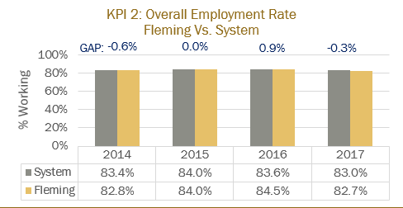  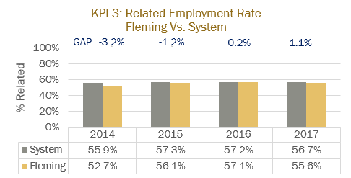
2.0 Key Performance Indicators  Review and analyze the formal Key Performance Indicator (KPI) results for your program. | Summary of Key Findings
2.1 Student Satisfaction  - In addition to the formal Student Satisfaction KPI results, comment upon any other formal or informal discussions with students and graduates such as student focus groups, class councils, class representatives, individuals or delegations, or debriefing sessions following a field placement, clinical placement, or practical work integrated learning experience.  From 2014-2017  Satisfaction with Learning Experience: 83.13% on par with System average  Satisfaction with Teachers: 76%, 2.1% above System average  Current Students: Student satisfaction is low currently due to the present construction of A wing. They feel that they are not being listened to or respected with regards to their Health and Safety. They are satisfied with the St. Joseph's @ Fleming placement. | 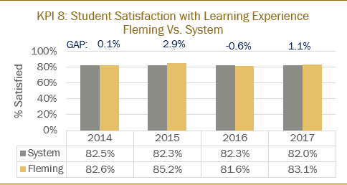  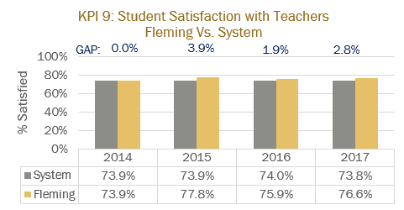
2.2 Retention Rate  - Use the IPP (Integrated Program Planning) data that focuses on Retention.  - Review patterns of retention on a semester by semester basis over the last five years.  - Comment on the effectiveness of any strategies adopted to improve student retention.  Comments: our greatest loss occurs between semester 1 and 2. We have adopted new testing procedures in A & P 1 and 2 which has improved retention.  New test called CASPER is used by some Nursing programs to pre-screen applicants to ensure the program is a good fit for the student. Would like to research this further to see if this is a tool we could use. | 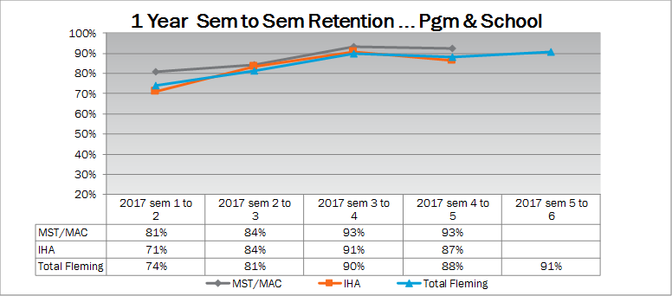
2.3 Graduate Rate  - Review patterns of graduation rates on a semester by semester basis over the last five years.  66.9%, 0.6% above System average | 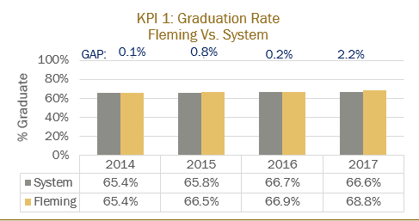
2.4 Graduate Satisfaction  - Review patterns of graduate satisfaction and provide comment.  Grad satisfaction with program: 83.7%, 1.3% above system average  Grad satisfaction with Learning Outcomes: 87.2%, 2.3% above system average | 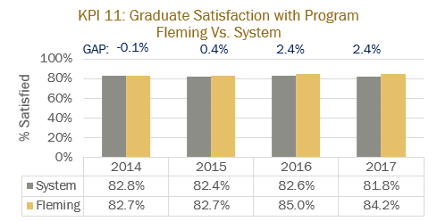  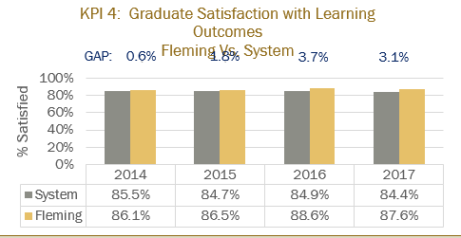
2.5 Enrolment Trends and Demand  - Your team will review and analyze the patterns in the number of program applicants, confirmations and actual registrants over the past 5 years. You will also examine changes, if any, in the student demographic profile and the impact, if any, of this changing student profile on program curriculum.  - Assess whether the program curriculum needs to change based on the above analysis.  - Use the FDR excel spreadsheet that provides Day 10 enrolment numbers for Fleming for the last 10 years, to assist you with your analysis.  - Please review the IPP (Integrated Program Planning) data that focuses on trends related to student demand, and the related ‘Situational Analysis’ information included for your program – select the Demand Trending Tab and Situational Analysis Tab.  Comments: enrolment has climbed since compressing our program into 5 semesters. We are now competitive with private colleges and 1 semester less than other public colleges.  In Fall 2017 Durham College had the first cohort in their newly formed Massage Therapy Program so we are unclear if this will affect our enrolment in the future. | 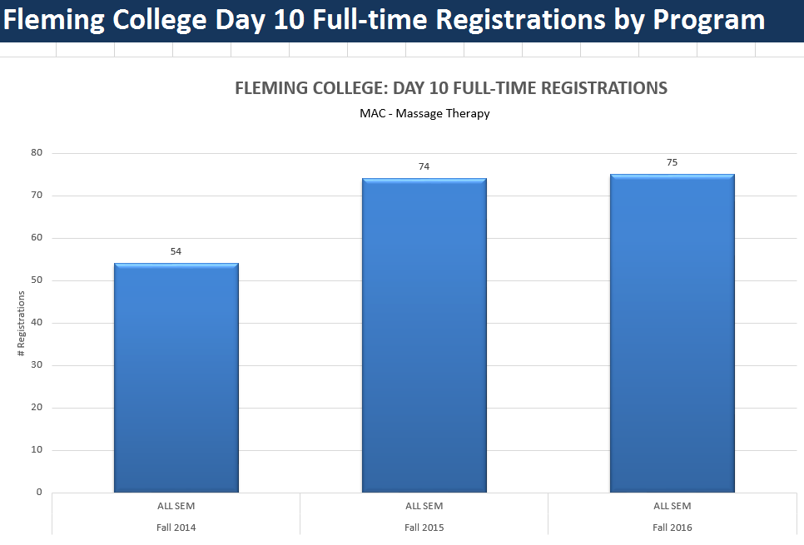  Our program's enrollment has gone up from 54 students to 75 students in all semesters from 2014 - 2016. This is due in part to our compressed program (6 semesters to 5)  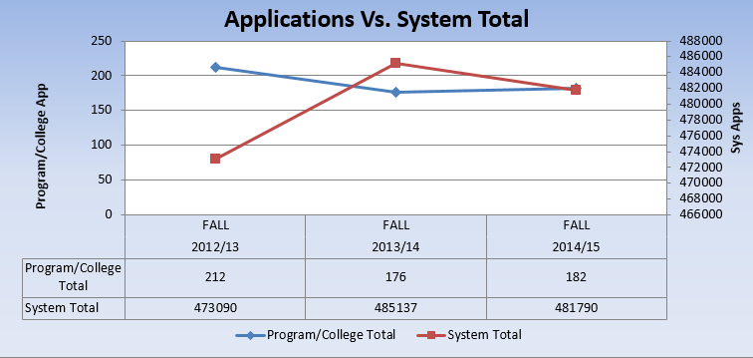  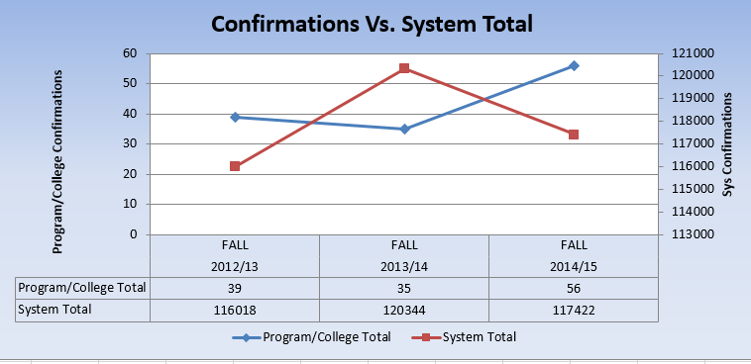  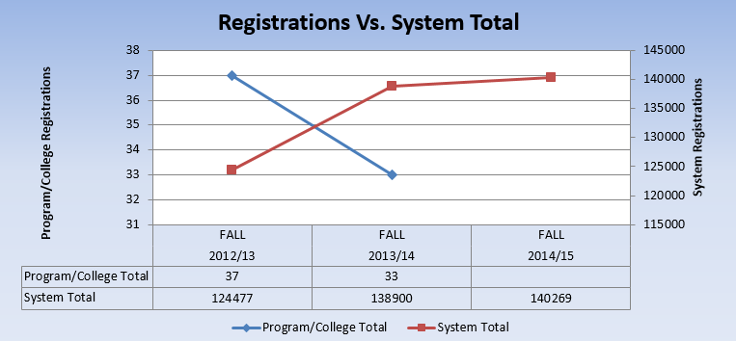  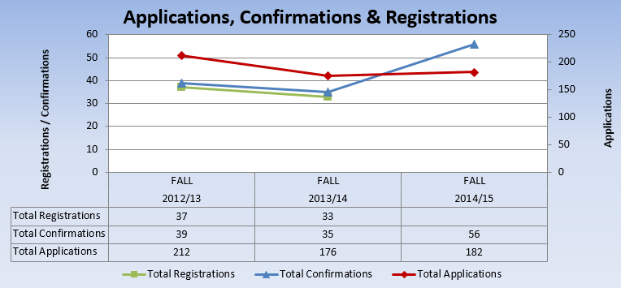
3.0 Program Curriculum | Summary of Key Findings
3.1 Program Learning Outcomes and/or Sector Standards  - Review program level learning outcomes in preparation for curriculum mapping (vocational, essential employability skills, general education)  - Where applicable review sector standards to ensure program is keeping up with new trends, developments and requirements. | School of Health and Wellness  Massage Therapy PROGRAM CODE: MAC  Program Vocational Learning Outcomes  Website for Ministry Standards for Massage Therapy  1 Conduct a massage therapy practice within a legal, professional and ethical framework.  2 Apply business principles relevant to a massage therapy practice.  3 Communicate and collaborate effectively and professionally with clients, colleagues and members of the interprofessional team.  4 Develop and maintain therapeutic relationships to optimize clients’ health and wellness.  5 Collect and assess clients’ information to determine their state of health and the treatment goals.  6 Develop a plan of care according to the client’s condition and the treatment goals.  7 Implement the plan of care according to the client’s condition and the treatment goals.  8 Evaluate the effectiveness of the plan of care.  9 Maintain documentation securely, accurately and in a timely manner.  10 Develop and implement ongoing effective strategies for personal and professional development to ensure quality care.

3.2 Program of Study, Course Outlines, Delivery and Program Map  - Review the feedback and suggestions received from Course-level survey completed by faculty at the end of each semester.  - Review the balance and frequency of assessment types across the curriculum and their appropriateness to learning outcomes for the course and program level outcomes.  - Collect a cross section of samples of student work as evidence of achievement of learning outcomes.  - Reflect and comment upon the variety of methods used to demonstrate program outcomes.  - Reflect and comment upon the degree of technology-enhanced delivery of the program outcomes.  - Discuss the degree and depth to which the program is providing work integrated learning experiences.  - Discuss the degree and depth to which the program includes Indigenous perspectives and record the courses in the curriculum in which Indigenous perspectives are covered  - Record the course in the curriculum that covers the college-wide sustainability learning outcome  - Review (or create) Program Curriculum Map(s) to ensure that there is alignment of current courses to the overall program outcomes, including the Vocational Learning Outcomes, the Essential Employability Skills, and adherence to the General Education Policy.  - Review pre and co-requisites to ensure that they do not hinder progress in the program, unnecessarily.  - Make recommendations to address any gaps identified or improvements required.  - Review the program’s current admission requirements and their suitability in relation to program rigour and student preparedness.  - Include an updated program curriculum map on your program and curriculum review web page. | ADMISSION REQUIREMENTS  OSSD with the majority of credits at the College (C) and Open (O) level, including:  - 2 College (C) English courses (Grade 11 or Grade 12)  - 2 College (C) Science courses (Grade 11 or Grade 12)  When (C) is the minimum course level for admission, (U) or (U/C) courses are also accepted.  Recommended:  - Grade 11/12 Biology and/or Chemistry  - Kinesiology, Health Science course  - U/C level courses
4.0 Strategic Positioning and New Opportunities | Summary of Key Findings
4.1 College and School Alignment

- Review program alignment with college priorities such as vision, mission, values, strategic plan, academic plan and the educational mandate, and / or academic priorities of the School.
- Review program webpage and promotional messaging to ensure accuracy and currency.
4.2 Competitor Programs  - Analyze key parallels and differences between this program and those of its closest competitors, where applicable.  - Comment on the ’Value-added’ program distinctions and their attractiveness to prospective students. | Durham College: 6 semesters, $2936 tuition + $1204 Ancillary + $500 incidental (texts not incl.); 6 – 7 courses offered each semester  Oxford Learning Centre: 88 weeks (we are 74); have to email to get more information – done in modules at own pace  Sutherland Chan offers an Advanced Standing into 2nd year after successful completion of a 12 week module if you apply from an approved degree or diploma program – listed in the link below  $14993 +$70 (TCAF) + $250 Ancillary + $1200 Books, supplies, uniform  /https://sutherland-chan.com/massage-therapy-program/advanced-standing-option-health-professionals/
4.3 Learning Pathways  - Comment on recent or anticipated initiatives that promote student pathways including secondary school partnerships, dual credits, program laddering, dual diplomas, and university transfer, articulations, and partnerships.  - Review all transfer credits.  - Identify any new pathways that could be developed. | /https://sutherland-chan.com/massage-therapy-program/advanced-standing-option-health-professionals/  Possible advanced standing like Sutherland Chan. Would need to develop and online module to be completed then OSCE and MCQ test and entrance into 3rd semester. Use our technique videos.
4.4 New Program or Redesign Ideas  - Are there opportunities for new program initiatives based on Program, School, or community strengths and alliances? | See above
5.0 External Relations | Summary of Key Findings
5.1 Community Partnerships  - Does your program have significant partnerships, relationships, connections, or offers of support from the community that help to enrich the program and the student experience?  - Are faculty, staff, and student involved in volunteer projects and events? | We have a partnership with St. Joseph's @ Fleming where our students do an outreach for the residents and nurses. We are going to reach out in 2018/2019 to do more community outreaches as we have in the past.  We currently do not have the budget to send a supervisor to volunteer events in which our students can partake. We have done Head of the Trent, Peterborough 1/2 Marathon, Women's 1/2 Marathon, Toronto International Marathon, Women's Night Out. We would like to try to bring these back into our program.
5.2 Program Advisory Committee  - Comment on the distribution of Committee membership by constituency, sector, and / or region.  - Comment on the vitality of the Committee (frequency of meetings, members’ level of participation, engagement, and turnover.) | https://department.flemingcollege.ca/program-advisory/  16 external members; Peterborough/Kawartha area  2 student representatives (one from each year)  Independent clinics, Spas, home based  Meetings are annual, low level of turnover
5.3 Alumni Relations  - Describe the type and range of alumnae involvement in the program.  - Current and future strategies to engage alumnae in the program. | https://department.flemingcollege.ca/advancement-alumni/  Our Alumni sit on our Program Advisory Committee. We often hire Alumni if part-time, partial load, or technologist positions arise. Alumni also have access to our Fleming College Career Services for employment opportunities within the community.
6.0 Program Resources | Summary of Key Findings
6.1 Program Revenue and Expenses  - Please review Integrated Program Planning (IPP) information for your program.  - Are program resources adequate, in the context of program currency and student numbers? (e.g. laboratory equipment, software, library holdings, or tools essential to program delivery and student learning.  - Are there opportunities for further program specific external revenue such as sponsorship, grants, donations or gifts-in-kind?  - Review the existing revenue and expenses associated with your program using the IPP tool and provide comments below.  - Review all textbooks for cost, format (hard-copy, e-book, rental), use in multiple semesters, content (curriculum alignment, Canadian content, readability, engagement level), ancillary materials (question bank, Powerpoint, online support, image bank), publisher support, AODA compliance, and conflict of interest.  Comments:  Program Resources: adequate but will need to replace 8 stationary tables with electric tables (Capital) to be AODA compliant. This capital request was submitted February 2018 and was successful.  The program operates a successful massage therapy clinic which contributes to the revenue of the program. It is expected that the revenue from the clinic will continue to grow over the next few years.  The program has maintained a positive contribution margin over the last 3 years, despite this, it is consistently below the College target of 35%. The IPP score, as well as all financial metrics, saw an increase in 2016, which was associated with higher enrolment and a full-time faculty member being away on sabbatical. It is very apparent that the financial health of the program is linked with the high number of full-time faculty associated with the program, especially given the student enrolment. The three-year trend for the CTO demonstrates an increasing margin, which is a positive sign for the programs financial health. Also, on June 30, 2019, one full-time faculty will be retiring, which will improve the financial health of the program. | 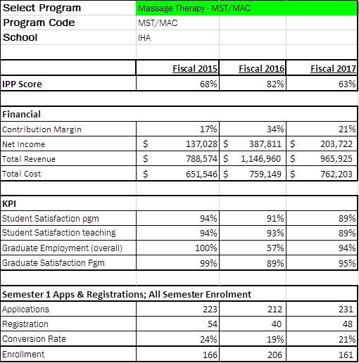
6.2 Faculty and Staff Resources  Please comment on:  - The number and distribution of all faculty, technicians, and technologists associated with the program including full-time, part-time, sessional, and cross-appointments.  - Profile of the faculty, and staff associated with the program including cumulative credentials, scholarship, work-related and teaching experience, and expertise in education.  - Significant faculty or staff accomplishments such as professional recognition and awards, achievement of credentials, and appointments.  - Hiring priorities over the next few years based on the above. | There are currently 4 full time professors dedicated to the Massage Therapy program, with one assuming coordinator duties for the program as well as teaching within the biology department of the school of Health & Wellness. The program has a strong contract faculty membership with five faculty regularly contributing to the program teaching hours. The program employs a technician during clinic hours in order to help facilitate enhanced customer service for community clients using the clinic.  All faculty and technicians who are associated with the program are registered, and in good standing, with the College of Massage Therapists of Ontario (CMTO).  The Massage Therapy team won the Fleming College Teamwork award in 2016 for their dedication and hard work associated with the renovation and re-development of the massage labs and clinic space. Carolyn Selkirk, one of the programs contract faculty, achieved their Master’s degree during the 2016/2017 academic year.  One of the full-time professors will be retiring at the end of the 2018/2019 academic year (June 30, 2019). Due to the size of the program and the single intake, there are no immediate hiring needs for the massage therapy program in the next 3-5 years.
6.3 Program Delivery Capital Assets  - Please review existing program space and equipment  - Determine needs for space and equipment to fulfill future needs | The Massage Therapy program has 2 dedicated lab rooms for the purposes of providing hands on experience in academic labs as well as operating as clinic space during the community clinic hours of operation.  Currently there are enough tables to support 24 students in the lab (12 per lab room). The space comfortably holds 24 students, a technician and a professor during lab/clinic times. There have been challenges this year due to the A-Wing construction in that the lab space was temporarily reduced in size which resulted in a maximum capacity of 20 students in the labs (10 per lab room).  8 more electric tables to replace old stationary ones  Some money in budget for replacement/repair tables  Upgrades to tablets for online charting  Need locking cabinets and shelving in “change room” for better use of space/storage  Will need to share EST body treatment room for added clinic day.

Program Improvement Plan

Based on the analysis of your key findings, identify areas that require attention and action in the next 1-3 year timeframe. Ensure that you only recommend actions that reflect the program’s priorities and its capacity to achieve them, and record the success of any changes implemented and the means by which they are being evaluated.

To make sure your goals are clear and reachable, each one should be:
- Specific (simple, sensible, significant).
- Measurable (meaningful, motivating).
- Achievable (agreed, attainable).
- Relevant (reasonable, realistic and resourced, results-based).
- Time bound (time-based, time limited, time/cost limited, timely, time-sensitive).

New Recommended Improvements | Timeframe | Person(s) Responsible | Approval: Dean, Chair, or VPA or  Not Feasible, with rationale
Advanced Physiology pre-requisite for Clinical Pathology 1 and 2 | September 2018 | Kathryn Jarvis, Nick Stone | Rationale: overlooked at last CR; students who are in Clinical Path 1 not succeeding without Advanced Physiology
Assessment change in Advanced Physiology  Must pass all tests with 70% with the chance of a re-write for each test | Spring 2018 semester | Kathryn Jarvis | To give students a greater opportunity to achieve success and not lose a year
Advanced Physiology pre-requisite for Treatments 2 | September 2018 | Kristina Lonsberry, Paul Clifford | If students not taking Clinical Pathology 1 they will not be learning content for Treatment 2
IJPC’s linked to assessments in D2L | September 2018 to September 2019 | All MAC faculty | Accreditation requirement is for students and faculty to be teaching and assessing to the Practice Competencies and Performance Indicators; currently within each course outline
Increase Clinic Hours to 330 hours | January 2018 | Nick Stone | Completed and on-going to meet Accreditation Standards
Increase amount of outreach opportunities | September 2018 | Kristina Lonsberry | To meet Accreditation Standard
Students to have CPR/1st Aid |  |  | To meet Accreditation Standard
Faculty/FAST Team to have CPR/1st Aid HCP level | Prior to Preliminary accreditation |  | To meet Accreditation Standard
Reallocate COMP345 hours  1 TCH to HLTH202 lecture  2 TCH’s to HLTH 282 lab | September 2018 | Kristina Lonsberry | As requested by Chair
Decrease BUSN hours by 1 hour and put into Standards and Legalities | Remove hour for fall 2019  Add in January 2020 HLTH311 | JBR and KL to fill in forms
Advanced Standing Option | ? 2020 ?
Therapeutic Exercise Text/Re-work course  Adopt Kisner & Colby | January 2019 | Kristina Lonsberry | As per student feedback
Tx 1 minus 1 hour lab give to Ortho Assess | Spring 2019 | KL, JBR | Hour needed more in OA
Tx 2 2 lec, 3 + 3 + 1 lab | Fall 2020 | KL | Hour needed in Massage Lab
Previous Recommended Improvements | Timeframe | Person(s) Responsible | Update and Rationale: Proceeding = P  Completed = C  Not Feasible = NF
Palpation 2 moved from semester 3 to semester 2 |  | MAC faculty, Molly Westland | C
Joint Play moved from semester 2 to semester 3 |  | MAC faculty, Molly Westland | C but not working
Survey Card to be made for client feedback |  | MAC faculty | P: need to include Clinic Techs
Survey of Students in FLPL for feedback |  | MAC faculty, FDR | P: put in D2L survey?

