Program and Curriculum Review Template

Instructions: Review all information that is stored on your program and curriculum review web page.

https://department.flemingcollege.ca/pcr

Program Coordinator: | Mark Parolin | Chair: | Nick Stone
Review Facilitator: |  | Date Completed: | 30-01-2018
Program Name: | Therapeutic Recreation (Recreation for Special Populations) | Program Code: | THR
1.0 Industry Trends and Employment |  | Summary of Key Findings
- Labour Market & Occupational Standard Trends  Review and discuss the following:  - Industry / sector changes or issues identified by the Program Advisory Committee  - Recent labour market data or sector reports as provided by the Fleming Library Researchers.  - Recent or anticipated changes in occupational standards, level of entry and credential and / or standards of accreditation  - Based on the above, do these changes or issues necessitate changes to your program, either immediately, or in the next few years? |  | - Therapeutic recreation (TR) is not currently a regulated healthcare profession in Ontario.  - TR professionals in Ontario may choose to belong to the professional association Therapeutic Recreation Ontario (TRO).  - TRO has a voluntary registration process which has recently differentiated between individuals with a degree level education (R/TRO) and those with a diploma level education (R/TRO – dip). Students who complete our graduate certificate with a previous university degree would be eligible for registration at the R/TRO level whereas students who complete our graduate certificate with a previous college diploma would be eligible at the R/TRO dip level.  - As this is a recent change it is unclear at this point if it will impact hiring practices moving forward and should be monitored.  - TRO just announced at their June 2018 AGM that they would be undergoing a review of the R/TRO designation. Will need to monitor this moving forward to determine if there are changes and if they would in-fact impact our students and graduates  - St. Lawrence College started a graduate certificate program in TR in fall 2017 which will increase the competition for students particularly from the eastern part of the province.  - Fewer full time jobs are available and many new graduates are starting out in casual and/or part-time positions  - PAC members have reported that there is more focus on dual and multiple diagnoses within all types of agencies. In long-term care there is an increase in the complexity of client needs which is leading to more one-to-one and small group programming.

1.2 Graduate Employment & Employment Trends  Review and discuss the following:  - Graduate employment statistics over the last few years, including those of students employed in the field, in a related field, outside the field, or unemployed, and any emerging patterns in this data.  - Emergent employment trends such as new types of positions, changing job market, regional distinctions, changing employer profile, or emerging skill shortages | 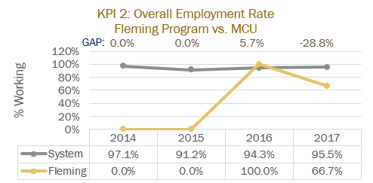  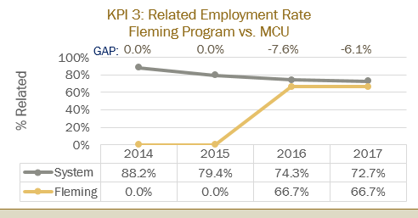  - An aging population continues to lead to growth potential in long-term care and adult day programs. Increases in government funding to mental health initiatives has seen a moderate increase in TR positions in this field.  - Graduates work in hospital, community and long-term care settings. More opportunities currently exist with seniors in day-program and long-term care facilities. Many graduates are initially finding part-time and casual employment in the field.  - Data is lacking for employment rates with our graduates. 2017 data had only three respondents with two working in the field.
2.0 Key Performance Indicators  Review and analyze the formal Key Performance Indicator (KPI) results for your program. | Summary of Key Findings
2.1 Student Satisfaction  - In addition to the formal Student Satisfaction KPI results, comment upon any other formal or informal discussions with students and graduates such as student focus groups, class councils, class representatives, individuals or delegations, or debriefing sessions following a field placement, clinical placement, or practical work integrated learning experience. | 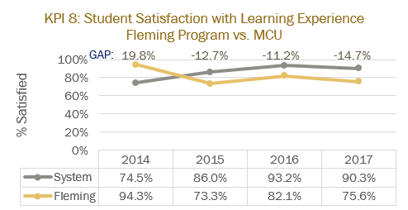  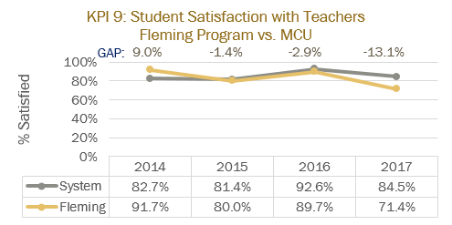  - KPIs for satisfaction with learning experience and with teachers were down in 2017. This may simply represent a one year dip with the faculty satisfaction number of 71.4% being the first time the number had gone below 80%. Discussions were held to rectify this and effort has been made to further engage students and to give them a platform.  - We typically collect course/program feedback at the end of first and second semester. Feedback has consistently been positive in terms of our combination of face-to-face and online delivery, the flexibility that it provides for volunteering and networking within the profession. the real-life examples that our experienced faculty can bring to the classroom and their flexibility in terms of volunteering and finding placements in agencies of their choice.  - They have consistently identified that they would like our Anatomy & Physiology course to be delivered face-to-face and for us to examine the online versus on-campus delivery style of courses in general.  - They feel that the practical experience gained through volunteering, class assignments and placements prepares them well for a future in the field
2.2 Retention Rate  - Use the IPP (Integrated Program Planning) data that focuses on Retention.  - Review patterns of retention on a semester by semester basis over the last five years.  - Comment on the effectiveness of any strategies adopted to improve student retention. | 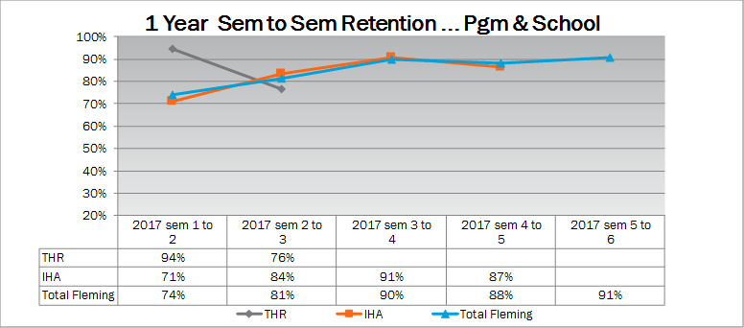  In the past we have lost students primarily for one of four reasons:  - Lack of awareness of what TR involved before starting the program and deciding that it was not for them  - Lack of awareness that half of our program is delivered through online courses and deciding that the delivery was not for them  - Lack of ability/work ethic to handle the rigors of a graduate certificate program  - Issues of academic integrity with some International students.  Efforts have been made to address the awareness of the program/online delivery of some courses through ongoing improvements made to the program web-page over the past two years  Efforts have been made to support international students and clarify the expectations of research and citations within the program. Students have been directed to the online plagiarism course, have been scheduled for individual meetings with faculty/program coordinator, had APA resources shared and had assignment directions covered in more detail and earlier in the program
2.3 Graduate Rate  - Review patterns of graduation rates on a semester by semester basis over the last five years. | 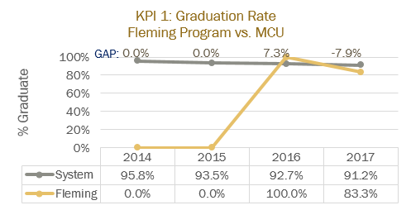  - The dip in the 2017 graduation rate was attributed to an increase in issues of academic integrity in semester two courses that year. As addressed above, more effort has been made to educate and support international students in this regard and all students who completed semester two courses were able to go out on placement in the 2018 academic year.
2.4 Graduate Satisfaction  - Review patterns of graduate satisfaction and provide comment. | 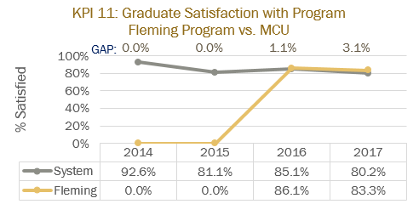  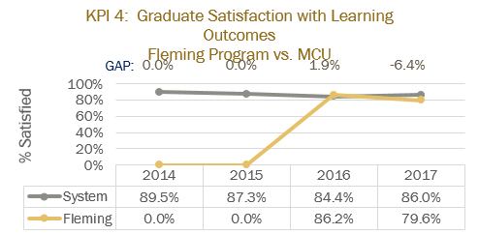  - Limited results to refer to with only two respondents for the 2015/16 year for question 32 and three respondents for question 22. Most scores were 67 or 100%.  - In general, our scores are in line and typically slightly above ministry comparables  - Anecdotally, graduates that have provided feedback have been satisfied with the program and felt that they were well prepared for their placement and working in the field of TR.
2.5 Enrolment Trends and Demand  - Your team will review and analyze the patterns in the number of program applicants, confirmations and actual registrants over the past 5 years. You will also examine changes, if any, in the student demographic profile and the impact, if any, of this changing student profile on program curriculum.  - Assess whether the program curriculum needs to change based on the above analysis.  - Use the FDR excel spreadsheet that provides Day 10 enrolment numbers for Fleming for the last 10 years, to assist you with your analysis.  - Please review the IPP (Integrated Program Planning) data that focuses on trends related to student demand, and the related ‘Situational Analysis’ information included for your program – select the Demand Trending Tab and Situational Analysis Tab. | 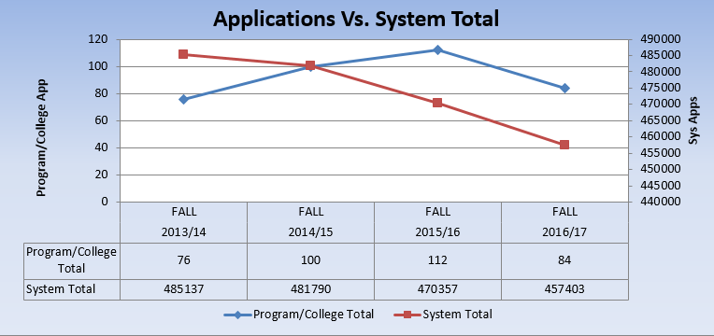  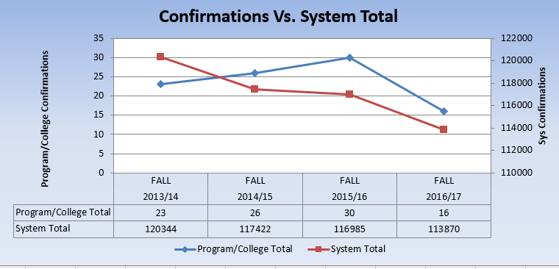  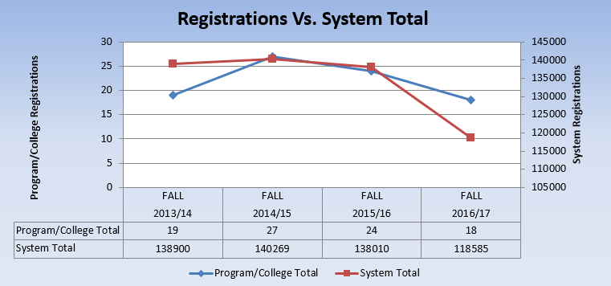  - Numbers have been relatively consistent but below targets.  - Registrations have consistently been about half of the total students at Georgian College and about 1.5 times the enrollment at Lambton College.  - Georgian College’s program was the only graduate certificate in the province for decades and they have a large number of graduates working in the field which enhances their reputation in the profession. As we continue to graduate quality professionals we should close the gap on Georgian College.  - The new program at St. Lawrence College may impact the number of applicants from eastern Ontario.  - We have had years where we were waitlisted but did not meet our enrollment targets. In those years, large numbers of international students were being offered spots which lead to domestic students being placed on waitlists. When the majority of international students didn’t come to the college we were left with lower numbers.  - We have typically received between four and seven international students per year with the majority coming from India.  - Numbers were down the past two falls, which coincides with the program having a program coordinator who was not directly knowledgeable about the field of TR.  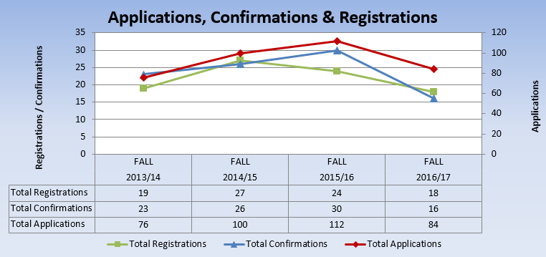
3.0 Program Curriculum | Summary of Key Findings
3.1 Program Learning Outcomes and/or Sector Standards  - Review program level learning outcomes in preparation for curriculum mapping (vocational, essential employability skills, general education)  - Where applicable review sector standards to ensure program is keeping up with new trends, developments and requirements. | - There are currently no ministry standards for TR education in the province.  - TRO has offered to assist the ministry through the sharing of the ECF document that was developed by the TRO educators committee.  - Our curriculum was based off extensive research, experience as a recreation therapist and TR educator and was tied to the TRO Standards of Practice  - TRO’s educators committee has started discussions around developing standards for placement experiences. When/if these are developed/standardized we will need to review our curriculum

3.2 Program of Study, Course Outlines, Delivery and Program Map  - Review the feedback and suggestions received from Course-level survey completed by faculty at the end of each semester.  - Review the balance and frequency of assessment types across the curriculum and their appropriateness to learning outcomes for the course and program level outcomes.  - Collect a cross section of samples of student work as evidence of achievement of learning outcomes.  - Reflect and comment upon the variety of methods used to demonstrate program outcomes.  - Reflect and comment upon the degree of technology-enhanced delivery of the program outcomes.  - Discuss the degree and depth to which the program is providing work integrated learning experiences.  - Discuss the degree and depth to which the program includes Indigenous perspectives and record the courses in the curriculum in which Indigenous perspectives are covered  - Record the course in the curriculum that covers the college-wide sustainability learning outcome  - Review (or create) Program Curriculum Map(s) to ensure that there is alignment of current courses to the overall program outcomes, including the Vocational Learning Outcomes, the Essential Employability Skills, and adherence to the General Education Policy.  - Review pre and co-requisites to ensure that they do not hinder progress in the program, unnecessarily.  - Make recommendations to address any gaps identified or improvements required.  - Review the program’s current admission requirements and their suitability in relation to program rigour and student preparedness.  - Include an updated program curriculum map on your program and curriculum review web page. | ADMISSION REQUIREMENTS  - Ontario College Diploma or university degree in a related field, or the equivalent  As a graduate certificate, this is the required and appropriate level for admissions requirements  - Course evaluation is mapped for students in each semester to help ensure balance and a manageable workload.  - Assessment includes a variety of practical application opportunities including but not limited to the 100 hours of volunteering required in RECR 138, program development and presentation assignments in RECR 128, 130, 134 and 139. Practical assessment skills are developed in RECR 133 and a community inclusion exercise is conducted in RECR 129.  - Students demonstrate learning through the above practical application assignments but also through weekly reflections, the use of discussion board assignments through D2L, TR research-based assignments and testing.  - SCIE 155 utilizes web-resources from the publisher to augment student learning  - Web-links to TR documents (Codes of Ethics, Standards of Practice, TR agencies/programs, research results, etc.) are used in most courses.  - InterviewStream will be utilized in W2019 in RECR 133 and RECR 138  - Cultural competency is addressed in RECR 136, although it could be enhanced to more clearly address Indigenous perspectives  - The sustainability learning outcome is supported through content in RECR 127, 128, 129, 131, 132, 134, 135, 136, 137 and 139  - We intentionally limited the number of pre and co-requisites when we developed the program as we envisioned more working professionals choosing to take courses on a part-time basis and did not want to hinder their ability to move through the program. As we have not had those students enroll in the program we should consider reviewing pre and co-requisites to see if more are warranted. At this point, the only pre-requisite is that all coursework is completed prior to taking the final internship
4.0 Strategic Positioning and New Opportunities | Summary of Key Findings
4.1 College and School Alignment  - Review program alignment with college priorities such as vision, mission, values, strategic plan, academic plan and the educational mandate, and / or academic priorities of the School.  - Review program webpage and promotional messaging to ensure accuracy and currency. | - The program webpage has been updated over the past year with effort made to clarify our delivery style and the advantages that it provides in terms of flexibility  - Given these recent changes the information is accurate ad current  - Videos were added this spring of our part-time faculty member and one of our students. Other videos were also made for additional students  - We will be taping one or two of our students on placement this summer to add the placement perspective.  - Our next target should be the utilization of alumni in our marketing approach
4.2 Competitor Programs  - Analyze key parallels and differences between this program and those of its closest competitors, where applicable.  - Comment on the ’Value-added’ program distinctions and their attractiveness to prospective students. | - TR education in Ontario occurs at the diploma, graduate certificate and degree levels.  - The most direct competitors are the graduate certificate programs at Georgian College and St. Lawrence College (began fall of 2017). Note as well that Lambton College has changed their graduate certificate program in TR to a diploma program effective Fall 2018.  - The graduate certificate programs all share the majority of the curriculum. The St. Lawrence program is modelled very closely after our own with 10 of our 12 courses offered.  - The value added in our program stems from its delivery and contents. In terms of contents, our program is the only graduate certificate with a course that focuses exclusively on TR and Aging.  - Given the demographic trend outlined above this is a plus.  - In terms of delivery, our combination of on-campus and online courses allows a great deal of flexibility to students. Being on campus for classes only two days a week allows them to volunteer and build relationships in the TR field in the location of their choice. It also allows for flexibility to continue employment while in school and to balance school, work and family based on personal needs.
4.3 Learning Pathways  - Comment on recent or anticipated initiatives that promote student pathways including secondary school partnerships, dual credits, program laddering, dual diplomas, and university transfer, articulations, and partnerships.  - Review all transfer credits.  - Identify any new pathways that could be developed. | - Currently no documented pathways exist.  - As a graduate certificate program, it is more likely that pathways will exist leading into our program.  - Efforts were made this year to work on improving awareness of pathways within Fleming College that highlight the potential for diploma graduates to enter our program.  - Efforts should be extended to look at raising awareness of our program for diploma graduates at Fleming College and external colleges.  - In addition, raising awareness of the potential path for university students should be a priority. Students in programs such as psychology, kinesiology and health studies should be targeted.  - Depending on the impact of the R/TRO (dip) designation on hiring practices it might be necessary in the future to look at developing new pathways for our diploma trained graduates into degree-based programs after they are done our program
4.4 New Program or Redesign Ideas  - Are there opportunities for new program initiatives based on Program, School, or community strengths and alliances? | - As a relatively new program and based on our current status it would be best to continue developing our program as it is rather than extending in new directions
5.0 External Relations | Summary of Key Findings
5.1 Community Partnerships  - Does your program have significant partnerships, relationships, connections, or offers of support from the community that help to enrich the program and the student experience?  - Are faculty, staff, and student involved in volunteer projects and events? | - When it comes to student internships, the program has developed affiliation agreements and a working relationship with a wide variety of agencies. Our students typically leave the Peterborough region for placement, so we do not have partnerships with agencies for consistent year by year placement.  - The 100 hours of volunteer work that students do as part of RECR 138 allows the program and the student to form relationships and share awareness throughout the province.  - One of our internship competencies is a special project where the student completes one extra piece and tries to leave the agency with a tangible product  - We have attempted to form extended relationships with local agencies including Five Counties Children’s Centre and St. Joseph’s of Fleming for opportunities to get more hands-on experience with clients that can be tied our courses but they have not felt that the payoff was worth the effort of putting that many extra students through their volunteer orientation processes. This remains a target area moving forward.  - We have targeted February 2019 to develop a new joint student/alumni initiative for TR Awareness Month and will work on integrating local agencies into our planning
5.2 Program Advisory Committee  - Comment on the distribution of Committee membership by constituency, sector, and / or region.  - Comment on the vitality of the Committee (frequency of meetings, members’ level of participation, engagement, and turnover.) | - PAC membership includes representatives from a variety of clinical/hospital, long-term care and community agencies  - Many of the members have remained on the PAC for 5 years of the program’s existence but we have worked on adding newer members over the past two years  - Many of the active members work in long-term care and we would benefit from more involvement from other types of agencies and with more recent TR educational backgrounds
5.3 Alumni Relations  - Describe the type and range of alumnae involvement in the program.  - Current and future strategies to engage alumnae in the program. | - As a newer program, we do not yet have a large alumni pool to draw on.  - Alumni have approached the program to recruit student volunteers and potential placement students  - 2017/18 students have started a facebook page with the intent of continuing it as alumni and inviting future students to join to provide mentoring  - As outlined above, discussion have begun with current students to return next February to partner with the new students on an alumni/student initiative for TR Awareness month  - Alumni should also be targeted for an alumni addition to the program web-page  - Alumni should be targeted for our Program Advisory Committee
6.0 Program Resources | Summary of Key Findings
6.1 Program Revenue and Expenses  - Please review Integrated Program Planning (IPP) information for your program.  - Are program resources adequate, in the context of program currency and student numbers? (e.g. laboratory equipment, software, library holdings, or tools essential to program delivery and student learning.  - Are there opportunities for further program specific external revenue such as sponsorship, grants, donations or gifts-in-kind?  - Review the existing revenue and expenses associated with your program using the IPP tool and provide comments below.  - Review all textbooks for cost, format (hard-copy, e-book, rental), use in multiple semesters, content (curriculum alignment, Canadian content, readability, engagement level), ancillary materials (question bank, Powerpoint, online support, image bank), publisher support, AODA compliance, and conflict of interest. | 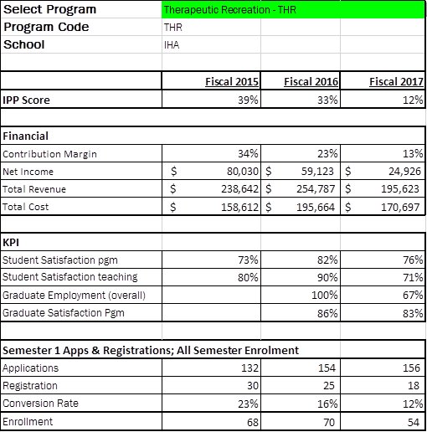  - The program requires very little resources in order to operate. The majority of the resources used in the program revolve around purchasing copyrighted assessments to be used in class.  - The program has contributed positively to the College over the past three years, however it is demonstrating a downward trend in CTO. This is largely linked to declining enrolment. A shared coordinator model was used for several years in this program to see if it would help with improving the CTO. Unfortunately, it was identified that this shared coordinator model was directly linked to the decrease in CTO. For the Fall 2017 academic year the dedicated THR coordinator position was re-established. Fall 2018 enrolment will help determine if this re-establishment has been, in part, effective at helping the program improve its financial health.  - Textbooks and other resources continue to be updated on an annual basis. Many textbooks are used across multiple courses in an effort to keep costs down.  - Most books are available in both hard-copy and e-book formats. Therapeutic Recreation is a small field for publishing so there are not multiple options for most content areas. That said Canadian content is incorporated where possible and resources are readable and appropriate for the level of the program.
6.2 Faculty and Staff Resources  Please comment on:  - The number and distribution of all faculty, technicians, and technologists associated with the program including full-time, part-time, sessional, and cross-appointments.  - Profile of the faculty, and staff associated with the program including cumulative credentials, scholarship, work-related and teaching experience, and expertise in education.  - Significant faculty or staff accomplishments such as professional recognition and awards, achievement of credentials, and appointments.  - Hiring priorities over the next few years based on the above. | - There is currently one full-time faculty member within the program, who also coordinates. We have recently revitalized our contract faculty pool, which has increased our contract faculty membership to three faculty.  - With the exception of the faculty member teaching our anatomy and physiology course, faculty are required to be members in good standing with Therapeutic Recreation Ontario (TRO)  - The hiring plan over the next 3-5 years is to maintain the current full-time and contract faculty membership.
6.3 Program Delivery Capital Assets  - Please review existing program space and equipment  - Determine needs for space and equipment to fulfill future needs | - The THR program does not require a dedicated space within the college and operates successfully out of the SMART classrooms available at the College.  - In order to help increase the enrolment in THR it would be worthwhile investigating an all-year outdoor education classroom within the College property. Designed to support the ecotherapy (possible new program in itself) and outdoor education aspect of therapeutic recreation, this would make our program standout against our competitors.

Program Improvement Plan

Based on the analysis of your key findings, identify areas that require attention and action in the next 1-3 year timeframe. Ensure that you only recommend actions that reflect the program’s priorities and its capacity to achieve them, and record the success of any changes implemented and the means by which they are being evaluated.

To make sure your goals are clear and reachable, each one should be:
- Specific (simple, sensible, significant).
- Measurable (meaningful, motivating).
- Achievable (agreed, attainable).
- Relevant (reasonable, realistic and resourced, results-based).
- Time bound (time-based, time limited, time/cost limited, timely, time-sensitive).

New Recommended Improvements | Timeframe | Person(s) Responsible | Approval: Dean, Chair, or VPA or  Not Feasible, with rationale
SCIE 155 - A&P in TR delivery  - Student and instructor feedback both suggest that for student success this course should be changed to a fully face-to-face delivery  - Many students are entering the program without a science background or having taken related courses at the beginning of their four-year degree  - Proposed change to a 2 hour lecture plus 1 hour lab | Fall 2019 | Kathryn Jarvis
RECR 138 – Preparing for Field Placement in TR  - This course is currently offered in semester two which means that we are starting to offer content related to supporting students in their search for placement after some agencies have already made their decisions (by December)  - Student feedback has also stressed that they need support in the fall semester to search for and begin the volunteer assignment that is associated with this course. This is particularly true for International Students  - This course and the program would benefit by splitting the course into two smaller courses. RECR XXX – Preparing for Field Placement A would be a one- hour lecture offered in the fall semester. RECR XXX – Preparing for Field Placement B would be a two- hour lecture offered in the winter semester | Fall 2019/winter 2020 | Mark Parolin
Blended courses  - Student and instructor feedback have strongly supported the changing of the delivery of some courses from fully online OR fully face-to-face to a more blended or flipped classroom model  - RECR 130 - Leadership in TR offered in the fall semester is currently face-to-face for three hours. Students and the instructor feel that there is a great deal of theory in this course that could be worked on independently prior to classroom time that could then be focused more on application of contents.  - Note that this change also provides an hour of class time that would be utilized for the added hour of Prep for Field Placement discussed above  - RECR 136 – Issues & Trends in TR is currently a completely online course offered in the winter semester. Student and instructor feedback supports the idea of providing one hour of face to face seminar time with two hours of online class time. This will provide more opportunity for discussion, application and presentations/seminars to help provide a more in-depth examination of the issues being studied.  - Note that the change of the Prep for Field Placement course in semester two from 3 to 2 hours of face-to-face time provides for the hour needed for RECR 136.  - Review this new delivery style for these two courses to determine the effectiveness and consider the potential benefits of making changes to the delivery style of other face-to-face or online courses | Fall 2019  Winter 2020  June 2020 | Laurie Porter (RECR 130)  Mark Parolin (RECR 136)  Mark Parolin
Alumni involvement  - The 2017/18 TR class began a new Facebook page with the intent of continuing it as a program page for alumni and current students. We will share this resource with the new 2018 students as well as past alumni from earlier graduating years  - The program webpage on the Fleming College website was updated this past year with the addition of student and faculty videos. We will add to this by recruiting and filming alumni testimonials to provide a more complete overview of the program  - Alumni engagement will also be targeted in terms of involvement in planning an event for TR Month which occurs in February of every year. This will be a joint event offered by the program, current students and alumni. It may include an event for the greater college community to start with an eye on evolving into an opportunity to also give back to local agencies that support us through volunteer and placement opportunities | January 2019  June 2019  February 2020 | Mark Parolin with support of TR alumni and  Fleming College Alumni Relations  Mark Parolin and Lori Humphrey (Marketing)  Program faculty and alumni member Margaret Camp
Student recruitment  - Focus on increasing interaction and recruitment of current Fleming College diploma students by utilizing information and presentations to make sure they are aware of the option of the TR program  - Focus on increasing recruitment of diploma programs at other colleges. With graduate certificates in TR offered in Peterborough, Kingston and Orillia focus on geographic areas not currently served as well as areas closest to us (Durham, GTA, etc.)  - Targeting university students in related programs (psychology, kinesiology, health programs, etc.) to help ensure that they are aware of the option of the TR program  - Review current practices to help improve current conversion rates of applicants | June 2019 | - Program faculty  - Marketing department  - Grad recruiters  - Registrar’s Office
Technology  - Incorporate InterviewStream program into RECR 138 – Prep for Field Placement and RECR 133 – Assessment & Documentation for TR | January 2019 | Mark Parolin  Laurie Porter
Community partnerships  - Identify agencies that we can partner with for learning opportunities.  - Approach agencies about the possibility of students coming to facilitate programs, conduct assessments, provide in-services on what is current in the field | January 2020 | Mark Parolin and program faculty
Previous Recommended Improvements | Timeframe | Person(s) Responsible | Update and Rationale: Proceeding = P  Completed = C  Not Feasible = NF
Add more information to THR website | March 2017 | Alex Smith, Mark Parolin and Molly Westland | C/P. Website was updated for clarity regarding online delivery. This past year we have also added video testimonials from students and faculty. Will continue to update next year with more of an alumni presence
Investigate the balance of online to face-to-face delivery methods to ensure student success |  | Mark Parolin | C/P. Delivery was reviewed with changes noted above for implementation over the next two years.
Review online courses against the Quality Matters Framework | May/June 2017 | Mark Parolin | C. Courses were reviewed. As courses are updated through this process they will continue to be held against this standard
Review current course resources and adjust curriculum and book lists as required | January 2018 | Mark Parolin | C/P – Regular changes are being made with some new resources identified to be used in the Fall 2018 and Winter 2019 semesters
Implement movement of RECR129 from online to face-to-face delivery | Fall 2018 | Mark Parolin & Nick Stone | NF – this change was delayed based on the ongoing program review process. Other changes outlined above have taken priority over this change at this time.

