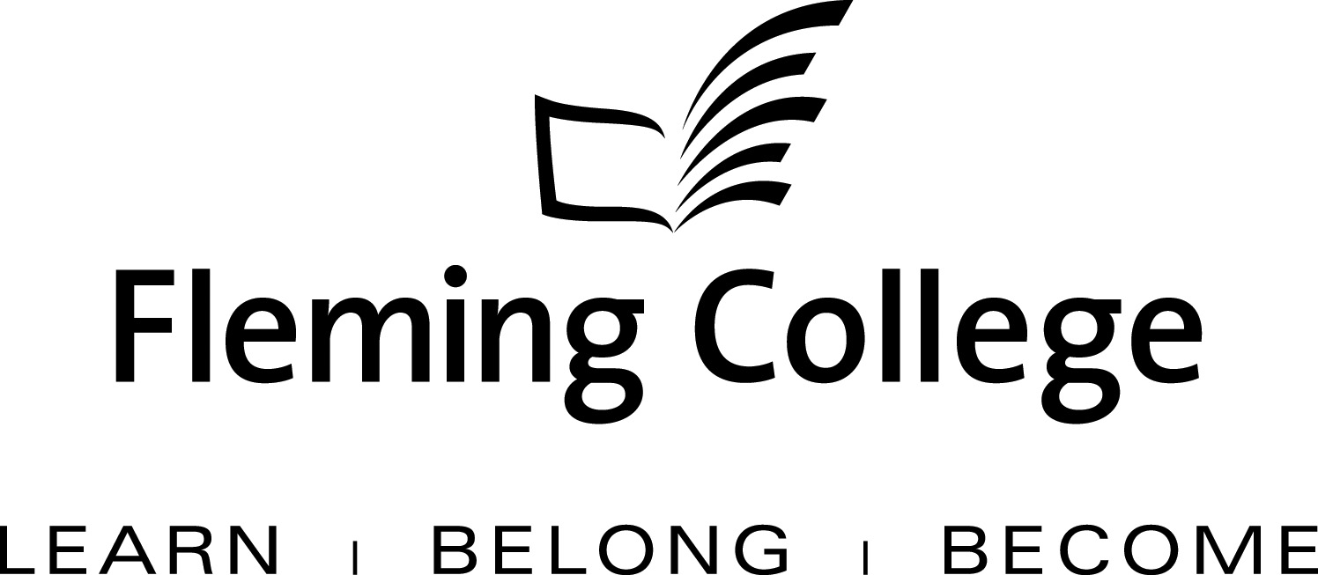

APDC/ASA EXECUTIVE SUMMARY TEMPLATE
FOR PROGRAM REVIEW

The Executive Summary will be presented to the Academic Planning and Development Committee and the ASA Committee of the Board of Governors for information and feedback.

Subject: | School of Law, Justice and Community Services Program Review Report
Presented by: | Paul Legacy, Dean, School of Law, Justice and Community Services
Action: | For Discussion / Information

SOURCE
• Fleming’s Quality Assurance Process (College Policy 2-207)
• ASA Committee mandate (Board Policy 1-102J) to conduct reviews of existing programs of instruction on an ongoing basis, subject to current regulation, legislation and policy directives

BACKGROUND
Fleming’s quality assurance process is a two-staged process that includes: Curriculum Renewal (conducted annually) and Program Review (conducted every five years). These two internal processes are integrated so there is an ongoing focus on curriculum quality.

The Program Review process is characterized by both depth and breadth of analysis. Program data are collated, reviewed and assessed against given criteria, providing a measure of both the vitality and viability of each program. Based on this analysis, long-term plans are then created to guide continuous curriculum improvement and build on the cumulative outcomes of annual curriculum renewal. At the end of this process a Program Review Panel (convened by the Dean) is charged with the responsibility of making recommendations concerning program viability as well as suggesting program/curriculum revisions.

In adhering to the mandate of the APDC/ASA Committee to receive reviews of existing programs of instruction, the Executive Summary for the School of Law, Justice and Community Service is hereby provided for the Committee’s information.

- Drug and Alcohol Counsellor Program

PROGRAM STRENGTHS
Our relationship with the University of Lethbridge addictions degree (B.HSc) offers an opportunity for students to continue their education.

Historically the KPI data have been positive in this program.

Ninety three percent of graduates are satisfied with their experience in this program. This speaks to the dedicated faculty, both full-time and part-time.
This program has seen a steady increase in enrolment, due in part to the Second Career opportunity.

This program has a strong Aboriginal Emphasis component.

PROGRAM CHALLENGES
Should enrolment continues to increase, placement opportunities will be a challenge.

This program shares a number of courses with the Social Services Worker program this limits opportunities to change, modify, delete or include specialized curriculum. A distinct program identity is important and should be considered.

There is only one other Ontario Diploma program in this field of study. As this is a requirement for Second Career, there may be an influx of students to this program. With one full-time faculty (coordinator) and one full-time shared faculty, this will create a strain on current workloads.

Courses in this discipline do not lend themselves to being condensed. One of the new semester models being considered would require a great deal of curriculum reorganization.

SUMMARY OF RECOMMENDATIONS

Program Review Panel Meeting Date: November 20, 2009

Program Review Panel Participants: External members: Wendy Love, Supervisor Central East Correctional Centre, Evelyn Larsen, Case Worker Canadian Mental Health Association, Donna Rogers, Director Fourcast Rick Mayoh, Supervisor Mamisarvik Healing Centre.
Internal members: Joe Ellis, Drug and Alcohol Program Coordinator, Paul Legacy, Dean School of Law Justice and Community Services, Deb Holts, Academic Lead School of Law Justice and Community Services, Lee Anne Cormier Partial Load Faculty Drug and Alcohol Program

Summary Recommendations:

- Revise curriculum to position this program as a leader in the field of Drug and Alcohol Counselling.

- Continue to focus curriculum on a wide variety of treatment/application/methodology to prepare students for entry level positions.

- Distinguish curriculum from current Social Service Worker program.

- Continue to offer a two year Ontario College Diploma.

- Investigate changes required to meet College of Social Worker standards.

- Community Justice Services

PROGRAM STRENGTHS
The program has an active advisory committee that is invested in the success of the program.

This program prepares graduates to apply their theoretical knowledge in a variety of practical settings in the community. This allows graduates to have a broad spectrum of employment opportunities.

Students are on a block placement for four months.

After a common semester, students in this program have numerous opportunities for small group discussion.

Graduate satisfaction in this program is 93%. As a result, alumni are very generous with their support, offering their time and their expertise.

The program coordinator is well respected within the community.

PROGRAM CHALLENGES
The biggest challenge in this program is the lack of full time complement. The coordinator is stretched to meet student/teacher expectations as well as secure field placements.

The program has a common semester and a full semester in the field. Although both of these are seen as strengths, and distinguishes from other colleges, it does mean the program core competencies must be met in two semesters. This can be challenging.

The program grew by 8% last year. This will create a challenge for the coordinator to find quality field placement opportunities in the fall 2010 semester.

SUMMARY OF RECOMMENDATIONS

Program Review Panel Meeting Date: March 25, 2009

Program Review Panel Participants: External Members: Nancy Best, Program Director Murray Mc Kinnon Foundation, David Bodrug, Case Worker, Edmison House,Lisa Fenn, Mon A Mark Mikoluff, Superintendent, Brookside Youth Centre.
Internal Members: Paul Legacy, Dean School of Law Justice and Community Services, Deb Holts, Academic Lead School of Law Justice and Community Services, Cindy Gervais, Community Justice Services Coordinator.

Summary Recommendations:

- Introduce a Motivational Counselling course into the program

- Create diploma alternatives using existing on-line and web based material for early leavers.

- Secure a youth placement option in FLPL 16 Field Observation

- Add an elective General Education course (this recommendation will be addressed at the March 25, 2010 meeting)

- Computer Security Investigation

PROGRAM STRENGTHS
There are several industry areas where graduates from Fleming receive certification including Cisco Certified Network Architect.

Co-op placements are within corporate security departments where students work on “live” real time projects. This opportunity frequently leads to employment with these organizations.

Majority of courses are “applied” hands on learning experiences in state of the art labs.

Local high schools are now part of the Cisco Academy training. This has increased the intake of local students.

The program has articulation agreements with UOIT and the University of Western Sydney.

PROGRAM CHALLENGES

Many government initiatives, such as the Second Career initiative, are not available to 3 year programs.

This program demands continual upgrading of faculty skills. Our current model makes that challenging.

Securing quality projects for students can be challenging.

This three year advanced technical program is at risk of not being adequately staffed. There is only one full time faculty member assigned to the CSI Program.

Capital support, the teaching environment and professional development continue to be challenges for this program.

The teaching environment is at risk. The computer commons and hardware labs were removed as a CSI resource in spring 2009. There is currently a proposal to remove the special purpose computer lab in 3612 which will require all specialized CSI technology to be taught in 3611.
This is a significant loss to the program. This could be fatal to the learning environment as well as the ability to attract and retain students.

SUMMARY OF RECOMMENDATIONS

Program Review Panel Meeting Date: Meeting will be held electronically, April 2010

Program Review Panel Participants: Internal Members: Blair Brown, CSI Coordinator, Paul Legacy, Dean School of Law Justice and Community Services, Deb Holts, Academic Lead School of Law Justice and Community Services,
External members: Jeff York, graduate Security Analyst OPSEC, Eugene Ng, Vice President NCI, John Bradley, President Siquest Jeff Dee President Defilaide.

Summary Recommendations:

- Several program courses will be revised to include new technology and software.

- Computer and Network Security courses will be changed from a shared course and revised to reflect the system security and certification requirements of sec+ and Network+ in a Windows environment. The constraints of sharing this course have prevented it from being a truly effective building block in the CSI curriculum.

- A direct marketing initiative should be conducted to the security industry, re-introducing them to CSI the program and the benefits of supporting co-op placements and hiring our graduates. This will need to be lead by Marketing with SME input from CSI.

- Develop CSI fast-track certificates.

- Explore alternative delivery, flip camera, one hour webinar plus lab blocks in week eight.

- Request specific professional development dollars for CSI faculty to maintain currency given the zooming pace of changes.

- More development time is required to adequately introduce new technologies into the learning environment. Lack of technological growth will ultimately lead to obsolescence.

- Copyright issues when webinars are developed needs discussion at the leaders table.

